ADHESIVES RESEARCH
Oracle EBS Attribute Location Confirmation
Item F-5412-991 - Adhesives
Prepared for | Caron Wills
Verification date | September 4, 2026
Document status | Review and confirmation requested

Purpose
This document requests confirmation of proposed Oracle EBS navigation paths and fields for attributes supplied for item F-5412-991. It is a mapping review, not the final verification report; no mapping is approved until Caron confirms it.
Source Item Reference
Item Number | F-5412-991
Item Type | Adhesives
Description | F-5412-991 (PRE-MIX FOR EC-72 MILLING)(350#)
UOM | POUND
ORG | GR

Review principle: Excel source values are transcribed exactly from the supplied workbook. The Oracle EBS screenshots show candidate locations or current values that still require confirmation.

Requested Review
Please confirm each proposed path in Section 2, provide the correct destination for the attributes in Section 1, and correct any mapping that does not reflect the intended Adhesives Research setup.
1. Attributes Without a Confirmed Oracle EBS Location
The following source attributes do not yet have a confirmed Oracle EBS destination. The screenshots are included to show the source value and the EBS area already reviewed.
1.1 Shelf Life From
Attribute | Excel Source Value | Current EBS Evidence
Shelf Life From | Date of Manufacture | Inventory > Lot Expiration (Shelf Life) shows Control = Shelf life days and Shelf Life Days = 90. No explicit Shelf Life From field is visible.

Confirmation requested: Please identify the exact standard attribute or descriptive flexfield that should store Shelf Life From = Date of Manufacture. Please also confirm whether this is a separate business attribute from Shelf Life Days.

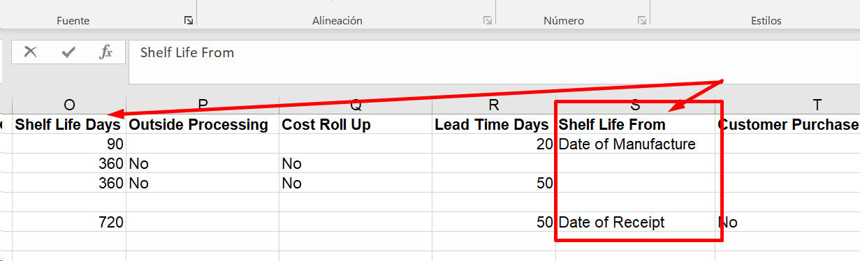
Figure 1 - Excel source excerpt showing Shelf Life From for the supplied item data.
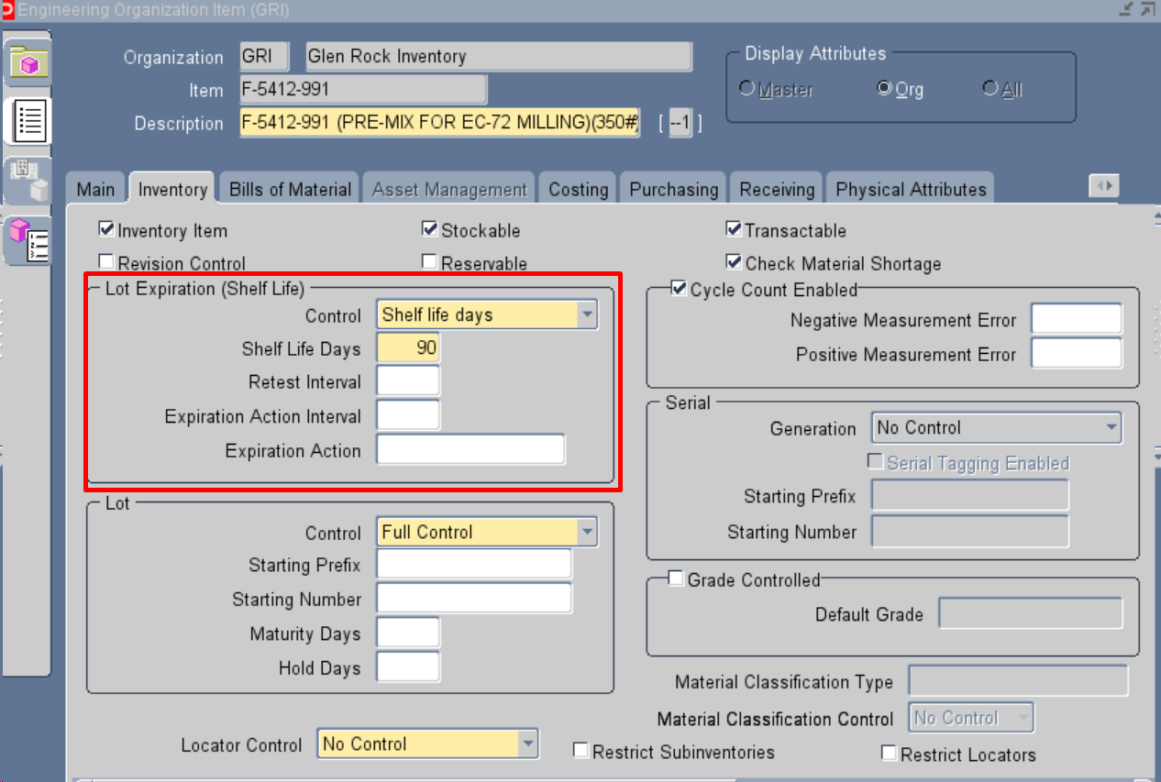
Figure 2 - Oracle EBS Inventory tab area reviewed while searching for the Shelf Life From destination.
1.2 Requested By
Attribute | Excel Source Value | Current EBS Evidence
Requested By | Christina Wilson | No Oracle EBS navigation path, standard field, or descriptive flexfield has been confirmed from the supplied screenshots.

Confirmation requested: Please provide the exact Oracle EBS navigation path and field or descriptive flexfield where Requested By should be stored and viewed for item F-5412-991.

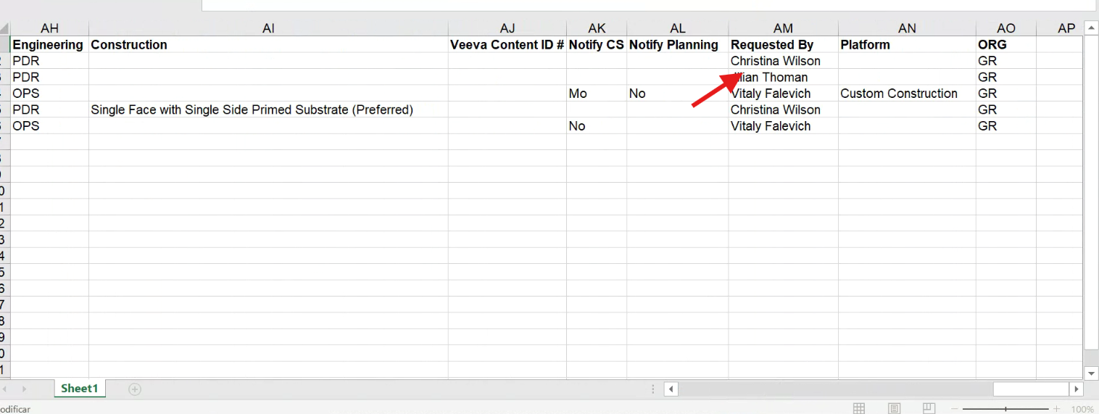
Figure 3 - Excel source excerpt showing Requested By = Christina Wilson for F-5412-991.
2. Proposed Oracle EBS Locations Requiring Confirmation
The following screens and fields have been identified as proposed Oracle EBS locations. Caron is requested to confirm whether each path and mapping is correct.
2.1 Main Tab - Item Identification and Status
Source Attribute | Excel Source Value | Oracle EBS Field / Value Shown
Item Number | F-5412-991 | Item header = F-5412-991
UOM | POUND | Main > Unit of Measure > Primary = POUND
Description | F-5412-991 (PRE-MIX FOR EC-72 MILLING)(350#) | Main > Long Description shows the same text.
Part Status | New | Main > Item Status = ENGINEER. Please confirm whether Part Status and Item Status are intended to map to each other.
Item Type | Adhesives | Main > User Item Type = Purchased Item. Please confirm whether this is the intended relationship.

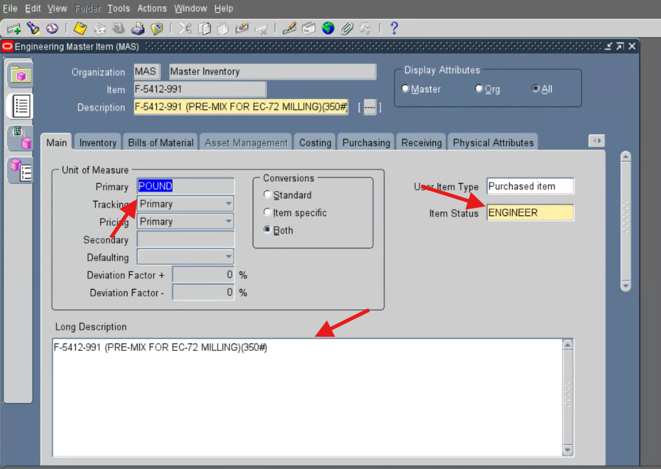
Figure 4 - Oracle EBS Main tab showing item number, primary UOM, item status, user item type, and long description for F-5412-991 in the Master organization.
2.2 Category Assignments
Source Attribute | Excel Source Value | Oracle EBS Field / Value Shown
Business Unit | Electronics | Category Set BUSINESS UNIT = ELECTRONICS; Control Level = Master
Division | ARcare | Category Set DIVISION = ARCARE; Control Level = Master
Engineering | PDR | The Engineering category set is not visible in the supplied Category Assignments screenshot.

Additional point: The screenshot also shows Inventory = DEFAULT- at the Org control level. No corresponding Inventory category value is present in the supplied Excel row. Please confirm whether this assignment is expected and whether the Engineering category should appear on the same screen.
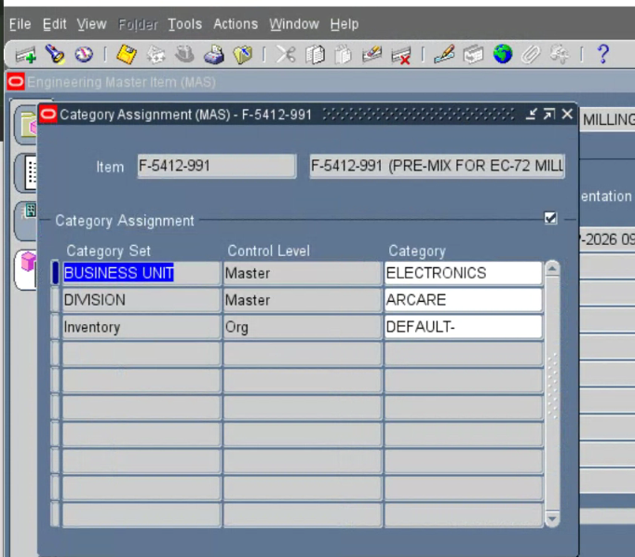
Figure 5 - Oracle EBS Category Assignments showing Business Unit, Division, and Inventory assignments for F-5412-991.
2.3 Item Descriptive Flexfield
Source Attribute | Excel Source Value | Oracle EBS Field / Value Shown
PDR | 26-16 | PDR NUMBER = 26-16
HIMS | 230 | HIMS = 230
Lead Time Days | 20 | LEAD TIME DAYS = 20
Percent Solids | 31.6 | PERCENT SOLIDS = 31.6
Average Container Size | No column or value is present in the supplied Excel row. | AVERAGE CONTAINER SIZE = 1500

Confirmation requested: Please confirm the descriptive flexfield context and fields used for PDR, HIMS, Lead Time Days, and Percent Solids. Please also confirm whether Average Container Size = 1500 applies to this item and identify its approved source.

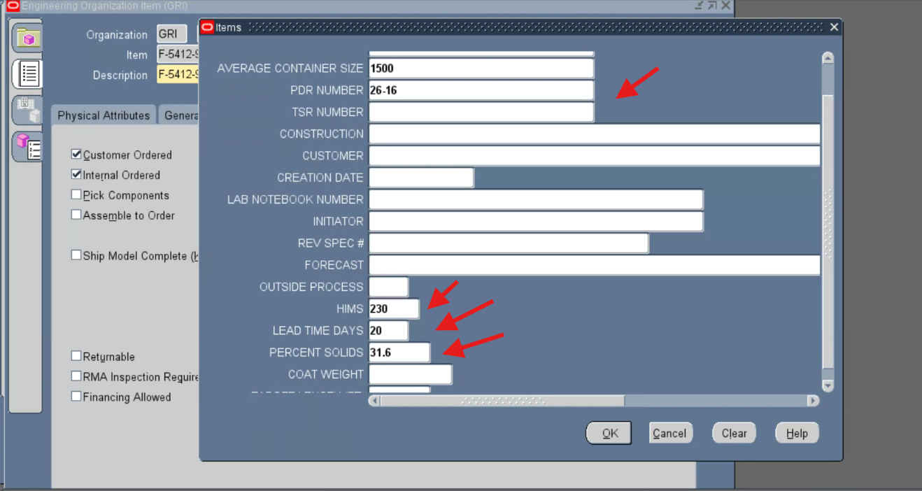
Figure 6 - Oracle EBS Items descriptive flexfield showing PDR Number, HIMS, Lead Time Days, Percent Solids, and Average Container Size.
2.4 Physical Attributes - Weight
Source Attribute | Excel Source Value | Oracle EBS Field / Value Shown
Weight Per Gallon | 7.5 | Physical Attributes > Weight > Unit Weight = 7.5
UOM | POUND | Physical Attributes > Weight > Unit of Measure = POUND

Confirmation requested: Because Weight Per Gallon and Unit Weight may represent different business concepts, please confirm whether Unit Weight is the correct destination for Weight Per Gallon. If not, please identify the correct standard field or descriptive flexfield and its required unit of measure.

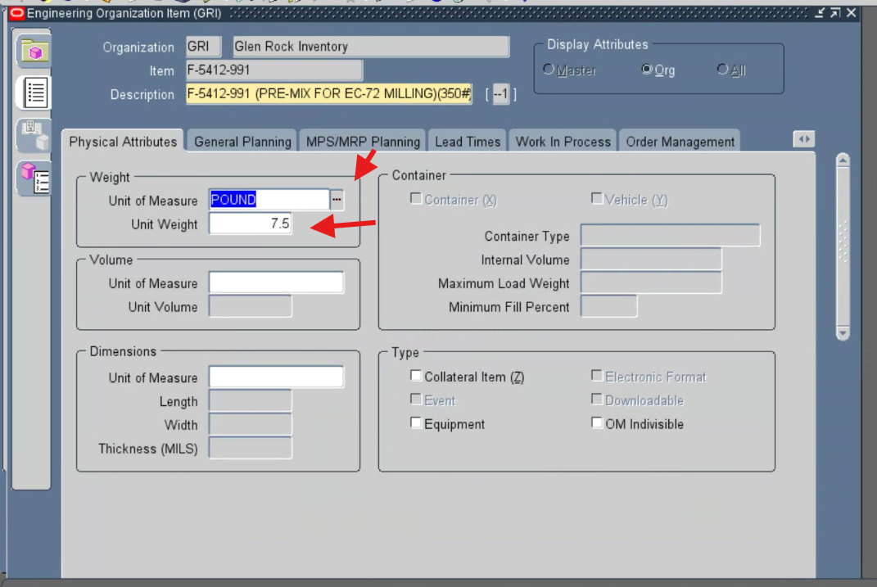
Figure 7 - Oracle EBS Physical Attributes tab showing Unit of Measure = POUND and Unit Weight = 7.5 for F-5412-991 in the GRI organization.
2.5 Inventory Tab - Shelf Life Days
Source Attribute | Excel Source Value | Oracle EBS Field / Value Shown
Shelf Life Days | 90 | Inventory > Lot Expiration (Shelf Life) > Control = Shelf life days; Shelf Life Days = 90

Confirmation requested: Please confirm that Inventory > Lot Expiration (Shelf Life) is the correct Oracle EBS path for Shelf Life Days. The separate Shelf Life From question remains open in Section 1.1.
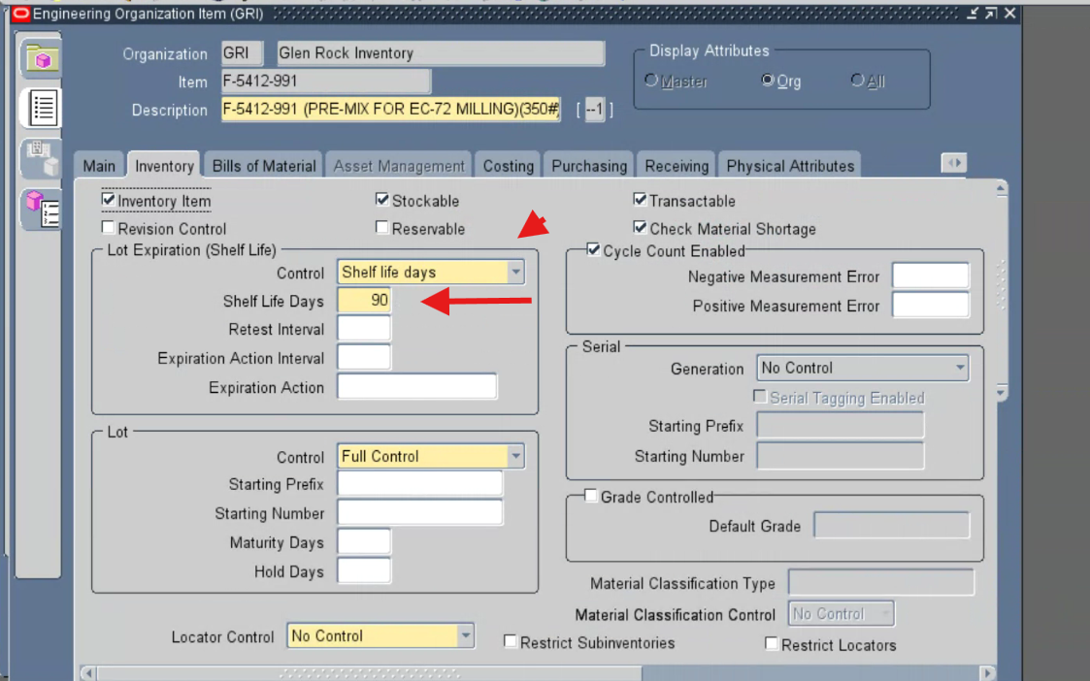
Figure 8 - Oracle EBS Inventory tab showing Shelf Life Control = Shelf life days and Shelf Life Days = 90 for F-5412-991 in the GRI organization.
2.6 Lead Times
Source Attribute | Excel Source Value | Oracle EBS Field / Value Shown
Lead Time Days | 20 | Lead Times > Processing = 20
Lead Time Days | 20 | Item descriptive flexfield > LEAD TIME DAYS = 20; also shown in Figure 6

Confirmation requested: Please confirm whether Lead Time Days should populate both the standard Processing lead time and the custom LEAD TIME DAYS flexfield, or identify which field should be authoritative.

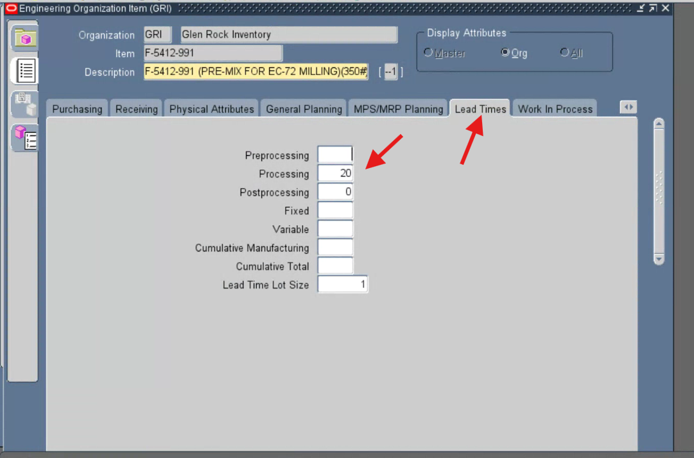
Figure 9 - Oracle EBS Lead Times tab showing Processing = 20 for F-5412-991 in the GRI organization.
3. Confirmation Items for Caron
Please confirm or correct the following items so the mapping can be finalized before the formal item and attribute verification report is prepared.
No. | Decision Required | Current Question
1 | Shelf Life From destination | Which Oracle EBS standard field or descriptive flexfield should store Date of Manufacture?
2 | Requested By destination | Which Oracle EBS path and field should store Christina Wilson?
3 | Part Status mapping | Does Excel Part Status = New map to Oracle EBS Item Status = ENGINEER?
4 | Item Type mapping | Does Excel Item Type = Adhesives map to Oracle EBS User Item Type = Purchased Item?
5 | Category assignments | Are Business Unit and Division correct at Master level, and where should Engineering = PDR be visible?
6 | Weight Per Gallon mapping | Should 7.5 be stored as Unit Weight, or in another standard field or descriptive flexfield?
7 | Lead Time Days mapping | Should 20 populate both Processing and LEAD TIME DAYS, or only one field?
8 | Average Container Size | Is 1500 applicable to this item, and what is its approved source?
9 | Organization code | Does source ORG = GR correspond to Oracle EBS organization GRI - Glen Rock Inventory?
10 | Master versus organization level | Are the displayed Master-level and Org-level attribute locations consistent with the intended control levels?

Next step: After Caron confirms or corrects these locations and mappings, the approved paths can be used to complete the formal Oracle EBS item and attribute verification report.

