- Items not identified (yet) on EBS
  - Shelf Life From
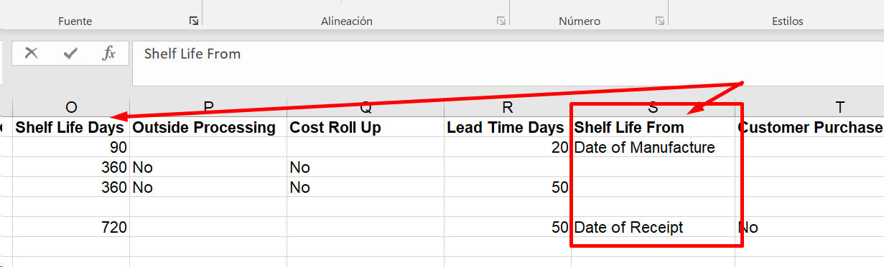
This colum seems to be related with this part on EBS:
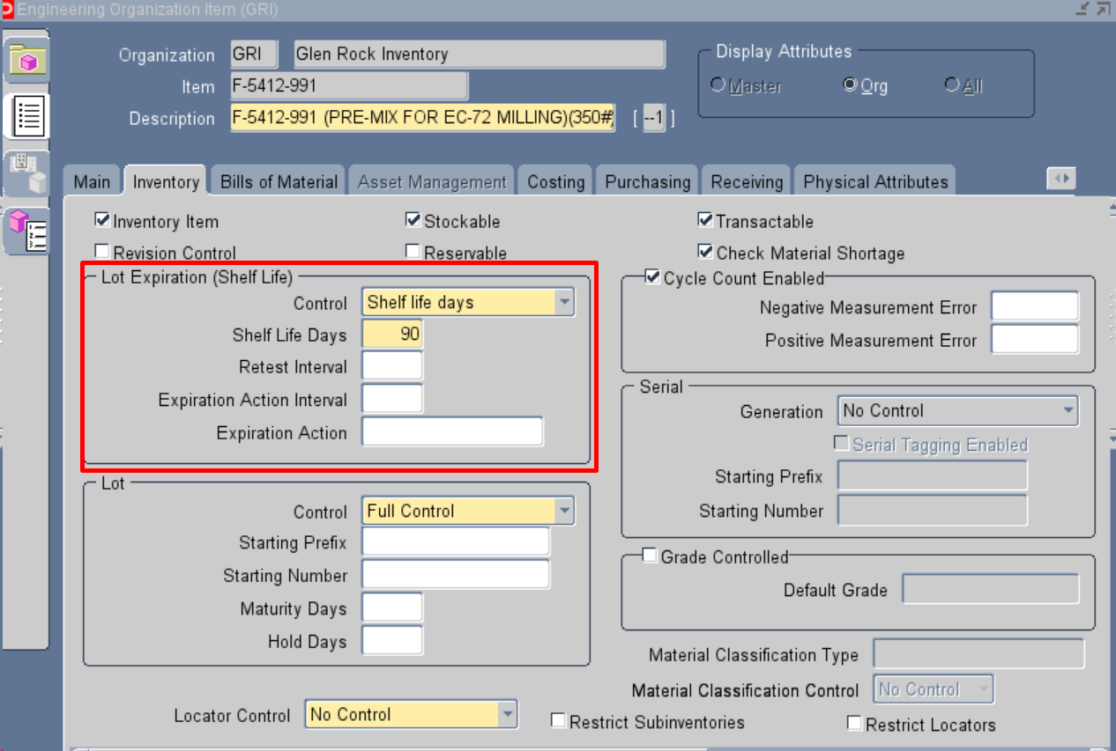
But I am not sure which attribute or Flexfields we should use to store it.

- Identified items on EBS (for confirmation)

