ADHESIVES RESEARCH
Oracle EBS Corrected Item Validation – F-5412-991
Follow-up to Caron Wills' Attribute Location Confirmation Review
Prepared for | Caron Wills
Validation date | September 4, 2026
Item | F-5412-991 - Adhesives
Document status | Corrected implementation review

Purpose
This document follows the Oracle EBS Attribute Location Confirmation review completed by Caron Wills. It records the corrected Oracle EBS configuration for item F-5412-991, demonstrates how Caron's comments were implemented, and isolates only the remaining final-confirmation items. Previously confirmed mapping decisions are not reopened.

Status Key
Corrected / Confirmed | Confirmation Requested | Evidence Exception

Evidence exception identified: The supplied Main-tab screenshot displays Item Status = Active, while Caron's confirmed requirement and the validated setup supplied for this report specify ENGINEER. This is not a mapping question. The Oracle EBS value or the screenshot evidence must be corrected before the item can be represented as fully validated.

1. Item Reference
Item Number | F-5412-991
Item Type | Adhesives
Description | F-5412-991 (PRE-MIX FOR EC-72 MILLING)(350#)
Primary UOM | POUND (LB)
Target Organization | GRI - Glen Rock Inventory
Current Target Template | ADHESIVES
Current Target Template ID | 107

2. Summary of Caron's Previous Corrections
The following decisions were already confirmed and are treated as approved requirements in this validation.
Attribute | Required / Confirmed Setup | Oracle EBS Evidence | Status
Requested By | Store in INITIATOR | INITIATOR = Christina Wilson | Corrected / Confirmed
Long Description | Leave blank | Blank in the Main-tab screenshot | Corrected / Confirmed
User Item Type | ARcare | ARCARE | Corrected / Confirmed
Item Status | ENGINEER | Screenshot currently displays Active | Evidence Exception
Inventory Category | DEVELOPMENTAL ADHESIVES- | Corrected category supplied; screenshot shows the DEVELOPMENTAL ADH... prefix | Corrected / Confirmed
INV_CLASS | WIP | WIP | Corrected / Confirmed
Engineering | PDR | PDR | Corrected / Confirmed
Weight Per Gallon | Do not populate Unit Weight | Unit Weight and Weight UOM are blank | Corrected / Confirmed
Construction | Percent Solids + Weight Per Gallon | 31.6 % SOLIDS; 7.5 LBS/GAL | Corrected / Confirmed
Shelf Life Days | Use Inventory > Lot Expiration | Shelf Life Days = 90 | Corrected / Confirmed
Lead Time | Keep standard lead time blank for make items | Processing and other standard lead-time inputs shown blank | Corrected / Confirmed
Organization | GR may be referred to as GRI | GRI - Glen Rock Inventory | Corrected / Confirmed

3. Corrected Oracle EBS Validation

3.1 Main Tab - Item Identification
Attribute | Required / Confirmed Setup | Oracle EBS Evidence | Status
Item Number | F-5412-991 | F-5412-991 | Corrected / Confirmed
Description | F-5412-991 (PRE-MIX FOR EC-72 MILLING)(350#) | F-5412-991 (PRE-MIX FOR EC-72 MILLING)(350#) | Corrected / Confirmed
Primary UOM | POUND / LB | POUND | Corrected / Confirmed
User Item Type | ARcare | ARCARE | Corrected / Confirmed
Item Type Code | ARCR | ARCR (validated setup; code is not displayed in this form) | Corrected / Confirmed
Long Description | Blank | Blank | Corrected / Confirmed
Item Status | ENGINEER | Active in the supplied screenshot | Evidence Exception

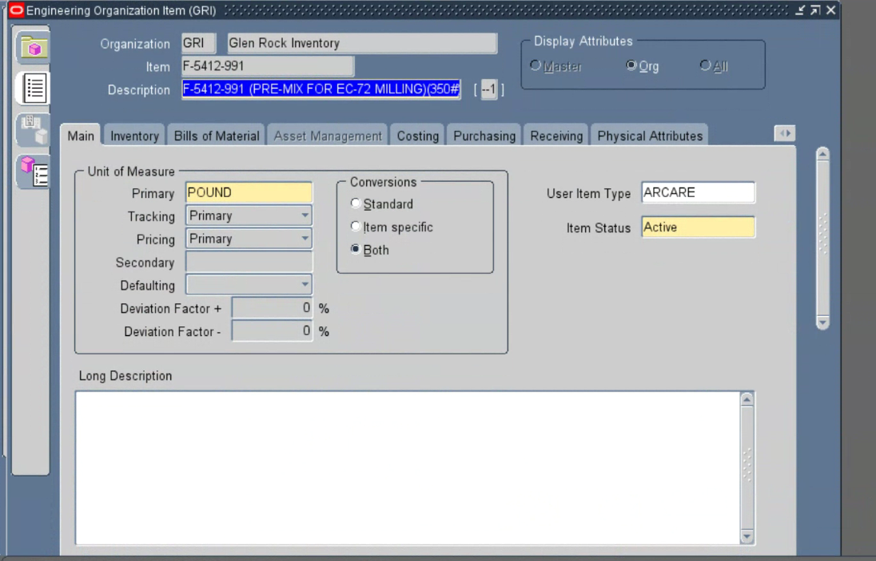
Figure 1 - Oracle EBS Main tab for F-5412-991 in GRI showing Primary UOM = POUND, User Item Type = ARCARE, a blank Long Description, and the Item Status evidence exception (Active displayed instead of ENGINEER).

3.2 Item Descriptive Flexfield
Attribute | Required / Confirmed Setup | Oracle EBS Evidence | Status
PDR NUMBER | 26-16 | 26-16 | Corrected / Confirmed
AVERAGE CONTAINER SIZE | 1500 | 1500 | Corrected / Confirmed
HIMS | 230 | 230 | Corrected / Confirmed
LEAD TIME DAYS | 20 | 20 | Corrected / Confirmed
PERCENT SOLIDS | 31.6 | 31.6 | Corrected / Confirmed
INITIATOR | Christina Wilson | Christina Wilson | Corrected / Confirmed
CONSTRUCTION | 31.6 % SOLIDS; 7.5 LBS/GAL | 31.6 % SOLIDS; 7.5 LBS/GAL | Corrected / Confirmed

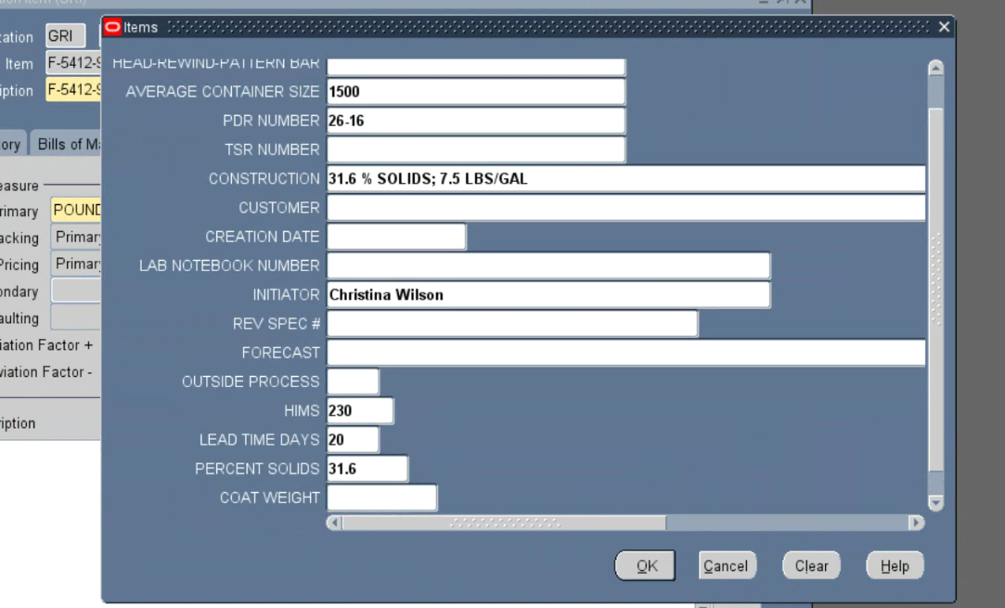
Figure 2 - Oracle EBS Items descriptive flexfield showing the corrected PDR Number, Average Container Size, Construction, Initiator, HIMS, Lead Time Days, and Percent Solids values.

3.3 Physical Attributes - Weight
Attribute | Required / Confirmed Setup | Oracle EBS Evidence | Status
Weight UOM | Blank | Blank | Corrected / Confirmed
Unit Weight | Blank | Blank | Corrected / Confirmed

Implemented correction: Weight Per Gallon is intentionally not stored in Physical Attributes. It is represented in the CONSTRUCTION descriptive flexfield together with Percent Solids.
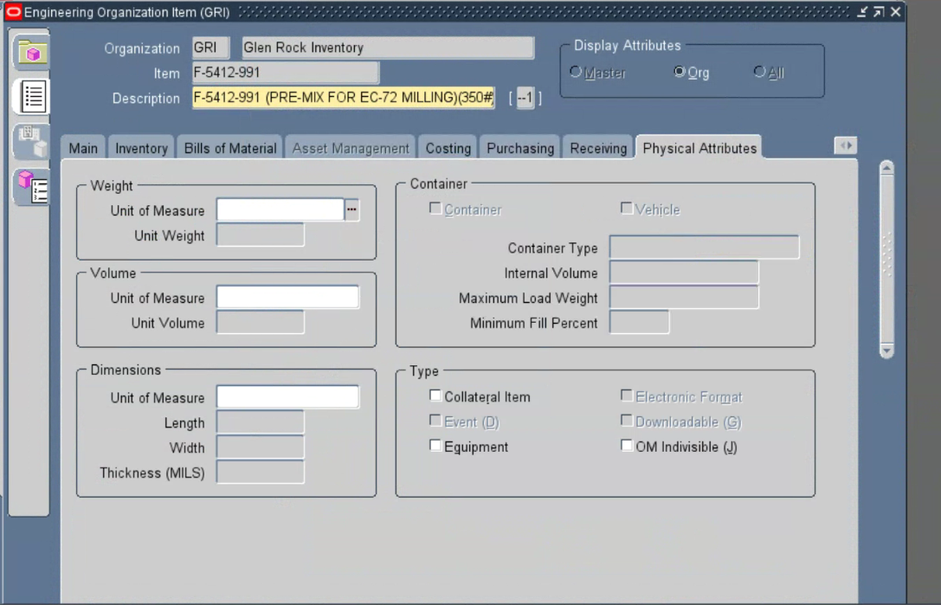
Figure 3 - Oracle EBS Physical Attributes tab showing blank Weight Unit of Measure and Unit Weight fields for F-5412-991 in GRI.

3.4 Inventory - Shelf Life
Attribute | Required / Confirmed Setup | Oracle EBS Evidence | Status
Shelf Life Control | Shelf life days | Shelf life days | Corrected / Confirmed
Shelf Life Days | 90 | 90 | Corrected / Confirmed

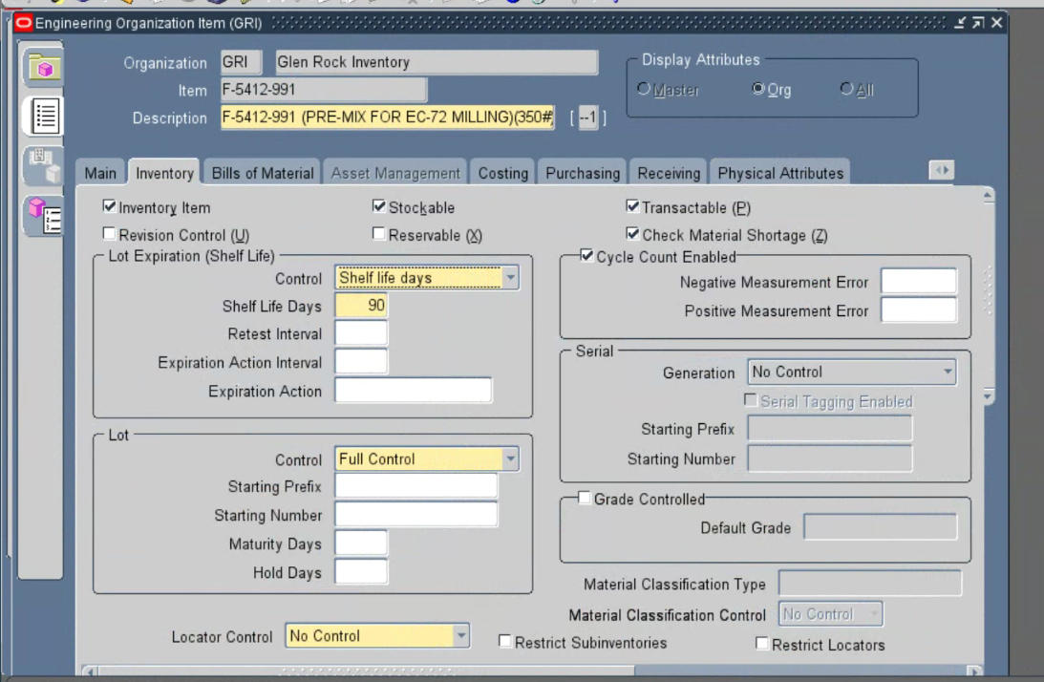
Figure 4 - Oracle EBS Inventory tab showing Shelf Life Control = Shelf life days and Shelf Life Days = 90 for F-5412-991 in GRI.

3.5 Lead Times
Attribute | Required / Confirmed Setup | Oracle EBS Evidence | Status
Processing | Blank | Blank | Corrected / Confirmed
Standard / Full Lead Time | Blank | Blank in validated setup; no populated standard lead-time value is shown | Corrected / Confirmed
LEAD TIME DAYS DFF | 20 | 20 in the Item descriptive flexfield (Figure 2) | Corrected / Confirmed

Confirmed rule: F-5412-991 is configured as a make item. The standard Oracle lead time remains unpopulated so Oracle can calculate it; the business Lead Time Days value remains only in the Item descriptive flexfield.
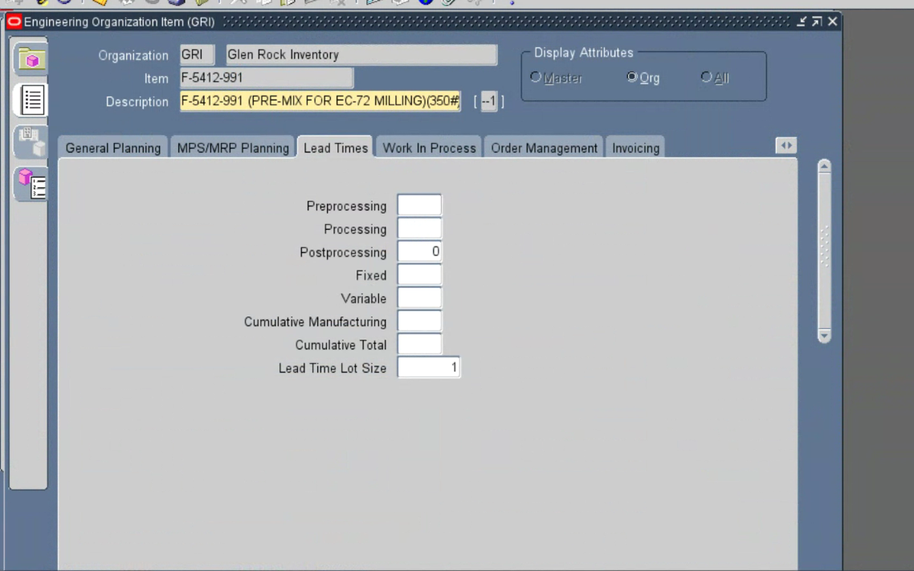
Figure 5 - Oracle EBS Lead Times tab showing blank Processing and other standard lead-time inputs for the make item F-5412-991 in GRI.

3.6 General Planning
Attribute | Required / Confirmed Setup | Oracle EBS Evidence | Status
Planner | 1 / 01 | 01 | Corrected / Confirmed
Make or Buy | Make | Make | Corrected / Confirmed

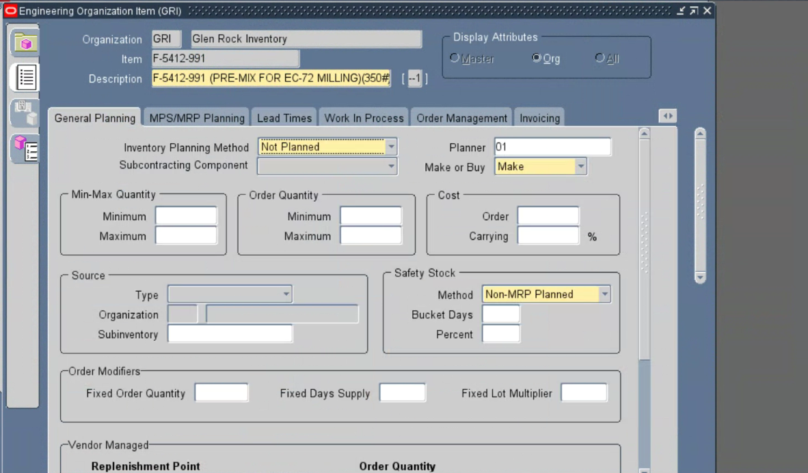
Figure 6 - Oracle EBS General Planning tab showing Planner = 01 and Make or Buy = Make for F-5412-991 in GRI.

3.7 Category Assignments
Attribute | Required / Confirmed Setup | Oracle EBS Evidence | Status
BUSINESS UNIT | ELECTRONICS (Master) | ELECTRONICS / Master | Corrected / Confirmed
DIVISION | ARCARE (Master) | ARCARE / Master | Corrected / Confirmed
ENGINEERING | PDR (Org / GRI) | PDR / Org | Corrected / Confirmed
INV_CLASS | WIP (Org / GRI) | WIP / Org | Corrected / Confirmed
Inventory | DEVELOPMENTAL ADHESIVES- (Org / GRI) | DEVELOPMENTAL ADH... / Org in screenshot; full value supplied in validated data | Corrected / Confirmed
PRICING | UNDEFINED-UNDEFINED-UNDEFINED- (Org / GRI) | UNDEFINED-UNDEFINE... / Org in screenshot; existing default value retained | Corrected / Confirmed

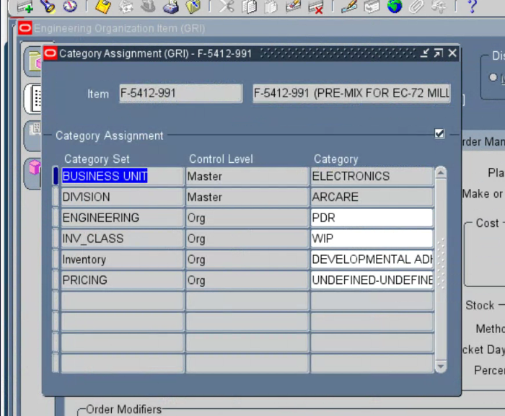
Figure 7 - Oracle EBS Category Assignments showing the corrected Business Unit, Division, Engineering, INV_CLASS, Inventory, and default Pricing categories for F-5412-991.

4. Remaining Confirmation Items for Caron
Only the following final decisions or acceptance confirmations remain. The approved attribute mappings summarized above are not being reopened.
1. Target Item Template
The item is currently using the ADHESIVES template (Template ID 107). In your previous review, you noted that the item is Electronics and asked which template was used.
Should this item continue using the ADHESIVES template, or should an Electronics-specific template be used instead? If a different template should be used, please provide the exact Oracle EBS template name.

2. Construction / Weight per Gallon
Construction = 31.6 % SOLIDS; 7.5 LBS/GAL. Physical Attributes Unit Weight and Weight UOM are blank.
Please confirm that this is the intended final setup.

3. Lead Time
LEAD TIME DAYS = 20 is stored in the Item descriptive flexfield. The standard Oracle EBS lead-time fields are blank for Oracle to calculate because this is a make item.
Please confirm that this is the intended final setup for this make item.

4. Long Description
The Long Description is blank, as requested.
Please confirm that this is correct.

5. Final Item Confirmation
The remaining attributes and categories have been updated based on your previous comments, including User Item Type = ARcare, Initiator = Christina Wilson, Inventory = DEVELOPMENTAL ADHESIVES-, and INV_CLASS = WIP.
Please confirm that the corrected item now reflects the intended Adhesives Research setup.

Internal evidence action before closure: Replace the Main-tab screenshot or correct the displayed Item Status from Active to ENGINEER. Caron already confirmed ENGINEER; no further mapping decision is requested.

