AR Global Item Creation - APEX Screen Concept
Client-review draft for dynamic item type fields and template-driven item creation

Purpose
This document proposes a dynamic Oracle APEX screen for AR Global item creation. The main idea is that the user selects the Item Type first. The application then loads the related template, shows only the fields needed for that item type, and validates the payload before calling the EBS item API.

Screen Behavior
- Item Type is the first field on the page and drives the screen layout.
- Template Name is derived from the item type and displayed as read-only.
- Common fields are always shown: Base Part Number, UOM, Description, Master Organization, and Target Organization.
- Dynamic sections are shown only when needed: Inventory Controls, BOM, Categories, Engineering, and Documents.
- A final Review & Actions panel shows required field completion, organization assignment, and API mode.

Hand-Drawn Style Sketch
The following sketch shows the proposed APEX layout at a high level. It is not a final UI design; it is a conversation starter for client validation.
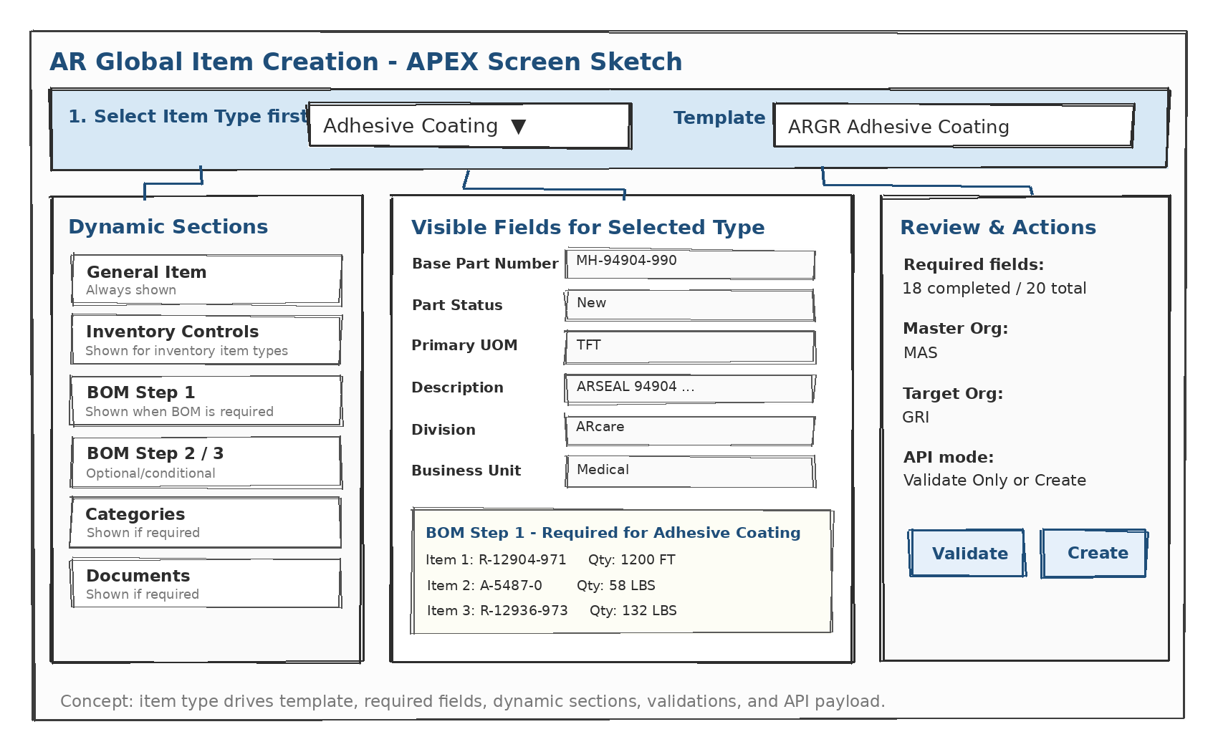

Client Confirmation Needed
- Confirm the exact EBS item template for each item type.
- Confirm which fields are required, optional, defaulted, or conditional.
- Confirm whether the item should be created only in the master organization or also assigned to child organizations.
- Confirm which item types require BOM, routing, categories, lot control, and shelf life.
- Confirm whether the APEX process should create immediately or first route the request for review/approval.

