ORACLE EBS
INVENTORY ITEM CREATION
VERIFICATION REPORT
Adhesives Research
Representative attribute comparison between the APEX/application verification layer and Oracle EBS for the MAS and GRI organizations.
Document Version | 1.0
Validation Date | August 31, 2026
Organizations | MAS / 59 - Master Inventory; GRI / 58 - Glen Rock Inventory
Overall Status | PASS - all included representative comparisons matched

Prepared for validation of the controlled Oracle EBS item-creation process. This document captures visual evidence only; it does not replace the automated SQL validation results or API logs maintained by the application process.

1. Executive Summary
This report documents representative post-creation verification for Oracle EBS inventory items created through the Adhesives Research APEX/application process. For each included item, one representative attribute is compared in the MAS master organization and one representative attribute is compared in the GRI target organization. The comparison uses application-side verification evidence and the corresponding Oracle EBS form value.
Validation conclusion: all sixteen representative organization-level comparisons included in this report are consistent between the application verification layer and Oracle EBS.

2. Scope and Item Inventory
Item | Target Template | Template ID | MAS Attribute | GRI Attribute | Status
MH-94904-1005 | MEDICAL COATING | 742 | BOM Item Type | End Assembly Pegging | PASS
MH-94904-1006 | ELECTRONICS ARCARE COATING | 740 | MRP Planning Method | Conversions | PASS
MH-94904-1007 | ENGINEERED TAPES COATING | 744 | Service Request | Cost of Goods Sold Account | PASS
MH-94904-1009 | ELECTRONICS ARCLAD COATING | 741 | Service Request | Build in WIP | PASS
MH-94904-1010 | INDUSTRIAL COATING | 718 | BOM Item Type | Forecast Control | PASS
MH-94904-1011 | SPLICING COATING | 743 | Service Request | Build in WIP | PASS
MH-94904-1012 | EXPENSE GR | 106 | Service Request | Item Status | PASS
MH-94904-1013 | PURCHASING GR | 105 | MRP Planning Method | Forecast Control | PASS
Scope exception - MH-94904-1008: This item is not included in the visual verification set because the target-organization flow did not complete successfully. The known target-template issue was handled separately and is outside the PASS population documented here.

3. Verification Method
- Application-side evidence: SQL/APEX verification output showing the business attribute, configured/template description, effective item value, and organization/effective source.
- Oracle EBS evidence: Engineering Master Item (MAS) or Engineering Organization Item (GRI) form displaying the persisted business value.
- Comparison rule: PASS is assigned when the business meaning and persisted value shown by the application evidence are consistent with the Oracle EBS form. Internal code values are shown only when they materially support the comparison.
- Coverage: this is a representative visual verification package. It validates selected attributes for each organization and is not intended to replace the complete field-by-field automated template validator, request logs, or API processing audit trail.

4.1 MH-94904-1005 - MAS / 59 Verification | Target Template: MEDICAL COATING / 742
Attribute | BOM Item Type | Result | MATCH
APEX / Application | Standard (internal value 4) | Organization | MAS / 59 - Master Inventory
Oracle EBS | Standard | Evidence | Target template: MEDICAL COATING / 742

APEX / Application-Side Evidence
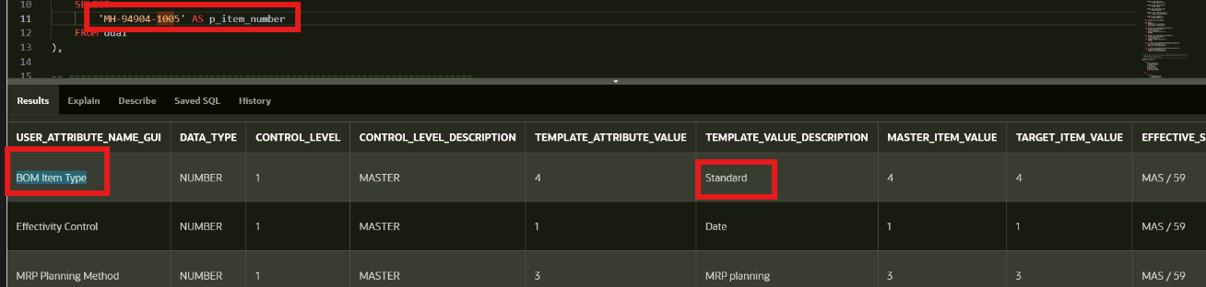
Application-side verification for MH-94904-1005 - MAS / 59 - Master Inventory: BOM Item Type.
Oracle EBS Evidence
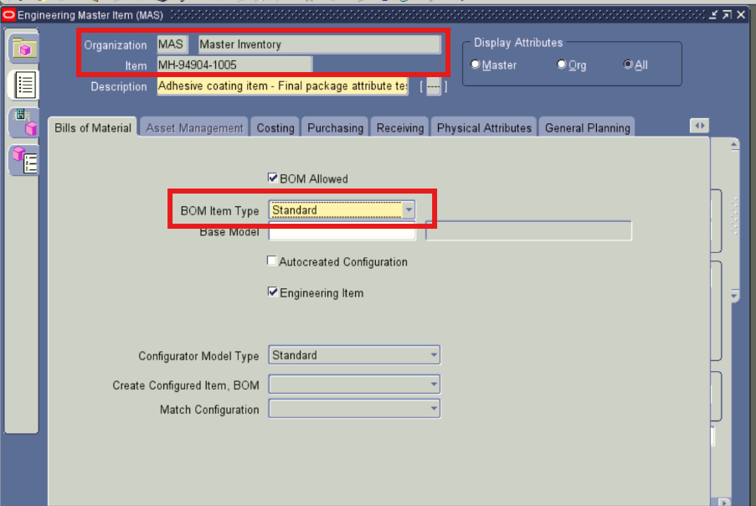
Oracle EBS form verification for MH-94904-1005 - MAS / 59 - Master Inventory: BOM Item Type.

4.1 MH-94904-1005 - GRI / 58 Verification (continued) | Target Template: MEDICAL COATING / 742
Attribute | End Assembly Pegging | Result | MATCH
APEX / Application | End Assembly / Soft Pegging (internal value B) | Organization | GRI / 58 - Glen Rock Inventory
Oracle EBS | End Assembly / Soft Pegging | Evidence | Target template: MEDICAL COATING / 742

APEX / Application-Side Evidence
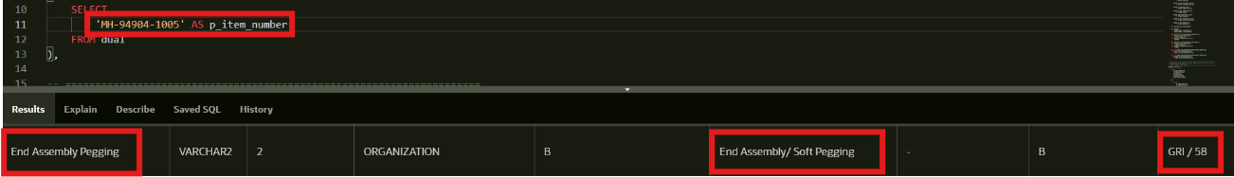
Application-side verification for MH-94904-1005 - GRI / 58 - Glen Rock Inventory: End Assembly Pegging.
Oracle EBS Evidence
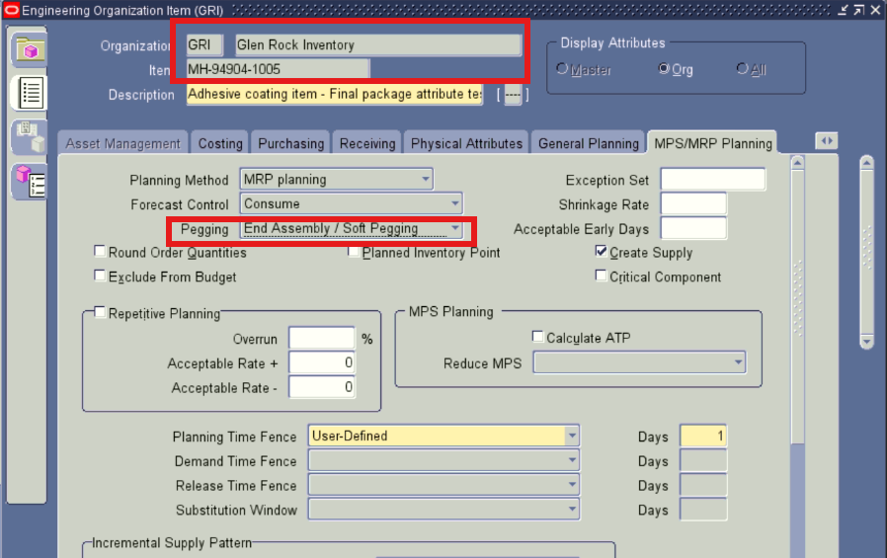
Oracle EBS form verification for MH-94904-1005 - GRI / 58 - Glen Rock Inventory: End Assembly Pegging.

4.2 MH-94904-1006 - MAS / 59 Verification | Target Template: ELECTRONICS ARCARE COATING / 740
Attribute | MRP Planning Method | Result | MATCH
APEX / Application | MRP planning (internal value 3) | Organization | MAS / 59 - Master Inventory
Oracle EBS | MRP planning | Evidence | Target template: ELECTRONICS ARCARE COATING / 740

APEX / Application-Side Evidence
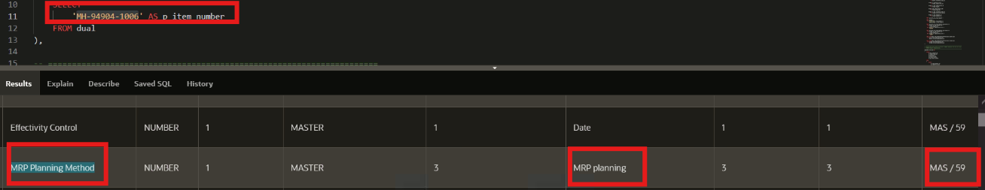
Application-side verification for MH-94904-1006 - MAS / 59 - Master Inventory: MRP Planning Method.
Oracle EBS Evidence
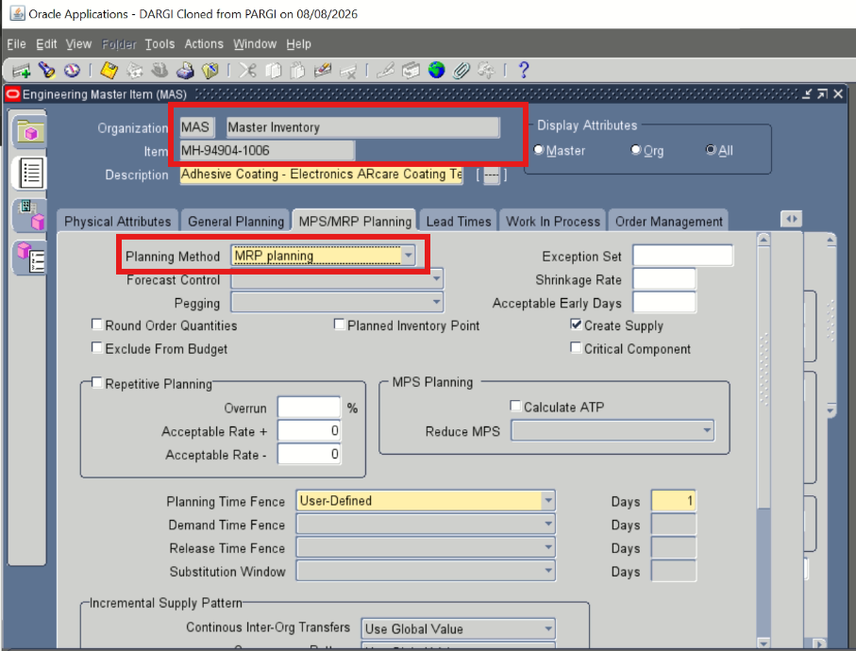
Oracle EBS form verification for MH-94904-1006 - MAS / 59 - Master Inventory: MRP Planning Method.

4.2 MH-94904-1006 - GRI / 58 Verification (continued) | Target Template: ELECTRONICS ARCARE COATING / 740
Attribute | Conversions | Result | MATCH
APEX / Application | Both standard and item specific (internal value 3) | Organization | GRI / 58 - Glen Rock Inventory
Oracle EBS | Both | Evidence | Target template: ELECTRONICS ARCARE COATING / 740

APEX / Application-Side Evidence
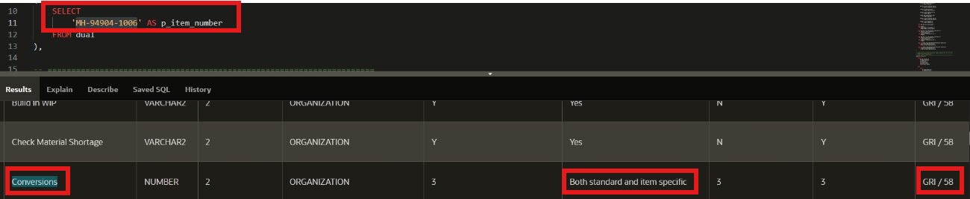
Application-side verification for MH-94904-1006 - GRI / 58 - Glen Rock Inventory: Conversions.
Oracle EBS Evidence
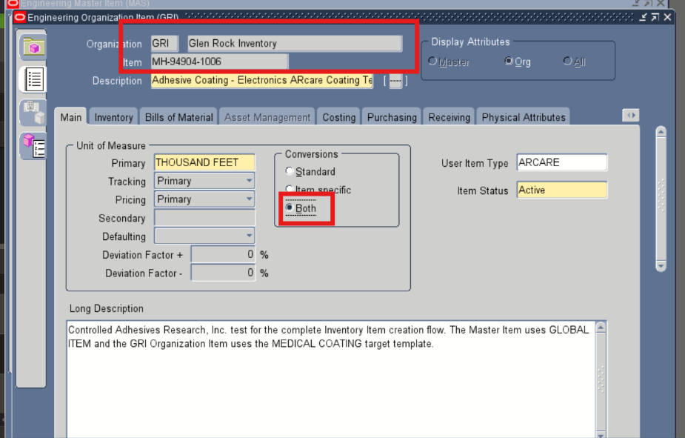
Oracle EBS form verification for MH-94904-1006 - GRI / 58 - Glen Rock Inventory: Conversions.

4.3 MH-94904-1007 - MAS / 59 Verification | Target Template: ENGINEERED TAPES COATING / 744
Attribute | Service Request | Result | MATCH
APEX / Application | Enabled (internal value E) | Organization | MAS / 59 - Master Inventory
Oracle EBS | Enabled | Evidence | Target template: ENGINEERED TAPES COATING / 744

APEX / Application-Side Evidence
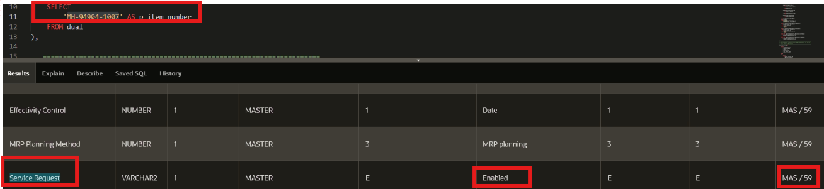
Application-side verification for MH-94904-1007 - MAS / 59 - Master Inventory: Service Request.
Oracle EBS Evidence
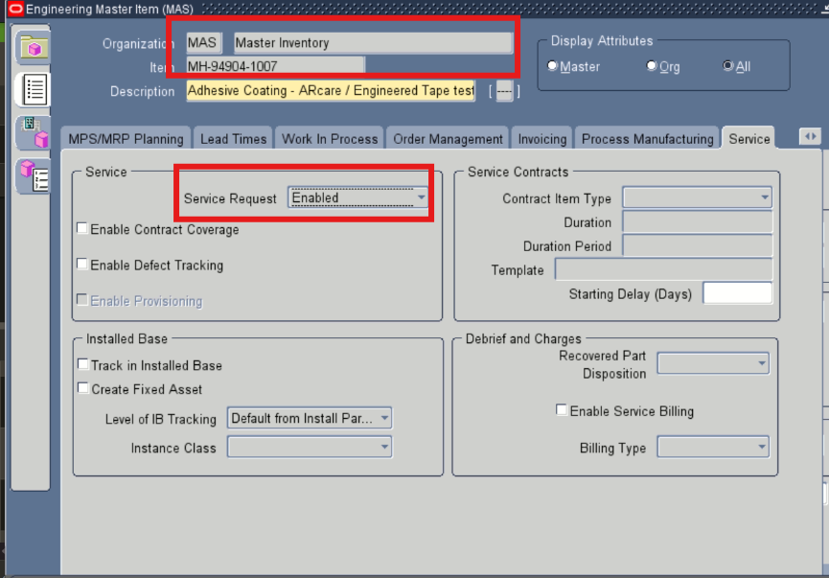
Oracle EBS form verification for MH-94904-1007 - MAS / 59 - Master Inventory: Service Request.

4.3 MH-94904-1007 - GRI / 58 Verification (continued) | Target Template: ENGINEERED TAPES COATING / 744
Attribute | Cost of Goods Sold Account | Result | MATCH
APEX / Application | 01-01-0270-0001-51100-0000 | Organization | GRI / 58 - Glen Rock Inventory
Oracle EBS | 01-01-0270-0001-51100-0000 | Evidence | Target template: ENGINEERED TAPES COATING / 744

APEX / Application-Side Evidence
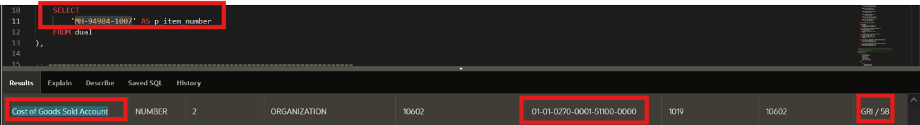
Application-side verification for MH-94904-1007 - GRI / 58 - Glen Rock Inventory: Cost of Goods Sold Account.
Oracle EBS Evidence
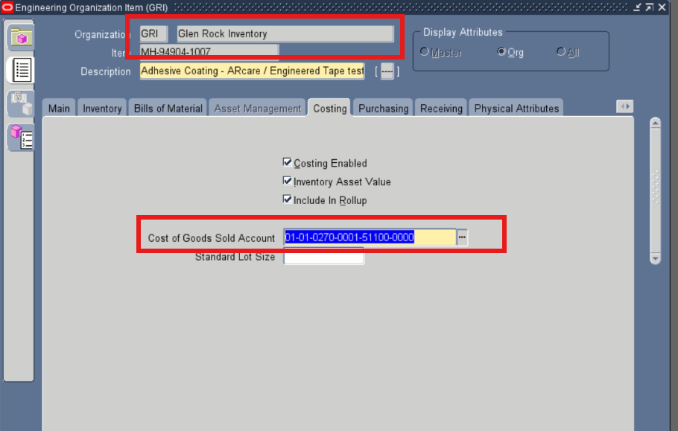
Oracle EBS form verification for MH-94904-1007 - GRI / 58 - Glen Rock Inventory: Cost of Goods Sold Account.

4.4 MH-94904-1009 - MAS / 59 Verification | Target Template: ELECTRONICS ARCLAD COATING / 741
Attribute | Service Request | Result | MATCH
APEX / Application | Enabled (internal value E) | Organization | MAS / 59 - Master Inventory
Oracle EBS | Enabled | Evidence | Target template: ELECTRONICS ARCLAD COATING / 741

APEX / Application-Side Evidence
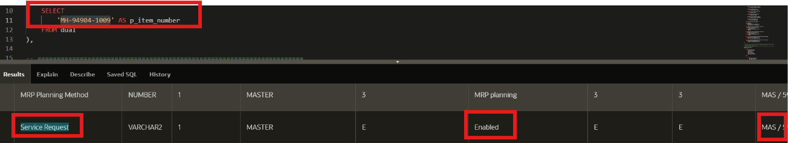
Application-side verification for MH-94904-1009 - MAS / 59 - Master Inventory: Service Request.
Oracle EBS Evidence
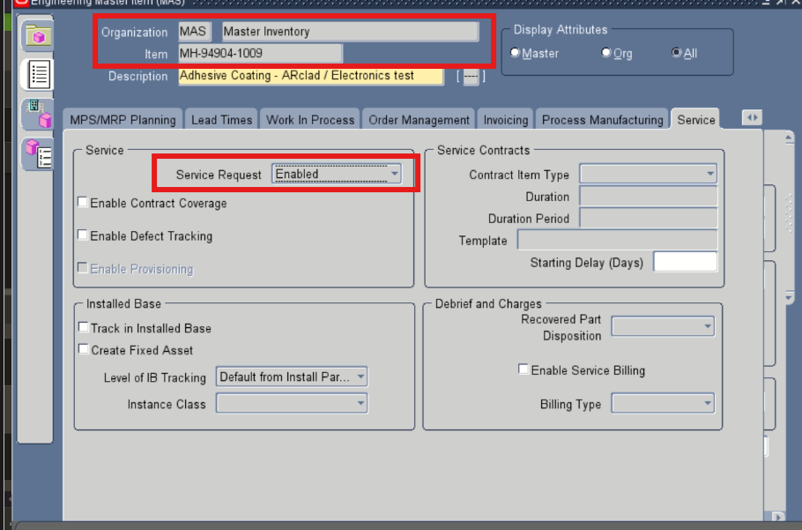
Oracle EBS form verification for MH-94904-1009 - MAS / 59 - Master Inventory: Service Request.

4.4 MH-94904-1009 - GRI / 58 Verification (continued) | Target Template: ELECTRONICS ARCLAD COATING / 741
Attribute | Build in WIP | Result | MATCH
APEX / Application | Yes (internal value Y) | Organization | GRI / 58 - Glen Rock Inventory
Oracle EBS | Checked / Yes | Evidence | Target template: ELECTRONICS ARCLAD COATING / 741

APEX / Application-Side Evidence
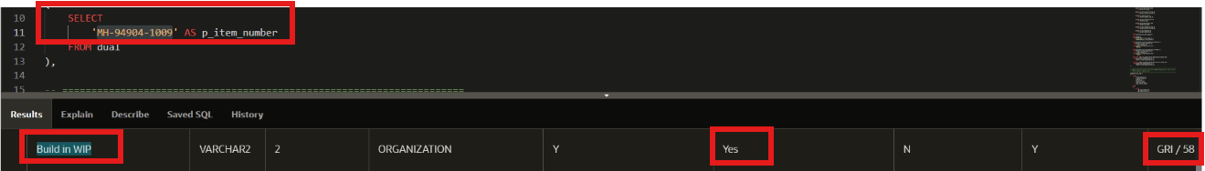
Application-side verification for MH-94904-1009 - GRI / 58 - Glen Rock Inventory: Build in WIP.
Oracle EBS Evidence
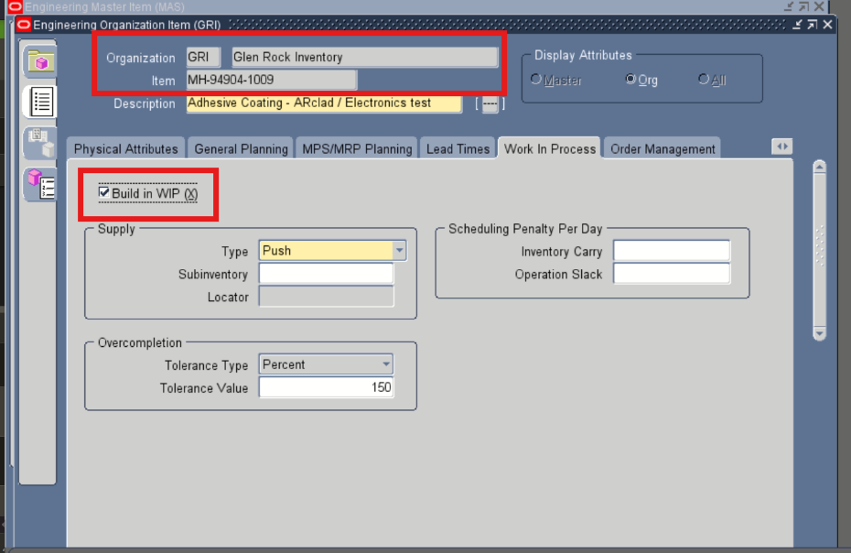
Oracle EBS form verification for MH-94904-1009 - GRI / 58 - Glen Rock Inventory: Build in WIP.

4.5 MH-94904-1010 - MAS / 59 Verification | Target Template: INDUSTRIAL COATING / 718
Attribute | BOM Item Type | Result | MATCH
APEX / Application | Standard (internal value 4) | Organization | MAS / 59 - Master Inventory
Oracle EBS | Standard | Evidence | Target template: INDUSTRIAL COATING / 718

APEX / Application-Side Evidence
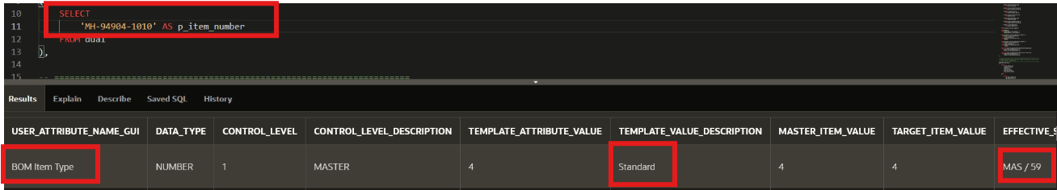
Application-side verification for MH-94904-1010 - MAS / 59 - Master Inventory: BOM Item Type.
Oracle EBS Evidence
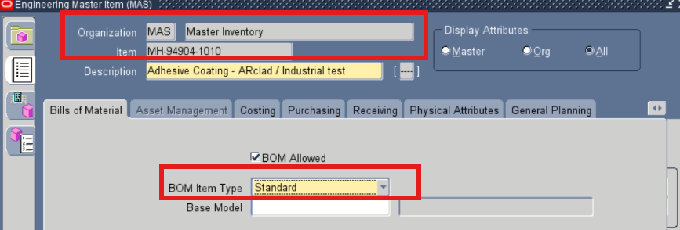
Oracle EBS form verification for MH-94904-1010 - MAS / 59 - Master Inventory: BOM Item Type.

4.5 MH-94904-1010 - GRI / 58 Verification (continued) | Target Template: INDUSTRIAL COATING / 718
Attribute | Forecast Control | Result | MATCH
APEX / Application | Consume Forecast (internal value 1) | Organization | GRI / 58 - Glen Rock Inventory
Oracle EBS | Consume | Evidence | Target template: INDUSTRIAL COATING / 718

APEX / Application-Side Evidence
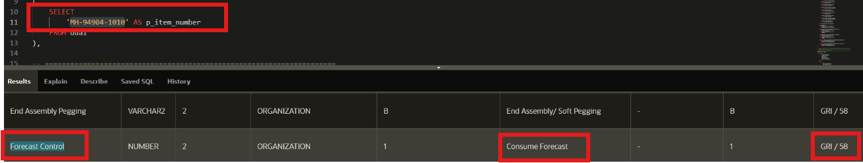
Application-side verification for MH-94904-1010 - GRI / 58 - Glen Rock Inventory: Forecast Control.
Oracle EBS Evidence
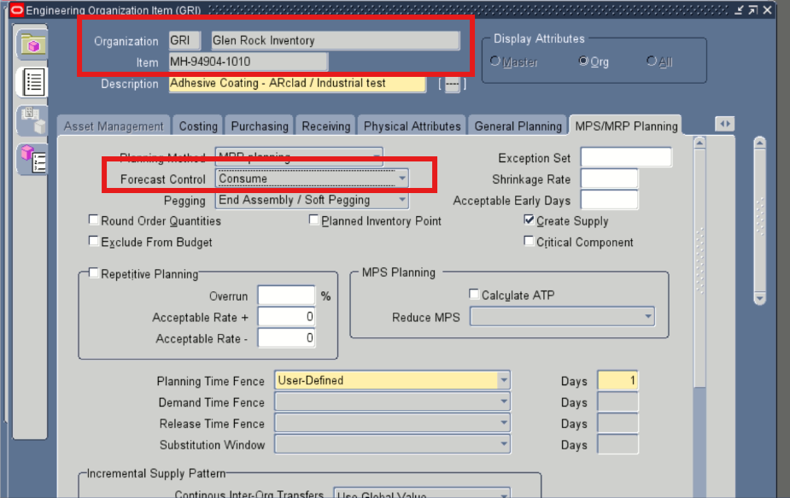
Oracle EBS form verification for MH-94904-1010 - GRI / 58 - Glen Rock Inventory: Forecast Control.

4.6 MH-94904-1011 - MAS / 59 Verification | Target Template: SPLICING COATING / 743
Attribute | Service Request | Result | MATCH
APEX / Application | Enabled (internal value E) | Organization | MAS / 59 - Master Inventory
Oracle EBS | Enabled | Evidence | Target template: SPLICING COATING / 743

APEX / Application-Side Evidence
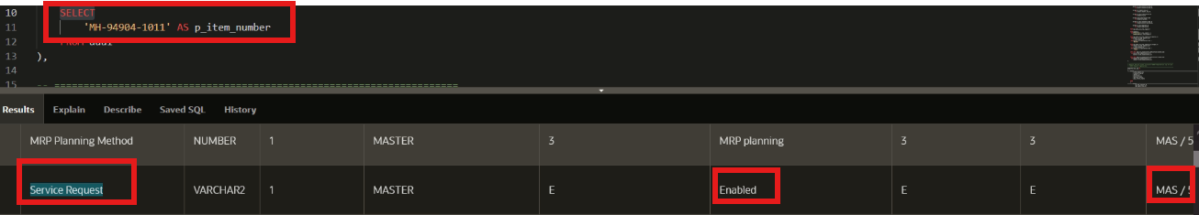
Application-side verification for MH-94904-1011 - MAS / 59 - Master Inventory: Service Request.
Oracle EBS Evidence
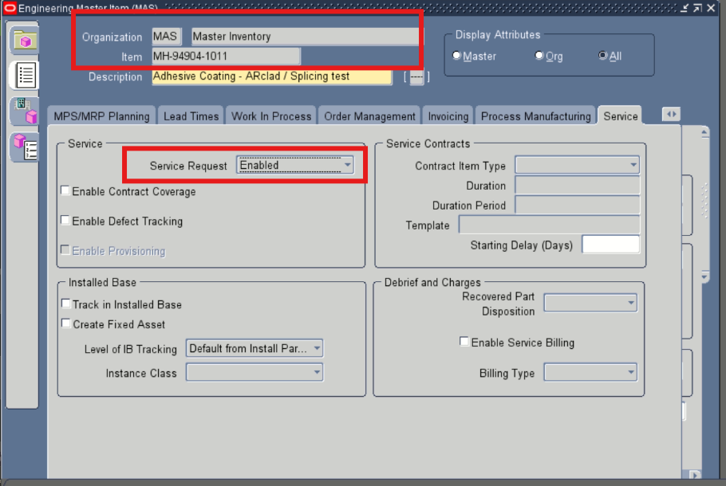
Oracle EBS form verification for MH-94904-1011 - MAS / 59 - Master Inventory: Service Request.

4.6 MH-94904-1011 - GRI / 58 Verification (continued) | Target Template: SPLICING COATING / 743
Attribute | Build in WIP | Result | MATCH
APEX / Application | Yes (internal value Y) | Organization | GRI / 58 - Glen Rock Inventory
Oracle EBS | Checked / Yes | Evidence | Target template: SPLICING COATING / 743

APEX / Application-Side Evidence
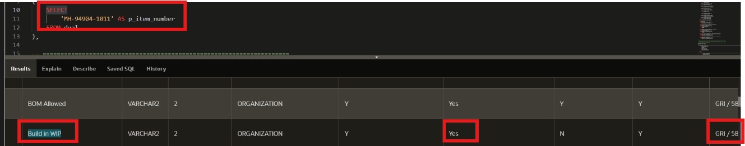
Application-side verification for MH-94904-1011 - GRI / 58 - Glen Rock Inventory: Build in WIP.
Oracle EBS Evidence
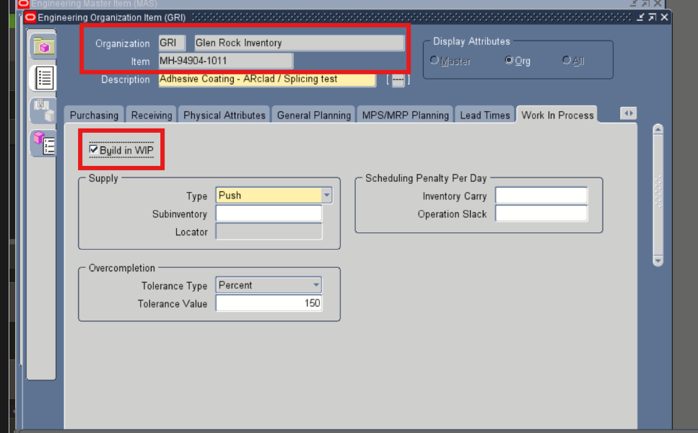
Oracle EBS form verification for MH-94904-1011 - GRI / 58 - Glen Rock Inventory: Build in WIP.

4.7 MH-94904-1012 - MAS / 59 Verification | Target Template: EXPENSE GR / 106
Attribute | Service Request | Result | MATCH
APEX / Application | Enabled (internal value E) | Organization | MAS / 59 - Master Inventory
Oracle EBS | Enabled | Evidence | Target template: EXPENSE GR / 106

APEX / Application-Side Evidence
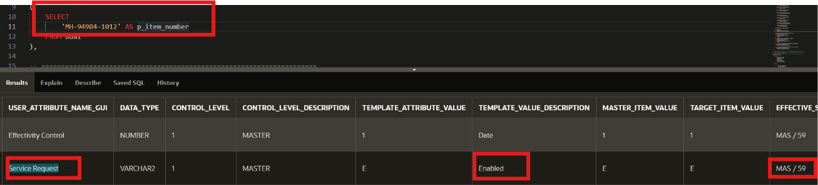
Application-side verification for MH-94904-1012 - MAS / 59 - Master Inventory: Service Request.
Oracle EBS Evidence
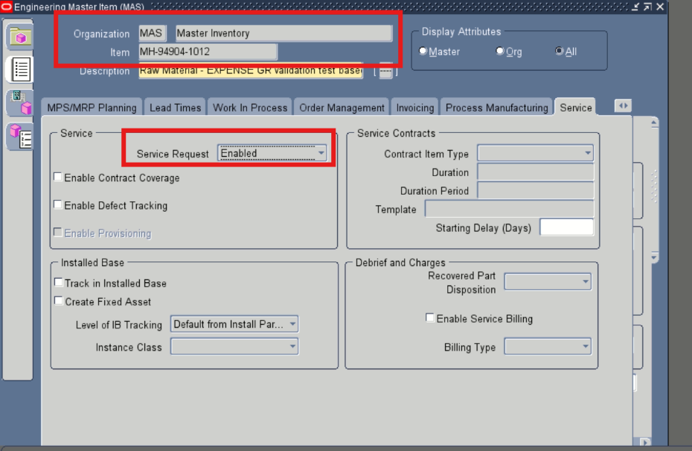
Oracle EBS form verification for MH-94904-1012 - MAS / 59 - Master Inventory: Service Request.

4.7 MH-94904-1012 - GRI / 58 Verification (continued) | Target Template: EXPENSE GR / 106
Attribute | Item Status | Result | MATCH
APEX / Application | Active | Organization | GRI / 58 - Glen Rock Inventory
Oracle EBS | Active | Evidence | Target template: EXPENSE GR / 106

APEX / Application-Side Evidence
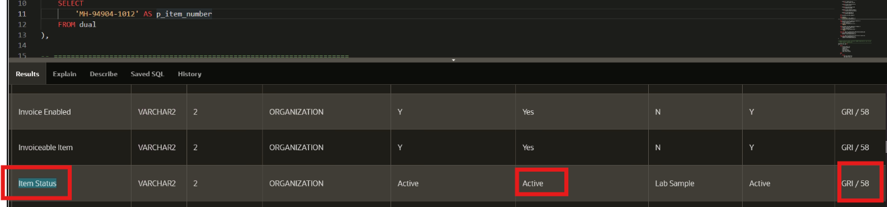
Application-side verification for MH-94904-1012 - GRI / 58 - Glen Rock Inventory: Item Status.
Oracle EBS Evidence
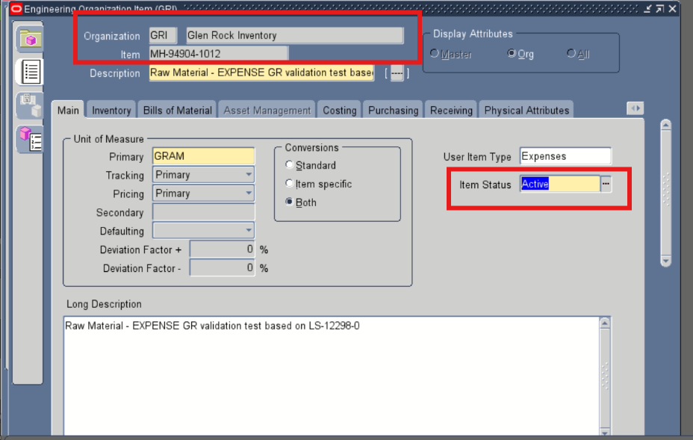
Oracle EBS form verification for MH-94904-1012 - GRI / 58 - Glen Rock Inventory: Item Status.
Validation note: The GRI target item status is Active, consistent with the resolved EXPENSE GR template. The application evidence also shows the master-side value as Lab Sample; this does not alter the target comparison.

4.8 MH-94904-1013 - MAS / 59 Verification | Target Template: PURCHASING GR / 105
Attribute | MRP Planning Method | Result | MATCH
APEX / Application | MRP planning (effective value sourced from MAS / 59) | Organization | MAS / 59 - Master Inventory
Oracle EBS | MRP planning | Evidence | Target template: PURCHASING GR / 105

APEX / Application-Side Evidence
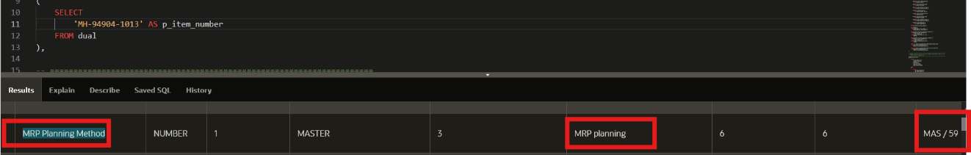
Application-side verification for MH-94904-1013 - MAS / 59 - Master Inventory: MRP Planning Method.
Oracle EBS Evidence
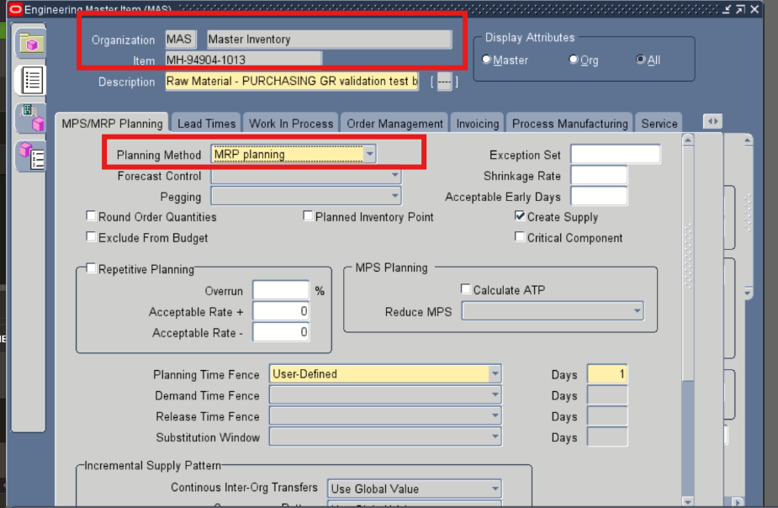
Oracle EBS form verification for MH-94904-1013 - MAS / 59 - Master Inventory: MRP Planning Method.

4.8 MH-94904-1013 - GRI / 58 Verification (continued) | Target Template: PURCHASING GR / 105
Attribute | Forecast Control | Result | MATCH
APEX / Application | None (internal value 3) | Organization | GRI / 58 - Glen Rock Inventory
Oracle EBS | None | Evidence | Target template: PURCHASING GR / 105

APEX / Application-Side Evidence
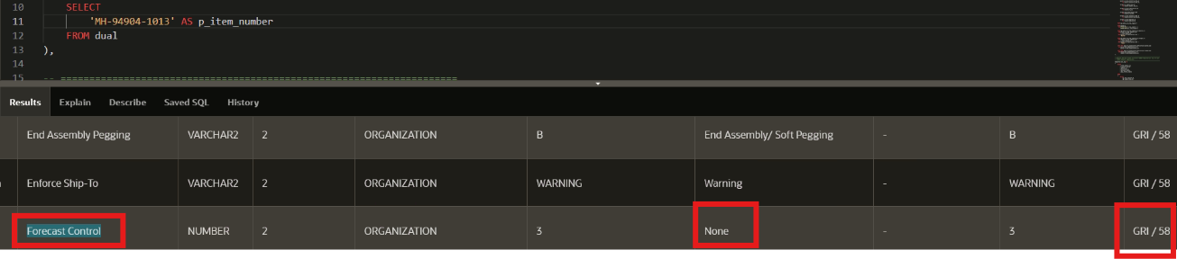
Application-side verification for MH-94904-1013 - GRI / 58 - Glen Rock Inventory: Forecast Control.
Oracle EBS Evidence
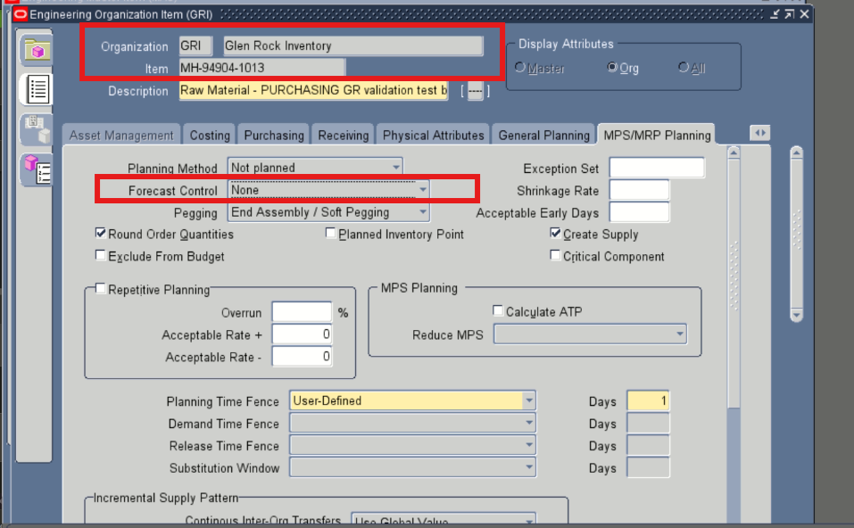
Oracle EBS form verification for MH-94904-1013 - GRI / 58 - Glen Rock Inventory: Forecast Control.
Validation note: For the MAS comparison, the application evidence identifies MAS / 59 as the effective source. The Oracle EBS form displays the corresponding business value as MRP planning.

5. Final Validation Conclusion
The representative visual evidence confirms that the selected MAS and GRI attributes for all eight included inventory items are consistent between the Adhesives Research application verification layer and Oracle EBS. Each included item shows a MATCH at the business-value level for both organizations.
OVERALL REPRESENTATIVE VERIFICATION STATUS: PASS
Items included: MH-94904-1005, MH-94904-1006, MH-94904-1007, MH-94904-1009, MH-94904-1010, MH-94904-1011, MH-94904-1012, MH-94904-1013.
Organizations verified: MAS / 59 and GRI / 58.
Evidence basis: application-side verification output and Oracle EBS item forms.

