|  |  |  |  |  |  |  |  |
| --- | --- | --- | --- | --- | --- | --- | --- |
| **ASSIGNMENT COVERSHEET** | | | | UTS LOGO | | | |
| **UTS: ENGINEERING & INFORMATION TECHNOLOGY** | | | | | | | |
|  | **NAME OF STUDENT(s) (PRINT CLEARLY)**  Joel Cappelli  *SURNAME FIRST NAME* | | | | | | **STUDENT ID(s).**  12137384 |
| **STUDENT EMAIL**  joel.cappell@gmail.com | | | | **STUDENT CONTACT NUMBER**  0422 384 087 | | | |
| **NAME OF TUTOR** | | | **TUTORIAL GROUP** | | | **DUE DATE**  19 May 2016 | |
| **ASSESSMENT ITEM NUMBER/ TITLE**  Hung Nguyen  49275 NEURAL NETWORKS AND FUZZY LOGIC Assignment 2 | | | | | | | |
| 🗆 I confirm that I have read, understood and followed the guidelines for assignment submission and presentation on page 2 of this cover sheet.  🗆 I confirm that I have read, understood and followed the advice in my Subject Outline about assessment requirements.  🗆 I understand that if this assignment is submitted after the due date it may incur a penalty for lateness unless I have previously had an extension of time approved and have attached the written confirmation of this extension.  **Declaration of Originality**: The work contained in this assignment, other than that specifically attributed to another source, is that of the author(s) and has not been previously submitted for assessment. I understand that, should this declaration be found to be false, disciplinary action could be taken and penalties imposed in accordance with University policy and rules. In the statement below, I have indicated the extent to which I have collaborated with others, whom I have named.  **Statement of Collaboration**:    19 May 2016  **Signature of Student(s) ____________________________________________________________**Date**_________________________** | | | | | | | |
| - -- - - - - - - - - - - - - - - - - - - - - - - - - - - - - - - - - - - - - - - - - - - - - - - - - - - - - - - - - - - - - - - - - - - - - - - - - - - - - - - - - - - - - - - - - - - - - - - - - - - - | | | | | | | |
| **ASSIGNMENT RECEIPT** | | | | To be completed by the student if a receipt is required | | | |
| **SUBJECT NAME/NUMBER** | | **NAME OF TUTOR**  49275 NEURAL NETWORKS AND FUZZY LOGIC | | | | | |
| **SIGNATURE OF TUTOR** | | | | | **RECEIVED DATE**  19 May 2016 | | |

# **49275 NEURAL NETWORKS AND FUZZY LOGIC**

## Assignment 2

### Joel Cappelli

### 12137384 19 May 2016

## Qu 1.1

Generalised XOR Problem

A neural network model with three input neurons (one augmented input), four hidden neurons (one augmented) in a single hidden layer, and an output neuron is used to learn the decision surface of the well-known generalised XOR problem. Weights were updated using error backpropagation training with a constant learning rate of 0.2 and augmented inputs of -1. All continuous perceptrons use the bipolar logistic function.

Initial weights (set at random):

Weight update after 1 step (first training pattern):

## Qu 1.2

The following formulae were used to compute cycle and pattern error.

There are 8 training patterns in the question. For every 1 cycle, there are 8 updates to the weights matrices.

Figure 1 and Figure 2 show the cycle and pattern error curves over 500 cycles (4000 steps) of training. The training set is recycled.

Weights after 4000 steps (500 cycles):

Considering two unseen test vectors, and below, we can examine the classification ability of the trained network.

Classification with and :

The results show that the trained network with final weight matrices above, correctly classify test vector 1 and fail to correctly classify test vector 2.

Figure 1 and Figure 2 how the cycle and pattern error curves over 500 cycles (4000 steps) of training. The cycle error is reducing over each cycle as the weights vector is converging to a minimum in the weights space. desired outputs are +1/-1 while the bipolar logistic function asymptotically approaches +/-1.



Figure 1: Bipolar logistic activation function



Figure : Qu1.2 Cycle error curve



Figure : Qu1.2 Pattern error curve

## Qu 2.2

To represent the error input to the controller, a set of linguistic variables is chosen to represent 5 degrees of error, 3 degrees of change of error, and 5 degrees of armature voltage. Membership functions are constructed to represent the input and output values' grades of membership as shown in Figure 5. The rule set in the form of "Fuzzy Associative Memories" below.

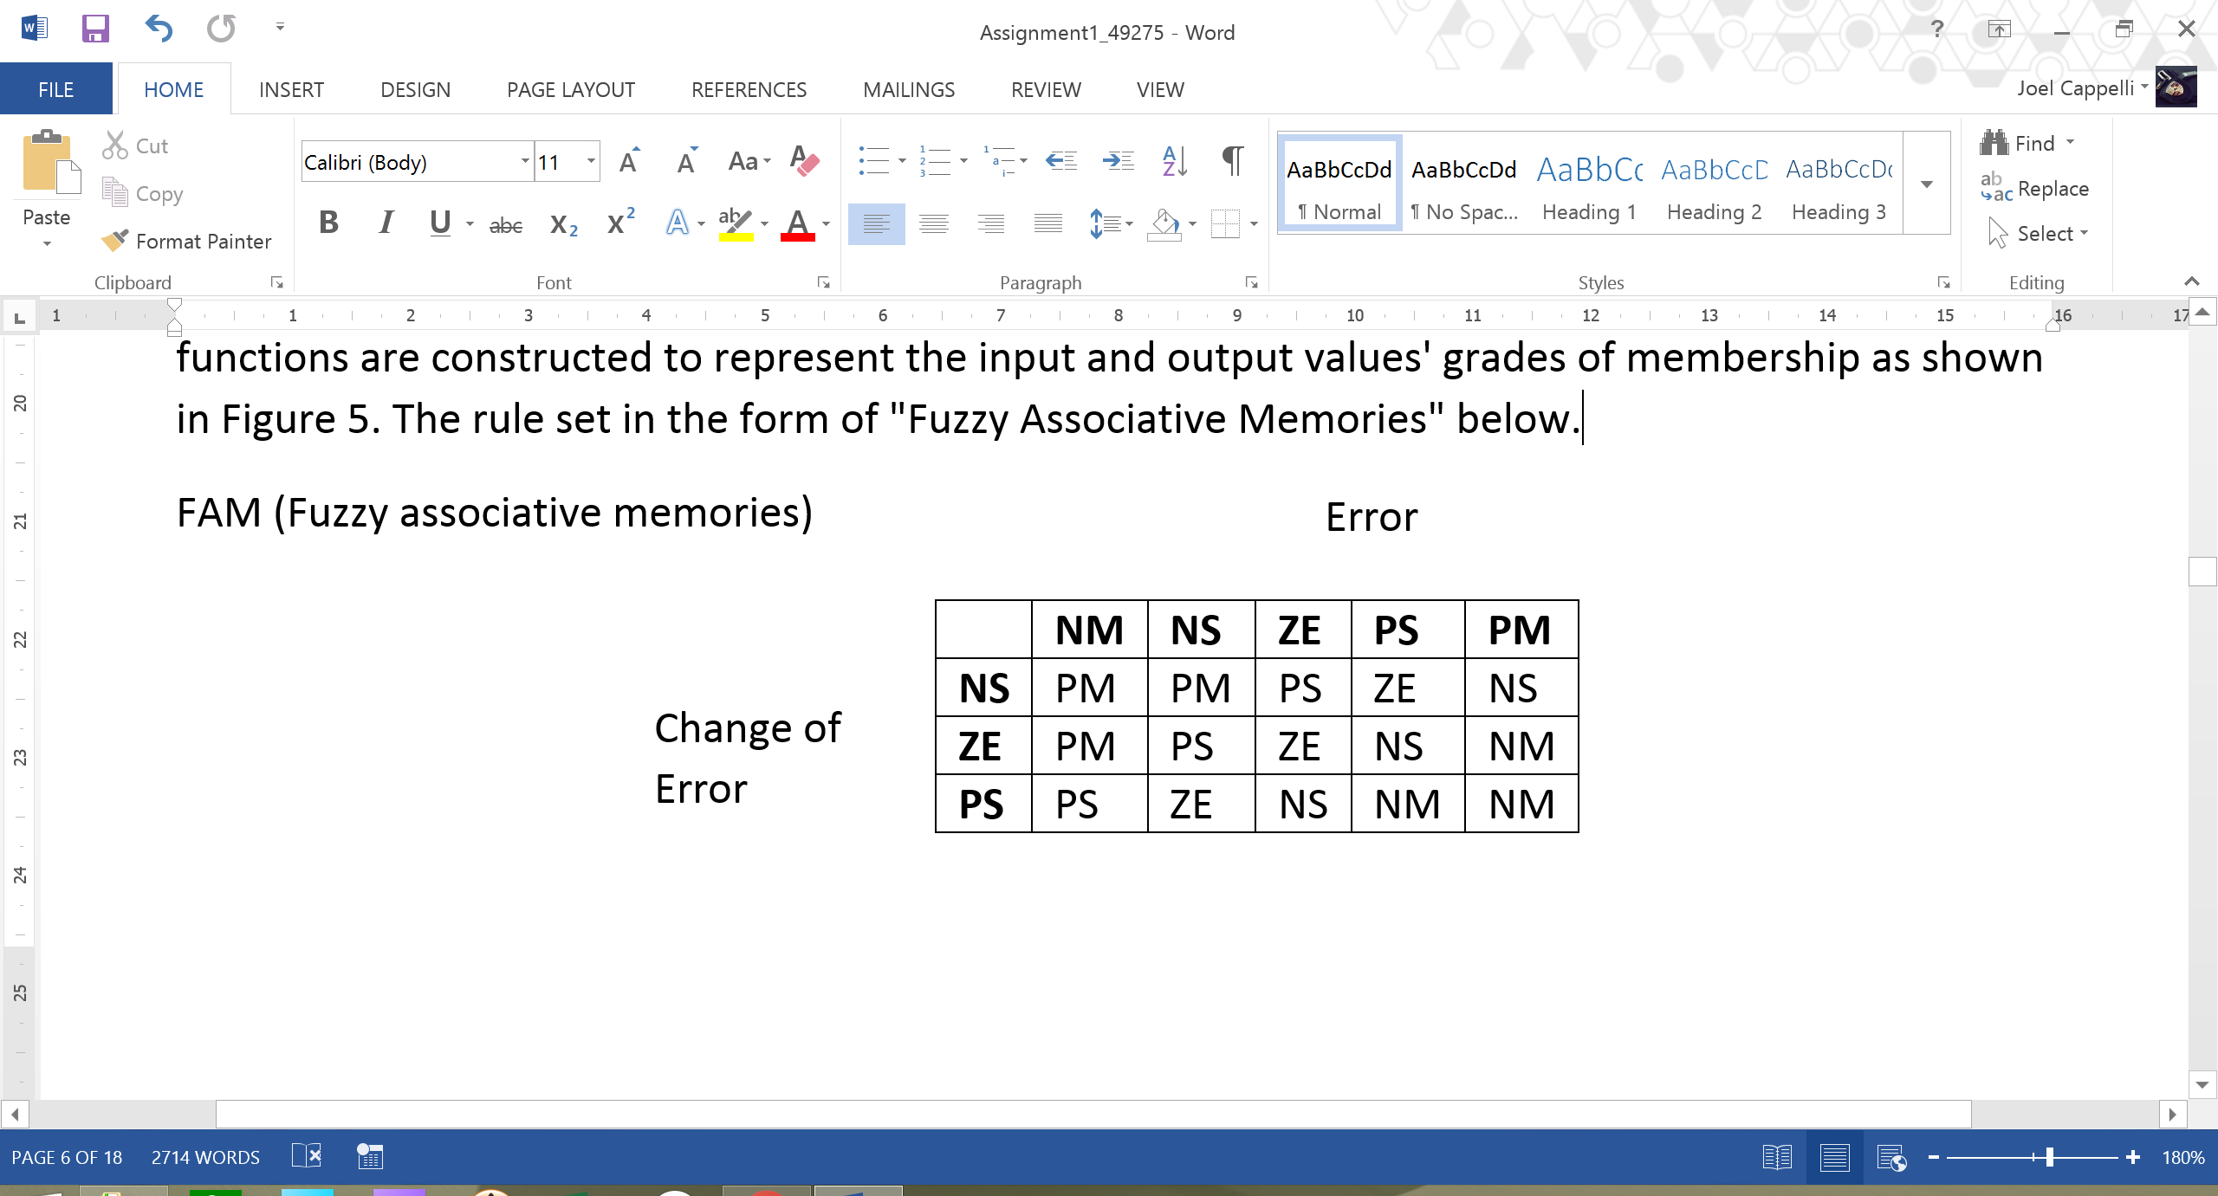

redo

Error input = 3.25, Error input = -0.2

With controller constant gains GE =1, GCE = 1, GU = 1



Figure 5: Qu2.2 Membership functions

In fuzzy notation;

Using the FAM above given in question and inference for each associated method;

|  |  |  |  |  |
| --- | --- | --- | --- | --- |
|  |  |  | U(MOM [sum-prod])) | U(COA [Max-min]) |
| Rule 1 |  |  |  |  |
| Rule 2 |  |  |  |  |
| Rule 3 |  |  |  |  |
| Rule 4 |  |  |  |  |

According to the MOM (Mean of maximum) method, the output is:

MOM Method (sum-prod) - Defuzzified Output for Error = 3.25, deltaError = -0.2

Output voltage = -6.1395V

According to the COA (Centre of area) method, the output can be found using Max-min inference as:

Defuzzification Piecewise Functions

Function 1 between -10 and -7.66667 is u(U) = 0.666667

Area 1 = 1.55556

Moment 1 = -13.7407

Function 2 between -7.66667 and -6.66667 is u(U) = -0.25*u + -1.25

Area 2 = 0.541667

Moment 2 = -3.90278

Function 3 between -6.66667 and -2.66667 is u(U) = 0.416667

Area 3 = 1.66667

Moment 3 = -7.77778

Function 4 between -2.66667 and -2.33333 is u(U) = -0.25*u + -0.25

Area 4 = 0.125

Moment 4 = -0.313272

Function 5 between -2.33333 and 3.33333 is u(U) = 0.333333

Area 5 = 1.88889

Moment 5 = 0.944444

Function 6 between 3.33333 and 5 is u(U) = -0.2*u + 1

Area 6 = 0.277778

Moment 6 = 1.08025

COA Method (max-min) - Defuzzified Output for Error = 3.25, deltaError = -0.2

Total Area = 6.0556

Total Moment = -23.7099

Output voltage = -3.9154V





Figure : Qu2.2 Defuzzification of controller output







Qu2.1 COA Strategy

Fuzzification UCOA - min

Rule 1: 0.21875/NM

Rule 2: 0.21875/NM

Rule 3: 0.714286/NM

Rule 4: 0.285714/NM

Defuzzification Piecewise Functions

Function 1 between -40 and -31.4286 is u(U) = 0.714286

Area 1 = 6.12245

Moment 1 = -218.659

Function 2 between -31.4286 and -10 is u(U) = -0.0333333*u + -0.333333

Area 2 = 7.65306

Moment 2 = -185.86

COA Method (max-min) - Defuzzified Output for initialXPosError = 15 m, initialTruckAngleError = 35 deg

Total Area = 13.7755

Total Moment = -404.519

theta(1) = -29.3651 deg

[phi(2), x(2), y(2)] = [49.1928, 15.7139, 15.4999]

Qu2.2 MOM Strategy

Fuzzification UMOM -prod: State:1

Rule 1: 0.15625/NM

Rule 2: 0.0625/NM

Rule 3: 0.558036/NM

Rule 4: 0.223214/NM

MOM Method (prod) - Defuzzified Output for xPosError = 15 m, truckAngleError = 35 deg

theta(1) = -40 deg

[phi(2), x(2), y(2)] = [53.7472, 15.6275, 15.4394]

Fuzzification UMOM -prod: State:2

Rule 1: 0.063451/NM

Rule 2: 0.0381288/NM

Rule 3: 0.561191/NM

Rule 4: 0.337229/NM

MOM Method (prod) - Defuzzified Output for xPosError = 15.6275 m, truckAngleError = 53.7472 deg

theta(2) = -40 deg

[phi(3), x(3), y(3)] = [72.4945, 16.0805, 16.0571]

## Source code