How to download Roll4All

* Download Pharo 4 <http://pharo.org/download>
* Download into Pharo4 the Roll4All configuration file 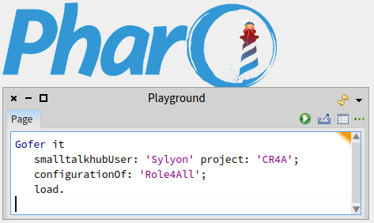
* Wait 1-2 min (download the class ConfigurationOfRoll4All)
* Load the last stable version of Roll4All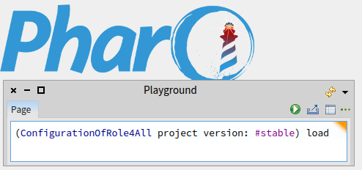
* Wait 10-15 min ( Download Roll4All and all the dependency )
* And it’s ok, you can use Roll4All (see the tutorial) .