Role4All Use Case

# Introduction

This document presents Role4All through a simple example. ….

Contents

Introduction 1

Context 1

Initialization 1

The Excels meta-model in Smalltalk 2

# Context

For this example we selected two files, an Excels document gathering some systems consumption and a Pimca model exponent a system. Moreover we know the global consumption of the system: 2 750 mW/h.

The first source of information is an array with two columns (Name and Consumption) and four rows (PC, FPGA, I7 and ARM) :

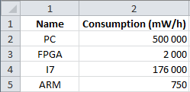

Figure 1: Excels file gathering some consumption

With this array we have a relation between some product name (PC, FPGA, …) and their consumptions.

The second source of information is a model created with Pimca.

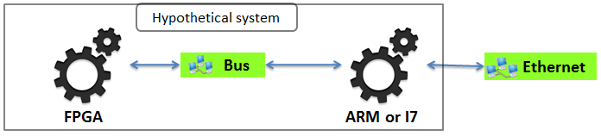

Figure 2: Pimca model of the hypothetical system

This model described a simple system including two elements, a FPGA and a processor. But we have an undetermined about the processor, it is an ARM or an I7 and we need to know which one. To solve our problem we simulate our system with an ARM and with an I7 and compare the consumption of the simulated system and of the real system. Therefore we need to create a link between our model and our Excels array that create a link between a Pimca file and an Excels file.

Role4All is one solution to create that type of link and to run simulations required.

# Initialization

Before use Role4All we need to create some elements:

* The Excels meta-model in Smalltalk (simplify for this example).
* A conversion from Excel to Smalltalk.
* The Pimca meta-model in Smalltalk (simplify for this example).
* A conversion from Pimca to Smalltalk.
* Role models.

## The Excels meta-model in Smalltalk

Excel is a complex tool therefore in our example we use a basic meta-model of Excel. An “Excel workbook” contains just a list of dictionary called “Excels element”.

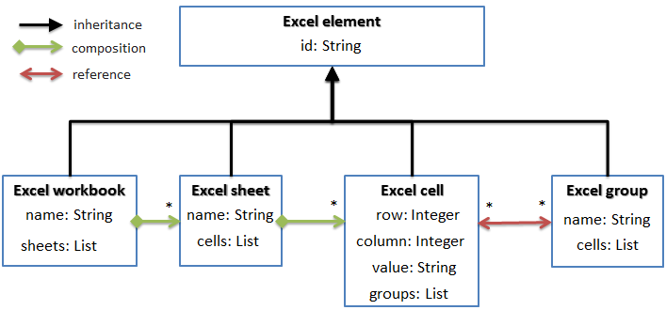

Figure 3: Simplify Excel's meta-model

Now with our Excel meta-model we can transform our Excel file to Smalltalk model.

## Conversion from Excel to Smalltalk

To convert an Excel file to Smalltalk we use two model transformations, the first one between Excel and Json and the second one between Json and Smalltalk. In this document we will not develop this transformations we focus one the result of this transformation: the Smalltalk codes.

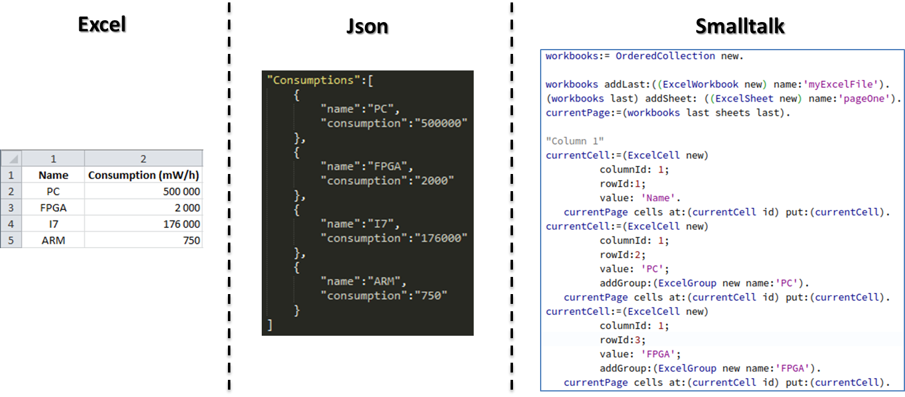

Figure 4: Model transformations between Excel and Smalltalk

The Smalltalk code present in the figure 4 was automatically generated from our Excels file.

Now we have two instance of Excel workbook class define in Smalltalk. Therefore we can create the role models.

## Role models definition

A Role model includes 3 elements:

* A Role type
* An adaptor
* A synchronizer

### Role type definition

In our example we create 2 role types: RoleFPGA and RolePC. We will create 2 instances of each Role type named: roleFPGA0, roleFPGA1, rolePC0 and rolePC1. This instances will be linked with an excel element.

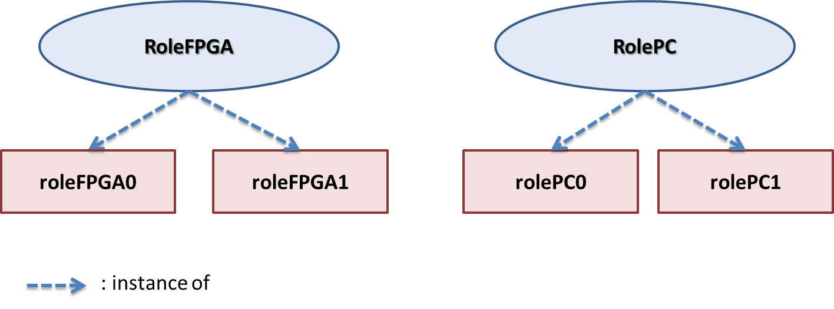

Figure 5: Role type definition