# Simulation through Role4All

## NewAge

The last two parts present the main units of Role4All: the role model generation and the synchronization but Role4All includes one more unit, the simulation. The simulation is possible due to a specific tool: NewAge. NewAge is a simulation tool using the concept of activity, with NewAge, a system is a collection of activity. An activity is association of two entity a software behavior and the hardware restriction. The first one describes the software behavior through machines states. The second one describes the hardware features like the memory consumption, the energy consumption, the number of physical hearts, etc. In NewAge the user implements the behaviors of the system and not the system himself, so according to our example the cyberterrorist can implement the behavior of his hypothetical systems with NewAge. The terrorist focused on the hardware system therefore he generates 4 simulations with the same software behavior but with 4 different hardware configuration. As an example, one of the hypothetical systems is FPGA+ARM, so the hardware behavior is a platform with little memory and a low consumption and a processor with a low consumption and a low execution speed. Another hypothetical system is Raspberry Pi + I7, the hardware behavior is a platform with large memory and a significant consumption and a processor with a big consumption and a high execution speed. Role4All can generate a part of the NewAge code more or less substantial depending on the role model design. The figure 7 presents NewAge according to 3 levels: the system (1), the activities (2) and states machines/ hardware restrictions (3).

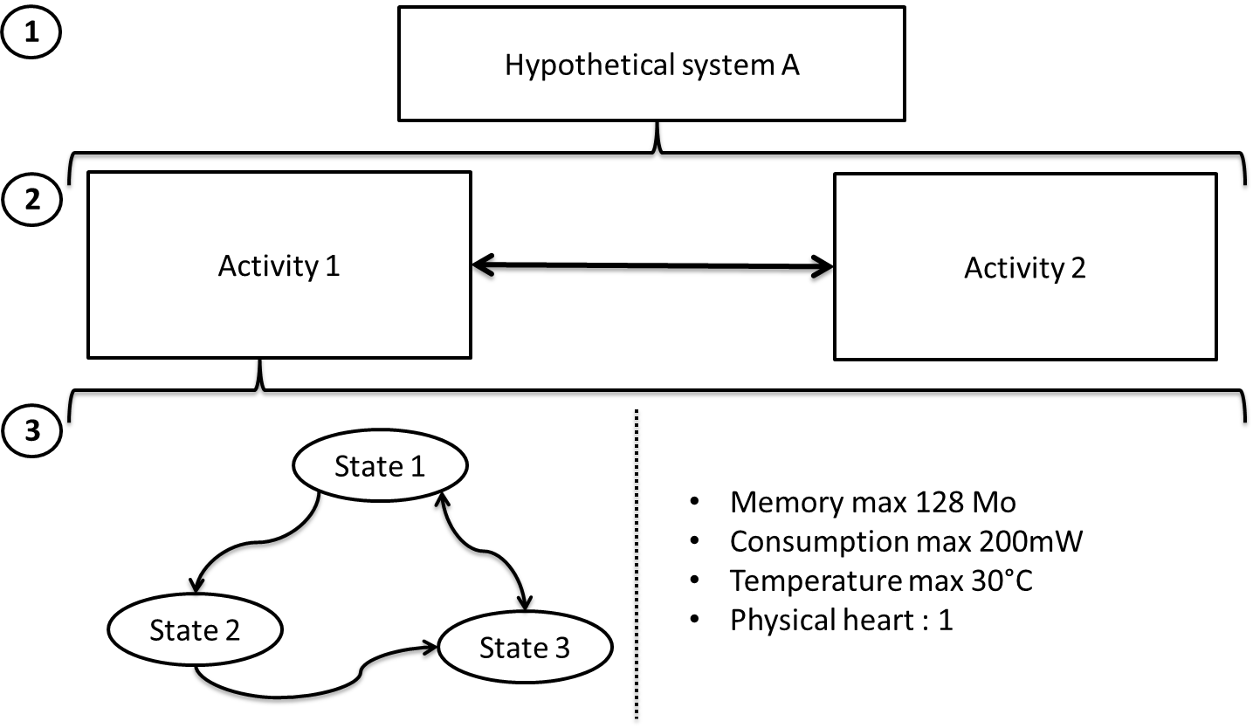

Figure 7 : NewAge design

NewAge returns two types of information, an executable code and many simulation measures (local or global consumption, memory consumption, etc.). The code produced by NewAge is executable in the real system and produced the same behavior than the real code (the same execution time, memory consumption, etc.). The terrorist can use this code to create a replica of the real system. The data returned by NewAge are an indicator of the real system, the user can use them to compare his simulation and the real system or to detect a failure in the real system.

Finally NewAge is a simulation tool based on the concept of activity, it use software behavior and hardware restriction to return executable code and hardware observations.

## Application in in a Cybersecurity Context

Part 2 describes a situation which a cyberterrorist wants infected a system therefore he collect data about the system and model these data with two tools, Pimca and Excel. Role4All allows him to create specific points of view on the system and to synchronize his tools due to the concept of role. Until now the specific points of view allows considering and using data independently of a tool but it is possible to create a point of view specialize for a tool, for example a simulation tool like NewAge. So Role4All formats the data from various tools to generate a simulation (figure 7). Consequently the terrorist can simulate his hypothetic systems.

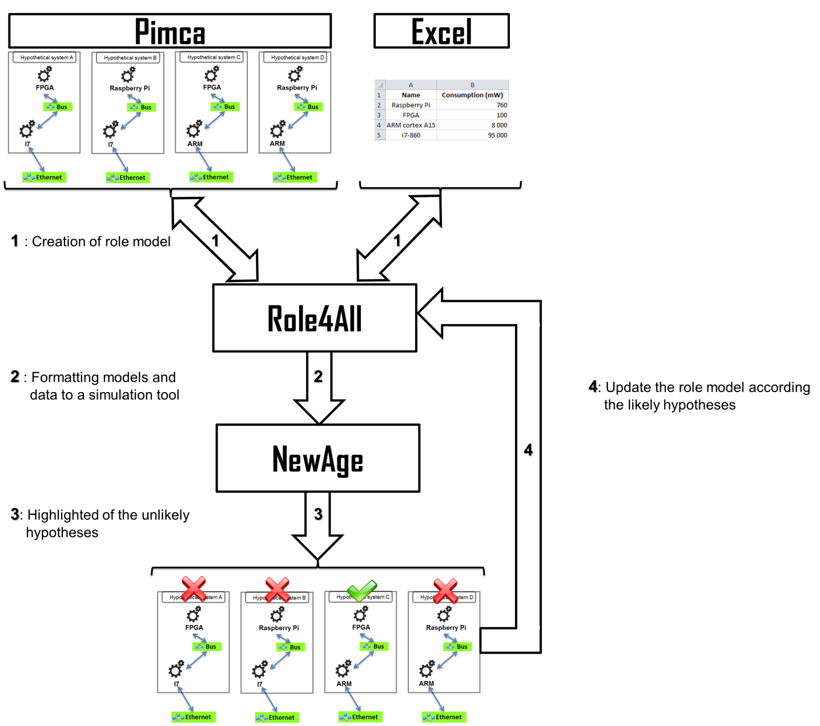

Figure 8 : Simulation in Role4All and NewAge

The figure 7 describes how the data collected and formatted through various tools are simulated on NewAge according to an example. In our example the cyberterrorist creates 4 hypothetical systems in Pimca composed of two elements: a platform (FPGA or Raspberry Pi) and a processor (I7 or ARM). Furthermore the terrorist has heterogeneous data like the consumption of the real system or an Excel file with the consumption of each platforms and processors. He used Role4All to create a point of view on his hypothetical models and data allowing implementing a simulation, so the 4 hypothetical systems (Pimca model + Excel data) are simulated. NewAge returns information about the simulation like the execution time or the consumption of the system. In our example the terrorist can compare the consumption of the hypothetical systems and the consumption of the real system to highlight the unlikely hypotheses. In our example the terrorist can select the hypothesis C (FPGA +ARM) like the only plausible system because NewAge rejects the other ones.

Finally the simulations allow testing many hypotheses according to heterogeneous data and models from various tools. Furthermore the dynamism due to Role4All allows to easily interpret the data from NewAge and to generate new hypothesis in order to better uncover the real system.