Technical Design | Version-Aware arXiv RAG
Python · FastAPI · Weaviate · SentenceTransformers · Ollama · PyMuPDF

1. Design — end-to-end architecture
The application ingests multiple arXiv paper revisions, answers research questions using cited passages, and compares versions to identify meaningful edits. It exposes FastAPI endpoints and CLI workflows; Weaviate stores version metadata and searchable text chunks, while Ollama runs local inference.
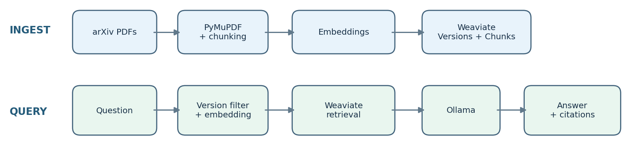

Ingestion and Weaviate schema
arXiv PDFs are downloaded, parsed with PyMuPDF, normalized and split into overlapping text chunks. SentenceTransformers all-MiniLM-L6-v2 embeds each chunk before indexing. The PaperVersion collection records arXiv ID, revision number, title, date, full extracted text, content hash and chunk count. PaperChunk stores chunk text, vector, paper/version identifiers, page, section and chunk index.
Versions are separate logical documents (for example, 2606.05387v1 and v2). Deterministic version/chunk identifiers and content hashes support repeatable, idempotent ingestion: unchanged versions are skipped rather than duplicated. This preserves prior revisions and supports precise retrieval filters.

Retrieval and comparison
For chat, the question is embedded with the same model, then Weaviate runs configurable dense vector or hybrid BM25/vector retrieval. Hybrid alpha controls the fusion balance. Paper/version filters select the requested revision or latest indexed version. Retrieved passages carry page/version source labels; Ollama qwen2.5:7b answers only from that evidence, citation labels are validated, and insufficient evidence should trigger abstention.
For comparison, the application retrieves the two stored full texts, normalizes PDF-extracted text, aligns paragraphs with difflib, removes certain moved-text and extraction artifacts, and classifies differences. Deterministic rules handle obvious formatting, metadata and numeric edits; Ollama assesses ambiguous changes. The output is a structured list of changes and classifications.

2. Feature highlights — engineering choices and evidence

A. Version-aware, idempotent indexing
A common RAG implementation overwrites documents when new revisions arrive or silently mixes evidence from different versions. Here, version-specific identifiers, metadata filters and content hashes preserve each revision and avoid duplicate writes. We verified four indexed versions totaling 951 chunks, with stored counts matching the corresponding PaperVersion metadata (216, 138, 138 and 459). A chatbot question explicitly requesting v1 of arXiv 2606.05387 returned a v1 page citation instead of defaulting to v2.

B. Hybrid scientific diff with PDF artifact handling
Pure text diffs are noisy on scientific PDFs: column order, line wrapping and paragraph movement can look like scientific edits. The comparator combines deterministic paragraph differences with artifact cleanup and LLM-assisted classification. During testing, a misplaced NISQ-related sentence was incorrectly flagged as a deletion because of PDF reading order. We added cleanup logic and a regression test; the 2606.05387 v1→v2 run subsequently reported three metadata changes and no detected substantive scientific changes. This is a pipeline result, not proof that the revisions are scientifically identical.

C. Focused functional validation
Twenty-three automated tests passed, covering chunking, deterministic IDs, numerical edits, formatting, metadata, moved text and PDF alignment artifacts, plus retrieval modes, configuration validation, version filters, citation validation and pooled-evaluation metrics. In a manual grounding check, the chatbot declined to provide an Apple stock price absent from the retrieved QML paper. These checks demonstrate selected behaviors; they are not an end-to-end benchmark of answer faithfulness or change-detection recall.
D. Hybrid retrieval quality evaluation: I compared dense retrieval with Weaviate hybrid retrieval at alpha 0.25, 0.50 and 0.75 using the same top-5 evaluation on 14 manually reviewed questions. Hybrid alpha 0.25 had the strongest observed pooled Recall@5 (0.813 vs 0.681 for dense), MRR (0.702 vs 0.544) and Precision@5 (0.386 vs 0.314); Hit Rate@5 tied at 0.786. Its median retrieval latency was 3.14 ms versus 2.10 ms for dense. This makes alpha 0.25 the best quality result in this test, with a latency trade-off. Recall is measured only over the pooled candidates returned by these systems, not exhaustively over the full corpus, and the 14-question assessment is too small to establish general performance.

3. What I would improve with more time
- Parsing and comparison accuracy: adopt layout-aware PDF extraction, section-aware alignment and explicit handling for equations, figures and tables; manually evaluate a labeled set of true scientific revisions.
- Retrieval and grounding: broaden the manually judged query set, add judgments beyond the pooled top-K to estimate corpus-wide recall, evaluate cross-encoder reranking, and validate whether each cited passage supports its associated claim.
- Production robustness: add authentication and authorization, structured logging, metrics, background/batch ingestion, failure recovery and external storage for full PDFs/text; restrict Weaviate and Ollama to private networks.
Key trade-off: local, reproducible inference and a simple two-collection schema make the assessment runnable, but PDF parsing fidelity and evidence-level evaluation are the principal constraints on scientific reliability.

