
Express Autocare ERP
User Manual
Step-by-step help for every role: owner, managers, service advisors, technicians,
drivers, parts coordinator, back office and marketing.
Version 1 · October 2026
Contents
1. About this manual 4
Which chapters should I read? 4
Words used in this manual 4
2. Getting started 6
2.1 Signing in 6
2.2 The screen at a glance 6
2.3 My Day — start here every morning 8
2.4 Search anything 8
2.5 The bell (alerts) 8
2.6 Branches 9
3. Attendance, leave and payslips (everyone) 10
3.1 Punch in and punch out 10
3.2 Applying for leave 11
3.3 Payslips, advances and money you hold 11
4. CRM: leads and follow-ups 13
4.1 Where leads come from 13
4.2 Your list for today 13
4.3 Adding a lead (calls, walk-ins, referrals) 14
4.4 Working on a lead 15
4.5 Booking a slot 18
4.6 Messages to send 19
4.7 What the customer sees 20
4.8 What happens by itself 21
5. Bookings and CRM insights 23
5.1 The bookings board 23
5.2 Insights and feedback (owner, managers) 23
6. Customers, job cards and the workshop floor 25
6.1 Customers and vehicles 25
6.2 Opening a job card 25
6.3 The job moves on by itself 27
6.4 Intake (advisor) 27
6.5 Estimate and customer approval (advisor) 27
6.6 Technicians: My Jobs and the job sheet 28
6.7 Trial, wash and final QC 29
7. Pickup, drop and home service 30
7.1 Advisor: planning trips 30
7.2 Driver: My Trips 30
8. Parts and purchases (parts coordinator) 32
8.1 The Parts Desk 32
8.2 When Purchases & Stock is switched on 32
9. Billing, payments and delivery 33
9.1 Taking a payment (advance or final) 33
9.2 From bill to delivery 33
9.3 Paid too much? Refunds and customer credit 34
9.4 Payments list 34
10. Accounts (back office, owner) 35
10.1 Recording an expense 35
10.2 Other entries 36
10.3 Reports 36
11. People: attendance register, leave, employees and payroll 39
11.1 Attendance register 39
11.2 Leave requests 39
11.3 Employees 40
11.4 Running the monthly payroll 41
11.5 Staff money and advances 42
12. Settings (owner, managers) 44
12.1 Journeys and creatives (automatic messages) 45
12.2 Lead sources and webhooks 45
12.3 Workshop location for attendance 46
12.4 Switching modules on or off (owner) 47
13. How it all connects: one car's journey 48
14. Daily checklists 49
15. Common questions 50

1. About this manual
Express Autocare ERP is the one system the whole workshop works in: from the first enquiry of a customer, through booking, the job card, parts, billing and delivery, to the reminder for the next service. Attendance, salaries and the accounts are in the same system, so nobody has to type the same thing twice.
This manual explains every screen in plain words, with pictures. You do not need to read all of it. Find your role in the table below and read those chapters first.

Which chapters should I read?
Your role | What you mainly do | Read chapters
Everyone | Sign in, My Day, attendance, leave, payslips | 2, 3
Marketing executive | Call leads, send prices and creatives, book slots | 2, 3, 4, 5
Service advisor / Body shop advisor | Bookings, job cards, estimates, technicians, parts, delivery | 2–9
Technician / Body shop technician | Job sheets: activities, photos, parts needed | 2, 3, 6.6
Driver / home-service technician | Pickups, drops, home visits | 2, 3, 7
Spare parts coordinator | Supplier prices, orders, receiving parts | 2, 3, 8
Back office executive | Bills, payments, expenses, payroll | 2, 3, 9, 10, 11
Manager / Body shop manager | Everything in the branch; approvals, attendance, QC | All, especially 11, 12
Owner | Dashboard, reports, accounts, settings | All

Words used in this manual
Word | Meaning
Lead | A person who has shown interest (ad, call, referral, walk-in) but has not yet brought the car.
Follow-up | The next time we should call or message a lead.
Booking / slot | An appointment for a day and time. Each time slot can take a fixed number of cars.
Journey / creative | An automatic series of WhatsApp messages (creatives = the pictures, videos or texts) sent over days or weeks.
Job card | The record of one car visit: customer, car, work, technicians, parts, bill.
Job sheet | The technician's checklist of activities for the job, with photos and videos.
Estimate | The price list for the job that the customer approves (or declines) line by line on WhatsApp.
Proforma / tax invoice | The proforma is the draft bill; the tax invoice is the final GST bill.
Gate pass | Permission for the car to leave. It is issued by itself when the bill is fully paid.
GRN | Goods Received Note: the record of parts received from a supplier (only if Purchases is switched on).
Customer credit | Extra money the customer paid (or a referral reward) kept for a later job.
Staff-held money | Customer money paid into an employee's own UPI or given to them in cash, until it is handed over.
Advance | Salary paid early to an employee, recovered from later salaries.
OT | Overtime. It counts only after the first hour beyond the shift.

Note The pictures in this manual were taken from a practice copy of the system filled with sample data (for example "Rahul Mehta" or "Andheri Branch"). Your screens will show your own customers and numbers. What you see also depends on your role: people only see the menus they need.

2. Getting started

2.1 Signing in
The ERP works on any phone or computer with a web browser (Chrome is best). There is nothing to download.
- Open the ERP link given by your manager.
- Type your mobile number (or your office email, e.g. name@expressautocare.in) and your password.
- Tap Sign in.
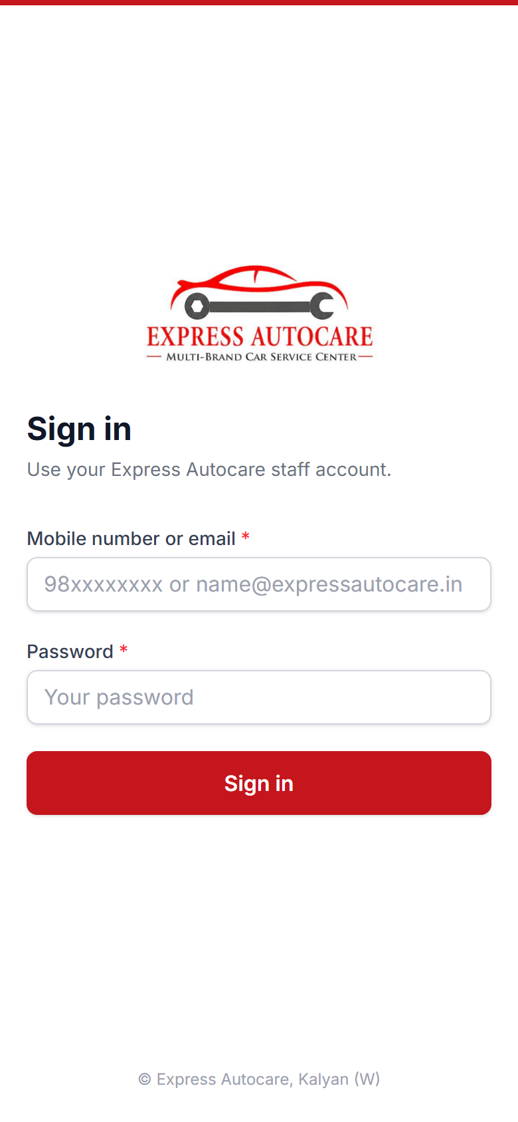
The sign-in screen

Tip On a phone, open the browser menu (⋮) and tap Add to Home screen. The ERP then opens like an app from its own icon.
Forgot your password? Ask the owner or manager. They reset it in Settings › Users. Never share your password: everything you do is recorded under your name.

2.2 The screen at a glance
On a computer, the menu is on the left, grouped by module: Home, CRM, Workshop, Customers, Parts & Stock, Billing, Accounts, People and Settings. Tap a group name to fold or open it. At the top you will find the branch name, the search box, the bell and your name.
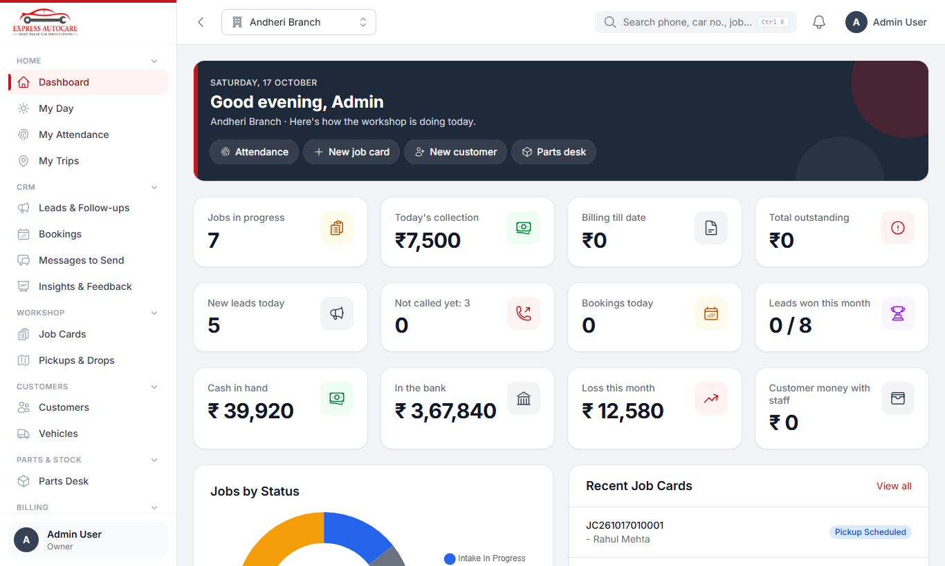
The owner's dashboard on a computer: jobs in progress, today's collection, billing and outstanding money
On a phone, the four screens you use most are on the bottom bar. Everything else is under More (bottom right).
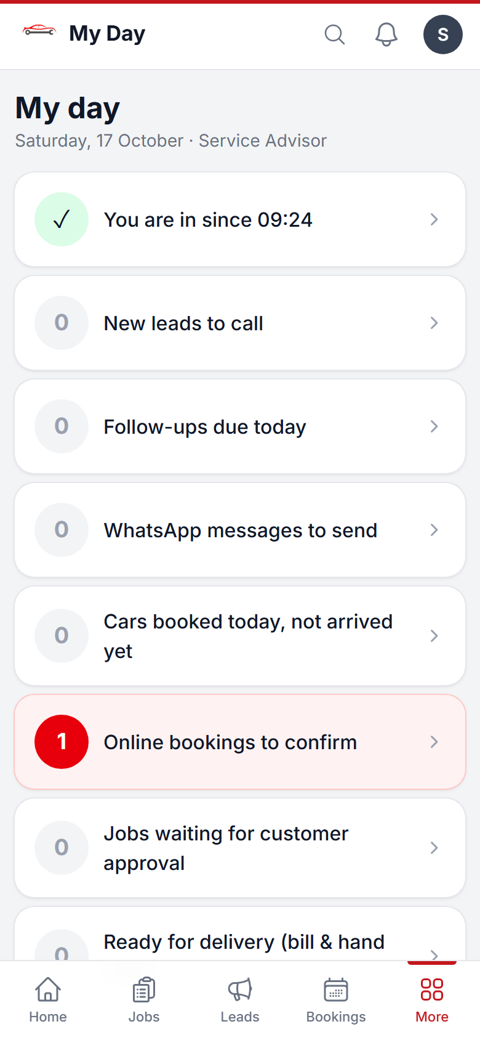  My Day with the bottom bar | 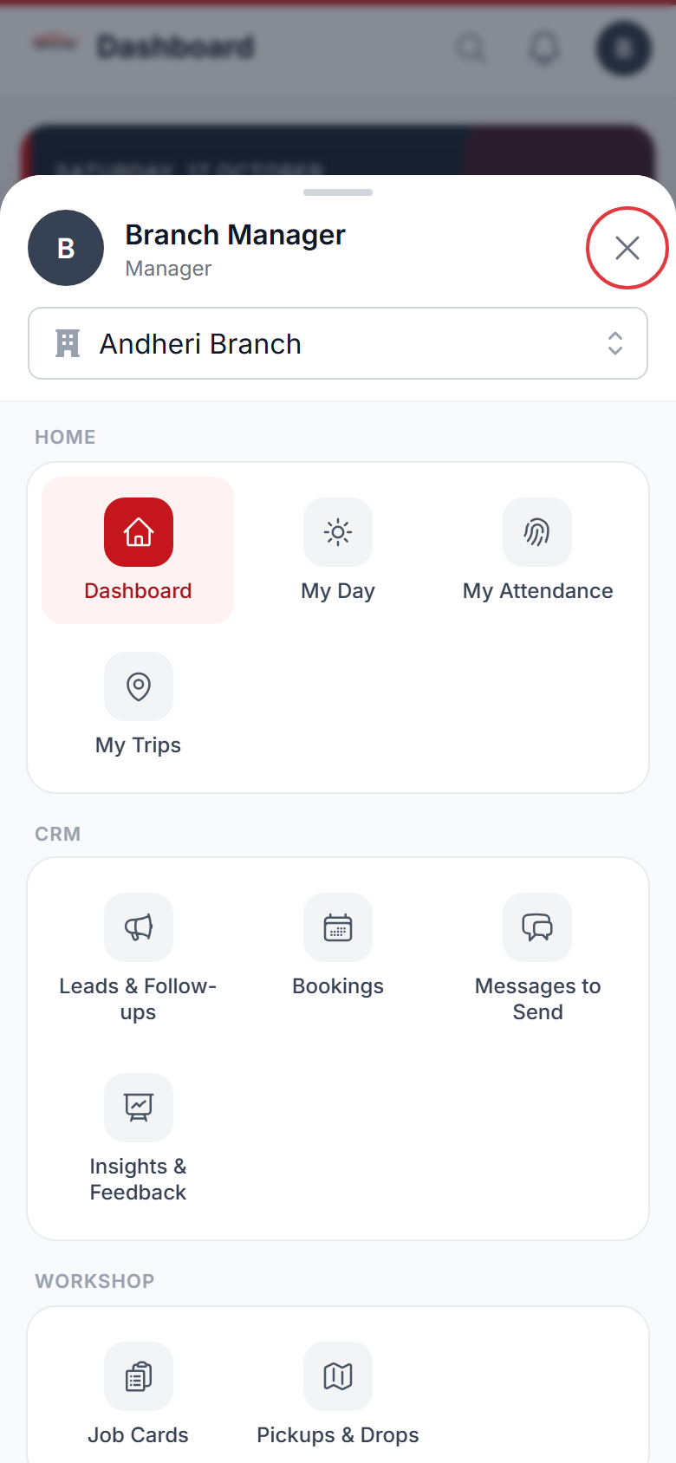  The full menu under More

2.3 My Day — start here every morning
My Day is your to-do list. It only shows what is waiting for you, for example:
- whether you have punched in today;
- new leads to call and follow-ups due;
- WhatsApp messages waiting to be sent;
- cars booked today that have not arrived, and online bookings to confirm;
- jobs waiting for customer approval, jobs ready for delivery, bills to make;
- leave requests to approve (managers).
A red card means something is waiting. Tap the card to go straight to the work. When every card shows 0, you are up to date.

2.4 Search anything
Tap the magnifier at the top (or press Ctrl + K on a computer). Type a few digits of a phone number, a car number, a job card, bill or booking number, or a name. The results show customers, cars, jobs, bills and leads together. Tap one to open it.
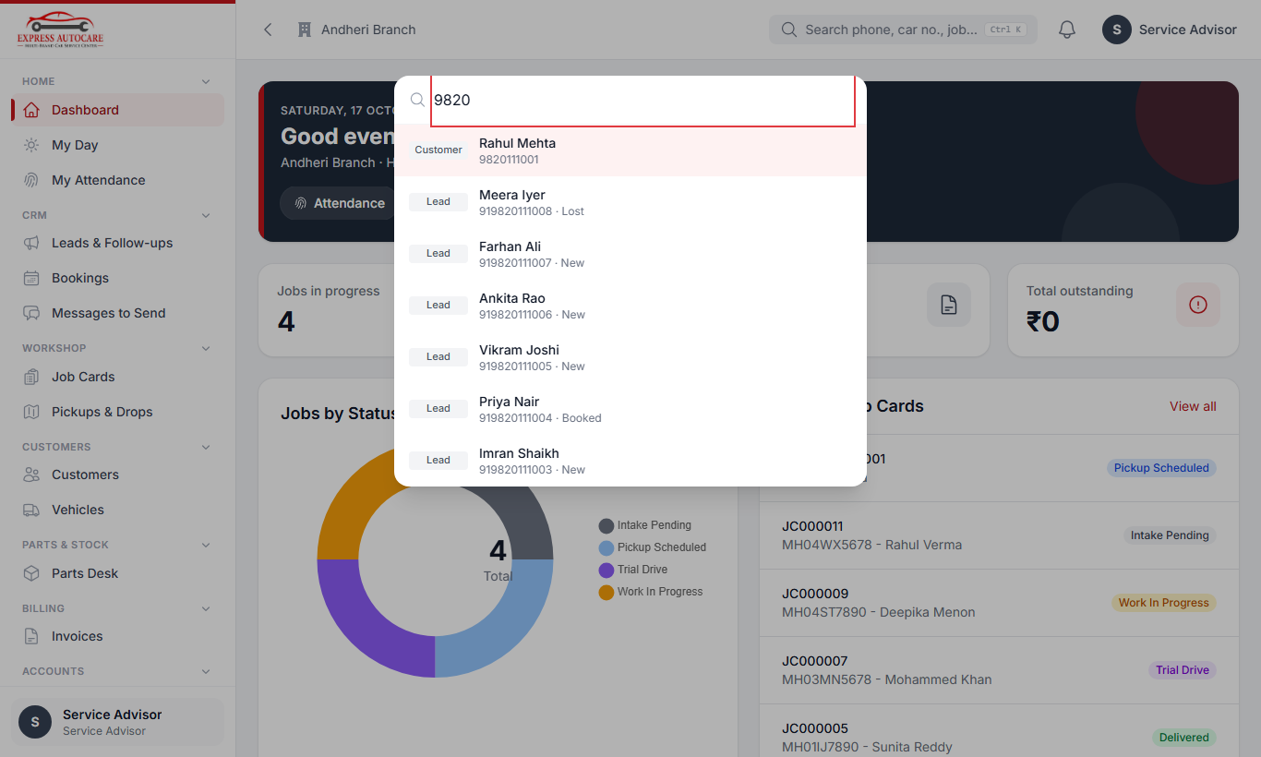
Searching "9820" finds customers, leads and bookings with that number

2.5 The bell (alerts)
The bell shows alerts meant for you: a new lead given to you, a job assigned to you, parts arrived, an estimate approved, your leave answered, and so on. A red number shows how many are unread. Tap an alert to open the record.

2.6 Branches
If you work at more than one branch, choose the branch at the top of the screen. Lists, bookings and reports then show that branch. The owner can see all branches.
Tip If a menu item you need is missing, either your role does not use it, or the owner has switched that module off (Settings › Modules). Ask your manager.

3. Attendance, leave and payslips (everyone)
Every employee marks attendance with a selfie taken at the workshop. The phone's location (GPS) proves you were there. Your attendance, overtime and leave are then counted for your salary automatically.

3.1 Punch in and punch out
- Reach the workshop and turn on Location on your phone.
- Open People › My Attendance (on the phone: Attendance in the bottom bar).
- Tap Punch in with a selfie. Allow the camera and location when the phone asks (only the first time).
- Look at the front camera and take the selfie. Wait for the green tick.
- When you leave for the day, open the same screen and tap Punch out.
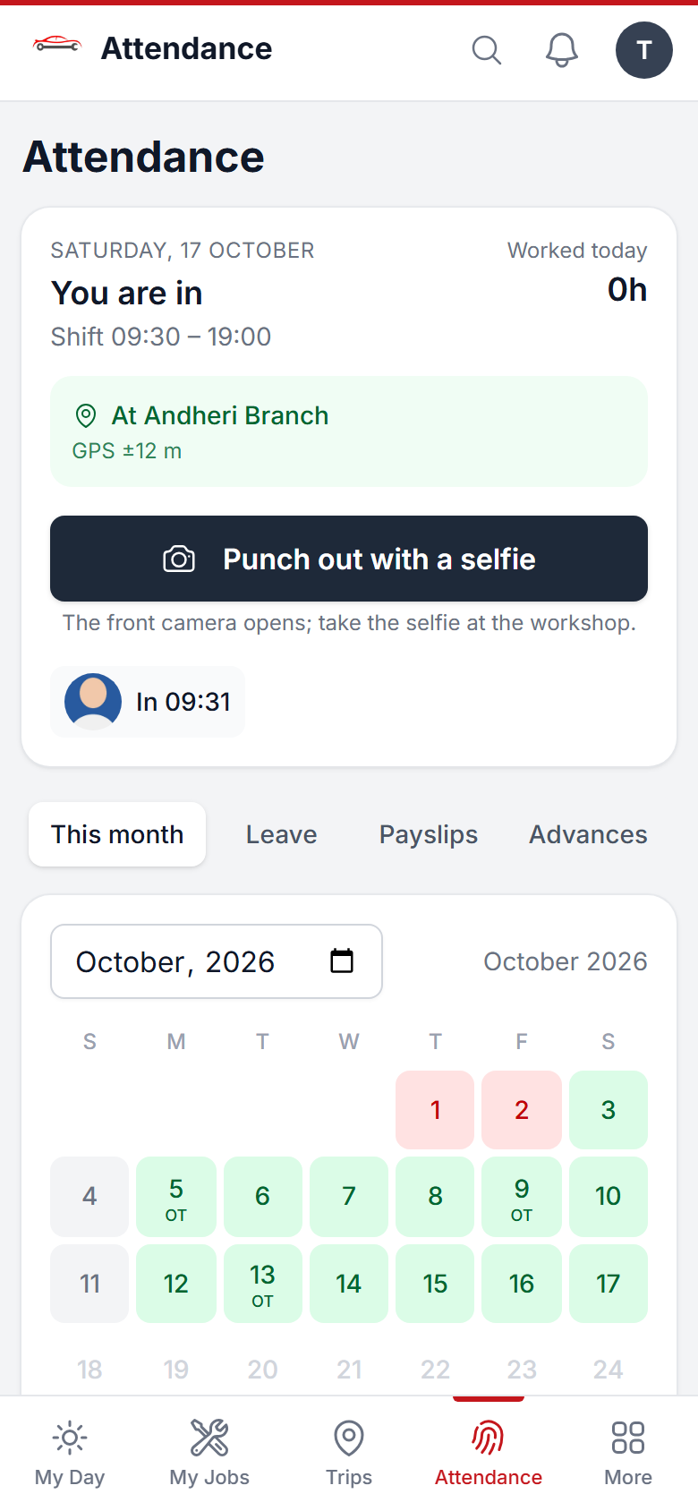  Punching in with a selfie | 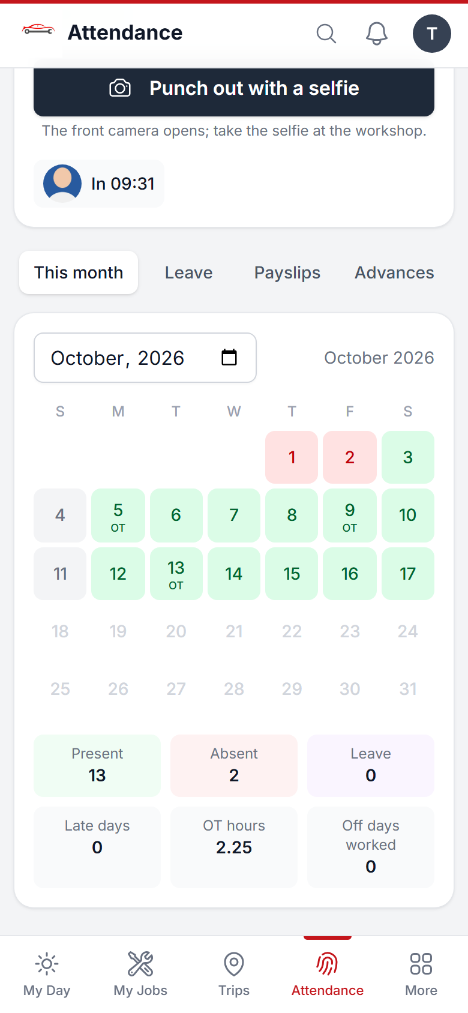  Your month: present, late, overtime

Careful The button only works inside the workshop area (for example within 150 metres). If it says you are too far away, move inside, wait a few seconds for the GPS, and try again. Drivers and home-service technicians on a trip that day can punch from where they are.
Forgot to punch, or the phone did not work? Tell your manager the same day. The manager adds the missing punch with a reason. You cannot change punches yourself.

Your month
Below the punch button is a calendar for the month. Colours: green present, red absent, purple leave, grey weekly off or holiday. Tap a day to see your in and out times, late minutes and overtime.
Note Overtime starts only after the first hour beyond your shift. Working on your weekly off or a holiday earns the extra pay set by the owner.

3.2 Applying for leave
- Open My Attendance and tap the Leave tab.
- Tap Apply for leave.
- Choose the leave type, the dates (or a half day) and write the reason.
- Tap Send. Your manager gets an alert.
- You get an alert back when it is approved or rejected. The tab also shows your balance of each leave type.
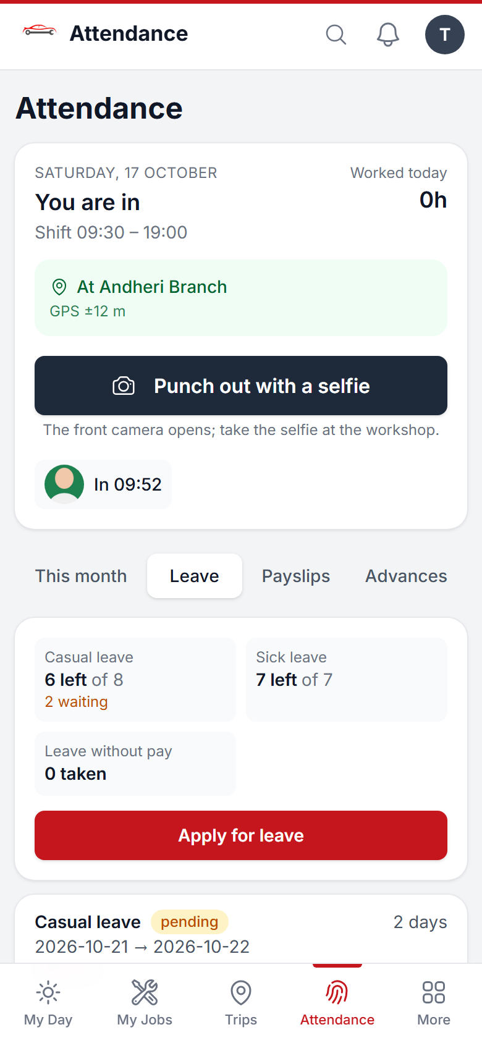
The Leave tab with balances and requests

Paid leave beyond your balance is taken as unpaid (it is cut from the salary).

3.3 Payslips, advances and money you hold
- Payslips tab: appears after the owner finalises the month's payroll. Tap a month to see every line, or open the PDF.
- Advances tab: salary advances still being recovered and how much is cut each month.
- Customer money you hold: if a customer paid you (your own UPI or cash), it shows here until you hand it over at the counter. Anything still with you at month end is cut from your salary.
Connects to Payroll (days, overtime and leave are counted from here) and CRM (new leads are not given to people who are absent or on leave).

4. CRM: leads and follow-ups
The CRM keeps every enquiry until it becomes a booking, and keeps in touch with customers after delivery so they come back. It is used by marketing executives and service advisors; managers watch it.

4.1 Where leads come from
- Meta (Facebook / Instagram) and Google ads, and the website: the lead arrives by itself, with the campaign name.
- Incoming calls, walk-ins and referrals: you add them with Add lead (below).
- Existing customers: the system makes a lead by itself when a car is due for service, insurance is due, work was left pending, or the customer has not visited for months.
Each new lead is given to the next executive in turn (round-robin). People who are absent or on leave today are skipped. You get a bell alert.
Note If the same mobile number already has an open lead, the system does not make a second one. It adds "enquired again" to the existing lead and marks it hot.

4.2 Your list for today
Open CRM › Leads & Follow-ups. The Today tab has two parts:
- Call now — new leads: people who have not been called yet. Call them within 15 minutes: the faster you call, the more bookings you get. If you don't, you get a reminder, and then your manager is told.
- Follow-ups due: leads whose next call is due now. A red dot means hot, yellow warm, grey cold. Overdue ones show in red.
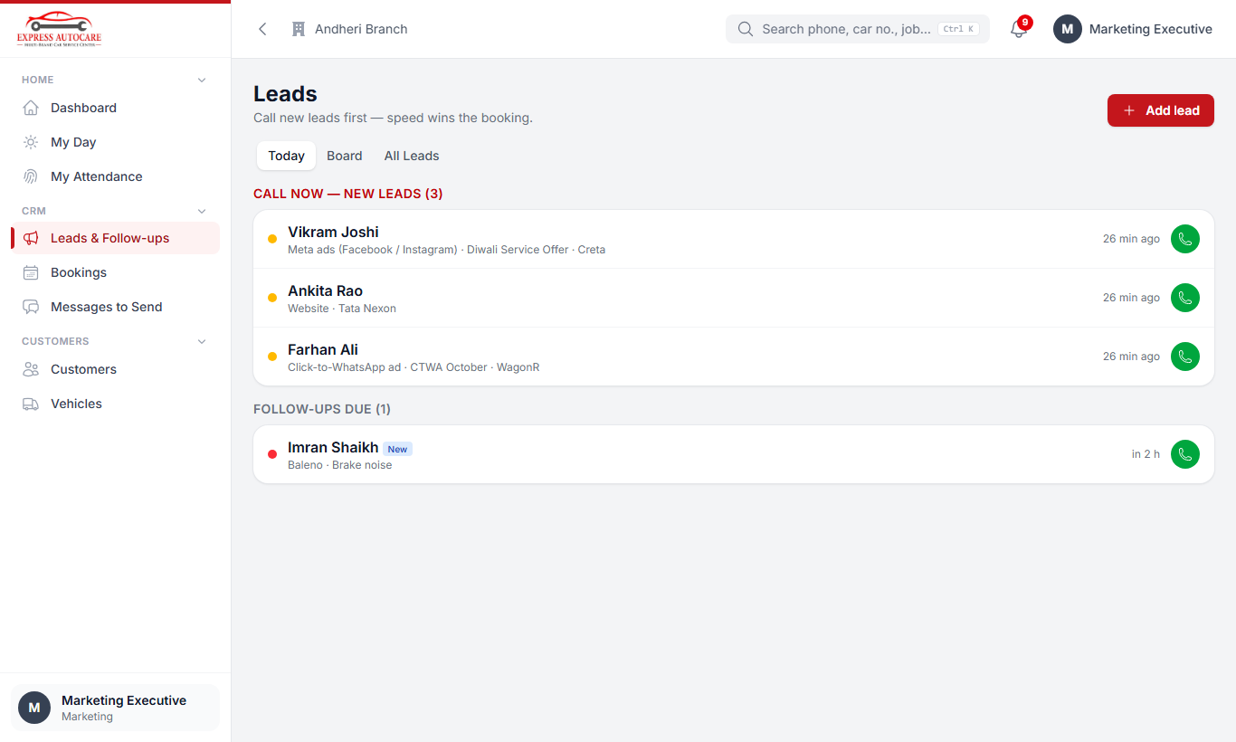
Leads › Today: new leads to call first, then follow-ups due
Tap the green phone button to call straight away, or tap the name to open the lead.

The Board and All Leads
Board shows all open leads in columns: New, Contacted, Interested, Booked. Use the filters at the top (source, temperature, kind, executive) to narrow the list. All Leads is the same as a list, with search. Managers can choose Everyone to see the whole team's leads.
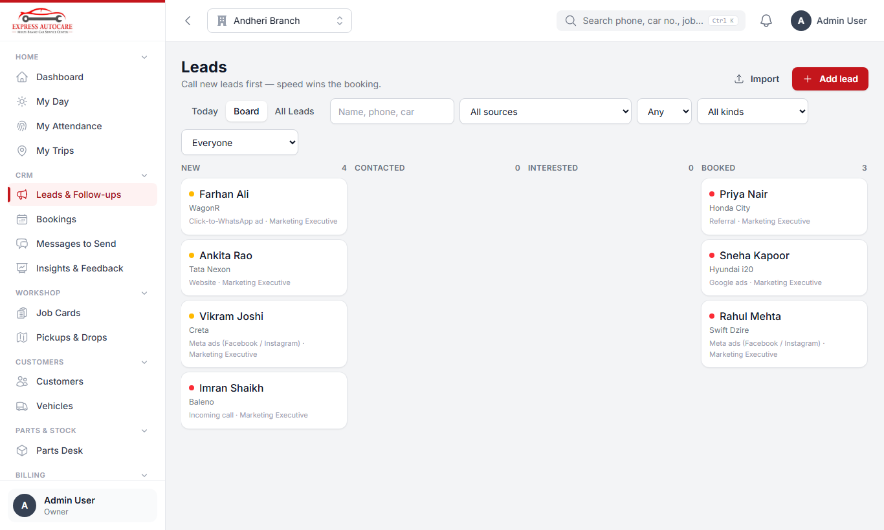
The Board: every open lead by stage

4.3 Adding a lead (calls, walk-ins, referrals)
- Tap Add lead.
- Type the mobile number (this is the only thing you must fill).
- Add the name, car and car number if you know them.
- In Came from, choose how they reached us (incoming call, walk-in, referral…). In Wants, choose what they want (service plan, AC, body shop…) and the plan if known.
- Write What they said in a few words, and choose How keen (hot, warm or cold).
- Tap Add lead.
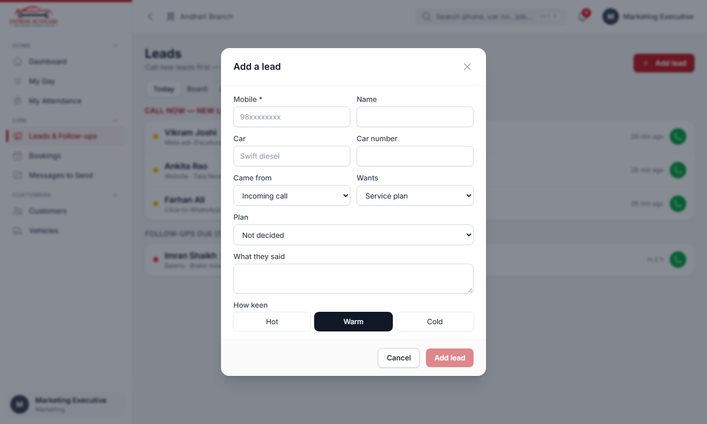
Add a lead: only the mobile number is required

4.4 Working on a lead
Open a lead to see everything about it: where it came from, who it is with, what they said, every call and message, and the next follow-up. The four big buttons do the main jobs.
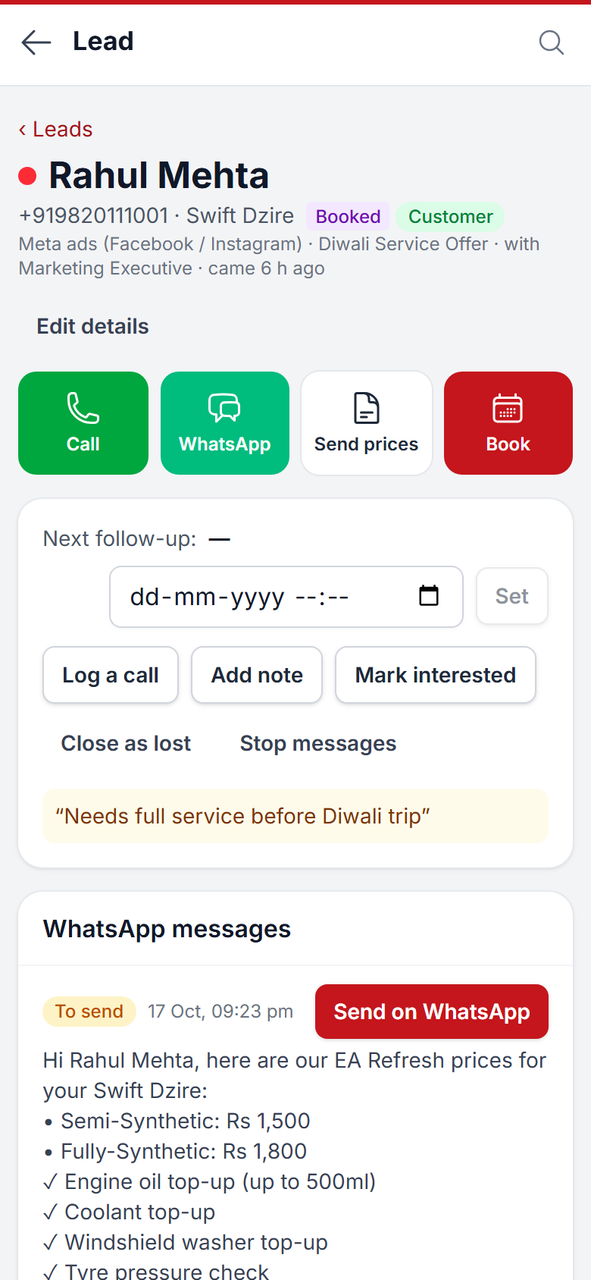
A lead on the phone

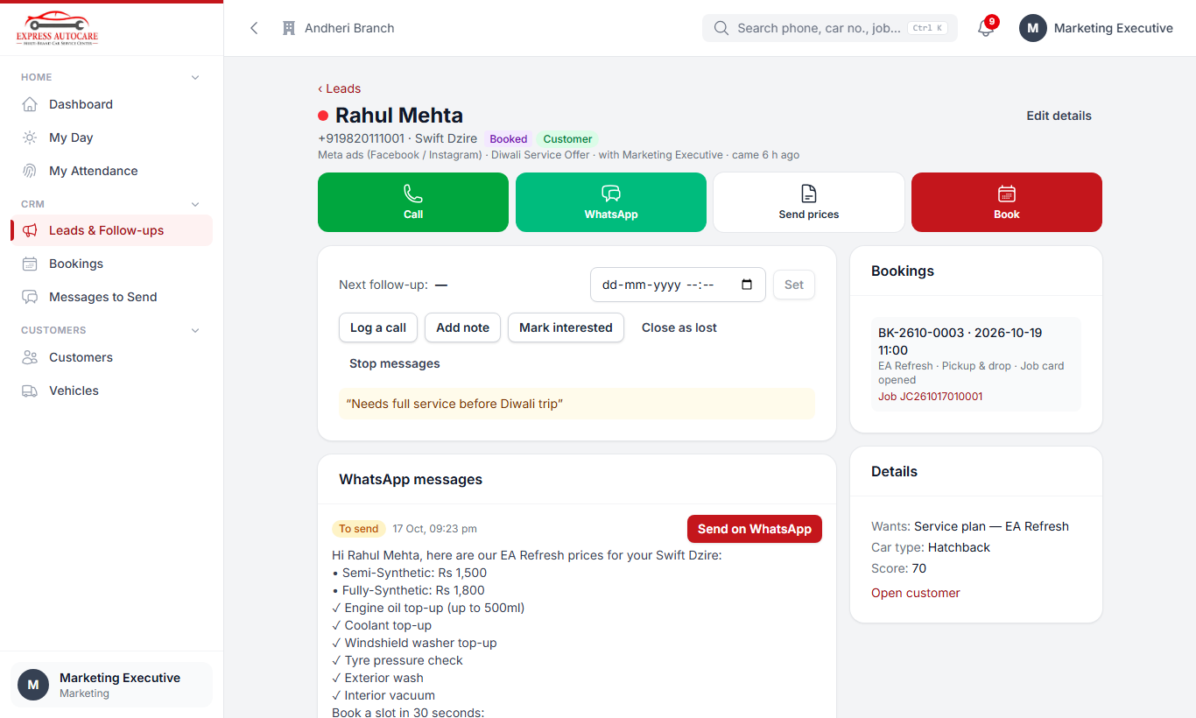
The same lead on a computer, with its timeline
Button | What it does
Call | Dials the customer. After the call, tell the system what happened (see Log a call).
WhatsApp | Opens a WhatsApp chat with the customer.
Send prices | Pick a plan. The message with the prices for their car type, what is included, and a booking link is made for you. Tap Send on WhatsApp.
Book | Books a slot (see 4.5).
Log a call | Records what happened on a call and sets the next follow-up by itself.
Add note | Anything worth remembering.
Mark interested | Moves the lead to Interested.
Close as lost | Needs a reason. "Not now" reasons keep sending a gentle message every few weeks.
Stop messages | Use it when the person asks us not to message them. No automatic messages go to them again.

Log a call
After every call, tap Log a call and choose what happened:
- Connected: write what they said and, if needed, when to call back.
- No answer: the system sets the next try for you: in 2 hours, then tomorrow, then in 3 days. After three tries the lead becomes unreachable and goes into the automatic messages.
- Call back at…: pick the date and time they asked for.
- Not interested: choose the reason.
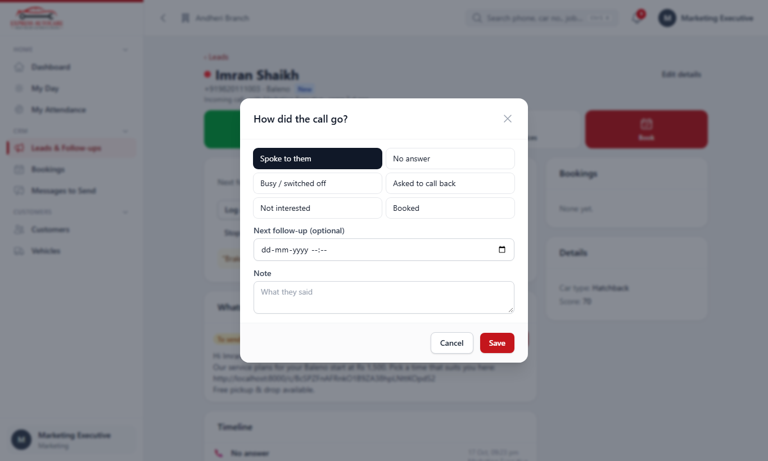
Logging a call: the next follow-up is set by itself

4.5 Booking a slot
- On the lead (or a customer page), tap Book.
- The first day with free slots is already chosen. Change the Day if the customer wants another one.
- Choose what the booking is For: a service plan or a repair (AC, body shop, electrical, detailing…).
- Tap a free time. Full times are greyed out; each shows how many places are left.
- Choose How: Drive-in, Pickup & drop or Home service. For pickup and home, type the address and landmark.
- Add a note if needed and tap Book. A confirmation message is ready to send to the customer.
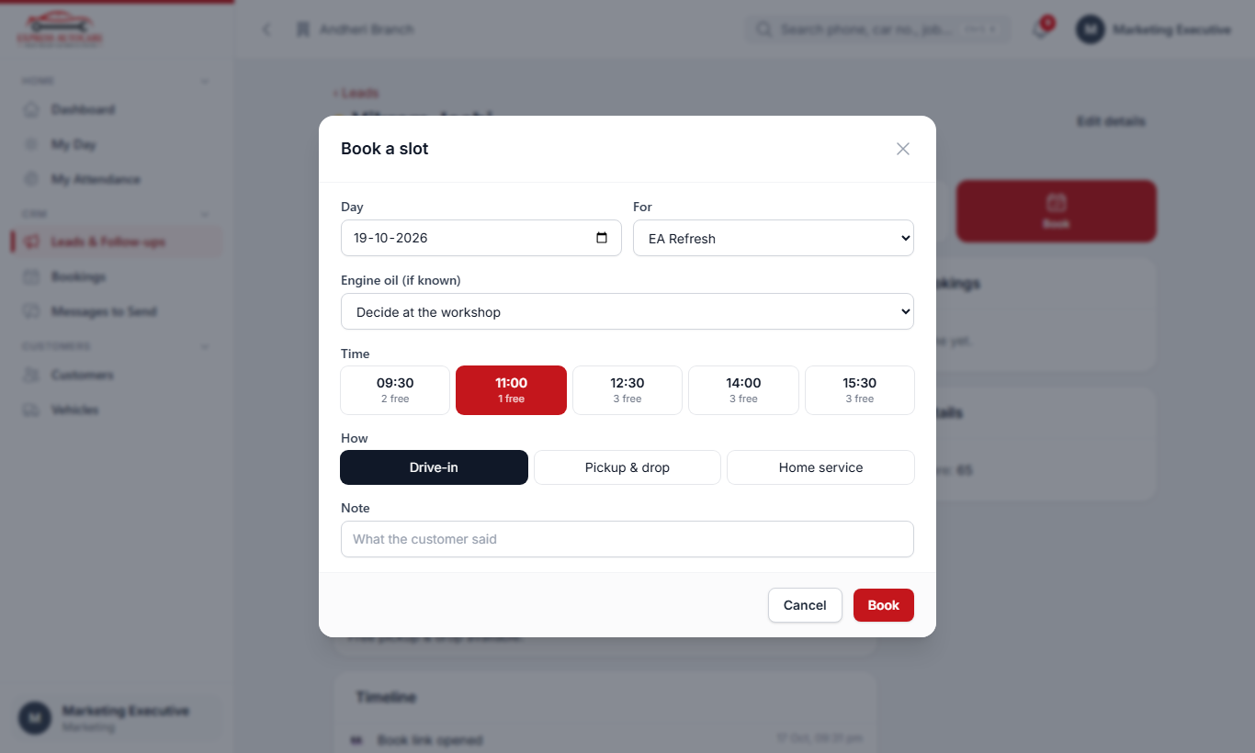
Booking a slot: day, what for, time and how
Tip Customers can also book by themselves from the link in the prices message. Those bookings appear as To confirm (see 5.1).

4.6 Messages to send
For now, WhatsApp messages are sent by you with one tap (later, an automatic WhatsApp service can send them without anyone tapping). Every message the system prepares waits in CRM › Messages to send: quotes, booking confirmations, follow-up creatives, thank-you and feedback messages, reminders.
- Open Messages to send. The Next message is shown at the top.
- Tap Send on WhatsApp. WhatsApp opens with the message already typed.
- Press send in WhatsApp, then come back to the ERP.
- The message is marked sent and the next one is ready. Tap Skip if a message should not go.
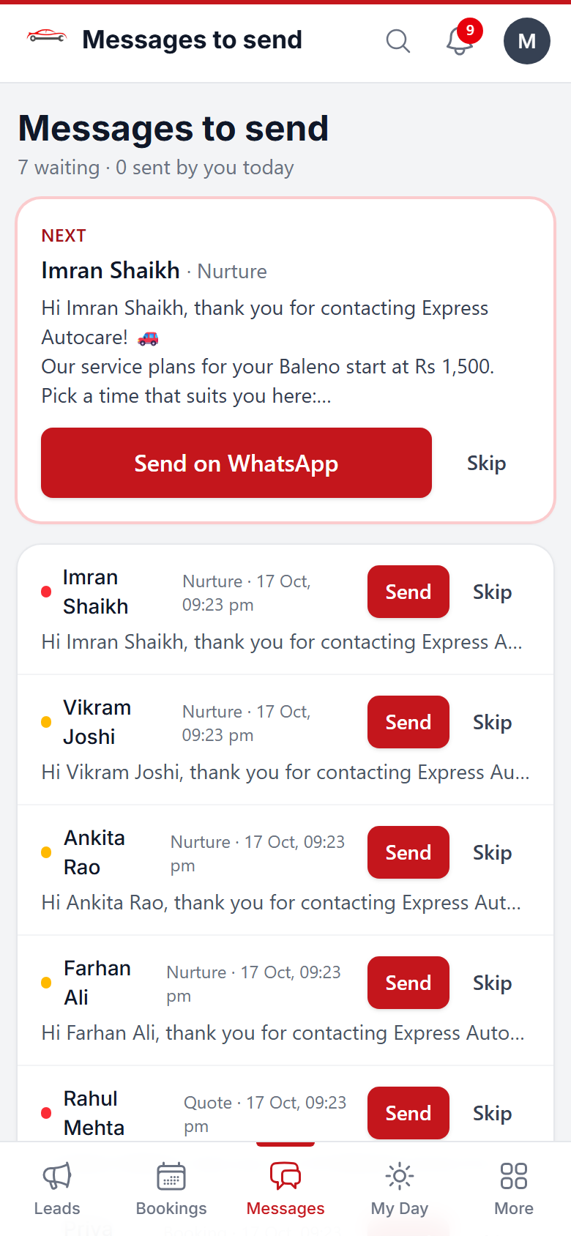
Messages to send: one tap per message

Note A message with a picture, video or PDF carries a short link to it, because WhatsApp links cannot attach files. Messages are only prepared during working hours, and a person does not get more than one marketing message every few days.

4.7 What the customer sees
The links in our messages open simple pages on the customer's phone. They do not need to sign in.
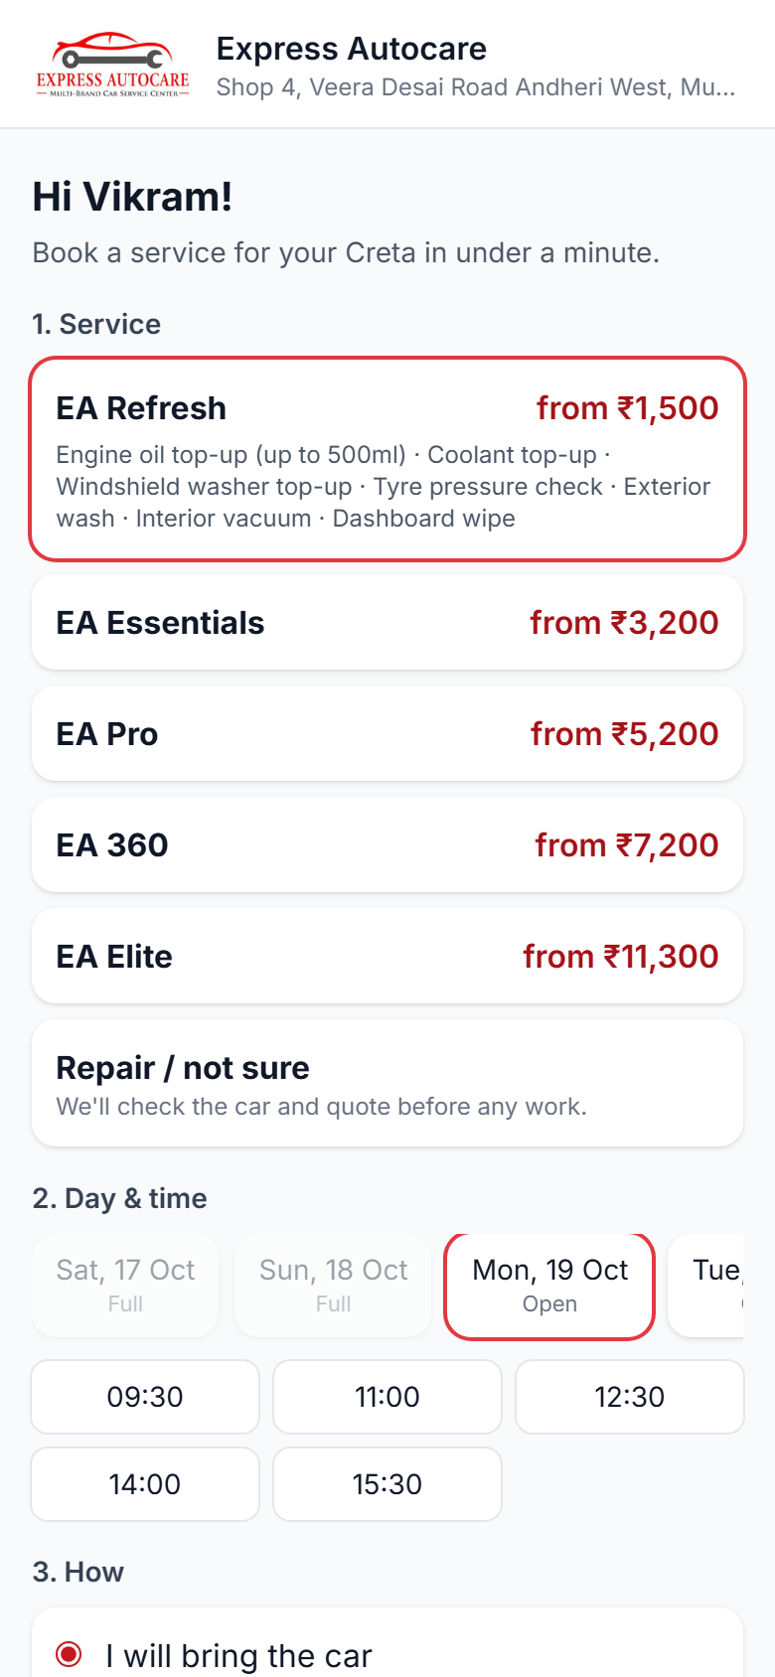  Self-booking page: plan, price and free times | 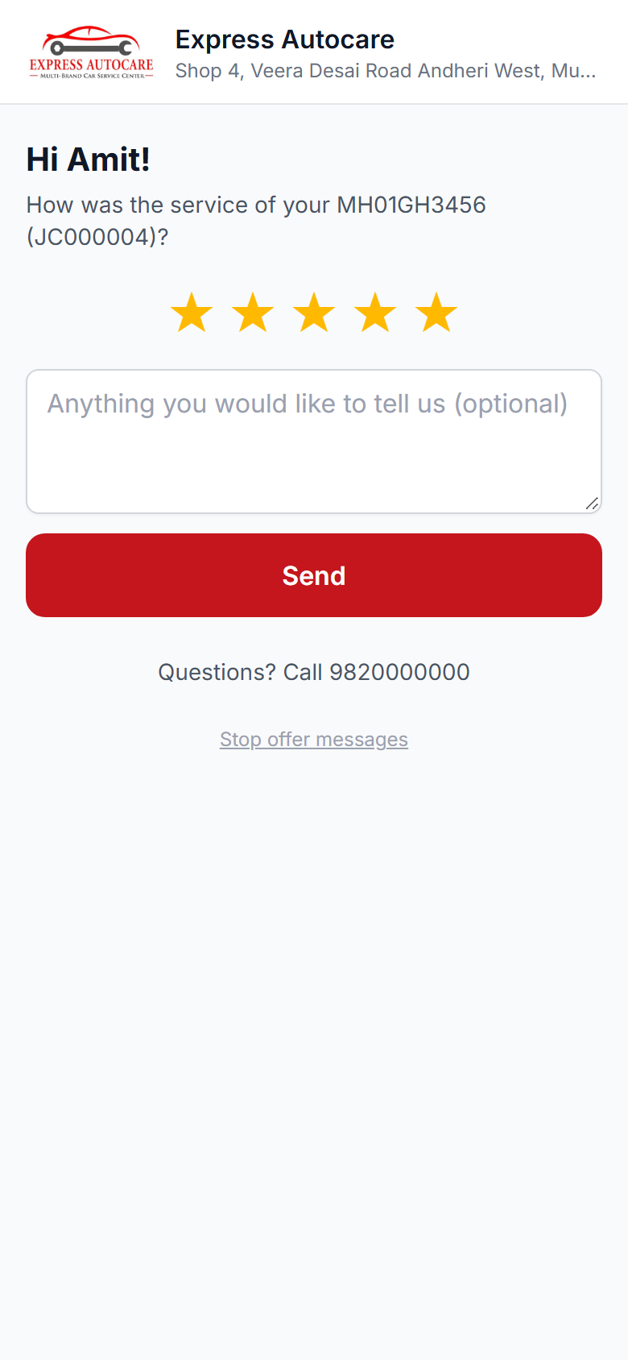  Rating page after delivery

After delivery the customer gets a thank-you with a one-tap rating. A rating of 4 or 5 asks them to review us on Google. A rating of 1 to 3 alerts the manager straight away, so we can call and fix it. The message also carries their personal referral link: when a friend books through it and the friend's car is delivered, the customer gets a reward as customer credit.

4.8 What happens by itself
When | What the system does
A new lead does not book | Sends the plan details at once, then reminders and creatives every 1–2 weeks (as set in the journeys).
A booking is made | Prepares the confirmation, a reminder the day before and a message on the day.
The customer does not come | Marks Did not come 3 hours after the slot and starts no-show messages.
The car is delivered | Marks the lead won with the bill amount; sends thank-you, rating and referral link.
Work was declined | About 2 weeks later, reminds the customer of the work still pending (a strong second sale).
Service is due | Reminds the customer before the due date, then makes a lead for a call.
Insurance is due | Reminds 30 and 7 days before expiry.
No visit for months | Starts win-back messages.

Connects to Bookings and job cards (a booking becomes a job card), Billing (the bill amount is credited to the lead and its campaign), Payroll (incentive per converted lead), Customers (everything shows on the customer page).

5. Bookings and CRM insights

5.1 The bookings board
CRM › Bookings shows who is coming on a day, slot by slot. Change the date at the top. Each booking shows the customer, the car, what it is for and how (drive-in, pickup or home).
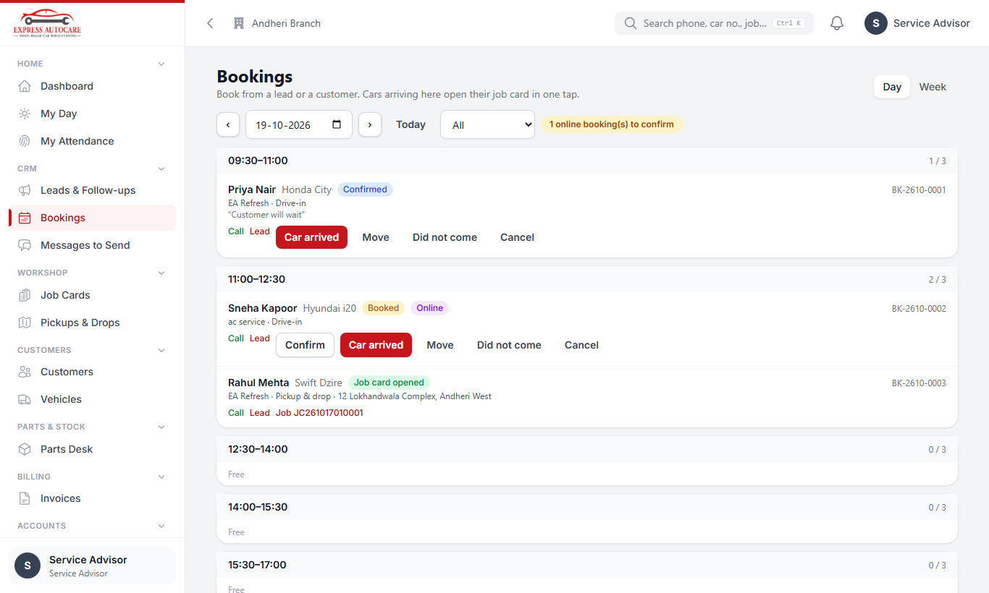
Bookings for a day: confirm, mark arrived, move or cancel
Button | When to use it
Confirm | For online bookings (To confirm): call the customer, then confirm. Pickup and home bookings open the job card and the driver's trip as soon as they are confirmed.
Car arrived | For drive-in bookings when the car reaches the workshop. Check the car number and car type: the job card form opens already filled in with the customer, car, plan and oil.
Move | The customer wants another day or time.
Cancel | The customer cancelled. Choose a reason.
Did not come | Also marked by itself 3 hours after the slot.

5.2 Insights and feedback (owner, managers)
CRM › Insights & Feedback shows how well leads turn into business, for any date range:
- Funnel: leads → contacted → booked → arrived → billed, with the percentage at each step.
- Revenue from leads, ad spend, cost per lead / booking and ROI (enter the monthly ad spend per campaign in Settings).
- How fast the first call is made, and how many were late.
- The same numbers by source, by campaign and by executive.
- Retention tab: services due this month and how many booked, repeat customers, referrals.
- Feedback tab: ratings and comments; unhappy customers first.
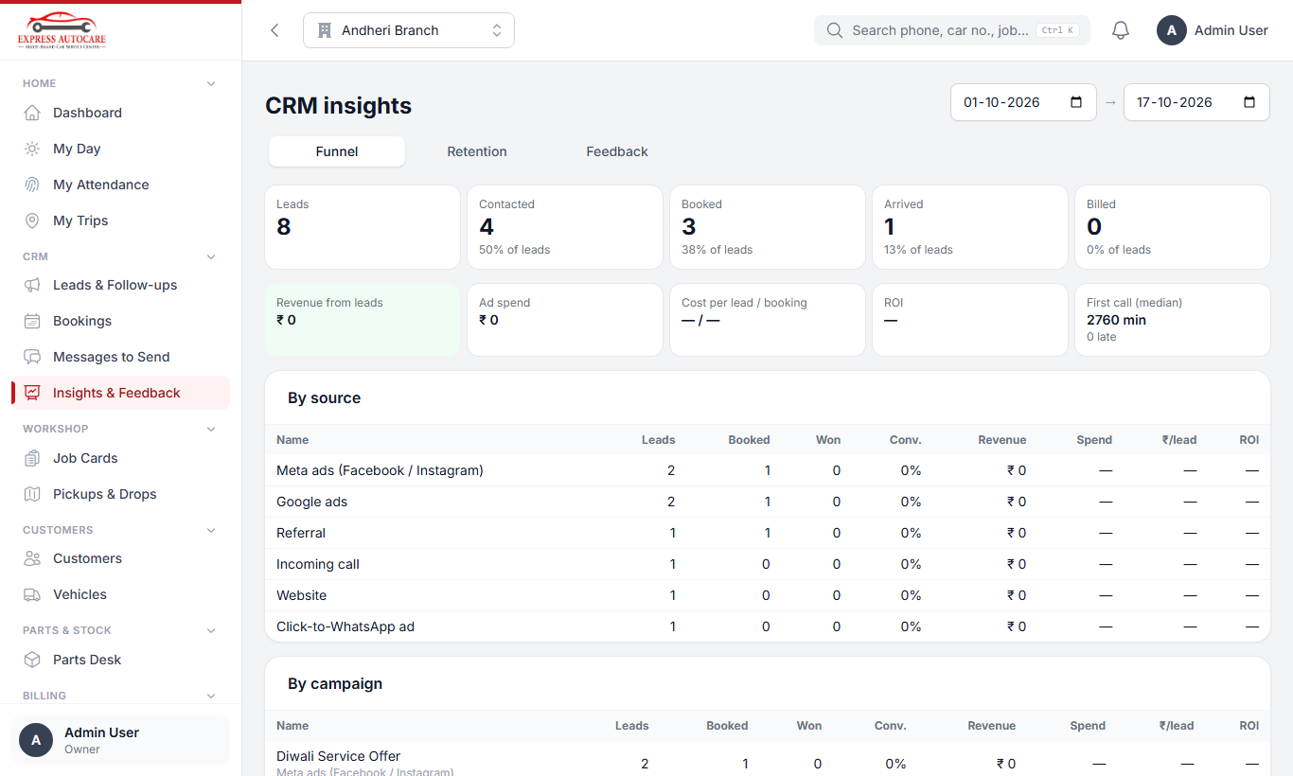
CRM insights: the funnel, by source and by campaign

6. Customers, job cards and the workshop floor

6.1 Customers and vehicles
- Open Customers › Customers and tap New (or search first: the customer may already exist).
- Type the name, mobile number and How did they find us.
- Save, then tap Add Vehicle: car number, make and model, and the car type (hatchback, sedan, SUV…). The car type decides the plan prices.
The customer page shows the visits, total spent, average rating, customer credit, people referred and one history of everything: enquiries, bookings, jobs, bills, messages and ratings. Use Book a service from here for a returning customer.
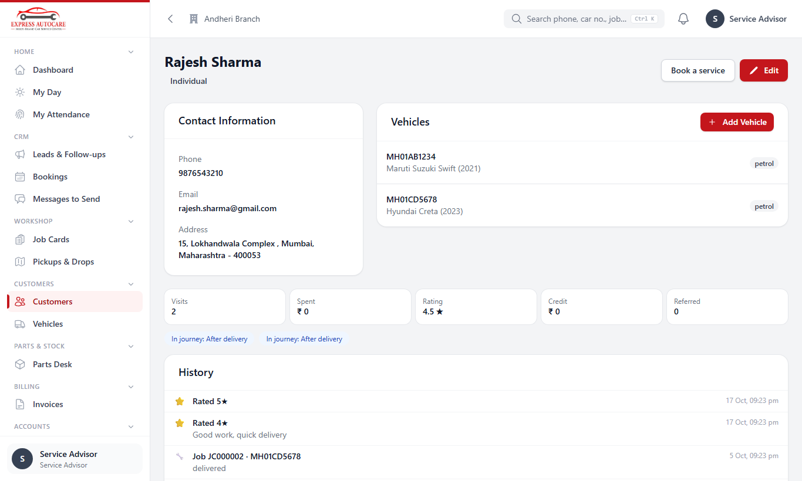
A customer page: cars, numbers and full history
Connects to CRM (leads and bookings), Job cards, Billing (customer credit).

6.2 Opening a job card
Most job cards open from a booking (Car arrived), already filled in. For a car that came without a booking:
- Open Workshop › Job Cards and tap New.
- Search and choose the Customer, then the Vehicle.
- Choose the Mode: Drive-in, Pickup & drop, or Home service.
- Choose the Service Type (a service plan, or a repair type) and the Engine Oil Type if a plan.
- Type the Odometer reading and choose the Fuel Level.
- Set the Estimated Delivery time.
- Write the Customer Complaints, one per line (you can also tap the microphone and speak). Each one appears on the technician's job sheet.
- Save. Then assign the technician(s) and the bay on the job card.
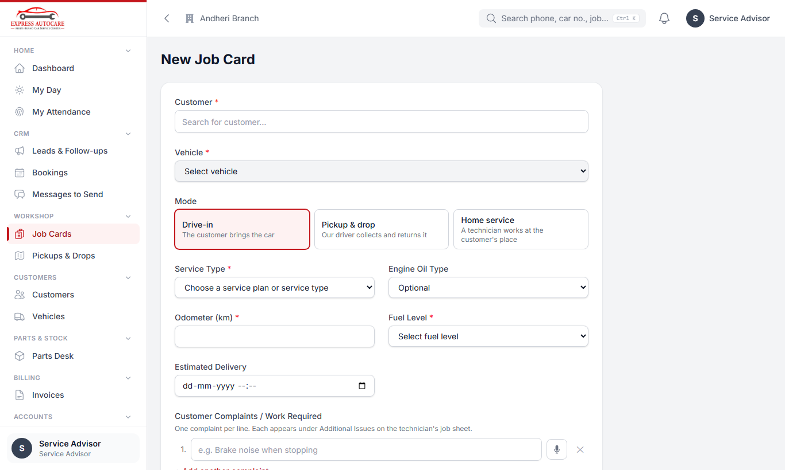
New job card
The Job Cards list shows every job with its stage. Use the filters and the search to find one.
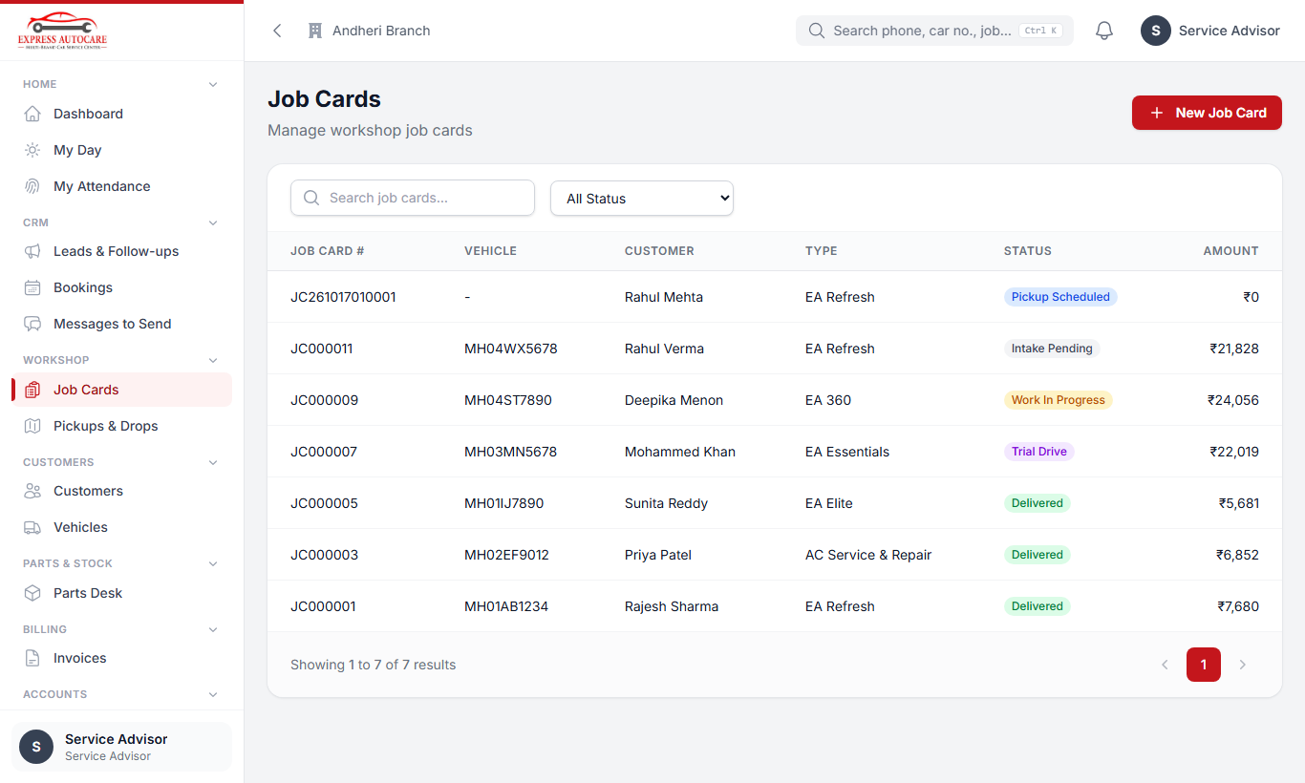
The job card list

6.3 The job moves on by itself
You never have to change a job's stage by hand. When the work of one stage is complete, the job moves to the next, and the customer gets that stage's WhatsApp message (if one is set):
Intake → Estimate & approval → Work in progress → Parts → Trial drive → Wash → Final QC → Bill → Gate pass → Delivered
The Next Step box on the job card always tells you what the job is waiting for, for example "Every technician job sheet is submitted".
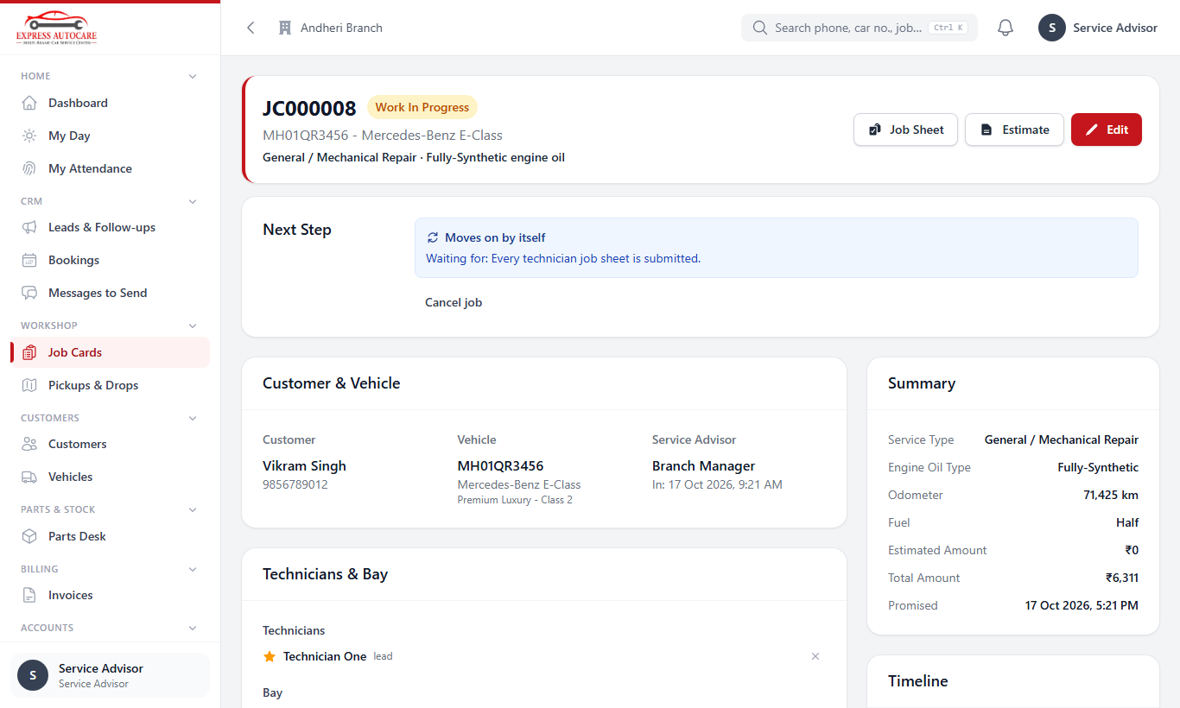
A job card: the Next Step box tells you what it is waiting for
Careful A manager can push a job on when needed (override), but always has to write a reason. The reason is kept in the job's timeline.

6.4 Intake (advisor)
- Do the trial drive with the customer and note what you found.
- Take the photos and videos of the car that the intake asks for (all sides, dashboard with odometer and fuel, damage).
- For a pickup, the driver's pickup photos are the intake.

6.5 Estimate and customer approval (advisor)
- On the job card, tap Estimate, then Prepare estimate. It starts from the plan's price list for this car.
- Add any extra work and parts (parts prices come from the parts coordinator, see chapter 8).
- Tap Send to customer. The customer gets a link on WhatsApp and approves or declines each line.
- You get an alert when they answer. Declined items are kept as "Recommended but not approved" and the customer is reminded about them later.
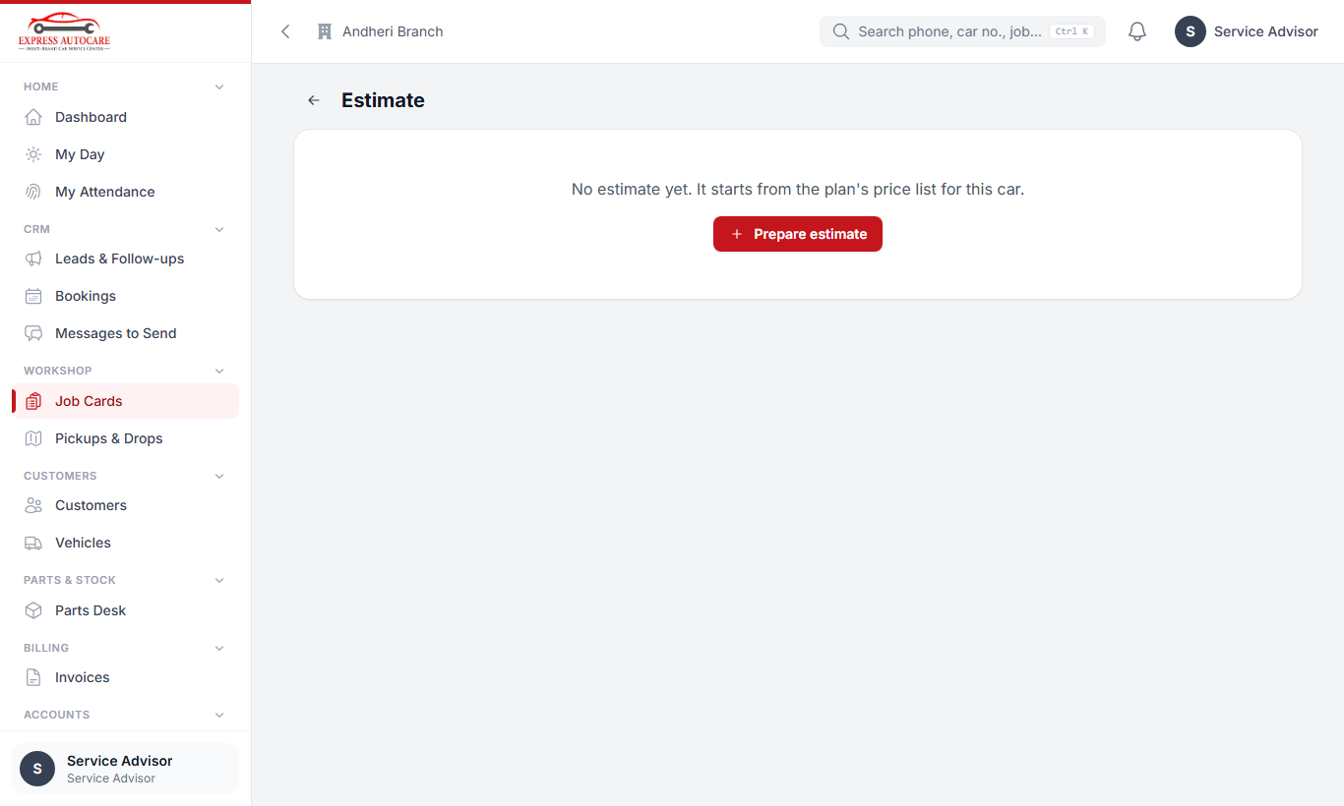
The estimate page before it is prepared

6.6 Technicians: My Jobs and the job sheet
Technicians work almost only from the phone.
- Open My Jobs. It lists the jobs assigned to you.
- Tap a job to open its job sheet: the list of activities for this plan or repair.
- For each activity, tap Done or N/A. Where it asks for a photo or video, take it in the app.
- Found another problem? Add it under Additional Issues with a photo of the faulty part, and list the parts needed.
- Tap Submit to SA for Parts so the advisor can get the price and the customer's approval.
- When the new part arrives you get an alert. Fit it, take a photo of the fitted part, and mark it Done.
- When everything is done, Submit the job sheet.
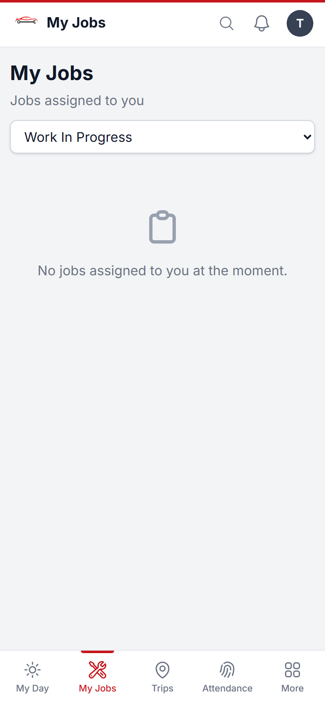  My Jobs | 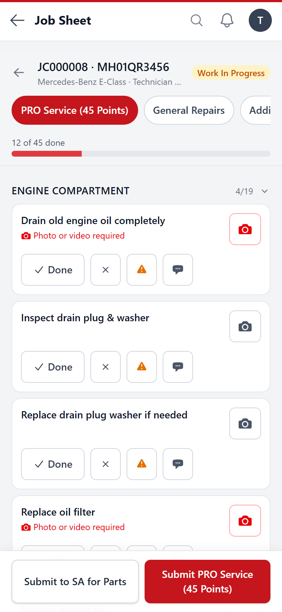  A job sheet with its activities

Tip Fit a new part only after it has arrived and been approved. If Purchases is switched on, you will also be asked to confirm the part is the right one.

6.7 Trial, wash and final QC
- Advisor: after the work, record Trial drive OK and Washing done on the job card.
- Manager: do the final QC check. The photo must be taken within 30 seconds, live, so it proves the car was checked.
- After final QC the job is ready for the bill (chapter 9).
Connects to Parts (chapter 8), Billing (the bill is made from the approved estimate), CRM (delivery wins the lead and starts the thank-you and feedback).

7. Pickup, drop and home service
When a customer chooses Pickup & drop or Home service, the job card gets one or more trips for a driver or a home-service technician.

7.1 Advisor: planning trips
- Trips are made by themselves from a pickup or home booking. You can also add one on the job card.
- Workshop › Pickups & Drops shows the day's trips by status, so you can give each one to a driver and see where every car is.
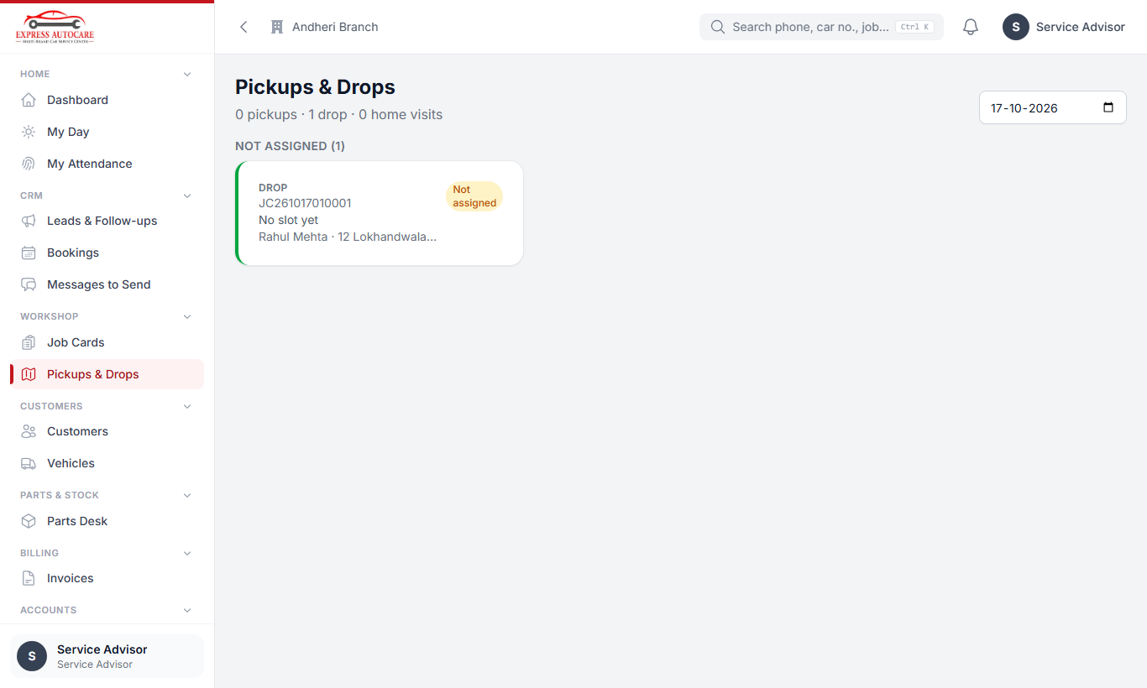
Pickups & Drops: today's trips

7.2 Driver: My Trips
- Open My Trips. It lists the pickups, drops and home visits given to you.
- Tap a trip and tap Start. Use Navigate to open the map.
- At the customer's place, tap Arrived.
- For a pickup: enter the odometer and fuel, and take the photos and videos asked for (this is the car's intake). Tap Collected.
- For a drop: the gate pass must be issued (the bill paid). Take the handover photos and tap Delivered.
- If the customer pays you, record it on the trip (it shows as money you hold until you hand it over).
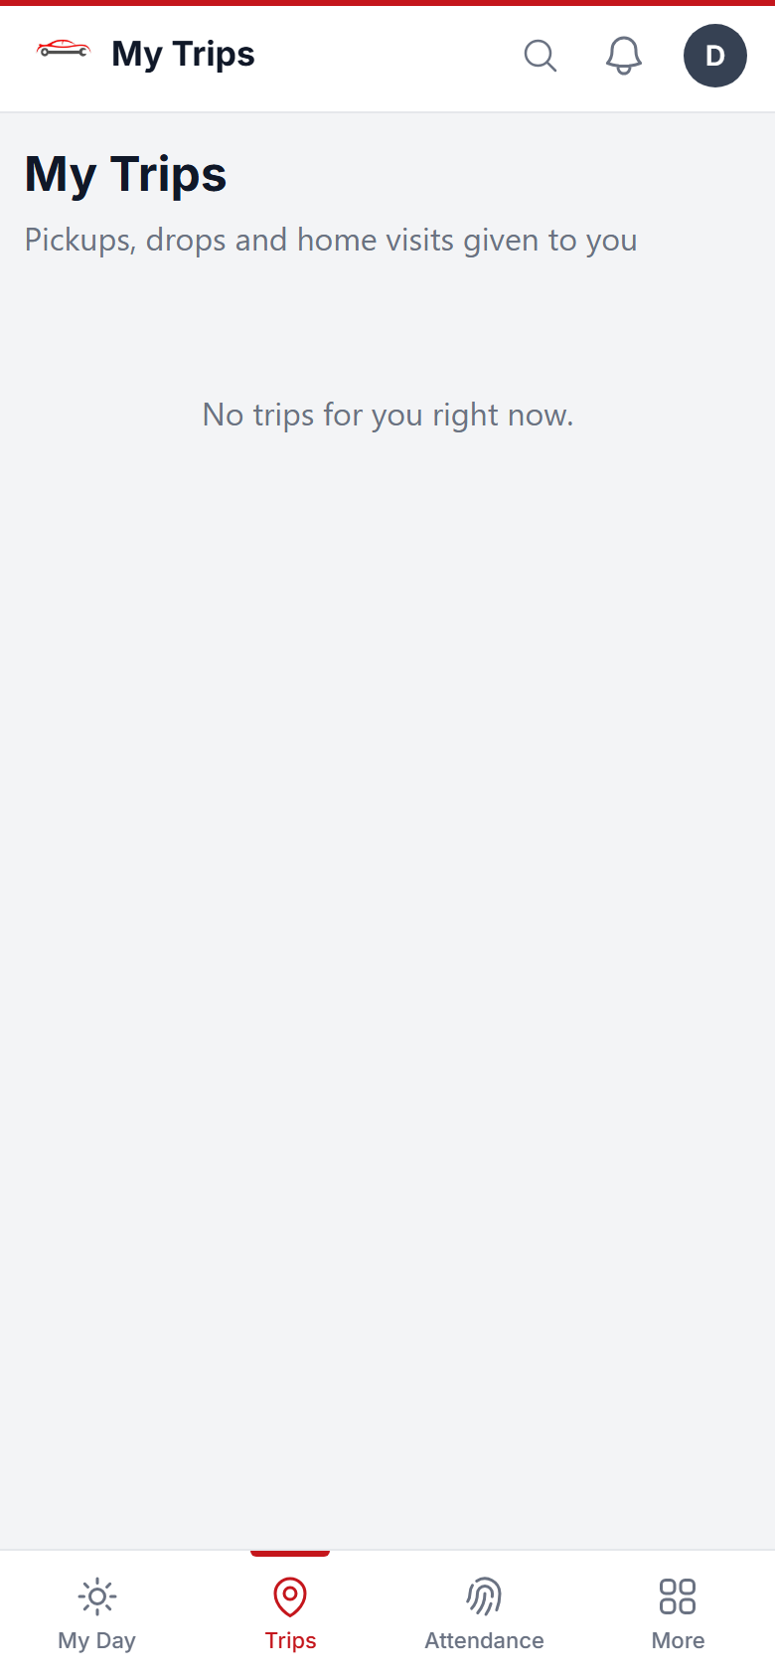
My Trips on a driver's phone

Home-service technician: the visit has its own job sheet. Work through it like any job sheet and close the visit with the photos asked for.
Connects to Job cards, Billing (pickup and home charges are added to the bill), Attendance (on a trip day you can punch from where you are).

8. Parts and purchases (parts coordinator)

8.1 The Parts Desk
Parts & Stock › Parts Desk lists the parts that advisors have asked for, job by job.
- For each part, get prices from suppliers and enter the best one (the selling price is worked out with the margin set by the owner).
- The advisor adds it to the estimate and the customer approves it.
- Order the approved parts from the supplier.
- When the parts arrive, mark them Received (or receive them on a GRN, below). The technician and advisor get an alert.
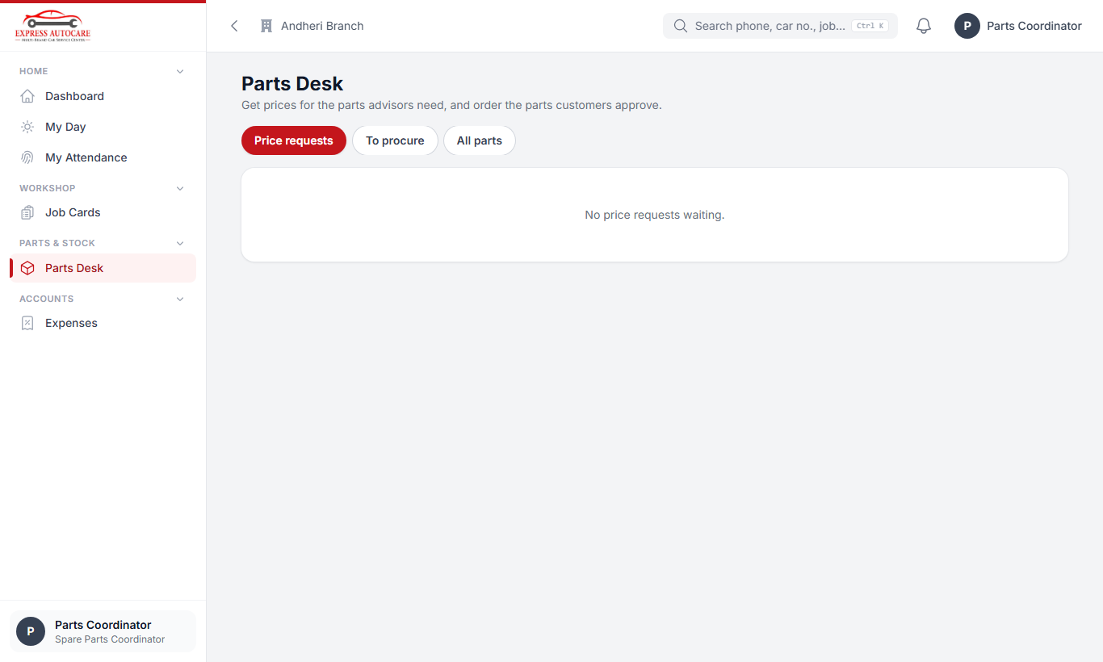
The Parts Desk

8.2 When Purchases & Stock is switched on
- GRN for every supplier bill: photo of each part, whether it is a GST bill, and whether it is on credit or paid.
- The technician confirms right part / wrong part before fitting.
- Stock for engine oil and consumables; plan kits are issued to jobs.
- Suppliers shows how much we owe each supplier and records payments to them.
- The bill for a job waits until all its parts are received on a GRN.
Connects to Job cards, Billing, Accounts (purchases and supplier dues are posted by themselves).

9. Billing, payments and delivery
Billing is done on the job card, in the Billing & Delivery part. The Billing menu has the lists of all invoices and payments and the billing reports.

9.1 Taking a payment (advance or final)
- Open the job card and go to Billing & Delivery.
- Tap Record payment.
- Enter the amount and choose how it was paid: cash, UPI, card, bank… One payment can be split (for example part cash, part UPI).
- If the customer paid an employee's own UPI or gave them cash, choose Collected by staff and the employee. The money shows against that employee until they hand it over.
- Save. A receipt is made.
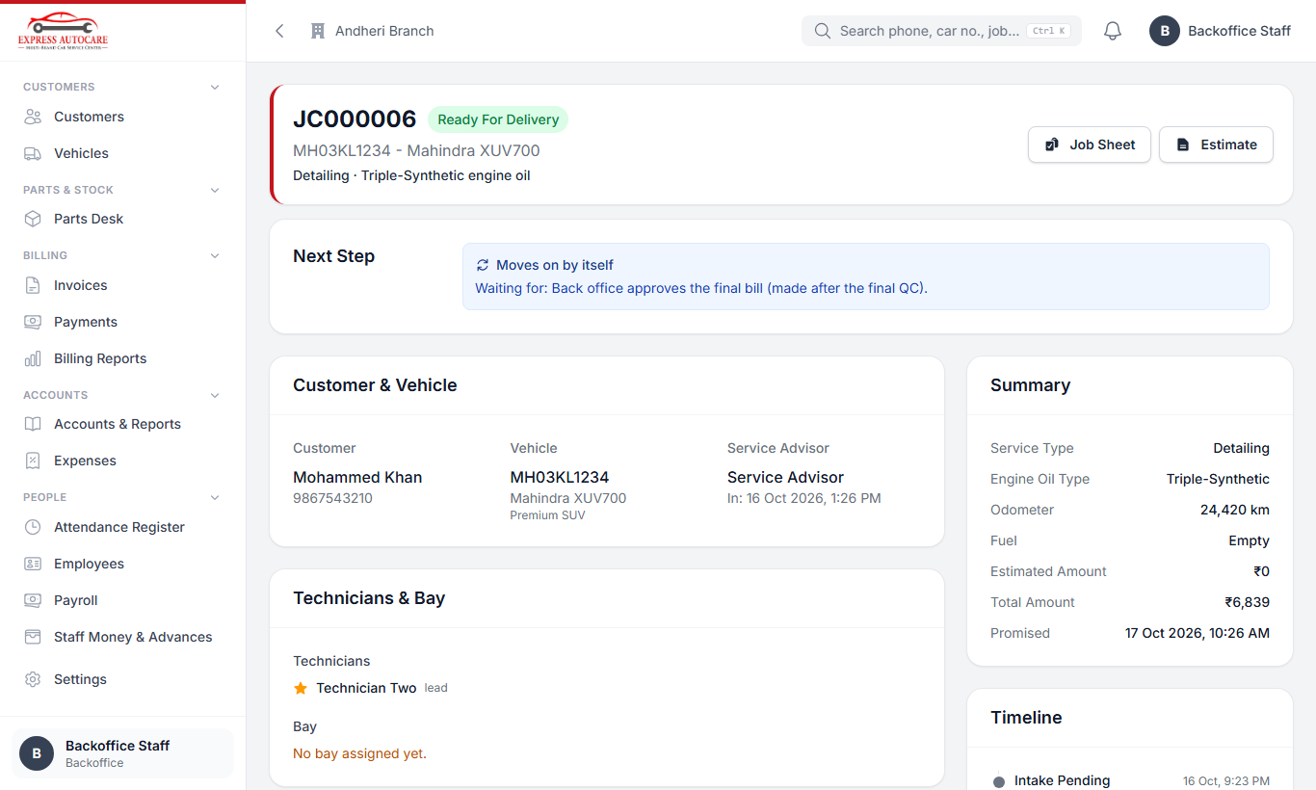
Billing & Delivery on a job card that is ready

9.2 From bill to delivery
- After final QC, tap Make bill. A proforma is made from the approved estimate (plan lines, extra work, parts, pickup charges).
- Check the lines, then tap Approve. The customer can be sent the bill to pay the balance.
- When it is paid, Convert to tax invoice (or close a paid proforma if no GST invoice is needed).
- Once the bill is paid in full, the gate pass is issued by itself.
- Tap Vehicle out when the customer takes the car. The job is delivered.
Careful A gate pass before full payment needs the owner or manager, with a reason.

9.3 Paid too much? Refunds and customer credit
If the customer paid more than the bill, choose either Refund (give the money back) or Keep as customer credit. The credit can be used on a later job and shows on the customer page.

9.4 Payments list
Billing › Payments lists every payment received, with filters by date and method. Billing Reports gives daily collection and billing totals.
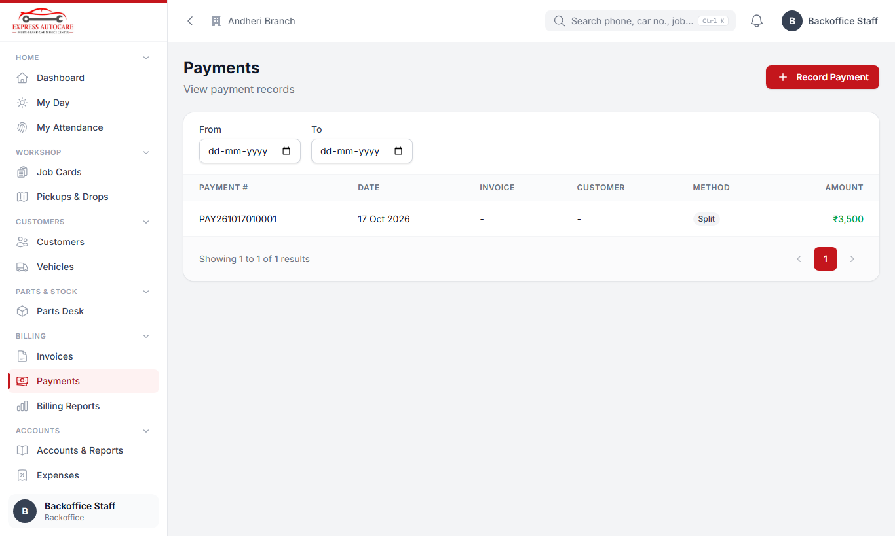
All payments received
Connects to Accounts (every bill and payment is posted by itself), CRM (the bill amount is credited to the lead), Payroll (money held by staff).

10. Accounts (back office, owner)
The accounts are kept by double entry, but you do not need to know accounting. Bills, payments, refunds, GRNs, supplier payments and payroll are posted to the books by themselves. You only enter what the system cannot know: expenses and a few transfers.

10.1 Recording an expense
- Open Accounts › Expenses and tap Add expense.
- Choose the date and what it was for (rent, electricity, fuel, tea, porter…).
- Type who it was paid to and the amount.
- Choose where the money came from: cash, bank, a supplier on credit, or customer money held by an employee.
- If it is a GST bill, tick it and choose the GST rate, and type the bill number.
- Take a photo of the bill and save.
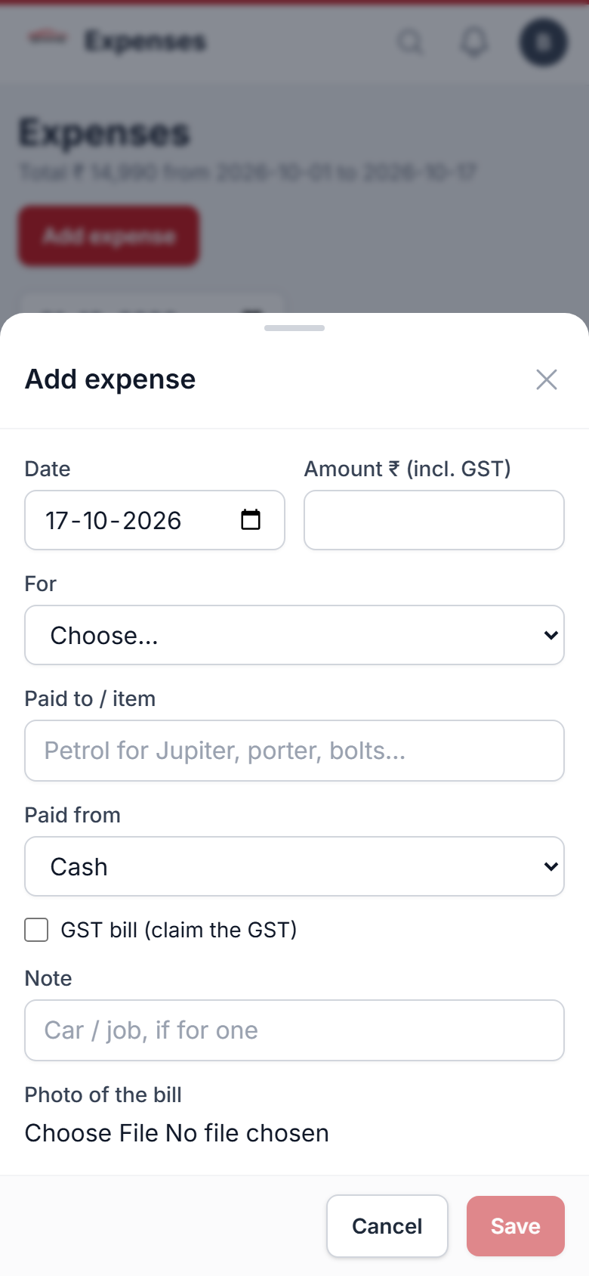
Adding an expense on the phone

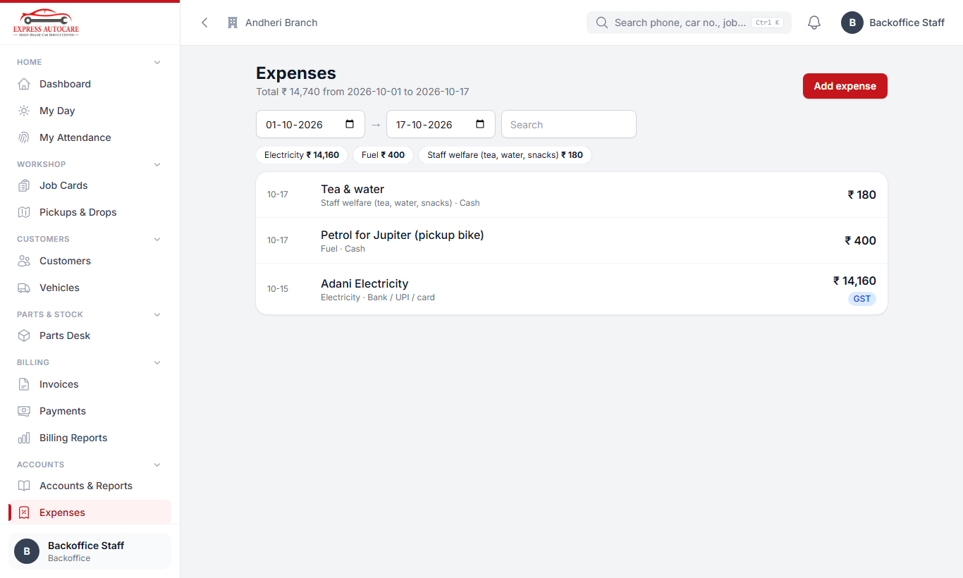
The expenses list

10.2 Other entries
- Cash ↔ bank: when cash is deposited in the bank, or cash is withdrawn.
- Journal voucher: for anything else (your CA can guide you).
- Opening balances: entered once, when you start using the system.

10.3 Reports
Accounts › Accounts & Reports has these tabs:
Report | What it tells you
Profit & loss | Income, expenses and profit for any period, by branch.
Balance sheet | What the business owns and owes on a date.
Cash & bank book | Every rupee in and out of cash and each bank account.
Who owes | Money customers owe us, money we owe suppliers, money with staff.
GST | Output GST on sales and input GST on purchases and expenses: the summary for your CA.
Day book, Ledgers, Trial balance | Detailed entries for checking.

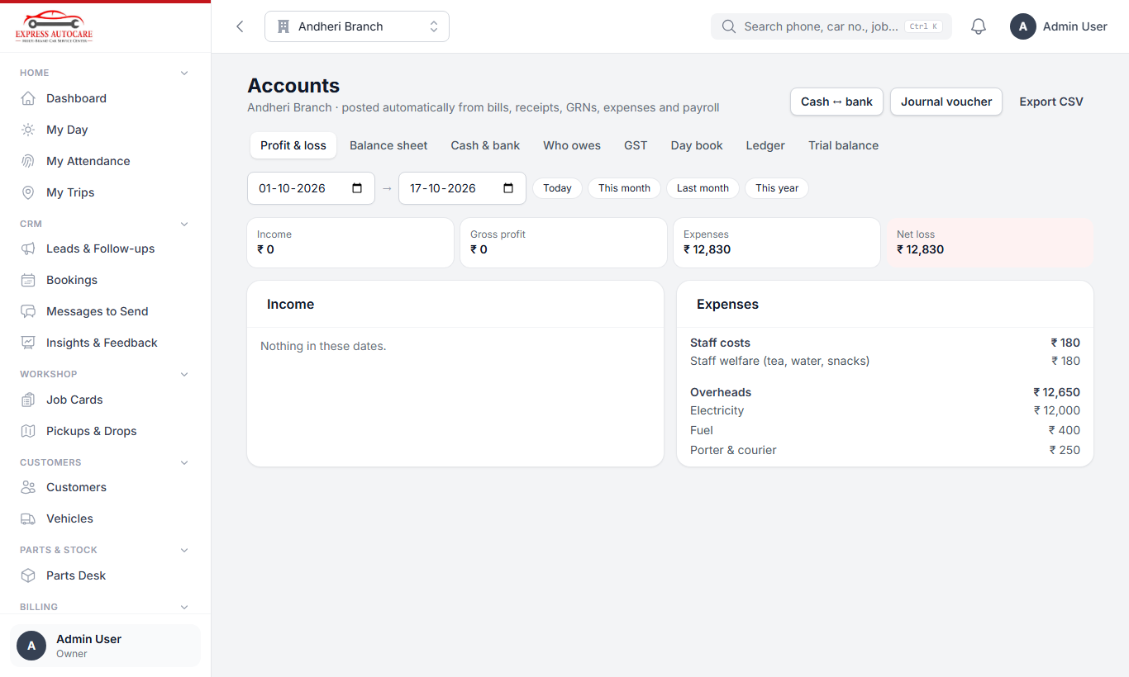
Profit & loss
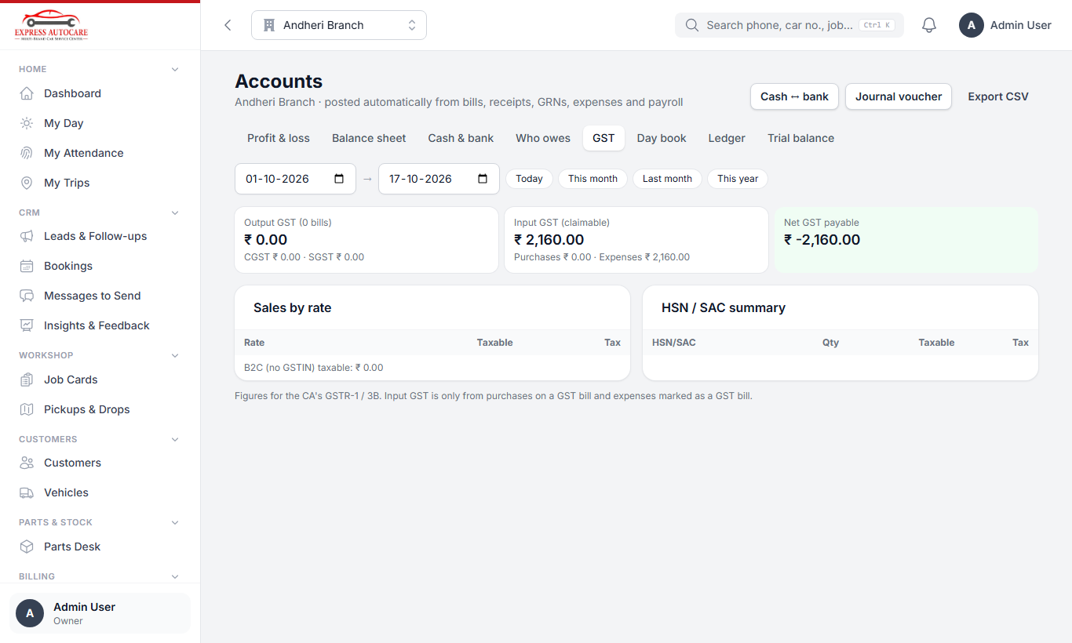
The GST summary
Tip Every report has Export CSV to open it in Excel or send it to the CA.
The owner can lock a finished month in Settings › Chart of Accounts, so nothing in it can be changed later.
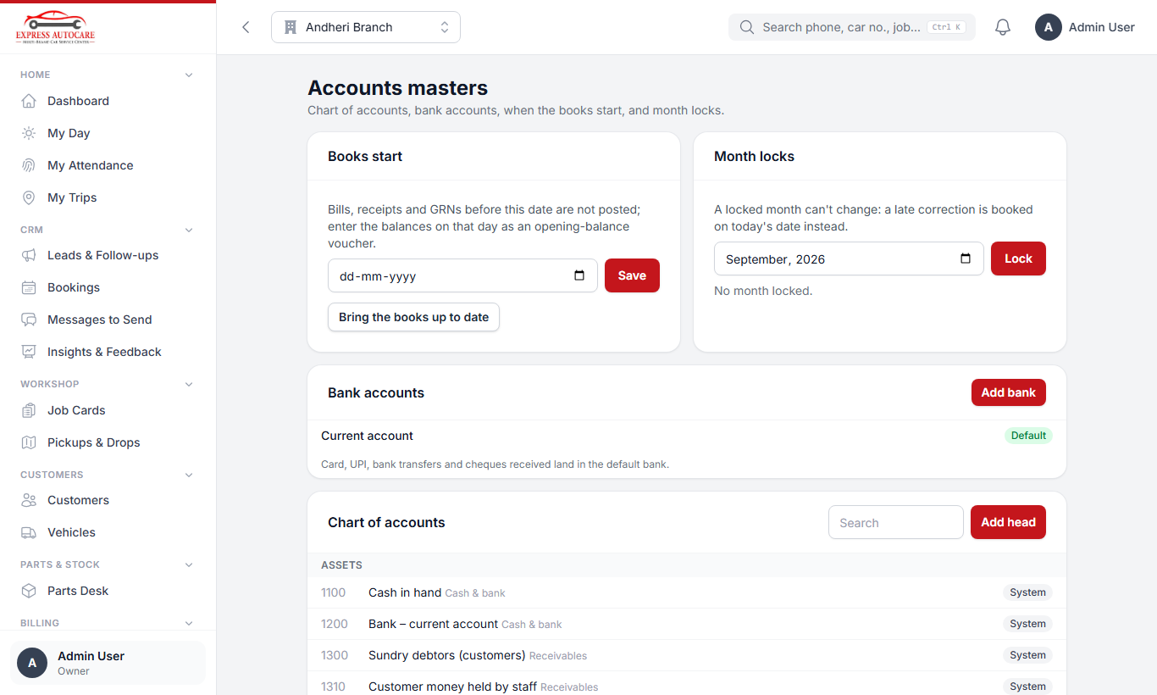
Settings › Chart of Accounts
Connects to Billing, Parts and purchases, Payroll, CRM (referral rewards).

11. People: attendance register, leave, employees and payroll
This chapter is for managers, the back office and the owner.

11.1 Attendance register
People › Attendance Register shows everyone's day with their selfies, in and out times and late minutes. The month grid shows the whole team at once.
- Tap a person to see their selfies and punch details.
- Add a missed punch (forgot, phone dead) or remove a wrong one: always with a reason.
- At night, the system closes the day by itself: people who did not punch out are flagged for you to correct.
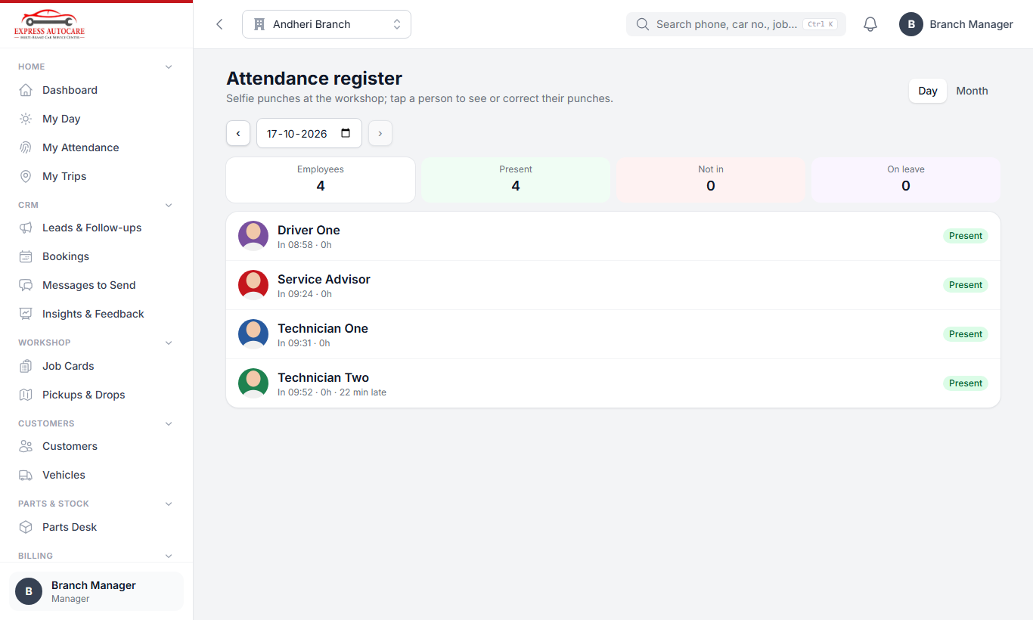
The attendance register with selfies

11.2 Leave requests
People › Leave Requests lists the requests waiting for you. Tap Approve or Reject (add a note if you reject). The employee gets an alert.
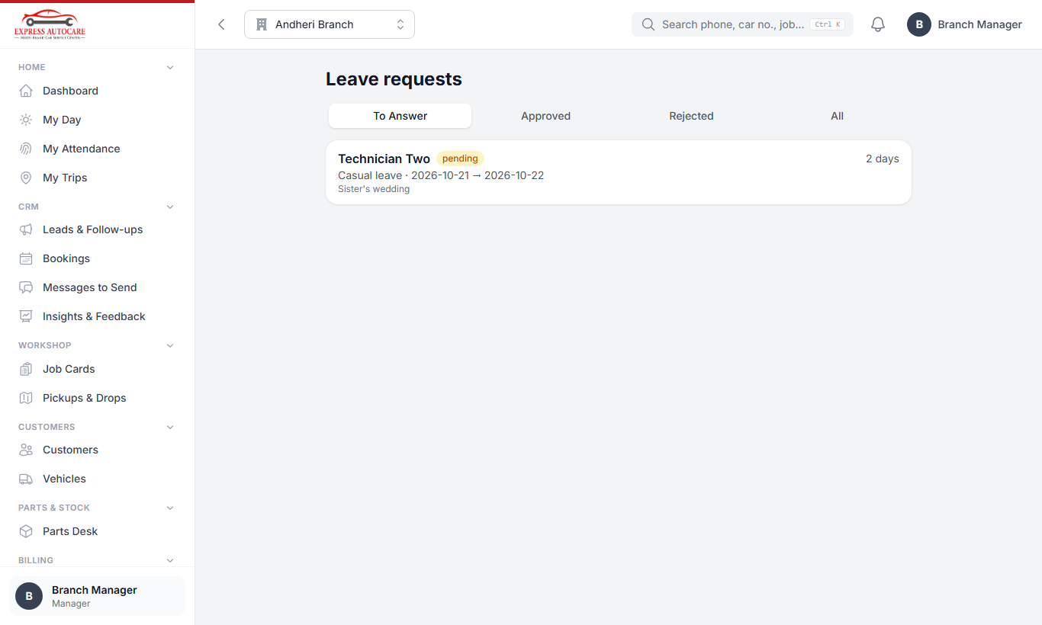
Leave requests waiting for approval

11.3 Employees
People › Employees has one record per employee: designation, branch, shift, weekly off, joining date, and their app login. Only people who prepare payroll can see and change pay details: monthly salary, overtime rate, off-day pay, PT / PF / ESI and bank account.
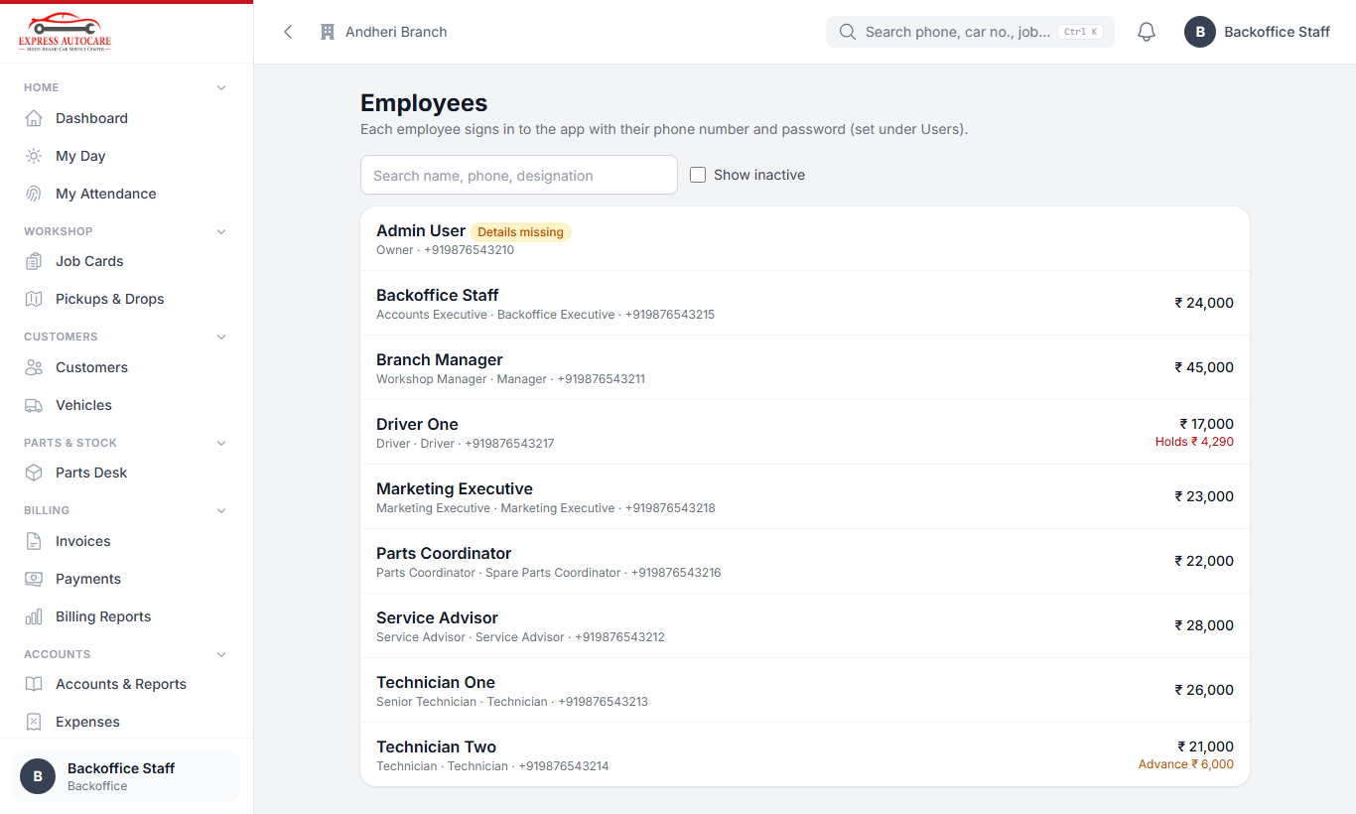
The employee list

11.4 Running the monthly payroll
- After the month ends, open People › Payroll and tap Work out a month. Choose the month.
- The system makes a payslip for every employee from attendance, leave, overtime, off-day work, incentives, advances to recover, staff-held money and deductions.
- Open each employee to check the lines. To correct a line, change it and write the reason.
- Add any bonus, incentive, deduction or penalty under Manual lines. Automatic incentives come from the incentive rules (Settings).
- If attendance was corrected after you worked out the month, tap Recalculate.
- The owner finalises the payroll. After that, payslips appear for the employees.
- When salaries are paid, tap Mark paid. The salary cost and payments go into the accounts by themselves.
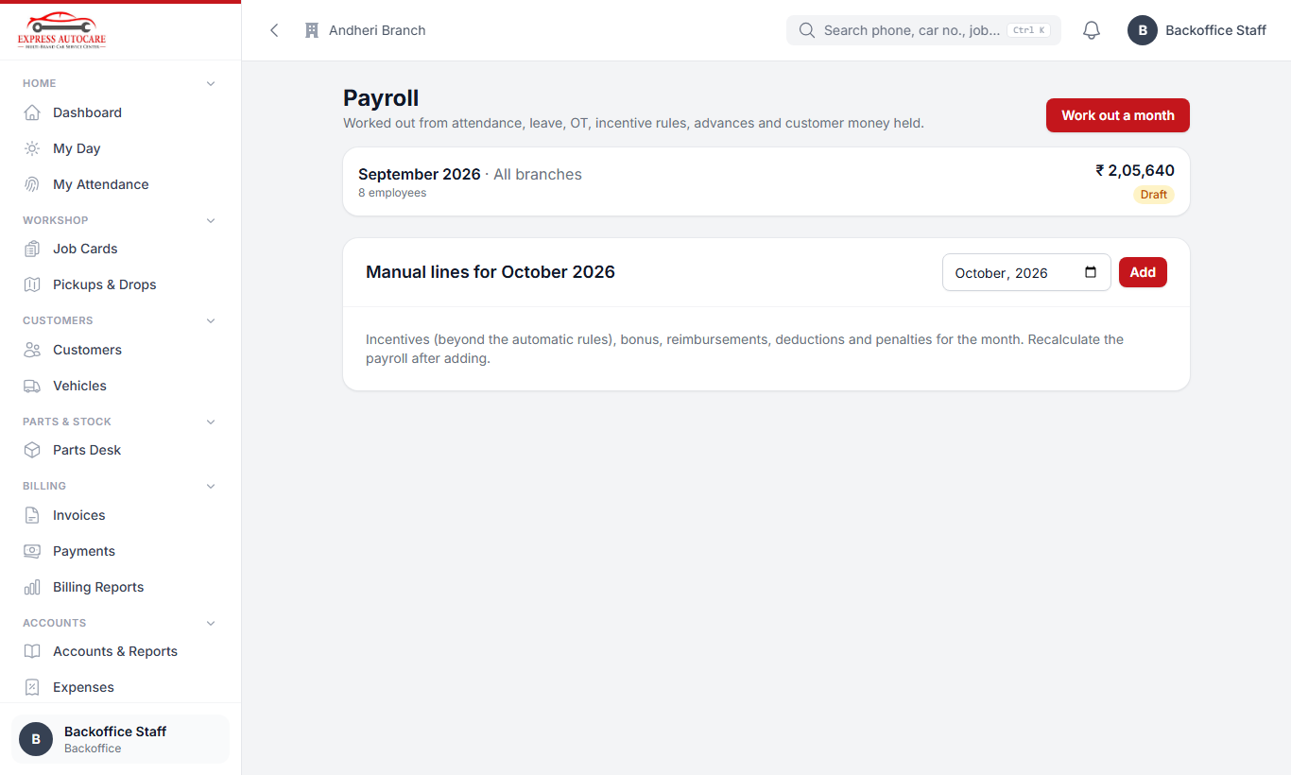
Payroll: one run per month
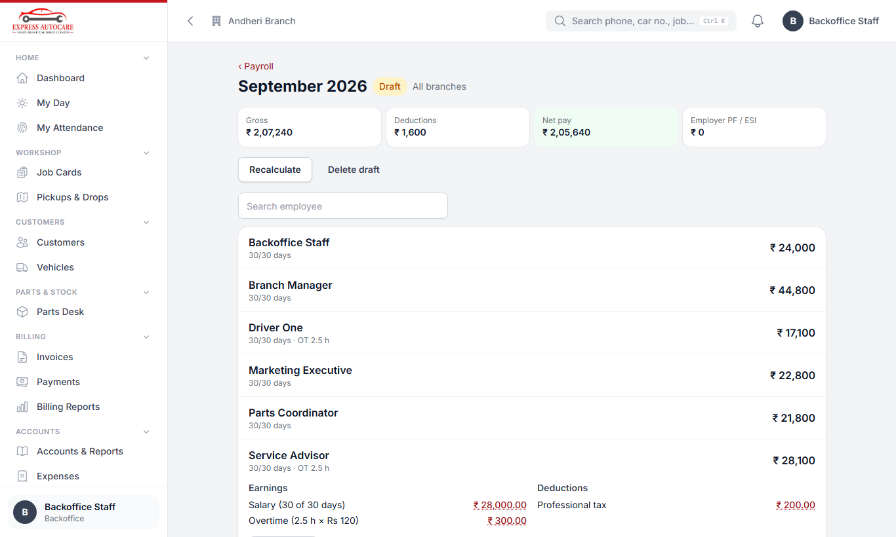
A draft month: totals, and one employee's earnings and deductions

11.5 Staff money and advances
People › Staff Money & Advances:
- Give an advance: amount, date, how it was paid, and how much to recover each month. It is cut from the salary automatically.
- Customer money held by staff: see who is holding how much. When an employee hands it over, record it here.
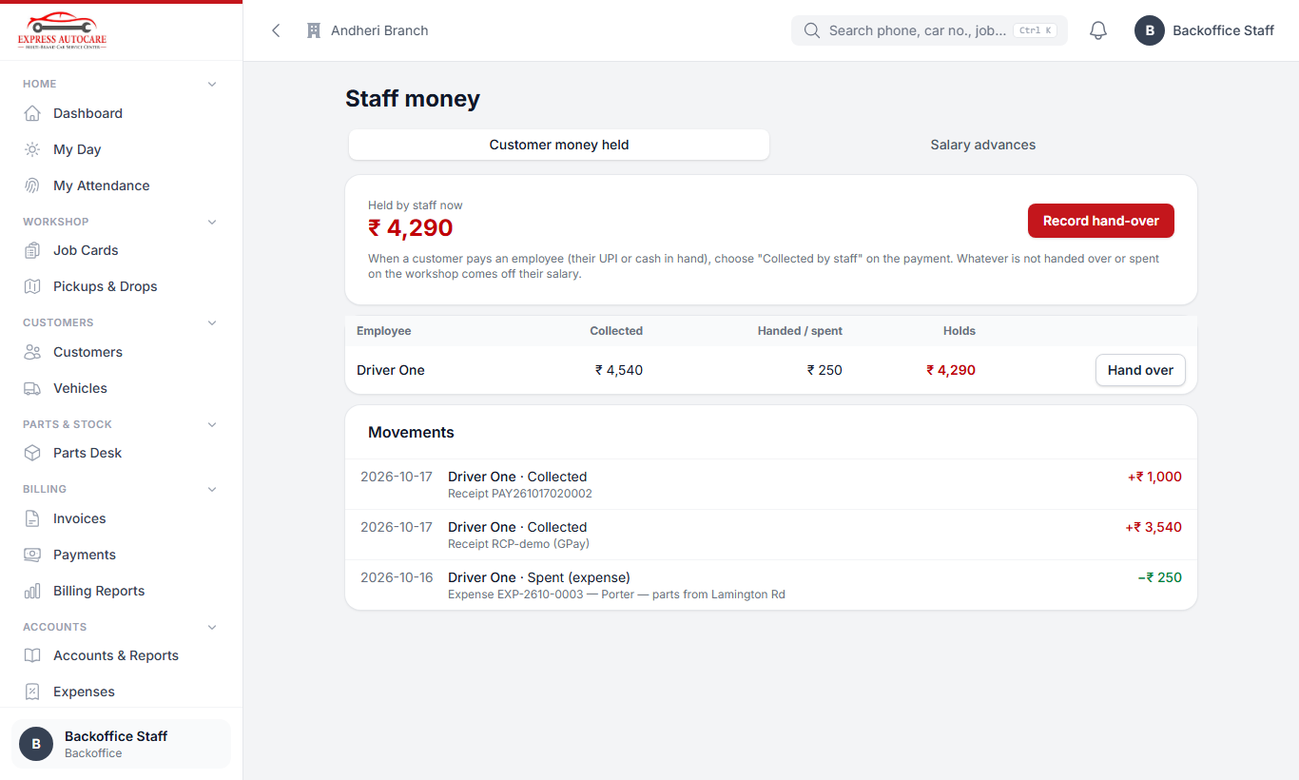
Staff money and advances
Connects to Attendance, Billing (staff-held money), CRM (incentives for converted leads), Accounts (salary cost and payments).

12. Settings (owner, managers)
All the masters (the lists and rules the system uses) are on one page: Settings. They are grouped by module, and there is a Find a setting box at the top. Every page has a Save bar at the bottom: nothing changes until you save.
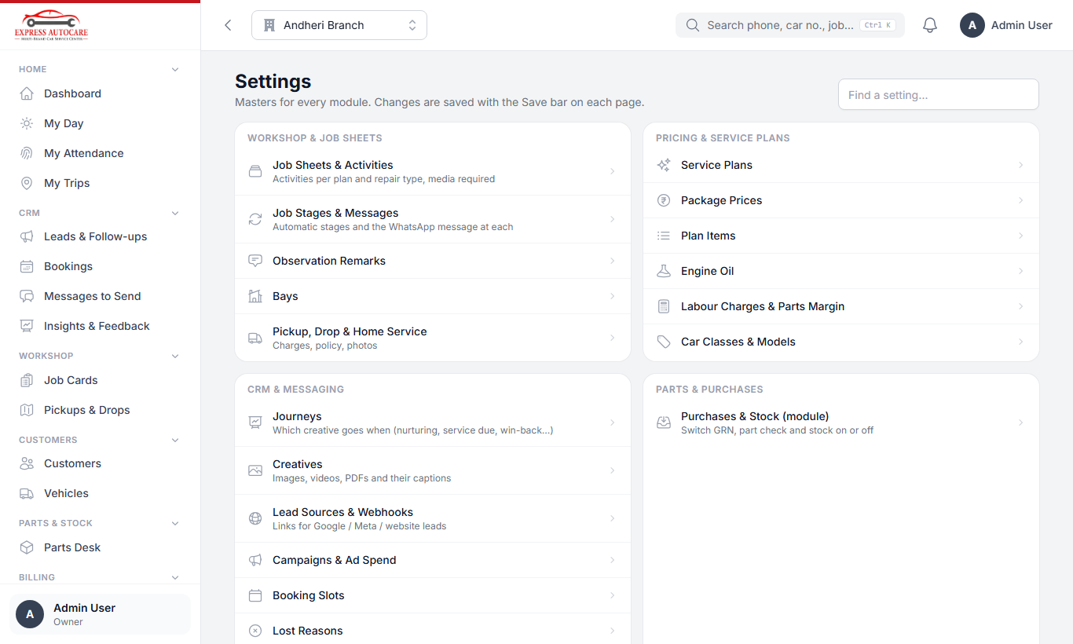
The Settings page: every master in one place
Group | What you set there
Workshop & job sheets | Job sheet activities per plan and repair type (and which photos / videos are required), job stages and their WhatsApp messages, observation remarks, bays, pickup / drop / home-service charges.
Pricing & service plans | Service plans, package prices per car type and oil, plan items, engine oils, labour charges and parts margin, car classes and models.
CRM & messaging | Journeys (which creative goes when), creatives, lead sources and webhook links, campaigns and ad spend, booking slots, lost reasons, CRM rules (call within N minutes, quiet hours, referral reward).
Parts & purchases | Switch Purchases & Stock on or off, suppliers.
HR & payroll | Pay and overtime rules, shifts, holidays, leave types, incentive rules, PT / PF / ESI.
Accounts | Chart of accounts, bank accounts, month lock.
Company & access | Users, branches (including the workshop location for attendance), roles and what each role may do, modules.

12.1 Journeys and creatives (automatic messages)
A creative is one message: a picture, video or PDF with its caption, or just text. In the caption you can use words that are filled in for each person: :name, :car, :plan, :price, :book_link, :offer and others.
A journey is a timetable of creatives. For example, "New lead not booked": day 0 plan details, day 2 reminder with the offer, day 7 a creative, then every 10 days up to day 60, then monthly. Each step can also be a task (for example "call them") instead of a message. A journey stops by itself when the person books, asks to stop, or is closed as lost.
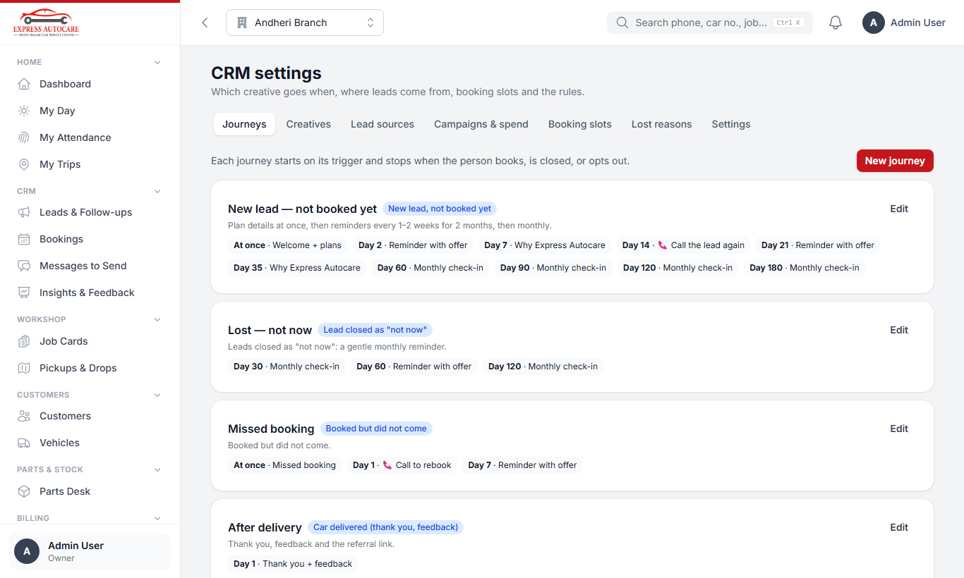
Journeys: which creative goes when

12.2 Lead sources and webhooks
Each source (Meta, Google, website…) has its own secret webhook link. Paste that link into Google Ads lead forms, or into Pabbly / Zapier / Make for Meta lead ads, and leads arrive in the CRM by themselves. Use Test to check it works.
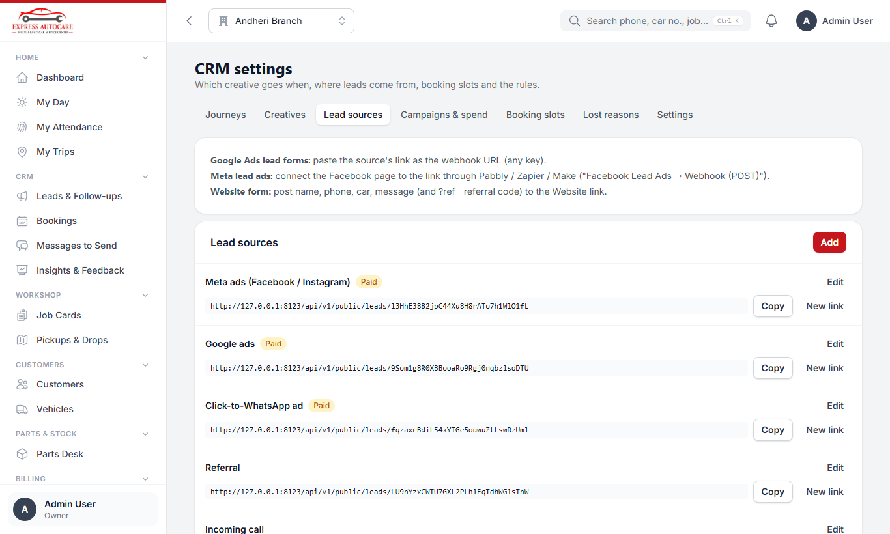
Lead sources with their webhook links

12.3 Workshop location for attendance
- Open Settings › Branches and edit the branch.
- Under Attendance — workshop location, stand inside the workshop and tap Use my current location (or paste a Google Maps link).
- Set the Punch radius in metres (for example 150) and the Weekly off day.
- Tap Check on map to make sure the pin is right, then save.
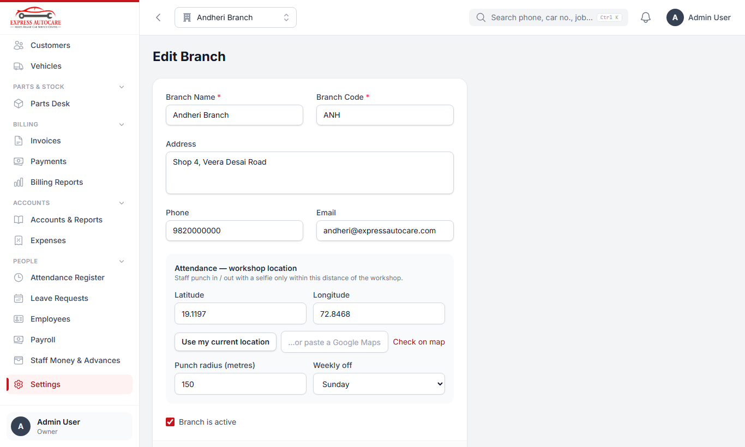
Setting the workshop location and punch radius

12.4 Switching modules on or off (owner)
In Settings › Modules the owner can switch Purchases & stock, Accounts, CRM & leads and Attendance & payroll on or off. When a module is off, its menus disappear and its automatic work stops; the rest of the system keeps working. Nothing is deleted. After switching Accounts back on, tap Bring the books up to date so the bills and payments made meanwhile are posted.
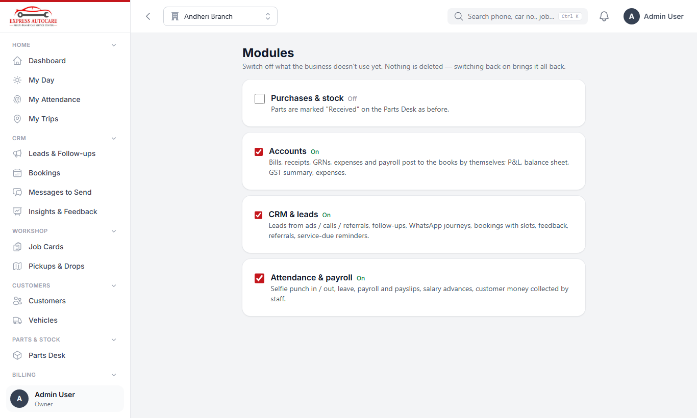
Settings › Modules
The HR & payroll masters (shifts, holidays, pay rules) are under Settings › HR & Payroll:
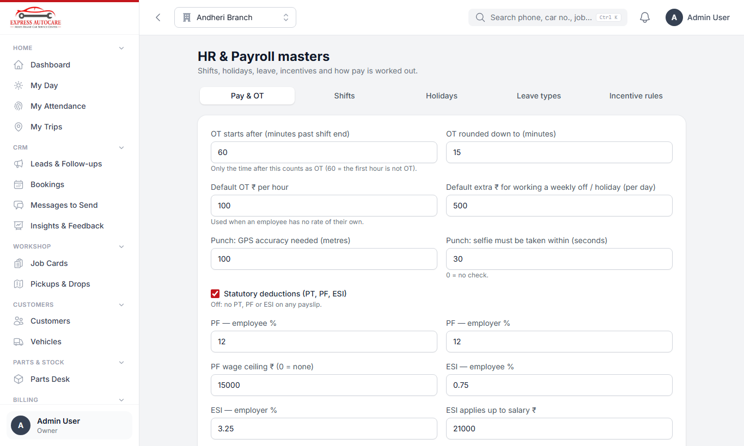
HR & payroll settings

13. How it all connects: one car's journey
This is how one customer moves through the whole system, and who does what at each step.
Step | What happens | Who | Module
1 | An ad, a call or a referral brings a lead. It is given to an executive. | System / marketing | CRM
2 | The executive calls, sends prices and follows up. Automatic messages keep in touch. | Marketing | CRM
3 | The customer books a slot (or books from the link). | Marketing / customer | CRM
4 | The car arrives (or the driver picks it up). The job card opens already filled in. | Advisor / driver | Bookings, Workshop
5 | Intake photos and trial drive. Estimate sent; the customer approves on WhatsApp. | Advisor | Workshop
6 | Technicians work through the job sheet; parts are priced, ordered and received. | Technician, parts coordinator | Workshop, Parts
7 | Trial drive, wash and final QC. | Advisor, manager | Workshop
8 | Bill made and approved; payments taken (maybe by staff); tax invoice. | Back office / advisor | Billing
9 | Paid in full → gate pass → Vehicle out (or drop by the driver). | Advisor / driver | Billing, Trips
10 | The sale, GST, payments and parts cost are posted to the accounts. | System | Accounts
11 | The lead is won with the bill amount; thank-you, rating and referral link go out. | System | CRM
12 | Before the next service is due, reminders start again from step 2. | System | CRM
13 | At month end, attendance, overtime and incentives (including converted leads) go into payroll. | Back office, owner | People

14. Daily checklists
A short list for each role. Print the one for your role and keep it near you.
Role | Every day
Everyone | Punch in with a selfie when you arrive · check My Day and the bell · punch out when you leave.
Marketing executive | Call every new lead within 15 minutes · work through Follow-ups due · log every call · send everything in Messages to send · confirm online bookings.
Service advisor | Check today's Bookings · mark cars arrived · intake photos · send estimates · forward parts to the parts desk · trial drive and wash · deliver ready cars · send pending messages.
Technician | Open My Jobs · complete each activity with its photos · report additional issues with photos · fit parts only after they arrive · submit the job sheet.
Driver | Open My Trips · start, arrive, photos, collected / delivered · hand over any customer money at the counter.
Parts coordinator | Open the Parts Desk · price new requests · order approved parts · mark parts received (or GRN).
Back office | Make and approve bills · record payments · convert to tax invoices · record expenses · collect money held by staff.
Manager | Approve leave · correct attendance · final QC · check overdue follow-ups and unhappy feedback · watch jobs that are late.
Owner | Dashboard: jobs in progress, daily collection, billing, outstanding · CRM insights weekly · finalise payroll monthly · lock finished months.

15. Common questions

I cannot see a menu that a colleague has.
Menus depend on your role. If you need it for your work, ask the owner or manager to change your role in Settings › Users. A module may also be switched off.

The punch button says I am too far from the workshop.
Turn on Location, go inside the workshop and wait a few seconds for the GPS to settle, then try again. If it still fails, ask your manager to add the punch.

I punched in but forgot to punch out.
Tell your manager. They will add the punch-out time with a reason in the Attendance Register.

WhatsApp does not open when I tap Send on WhatsApp.
On a phone, WhatsApp must be installed. On a computer, sign in to WhatsApp Web first in the same browser.

The customer says the link has expired.
Send a new one: on the lead, use Send prices or Book again; for an estimate, send it again from the job card.

The same customer came in again as a new lead.
The system joins it to the open lead by itself. If the old lead was closed, the new lead is linked to the existing customer so you can see their history.

The job card does not move to the next stage.
Read the Next Step box on the job card. It says exactly what it is waiting for (for example a job sheet not yet submitted, or parts not yet received).

I cannot make the bill.
Final QC must be done first. If Purchases is on, every part must be received on a GRN.

The gate pass was not issued.
The bill is not fully paid. Take the balance, or ask the owner / manager for a gate pass with a reason.

My salary shows days without pay.
Check your attendance month for red (absent) days and your leave balance. If a punch is missing, ask your manager to correct it before the owner finalises the payroll.

Note Need more help? Speak to your branch manager. For changes to plans, prices, messages or rules, ask the owner: they are all in Settings.

