**ATTENDANCE SYSTEM USING DEEP**

**LEARNING FACE IDENTIFICATION ALGORITHMS**

## **A PROJECT REPORT**

***Submitted by***

**JOEL REGO - 20171CSE0271**

**MEDHA M H - 20171CSE0387**

**AKSHAY KRISHNA - 20171CSE0036**

**MAHESHA R - 20171CSE0359**

### *Under the guidance of*

### **PROF. RAVINDRANATH**

***in partial fulfillment for the award of the degree***

***of***

**BACHELOR OF TECHNOLOGY**

**IN**

**COMPUTER SCIENCE AND ENGINEERING**

**At**



**Department of Computer Science and Engineering**

**School of Engineering**

**PRESIDENCY UNIVERSITY**

**BANGALORE**

**JANUARY 2020**

**DEPARTMENT OF COMPUTER SCIENCE AND ENGINEERING**

**SCHOOL OF ENGINEERING**

**PRESIDENCY UNIVERSITY**

**CERTIFICATE**

This is to certified that the Project report **“Attendance System using Deep Learning Face Identification Algorithms”** being submitted by **Joel Rego (20171CSE0271), Medha M H (20171CSE0387), Akshay Krishna (20171CSE0036), Mahesha R (20171CSE0359),** in partial fulfillment of requirement for the award of degree of **Bachelor of Technology** in **Computer Science and Engineering** is a bonafide work carried out under my supervision.

|  |  |
| --- | --- |
| **Dr. Mohan K G**  HOD  Department of CSE  Presidency University | **Mr. Ravindranath**  Guide  Professor  Department of CSE |

**DEPARTMENT OF COMPUTER SCIENCE AND ENGINEERING**

**SCHOOL OF ENGINEERING**

**PRESIDENCY UNIVERSITY**

**DECLARATION**

I hereby declare that the work, which is being presented in the project report entitled **“Attendance System using Deep Learning Face Identification Algorithms”** in partial fulfillment for the award of Degree of **Bachelor of Technology** in **Computer Science and Engineering**, is a record of our own investigations carried under the guidance of **Mr. Ravindranath, Assistant Professor, Department of Computer Science and Engineering, School of Engineering, Presidency University, Bangalore.**

We have not submitted the matter presented in this report anywhere for the award of any other Degree.

|  |  |
| --- | --- |
|  | **Joel Rego (20171CSE0271)**  **Medha M H (20171CSE0387)**  **Akshay Krishna (20171CSE0036)**  **Mahesha R (20171CSE0359)** |

**TABLE OF CONTENTS**

|  |  |  |
| --- | --- | --- |
| **CHAPTER NO.** | **TITLE** | **PAGE NO.** |
|  | **ABSTRACT ACKNOWLEDGMENT** | **ii**  **iii** |
| **1.** | **INTRODUCTION** |  |
|  | 1.1 WHAT IS DEEP LEARNING | 1 |
|  | 1.2 EXAMPLES OF DEEP LEARNING | 2 |
|  | 1.3 HOW DEEP LEARNING WORKS | 5 |
|  | 1.2.2.1 General | 8 |
|  | 1.2.2.2. . . . . . . . | 10 |
|  | 1.2.2 | 12 |
|  | 1.3 . . .. . . . . . .. . . . . . . | 13 |
|  | 1.4 . . . . . . . . . . . . . . . . | 15 |
| **2.** | **LITERATURE REVIEW** | **16** |
|  | 2.1 GENERAL | 17 |
|  | 2.2 . . . . .. | 19 |
|  | 2.2. | 20 |

**List of Tables**

|  |  |  |  |
| --- | --- | --- | --- |
| **Sl. No.** | **Table Name** | **Table Caption** | **Page No.** |
| 1 | Table 1.1 | Software modules versus Reusable components | 5 |

**List of Figures**

|  |  |  |  |
| --- | --- | --- | --- |
| **Sl. No.** | **Figure Name** | **Caption** | **Page No.** |
| 1 | Figure 1.1 | Software modules versus Reusable components | 5 |

**ABSTRACT**

Face detection, feature extraction and face recognition are three of the most crucial steps in a multi-stage process of face recognition using deep learning algorithms. This process could be a computationally expensive. Most applications of face recognition, such as a student and/or employee attendance system that is traditionally done using pen and paper, use Convolutional neural networks to produce a deep-metric image encoding and a K-NN to classify the students’ faces. In order to improve the speed and allow such methods to be used in already existing on-premise low-memory devices such as CCTV cameras, we encode the images with histogram of oriented gradients (HOG) instead of CNN. This allows us to encode faces without a GPU (with only a CPU) with sufficient speed with moderate accuracy.

**Thus, this project offers a better, more robust, and faster implementation of deep-learning face-recognition system for student attendance.**

**ACKNOWLEDGEMENT**

First of all, We indebted to the GOD ALMIGHTY for giving me an opportunity to excel in our efforts to complete this project on time.

We are extremely grateful to **Dr. C. Prabhakar Reddy**, Dean, School of Engineering and **Dr.Mohan K G**, Head of the Department, Department of Computer Science and Engineering, for providing all the required resources for the successful completion of this project.

We sincerely thank our project guide, **Prof. Ravindranath**, for his guidance, help and motivation. Apart from the area of work, we learnt a lot from him, which we are sure will be useful in different stages of our life. We would like to express our gratitude to Faculty Coordinators and Faculty, for their review and many helpful comments.

We would like to acknowledge the support and encouragement of our friends.

**Joel Rego (20171CSE0271)**

**Medha M H (20171CSE0387)**

**Akshay Krishna (20171CSE0036)**

**Mahesha R (20171CSE0359)**

**1. INTRODUCTION**

**1. 1 DEEP LEARNING**

Deep learning is a machine learning technique that teaches computers to do what comes naturally to humans: learn by example. Deep learning is a key technology behind driverless cars, enabling them to recognize a stop sign, or to distinguish a pedestrian from a lamppost. It is the key to voice control in consumer devices like phones, tablets, TVs, and hands-free speakers. Deep learning is getting lots of attention lately and for good reason. It’s achieving results that were not possible before.

In deep learning, a computer model learns to perform classification tasks directly from images, text, or sound. Deep learning models can achieve state-of-the-art accuracy, sometimes exceeding human-level performance. Models are trained by using a large set of labeled data and neural network architectures that contain many layers.

In a word, accuracy. Deep learning achieves recognition accuracy at higher levels than ever before. This helps consumer electronics meet user expectations, and it is crucial for safety-critical applications like driverless cars. Recent advances in deep learning have improved to the point where deep learning outperforms humans in some tasks like

classifying objects in images.

While deep learning was first theorized in the 1980s, there are two main reasons it has only recently become useful:

1. Deep learning requires large amounts of labeled data. For example, driverless car development requires millions of images and thousands of hours of video.
2. Deep learning requires substantial computing power. High-performance GPUs have a parallel architecture that is efficient for deep learning. When combined with clusters or cloud computing, this enables development teams to reduce training time for a deep learning network from weeks to hours or less.

**1. 2 EXAMPLES OF DEEP LEARNING IN REAL LIFE**

Deep learning applications are used in industries from automated driving to medical devices.

* Automated Driving: Automotive researchers are using deep learning to automatically detect objects such as stop signs and traffic lights. In addition, deep learning is used to detect pedestrians, which helps decrease accidents.
* Aerospace and Defense: Deep learning is used to identify objects from satellites that locate areas of interest and identify safe or unsafe zones for troops.
* Medical Research: Cancer researchers are using deep learning to automatically detect cancer cells. Teams at UCLA built an advanced microscope that yields a high-dimensional data set used to train a deep learning application to accurately identify cancer cells Many other medical schools like Johns Hopkins have Deep Learning laboratories.
* Industrial Automation: Deep learning is helping to improve worker safety around heavy machinery by automatically detecting when people or objects are within an unsafe distance of machines.
* Electronics: Deep learning is being used in automated hearing and speech translation. For example, home assistance devices that respond to your voice and know your preferences are powered by deep learning.

**1. 3 HOW DEEP LEARNING WORKS**

Most deep learning methods use neural network architectures, which is why deep learning models are often referred to as deep neural networks. The term “deep” usually refers to the number of hidden layers in the neural network. Traditional neural networks only contain 2-3 hidden layers, while deep networks can have as many as 150. Deep learning models are trained by using large sets of labeled data and neural network architectures that learn features directly from the data without the need for manual feature extraction.

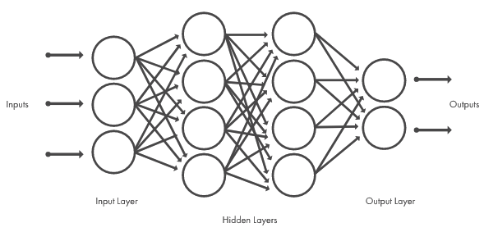**Fig 1.** Neural networks, which are organized in layers consisting of a set of interconnected nodes. Networks can have tens or hundreds of hidden layers.

One of the most popular types of deep neural networks is known as convolutional neural networks (CNN or ConvNet). A CNN convolves learned features with input data, and uses 2D convolutional layers, making this architecture well suited to processing 2D data, such as images.

CNNs eliminate the need for manual feature extraction, so, you do not need to identify features used to classify images. The CNN works by extracting features directly from images. The relevant features are not pretrained; they are learned while the network trains on a collection of images. This automated feature extraction makes deep learning models highly accurate for computer vision tasks such as object classification.

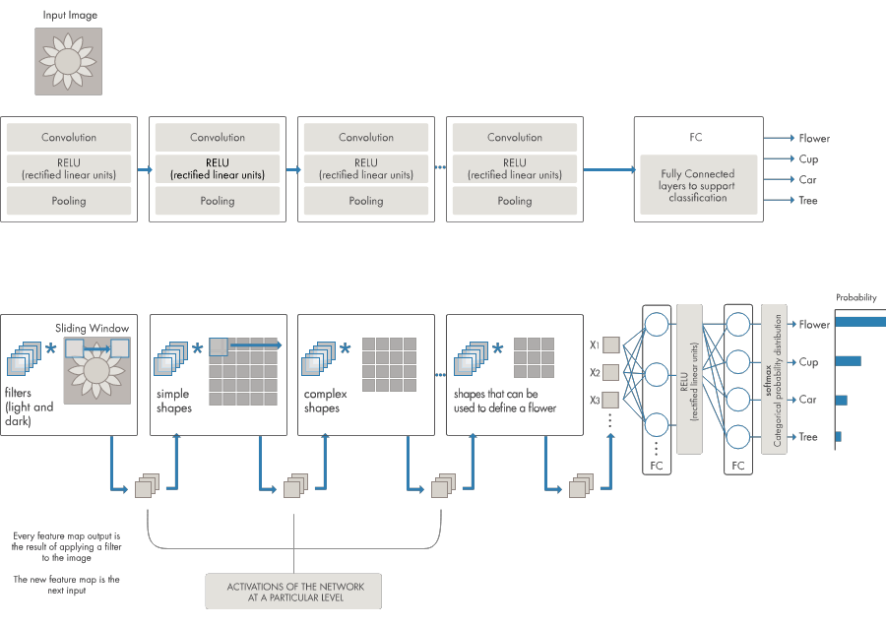**Fig 2.** Example of a network with many convolutional layers. Filters are applied to each training image at different resolutions, and the output of each convolved image serves as the input to the next layer.

CNNs learn to detect different features of an image using tens or hundreds of hidden layers. Every hidden layer increases the complexity of the learned image features. For example, the first hidden layer could learn how to detect edges, and the last learns how to detect more complex shapes specifically catered to the shape of the object we are trying to recognize.

**1. 4 WHAT IS THE DIFFERENCE BETWEEN MACHINE LEARNING AND DEEP LEARNING?**

Deep learning is a specialized form of machine learning. A machine learning workflow starts with relevant features being manually extracted from images. The features are then used to create a model that categorizes the objects in the image. With a deep learning workflow, relevant features are automatically extracted from images. In addition, deep learning performs “end-to-end learning” – where a network is given raw data and a task to perform, such as classification, and it learns how to do this automatically.

Another key difference is deep learning algorithms scale with data, whereas shallow learning converges. Shallow learning refers to machine learning methods that plateau at a certain level of performance when you add more examples and training data to the network.

A key advantage of deep learning networks is that they often continue to improve as the size of your data increases.

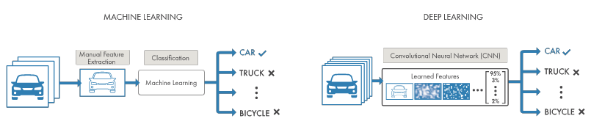**Fig 3.** Comparing a machine learning approach to categorizing vehicles (left) with deep learning (right).

In machine learning, you manually choose features and a classifier to sort images. With deep learning, feature extraction and modeling steps are automatic.

**1. 5 HOW TO CREATE AND TRAIN DEEP LEARNING MODELS**

The three most common ways people use deep learning to perform object classification are:

**1. 5. 1 Training from Scratch**

To train a deep network from scratch, you gather a very large labeled data set and design a network architecture that will learn the features and model. This is good for new applications, or applications that will have a large number of output categories. This is a less common approach because with the large amount of data and rate of learning, these networks typically take days or weeks to train.

**1. 5. 2 Transfer Learning**

Most deep learning applications use the transfer learning approach, a process that involves fine-tuning a pre-trained model. You start with an existing network, such as AlexNet or GoogleNet, and feed in new data containing previously unknown classes.

After making some tweaks to the network, you can now perform a new task, such as categorizing only dogs or cats instead of 1000 different objects.

This also has the advantage of needing much less data (processing thousands of images, rather than millions), so computation time drops to minutes or hours.

Transfer learning requires an interface to the internals of the pre-existing network, so it can be surgically modified and enhanced for the new task.

**1.5.3 Feature Extraction**

A slightly less common, more specialized approach to deep learning is to use the network as a feature extractor. Since all the layers are tasked with learning certain features from images, we can pull these features out of the network at any time during the training process. These features can then be used as input to a machine learning model such as support vector machines (SVM).

**1. 6 FACE RECOGNITION**

Face detection is a computer vision problem that involves finding faces in photos. It is a trivial problem for humans to solve and has been solved reasonably well by classical feature-based techniques, such as the cascade classifier.

More recently deep learning methods have achieved state-of-the-art results on standard benchmark face detection datasets. One example is the Multi-task Cascade Convolutional Neural Network, or MTCNN for short.

The face recognition system needs to find a face in the image and highlight this area. For this, the software can use a variety of algorithms: for example, determining the similarity of proportions and skin color, the selection of contours in the image and their comparison with the contours of faces, the selection of symmetries using neural networks. The most effective is the Viola-Jones method, which can be used in real time. With it, the system recognizes faces even when rotated 30 degrees.

The method is based on the signs of Haar, which are a set of black and white rectangular masks of different shapes. The masks are superimposed on different parts of the image, and the algorithm adds the brightness of all the pixels of the image that are under the black and white parts of the mask and then calculates the difference between these values. Next, the system compares the results with the accumulated data and having determined the face in the image, continues to track it to select the optimum angle and image quality.

For this purpose, motion vector prediction algorithms or correlation algorithms are used. Having chosen the most successful pictures, the system proceeds to face recognition and its comparison with the existing base. It works according to the same principles as the artist paints portraits — the program finds the reference points on the person’s face that make up the individual features.

As a rule, the program allocates about 100 such points. The most important measurements for face recognition programs are the distance between the eyes, the width of the nostrils, the length of the nose, the height and shape of the cheekbones, the width of the chin, the height of the forehead and other parameters.

After that, the obtained data are compared with those available in the database, and, if the parameters coincide, the person is identified.

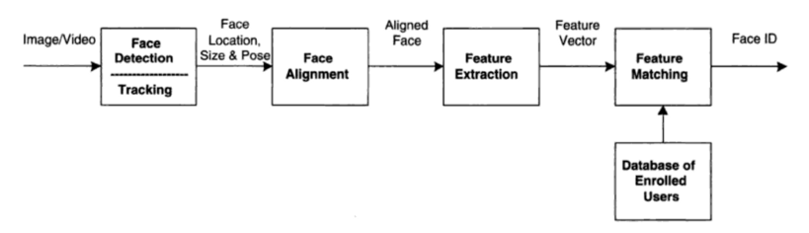**Fig 4.** Face Recognition Processing Flow Diagram

Face recognition is a sequence of several related steps as shown in the Processing flow diagram above. The steps are as follows:

1. First, you need to look at the image and find all the faces on it.
2. Secondly, it is necessary to focus on each face and determine that, despite the unnatural turn of the face or poor lighting, it is the same person.
3. Thirdly, it is necessary to highlight the unique characteristics of the face, which can be used to distinguish it from other people — for example, the size of the eyes, the elongation of the face, etc.
4. In conclusion, it is necessary to compare these unique characteristics of the face with the characteristics of other people you know to determine the name of the person.

**2. LITERATURE REVIEW**

**4. APPLICATIONS IN OTHER AREAS**

**4. 1 IMAGE RECOGNITION**

Image recognition is one of the most common uses of machine learning. There are many situations where you can classify the object as a digital image. For example, in the case of a black and white image, the intensity of each pixel is served as one of the measurements.

In colored images, each pixel provides 3 measurements of intensities in three different colors – red, green and blue (RGB). Machine learning can be used for face detection in an image as well. There is a separate category for each person in a database of several people.

Machine learning is also used for character recognition to discern handwritten as well as printed letters. We can segment a piece of writing into smaller images, each containing a single character.

**4. 2 SPEECH RECOGNITION**

Speech recognition is the translation of spoken words into the text. It is also known as computer speech recognition or automatic speech recognition. Here, a software application can recognize the words spoken in an audio clip or file, and then subsequently convert the audio into a text file.

The measurement in this application can be a set of numbers that represent the speech signal. We can also segment the speech signal by intensities in different time-frequency bands.

Speech recognition is used in the applications like voice user interface, voice searches and more. Voice user interfaces include voice dialing, call routing, and appliance control. It can also be used a simple data entry and the preparation of structured documents.

**4. 3 MEDICAL DIAGNOSIS**

Machine learning can be used in the techniques and tools that can help in the diagnosis of diseases. It is used for the analysis of the clinical parameters and their combination for the prognosis example prediction of disease progression for the extraction of medical knowledge for the outcome research, for therapy planning and patient monitoring.

These are the successful implementations of the machine learning methods. It can help in the integration of computer-based systems in the healthcare sector.

**4. 4 STATISTICAL ARBITRAGE**

In finance, arbitrage refers to the automated trading strategies that are of a short-term and involve a large number of securities. In these strategies, the user focuses on implementing the trading algorithm for a set of securities on the basis of quantities like historical correlations and the general economic variables.

Machine learning methods are applied to obtain an index arbitrage strategy. We apply linear regression and the Support Vector Machine to the prices of a stream of stocks.

**4. 5 LEARNING ASSOCIATIONS**

Learning associations is the process of developing insights into the various associations between the products. A good example is how the unrelated products can be associated with one another. One of the applications of machine learning is studying the associations between the products that people buy.

If a person buys a product, he will be shown similar products because there is a relation between the two products. When any new products are launched in the market, they are associated with the old ones to increase their sales.

**4. 6 CLASSIFICATION**

A classification is a process of placing each individual under study in many classes. Classification helps to analyze the measurements of an object to identify the category to which that object belongs. To establish an efficient relation, analysts use data.

For example, before a bank decides to distribute loans, it assesses the customers on their ability to pay loans. By considering the factors like customer’s earnings, savings, and financial history, we can do it. This information is taken from the past data on the loan.

**4. 7 PREDICTION**

Machine learning can also be used in the prediction systems. Considering the loan example, to compute the probability of a fault, the system will need to classify the available data in groups. It is defined by a set of rules prescribed by the analysts.

Once the classification is done, we can calculate the probability of the fault. These computations can compute across all the sectors for varied purposes. Making predictions is one of the best machine learning applications.

**4. 8 EXTRACTION**

Extraction of information is one of the best applications of machine learning. It is the process of extracting structured information from the unstructured data.

For example, the web pages, articles, blogs, business reports, and emails. The relational database maintains the output produced by the information extraction. The process of extraction takes a set of documents as input and outputs the structured data.

**4. 9 REGRESSION**

We can also implement machine learning in the regression as well. In regression, we can use the principle of machine learning to optimize the parameters. It can also be used to decrease the approximation error and calculate the closest possible outcome.

We can also use the machine learning for the function optimization. We can also choose to alter the inputs in order to get the closest possible outcome.

**4. 10 FINANCIAL SERVICES**

Machine learning has a lot of potential in the financial and banking sector. It is the driving force behind the popularity of the financial services. Machine learning can help the banks, financial institutions to make smarter decisions. Machine learning can help the financial services to spot an account closure before it occurs. It can also track the spending pattern of the customers.

Machine learning can also perform the market analysis. Smart machines can be trained to track the spending patterns. The algorithms can identify the tends easily and can react in real time.