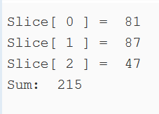Round 1:

package main

import "fmt"

import "math/rand"

func main() {

slice1 := make([]int, 3)

var sum int

for i:=0;i<len(slice1);i++ {

slice1[i] = rand.Intn(100)

sum += slice1[i]

fmt.Println("Slice[",i,"] = ",slice1[i])

}

fmt.Println("Sum: ", sum)

}

Round 2:

package main

import "fmt"

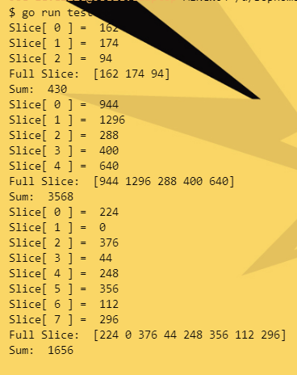import "math/rand"

func sliceMaker(length, randMult int) {

slice1 := make([]float32, length)

var sum float32

for i:=0;i<length;i++ {

slice1[i] = float32(rand.Intn(100)\*randMult)

sum += slice1[i]

fmt.Println("Slice[",i,"] = ",slice1[i])

}

fmt.Println("Full Slice: ",slice1)

fmt.Println("Sum: ", sum)

}

func main() {

sliceMaker(3, 2)

sliceMaker(5, 16)

sliceMaker(8, 4)

}

Round 3:

package main

import "fmt"

import "math"

func calcCircle(rad float64) (float64, float64){

circ := math.Pi \* 2 \* rad

area := math.Pi \* math.Pow(rad,2)

return circ, area

}

func main(){

radius := 7.5

c, a := calcCircle(radius)

fmt.Println("Radius: ", radius, " Circumference: ", c, " Area: ", a)

}

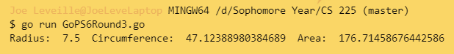

I have neither given or received, nor have I tolerated others’ use of unauthorized aid.

Joseph Leveille