Problem 10: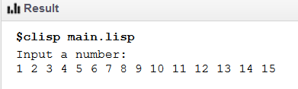

Problems 10/11: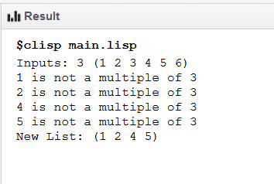

Sieve Problem 12: