Names and NSIDs: Joel Hill (jgh719), Jordan Lys (jcl175)
Project: jEdit
Change Number: 2: Zoom the Text Editor
Date: 02/09/2015

Zoom the Text Editor

- Change Request:
Under menu View, add two menu items “zoom+” and “zoom–“ to scale the editors. At this stage, the scaling factors are not defined. The view should be able to be scaled multiple times.

- Concept Location:
The search started with an analysis of the Jedit_gui.props file since it was known that the menu options were defined here. It was also known that methods were linked to menu items in xml files. Menu options that edited the text were investigated and searched for in actions.xml. A search for a text method found in actions.xml was conducted, and the TextArea.java base class was discovered to contain relevant text methods. The source code in the same package was read, and JEditTextArea was found to extend TextArea, and so it was a viable candidate to add features to.

Table 1. The list of all the classes visited during concept location.
# | File name | Tool used | Located? | Comments
1 | Jedit_gui.props | Read Source | Propagating | GUI actions stored here
2 | actions.xml | Read Source | Changed | Methods incommon with .props
3 | TextArea.java | Java Search -Method | Changed | Methods contained in actions related to text editing and views
4 | JEditTextArea.java | Read Source | Changed | Subclass appropriate for new features.

- Impact Analysis:
Table 2. The list of all the classes visited during impact analysis.
# | Class name | Tool used | Impacted? | Comments
 | JEditTextArea.java | Text Editor | Changed | Zoom added here
 | TextArea.java | Class View/ Editor | Changed | Added fields
 | Actions.xml | Text Editor | Changed | Added gui/method links
 | Jedit_gui.props | Text Editor/Search | Changed | Added menu items.

- Learning process: Include a partial UML class diagram.
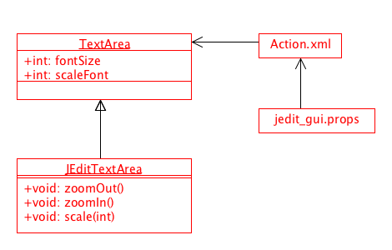
- Description of the implementation:
Explain where and why you made changes in the source code. Which classes or methods you created, or changed

- Sources: General research into .props file format

- Highlighted Source Code:

Actions.xml:

<ACTION NAME="zoom-in">
<CODE>
textArea.zoomIn();
</CODE>
</ACTION>

<ACTION NAME="zoom-out">
<CODE>
textArea.zoomOut();
</CODE>
</ACTION>

TextArea.java:

public class TextArea extends JComponent
{
int fontSize = 12;
int scaleFont = fontSize;

JEditTextArea.java:

public void zoomIn(){
this.scale(1);
}

public void zoomOut(){
this.scale(-1);
}

public void scale(int amount){
this.scaleFont = this.scaleFont + amount;
if(this.scaleFont <= 0){
this.scaleFont = 1;
}
Font font = new Font("Monospaced", Font.PLAIN, this.scaleFont);
this.painter.setFont(font);
SyntaxStyle[] styles = new SyntaxStyle[1];
styles[0] = new SyntaxStyle(Color.black, Color.white, font);
this.painter.setStyles(styles);
this.painter.repaint();
}

jedit_gui.props:

view=new-view \
new-plain-view \
new-view-buffer \
close-view \
- \
prev-buffer \
next-buffer \
recent-buffer \
show-buffer-switcher \
- \
toggle-line-numbers \
- \
zoom-in \
zoom-out \
toggle-whitespace \
%scrolling \
%splitting \
%docking
view.label=$View
new-view.label=New $View
new-plain-view.label=Ne$w Plain View
new-view-buffer.label=New View with Buffer
close-view.label=$Close View
prev-buffer.label=Go to $Previous Buffer
next-buffer.label=Go to $Next Buffer
recent-buffer.label=Go to $Recent Buffer
show-buffer-switcher.label=Show $Buffer Switcher
toggle-line-numbers.label=$Line Numbers
zoom-in.label=Zoom $+
zoom-out.label=Zoom $-
toggle-whitespace.label=toggle Whitespace Characters

