Cinch simulations

**Nucleotides chosen for analysis:**

* Top: nucleotide at top of pore
* Mid: nucleotide at middle of pore
* Bot: nucleotide at middle of pore
* Min: minimum z position for nucleotide on the pore at each given time
* Mean: average position of all given nucleotides

Top, min, bot shown here:

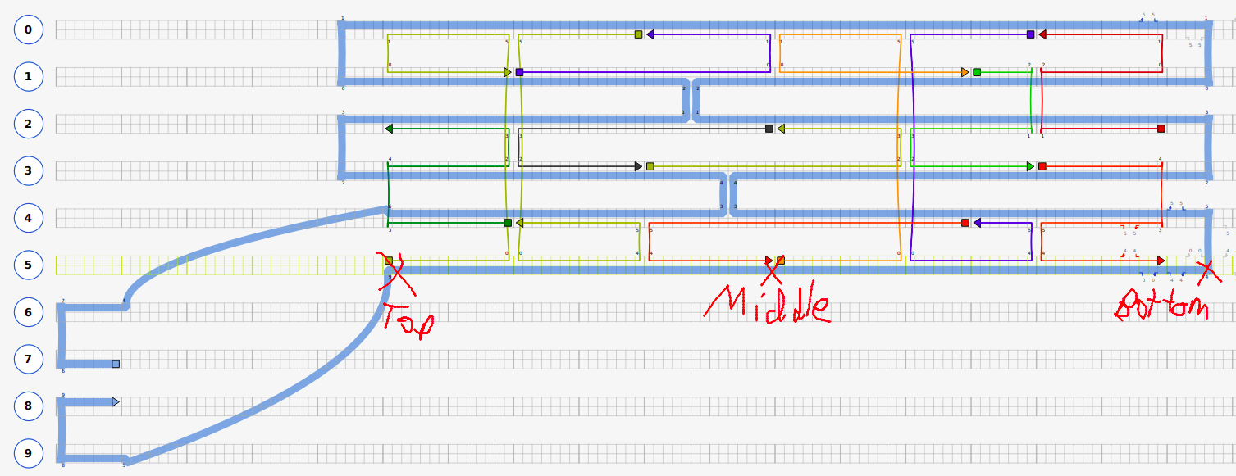

**Short-hand codes for each type of simulation:**

“42x2, s4” means 2 cinches each of length 42 nucleotides, with a spacer of 4 nucleotides between end of cinch and end of tether. (This refers to cinch1)

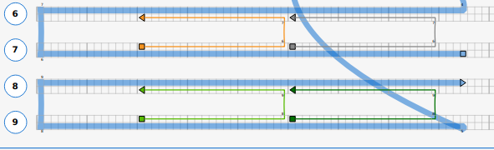

**Extra simulations that I ran (as well as ones you asked for):**

* Free (cinch0): Just a free pore, with no cinches

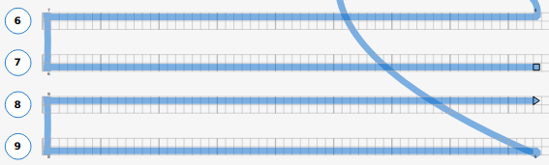

* 42, s42 (cinch5): A single cinch of length 42, with spacer of 42

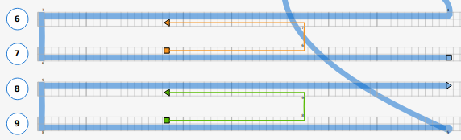

* One sided (cinch6): Spacer of 0. Has one sided cinches of length 42. This is to simulate effect that we discussed in last meeting. Other combinations of “one sided” are possible but I just ran this one.

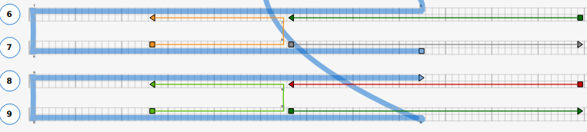

**Key results:**

|  |  |  |  |  |  |  |  |  |  |  |
| --- | --- | --- | --- | --- | --- | --- | --- | --- | --- | --- |
| **ID** | **Name** | **% out** | **<z> top (nm)** | **<r> top (nm)** | **<z> mid (nm)** | **<r> mid (nm)** | **<z> bot (nm)** | **<r> bot (nm)** | **<z> min (nm)** | **<r> min (nm)** |
| 0 | free | 1.00 | -16.48 | 3.56 | -30.72 | 4.78 | -44.24 | 6.62 | -45.32 | 9.61 |
| 1 | 42x2, s4 | 0.00 | -0.31 | 4.68 | -13.86 | 4.99 | -27.45 | 6.67 | -28.61 | 10.14 |
| 2 | 42x2, s6 | 0.00 | -1.04 | 4.45 | -14.89 | 3.11 | -27.91 | 6.29 | -29.00 | 9.89 |
| 3 | 46, s10 | 0.26 | -3.10 | 3.18 | -16.83 | 2.64 | -29.86 | 5.48 | -31.26 | 8.36 |
| 4 | 42x2, s0 | 0.00 | -0.75 | 6.20 | -13.49 | 2.41 | -26.71 | 5.59 | -27.82 | 9.89 |
| 5 | 42, s42 | 0.63 | -4.44 | 3.57 | -18.67 | 2.86 | -32.24 | 3.49 | -32.87 | 7.22 |
| 6 | 42, z42 | 0.99 | -5.15 | 3.35 | -19.42 | 3.07 | -32.95 | 3.69 | -33.62 | 10.37 |
| 7 | z42x2 | 1.00 | -12.34 | 4.34 | -26.43 | 5.69 | -40.20 | 6.12 | -40.87 | 9.39 |

Notes:

* <> refers to average
* Centre of barrel is defined as zero point. z=-30nm corresponds to bottom of barrel
* % out is the fraction of time where nucleotides of the pore are outside the barrel