Admin:

Max Score Rules

Max Operator Per Group

Max App Names

Max IP Blacklist

Banner Icon Url

Max Event Tags

Max Campaign Pixels

Max Schedulers

Max Site Per Account

Job Result Expire Days

連接cassandra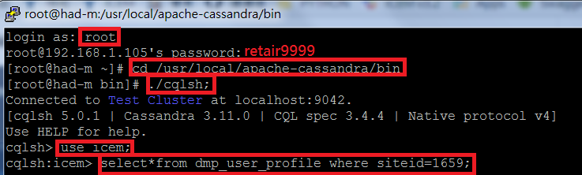

塞資料進cassandra (keyword)

UPDATE recommend_keyword_member_aggregate_counter SET impressionnum=impressionnum+1 WHERE siteid=1668 and retuid='MANUAL-6bea140c-5273-4856-9b39-af9003f18b05' and keyword='ktest';

有些table 是counter table 必須要用update指令去累加

Insert則是直接設定數字

* Campaign

campaign-pixel 測試 redirect url

Step Action :

1. 新增一個campaign pixel填上redirect url : https://tw.yahoo.com
2. parameter :不勾

然後 在網頁上 輸入code Snippet 和相關參數 ,

例如 : 在網頁上輸入http://icemdev.retchat.com/p/?a=1208&catclk=18-3381430207&cert=4ef21fba498cdce878efd52a7f8141a8&retUid=ec0affda-7e3a-4040-8376-705d2675b096&app=WEB

預期結果:會跳到https://tw.yahoo.com頁面且不帶參數

實際結果:與預期結果相同

1. 新增一個campaign pixel填上redirect url : https://tw.yahoo.com
2. parameter :勾

然後 在網頁上 輸入code Snippet 和相關參數 ,

例如 : 在網頁上輸入

http://icemdev.retchat.com/p/?a=1208&catclk=18-3382288305&cert=4ed042b8594443987a0595fe8e03f74d&app=WEB

預期結果:會跳到https://tw.yahoo.com頁面且後面會帶有參數

實際結果:與預期結果相同

___Campaign pixel打conversion的log時有特別規則需要到Miscellaneous設定Attribute Model

1. CONVERSION PERIOD (DAYS) : 1

CONVERSION EVENT : Count once for multiple event from an unique visitor

CONVERSION ATTRIBUTE MODEL : Last Click

打log需要同retUid打一次click的在打conversion的log

2. CONVERSION PERIOD (DAYS) : 1

CONVERSION EVENT : Count once for multiple event from an unique visitor

CONVERSION ATTRIBUTE MODEL : Last Click

* On-Site Analytics

siteId到On-site-Event的tag management看

cert到Event-tag的Code Snippet看(每個Event-tag不一樣)

Mcdonalds網頁的

retUid=ec0affda-7e3a-4040-8376-705d2675b096

vItemId要從Network點開Header看商品名稱然後到Console裡輸入encodeURIComponent(“商品名稱”)

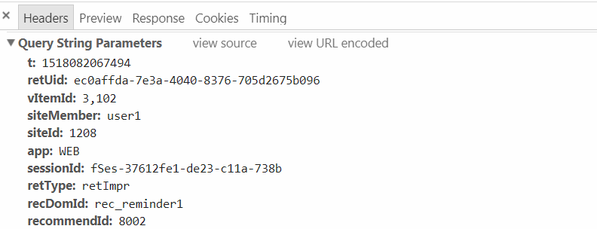

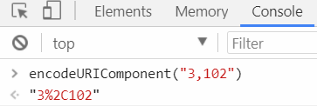

* **需要打log才會跑出圖表的部分**

**Detail Report -> COMMODITY ANALYTICS:**

http://icemdev.retchat.com/action/action.img?t=1517886742877&retUid=ec0affda-7e3a-4040-8376-705d2675b096&siteId=1208&retType=buy&app=WEB&sessionId=fSes-63d1b0fd-33c9-90d2-31ed&t=1517886742877&retCrt=c54c1040d15d563cad59e94d14bfa256&&shopDetail=商品code%2C價錢%2C數量&

**Detail Report -> SHOPPING CART ANALYTICS:**

http://icemdev.retchat.com/action/action.img?t=1517886742877&retUid=ec0affda-7e3a-4040-8376-705d2675b096&siteId=1208&retType=cart&app=WEB&sessionId=fSes-63d1b0fd-33c9-90d2-31ed&retCrt=c54c1040d15d563cad59e94d14bfa256&&cartDetail=商品code%2C價錢%2C數量&

**Content Analytics -> FORUM ID ANALYSIS:**

Impression的部分

需要到Items中找出Forum ID!

http://icemdev.retchat.com/action/action.img?t=1517886742877&retUid=ec0affda-7e3a-4040-8376-705d2675b096&siteId=1208&app=WEB&sessionId=fSes-63d1b0fd-33c9-90d2-31ed&retType=track&retCrt=c54c1040d15d563cad59e94d14bfa256&&fid=Forum ID

Impression跟click差別

click的部分

http://icemdev.retchat.com/action/action.img?t=1517886742877&retUid=ec0affda-7e3a-4040-8376-705d2675b096&siteId=1208&app=WEB&sessionId=fSes-63d1b0fd-33c9-90d2-31ed&retType=retClk&retCrt=c54c1040d15d563cad59e94d14bfa256&&fid= Forum ID

Onsite Custom Fields

首先到On-site Events -> Ext Filter String設定要的Custom參數

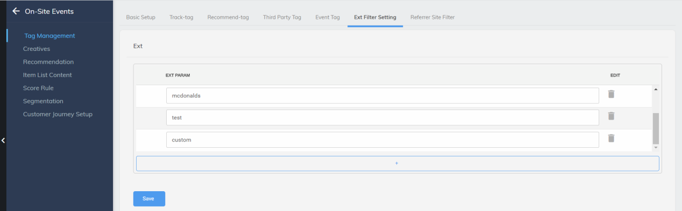

到Events-tag -> Code Snippet設定 再加上retUid

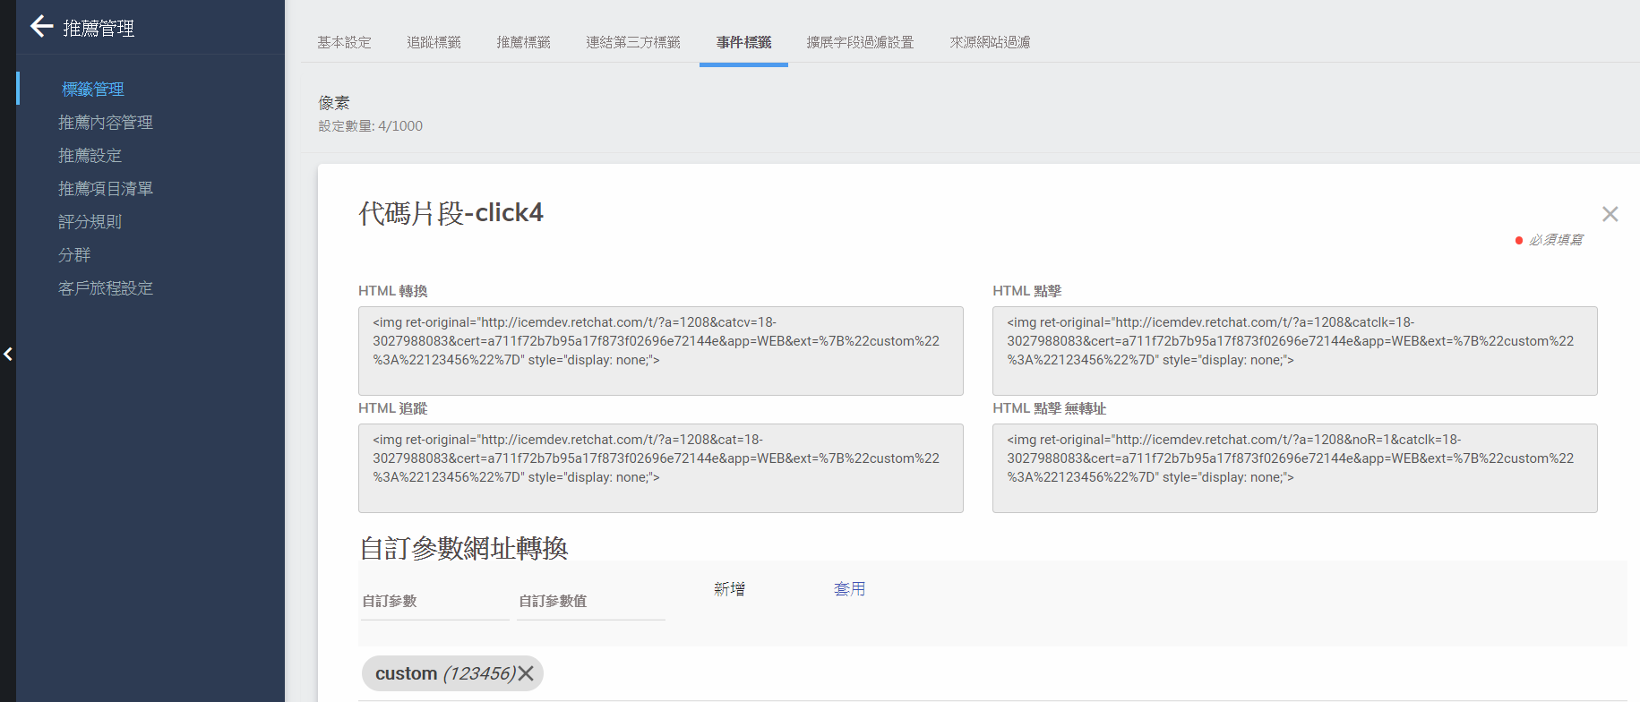

Impression的部分

http://icemdev.retchat.com/t/?a={SiteId}&cat={Eveng-tag_ID}&cert={Events-tag的cert}&retUid={自己網站的retUid}&app=WEB&ext=%7B%22{設定好的custom field} %22%3A%22{custom field value}%22%7D

click的部分

http://icemdev.retchat.com/t/?a={SiteId}&catclk={Eveng-tag_ID}&cert={Events-tag的cert}&retUid={自己網站的retUid}&app=WEB&ext=%7B%22{設定好的custom field} %22%3A%22{custom field value}%22%7D

On-Site Item Analytics

impression

http://icemdev.retchat.com/t/?a={SiteId}&cat={Eveng-tag_ID}&cert={Events-tag的cert}}&retUid={自己網站的retUid}&app=WEB&sessionId=fSes-160a9bcc-e35d-9f7-e8a5&t={自己網站上看log的t}&vItemId={自己網站上看log的vItemId}&from=ct

click

http://icemdev.retchat.com/t/?a={SiteId}&catclk={Eveng-tag_ID}&cert={Events-tag的cert}&retUid={自己網站的retUid}&app=WEB&sessionId=fSes-160a9bcc-e35d-9f7-e8a5&t={自己網站上看log的t}&vItemId={自己網站上看log的vItemId}&from=ct

http://icemdev.retchat.com/t/?a=1208&catclk=18-3027988083&cert=a711f72b7b95a17f873f02696e72144e&app=WEB&app=WEB&sessionId=fSes-160a9bcc-e35d-9f7-e8a5&t=1517886742877

尚未解決的(需要用到database)*****************************************

TITLE BASED ANALYTICS

網址是Eva的log

impression

http://icemdev.retchat.com/action/action.img?t=1509106809521&retUid=a208f458-9e0-1090-472b-7409d50ea4ca&siteId=800&app=WEB&sessionId=fSes-5ef3a3e6-f5aa-bd2-3f07&retType=track&retCrt=274d7f0204f46229fb13664ea0d32867&tid=100123

click

http://icemdev.retchat.com/action/action.img?t=1509106809521&retUid=a208f458-9e0-1090-472b-7409d50ea4ca&siteId=800&app=WEB&sessionId=fSes-5ef3a3e6-f5aa-bd2-3f07&retType=retClk&retCrt=274d7f0204f46229fb13664ea0d32867&tid=100123

*********************************************************************

Event DIY Label Report

需要到Event tag的EXT Filter設置打入log的ext才會跑出資料

Ex:打入的ext:麥當勞(大麥克),filter就要新增”麥當勞”

# API test case

__DMP-2624__[Auto Labeling Phase-1] Campaign Pixel / Event Tag related configuration

* POST /tag/setTagPixel/$siteId

{

"carryParam": true,

"htmlClick": "string",

"htmlClickApi": "string",

"htmlClickNoRedirect": "string",

"htmlClickNoRedirectApi": "string",

"htmlConversion": "string",

"htmlConversionApi": "string",

"htmlTracking": "string",

"htmlTrackingApi": "string",

"id": null,

"label": "string",

"memo": "string",

"name": "tag",

"pixelid": "null",

"redirectUrl": "string",

"status": "OFF",

"tagManagerId": 891,

"triggerVOList": [

],

"type": "ON_SITE"

}

* POST /tag/getTagPixel/$siteId

{

"id": null,

"name": "tag",

"pixelType": "ON_SITE",

"pixelid": "null",

"redirectUrl": "string",

"siteId": 1208,

"sortBy": "NAME",

"sortWay": "ASC"

}

* GET /tag/getTagManager/$siteId

siteId:1208

* POST /campaignPixel/setCampaignPixel/$siteId
* POST /campaignPixel/getCampaignPixel/$siteId

{

"ad": "123321",

"campaign": "imsofast",

"group": "group",

"id": null,

"siteId": 1208,

"tagPixelVO": {

"carryParam": true,

"htmlClick": "string",

"htmlClickApi": "string",

"htmlClickNoRedirect": "string",

"htmlClickNoRedirectApi": "string",

"htmlConversion": "string",

"htmlConversionApi": "string",

"htmlTracking": "string",

"htmlTrackingApi": "string",

"id": null,

"label": "",

"memo": "",

"name": "",

"pixelid": "",

"redirectUrl": "string",

"status": "OFF",

"tagManagerId": 891,

"triggerVOList": [

],

"type": "ON_SITE"

}

}

Target Sync Data流程

Log -> fastdata 每小時30分時會寫入->behavior table ->fastdata hourly run將table寫成一個.csv檔 -> dmp scheduler整點時會將此.csv寫入target database

Source Sync Data流程

.csv經過dmp scheduler daily run -> Cassandra 的 dmp_user_profile,dmp_user_profile_segment…等table

Audience segment

有6種rule

Score rule with

1.score就是看rule的score

2.ranking就是看score的排名

3.percentage則是score排名後再做百分率,都是介於百分0~100之間

比如:

select * from icem_member_score where site_id=1668;

|  |  |
| --- | --- |
| 58c76ff6-275c-c185-83b1-c7eec4634c05 | 0 |
| MANUAL-68ad80a9-ca70-4209-aa9d-f469d4fa4250 | 0 |
| MANUAL-6bea140c-5273-4856-9b39-af9003f18b05 | 5 |
| MANUAL-8c27d70f-c12d-41c4-9c63-2eca56e8c07f | 30 |

select * from (SELECT retuid, rank() OVER (ORDER BY score DESC) AS value FROM icem_member_score where site_id=1668 and ruleId=9025 ) as member_score;

|  |  |
| --- | --- |
| MANUAL-8c27d70f-c12d-41c4-9c63-2eca56e8c07f | 1 |
| MANUAL-6bea140c-5273-4856-9b39-af9003f18b05 | 2 |
| 58c76ff6-275c-c185-83b1-c7eec4634c05 | 3 |
| MANUAL-68ad80a9-ca70-4209-aa9d-f469d4fa4250 | 3 |

select * from (SELECT retuid, percent_rank() OVER (ORDER BY score DESC) AS value FROM icem_member_score where site_id=1668 and ruleId=9025 ) as member_score;

|  |  |
| --- | --- |
| MANUAL-8c27d70f-c12d-41c4-9c63-2eca56e8c07f | 0.0 |
| MANUAL-6bea140c-5273-4856-9b39-af9003f18b05 | 0.3333333333333333 |
| 58c76ff6-275c-c185-83b1-c7eec4634c05 | 0.6666666666666666 |
| MANUAL-68ad80a9-ca70-4209-aa9d-f469d4fa4250 | 0.6666666666666666 |

# Robot framework memo

Robot framework 提取list中的list

@{items}= set variable ${json["data"]["items"]}

Reponse中:[…]這是list , {…}這是dictionary

Integ_data_query_report.robot中的check部分

${response_content} get_element ${query_report_response} input_name=${None} icem_name_param=${None} icem_id_param=content get_what=get_content  
#先從dictionary把content這個list拿出來  
${content_list} get from list ${response_content} 0  
#把content這個list從dictionary中拿出來

${conversion} get_element ${content_list} input_name=${None} icem_name_param=${None} icem_id_param=conversion get_what=get_conversion  
#拿出conversion這個element

${conversion_log_times} evaluate ${conversion_log_times}  
#變成數字

should be equal ${conversion} ${conversion_log_times}

Domain name: http://icem.retair.com/icem-manager/index.html#!/