* On-Site Analytics

siteId到On-site-Event的tag management看

cert到Event-tag的Code Snippet看(每個Event-tag不一樣)

Mcdonalds網頁的

retUid=ec0affda-7e3a-4040-8376-705d2675b096

vItemId要從Network點開Header看商品名稱然後到Console裡輸入encodeURIComponent(“商品名稱”)

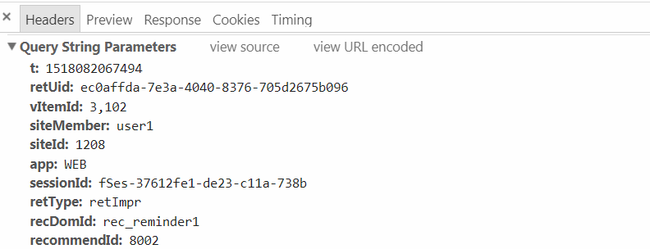

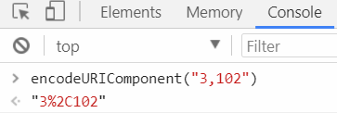

* **需要打log才會跑出圖表的部分**

**Detail Report -> COMMODITY ANALYTICS:**

http://icemdev.retchat.com/action/action.img?t=1517886742877&retUid=ec0affda-7e3a-4040-8376-705d2675b096&siteId=1208&retType=buy&app=WEB&sessionId=fSes-63d1b0fd-33c9-90d2-31ed&t=1517886742877&retCrt=c54c1040d15d563cad59e94d14bfa256&&shopDetail=商品code%2C價錢%2C數量&

**Detail Report -> SHOPPING CART ANALYTICS:**

http://icemdev.retchat.com/action/action.img?t=1517886742877&retUid=ec0affda-7e3a-4040-8376-705d2675b096&siteId=1208&retType=cart&app=WEB&sessionId=fSes-63d1b0fd-33c9-90d2-31ed&retCrt=c54c1040d15d563cad59e94d14bfa256&&cartDetail=商品code%2C價錢%2C數量&

**Content Analytics -> FORUM ID ANALYSIS:**

Impression的部分

需要到Items中找出Forum ID!

http://icemdev.retchat.com/action/action.img?t=1517886742877&retUid=ec0affda-7e3a-4040-8376-705d2675b096&siteId=1208&app=WEB&sessionId=fSes-63d1b0fd-33c9-90d2-31ed&retType=track&retCrt=c54c1040d15d563cad59e94d14bfa256&&fid=Forum ID

Impression跟click差別

click的部分

http://icemdev.retchat.com/action/action.img?t=1517886742877&retUid=ec0affda-7e3a-4040-8376-705d2675b096&siteId=1208&app=WEB&sessionId=fSes-63d1b0fd-33c9-90d2-31ed&retType=retClk&retCrt=c54c1040d15d563cad59e94d14bfa256&&fid= Forum ID

Onsite Custom Fields

首先到On-site Events -> Ext Filter String設定要的Custom參數

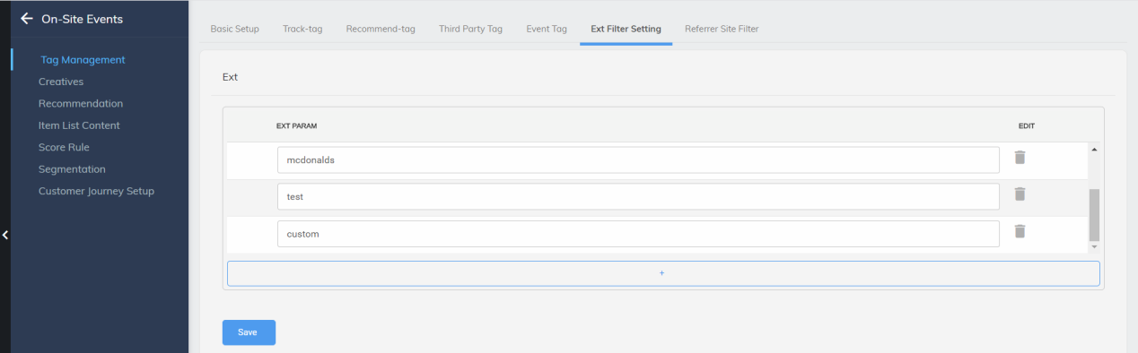

到Events-tag -> Code Snippet設定 再加上retUid

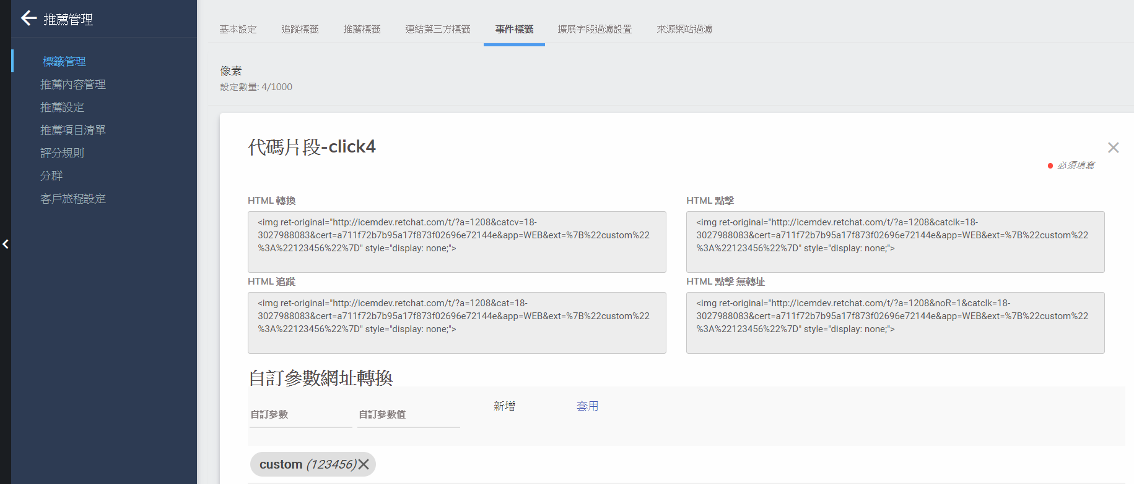

Impression的部分

http://icemdev.retchat.com/t/?a={SiteId}&cat={Eveng-tag_ID}&cert={Events-tag的cert}&retUid={自己網站的retUid}&app=WEB&ext=%7B%22{設定好的custom field} %22%3A%22{custom field value}%22%7D

click的部分

http://icemdev.retchat.com/t/?a={SiteId}&catclk={Eveng-tag_ID}&cert={Events-tag的cert}&retUid={自己網站的retUid}&app=WEB&ext=%7B%22{設定好的custom field} %22%3A%22{custom field value}%22%7D

On-Site Item Analytics

impression

http://icemdev.retchat.com/t/?a={SiteId}&cat={Eveng-tag_ID}&cert={Events-tag的cert}}&retUid={自己網站的retUid}&app=WEB&sessionId=fSes-160a9bcc-e35d-9f7-e8a5&t={自己網站上看log的t}&vItemId={自己網站上看log的vItemId}&from=ct

click

http://icemdev.retchat.com/t/?a={SiteId}&catclk={Eveng-tag_ID}&cert={Events-tag的cert}&retUid={自己網站的retUid}&app=WEB&sessionId=fSes-160a9bcc-e35d-9f7-e8a5&t={自己網站上看log的t}&vItemId={自己網站上看log的vItemId}&from=ct

尚未解決的(需要用到database)*****************************************

TITLE BASED ANALYTICS

網址是Eva的log

impression

http://icemdev.retchat.com/action/action.img?t=1509106809521&retUid=a208f458-9e0-1090-472b-7409d50ea4ca&siteId=800&app=WEB&sessionId=fSes-5ef3a3e6-f5aa-bd2-3f07&retType=track&retCrt=274d7f0204f46229fb13664ea0d32867&tid=100123

click

http://icemdev.retchat.com/action/action.img?t=1509106809521&retUid=a208f458-9e0-1090-472b-7409d50ea4ca&siteId=800&app=WEB&sessionId=fSes-5ef3a3e6-f5aa-bd2-3f07&retType=retClk&retCrt=274d7f0204f46229fb13664ea0d32867&tid=100123

*********************************************************************

* 測試Micro Site的page同步顯示手機Weixin是否正常開啟顯示

Wechat -> Micro Site -> Page -> Personalize Menu ,Hot Sales , Reminder 在設定推薦清單後要到On-Site-Event中Tag Management的Recommend-Tag的Status打開並且Recommendation的operation要Display items with empty result 再設定Default Item Group