FileCompareWithHTTPOutput

## Joel L. Ivey, Ph.D.

## jivey@jiveysoft.com

A Java program for viewing differences in files as HTTP output, with options to modify display colors and content of display. The original code was created in conjunction with the original version of the M-Editor for Eclipse which I wrote to display differences when starting to load M (or MUMPS) routines that differed from the routine that had previously been saved so that the developer could decide whether to load and edit the new code as well or revert to the previously edited version of the code. When J. Spivey and A. Ustundag updated the M-Editor for more recent versions of Eclipse (<http://code.osehra.org/journal/journal/view/90>), the comparison functionality, along with a number of other aspects were lost[1].

More recently I created an updated version of the code that can be run at the command line and will perform a comparison on files with the same names in two different directories. For those files in which a difference is found, it creates an html file which opens in the default browser (if a number of files may be different, it is suggested that a new page of the browser be opened prior to running the analysis) and a copy of the html file with its name including the name of the two files and their date/times is saved in location specified by an optional third argument (if the third argument isn't supplied, the files will be saved in the location of the most recent of the two files).

It is expected that a version of Java will already be installed on the system. To install the package, copy the 'fileCompare' directory and its contents to a folder (e.g. C:\Here). To use it, e.g., to compare files in the directories C:\Code\New and C:\Code\Old open a command line and move to the directory above fileCompare (cd \Here), then Windows use a command similar to:

c:\Here>java -cp . fileCompare.FileCompare c:\code\new c:\code\old c:\code\diffs

or in Linux:

$ java -cp . fileCompare.FileCompare ./test1 ./test2 ./diffs

In the Linux system, the folders fileCompare, test1, and test2 were all under the current folder, and diffs folder was created under the current folder. Also this code was run using the files as included in the package, and did not require recompiling or running dos2unix.

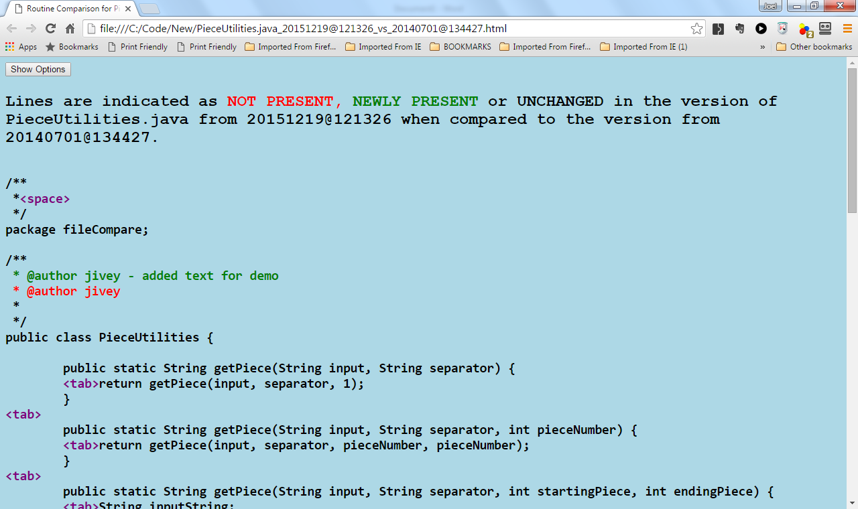

Figure 1. Example of html displayed by default on comparison of two files (with the more recent modified by inserting " - added text for demo")

By default the generated html files when opened in the browser displays (Figure 1) unchanged lines as black characters, those that were present in the older file, but not in the current file are displayed in red, and those that are present in the newer file, but not in the older version are shown in green. There are four additional optional arguments that can be used to modify these colors. Adding the following arguments followed by a desired color –old: , -new:, -same:, or –back: will change to the color(s) specified so that the old code no longer present will be shown in the color specified by –old: (e.g., old:purple will show the older code in purple instead of red), -new: will affect code that is present in the newest version, but not in the older version, -same: will be used for the code that remained unchanged, and –back: can be used to specify the desired background color.

Colors on the command line may also be specified as (using –new: as an example) hexadecimal notation (e.g., -new:#0000FF) or rgb notation (e.g., -new:rgb(0,0,255)), or any of the 140 predefined color names (e.g., -new:blue, which matches the previous examples, or something less common such as ‑new:blanchedalmond).

For changes at the time of viewing in the browser, there is a 'Show Options' button at the top of the displayed html page which opens a panel (Figure 2) with options to determine how much of the content of the two files is displayed and also provides a mechanism for changing the colors to be used for display of the different parts of the text and background (but the dropdown boxes if you want to change them in the browser list only a few color names) the latter changes the display on clicking the 'Activate' button. The "Show Options" button becomes a "Hide Options" button to close the dialog as well.

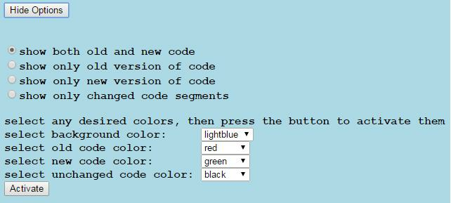

Figure 2. The display at the top of the browser page resulting from clicking the "Show Options" button in the web browser.

Comments and suggestions can be directed to the author at [jivey@jiveysoft.com](mailto:jivey@jiveysoft.com).

1. The original version of the M-Editor for Eclipse (with an embedded version of a Java version that it works with) is available at my GitHub site and does require a VistA server installation running VistALink as the recipient on the VistA side, and requires that three patches (included with the version) be installed on the VistA server before use.