Ted asked in his notebook last week when we Red Bull can conceivably win the constructors championship, here’s a look at the numbers… (thread 1/x)

Red Bull are currently comfortably at the top of the constructor’s championship with 411 points, the closest team being Mercedes with 203 points. That’s quite an advantage, but there are still a potential 588 points to be scored by any one team (including sprints and fastest lap points), so on paper we can’t write anyone off just yet!

The constructors will be officially won when the lead team is more points ahead of the second team than there are points available to be scored.

In the earliest possible scenario, Red Bull wins every point available whilst no other team surpasses Mercedes current points (203). In the chart below, Red Bull’s lead over second place is in navy while the available points remaining before the end of the season are in red – once the bar crosses the line it’s a done deal…

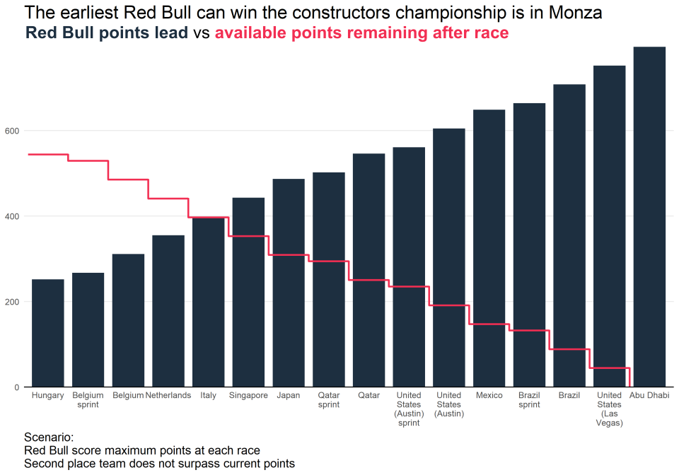

So in that very unlikely scenario Red Bull could take the constructors championship in Monza. But if we look at the proportion of available points each team has scored so far in 2023 and carry that on to the upcoming races, we can make a more realistic prediction.

So far this season, Red Bull have scored 87% of the possible points available as a team – Mercedes (in second place) have only managed to score 43% of the possible points available. If each team’s conversion rate of points continues, Red Bull will win the constructors championship in Japan:

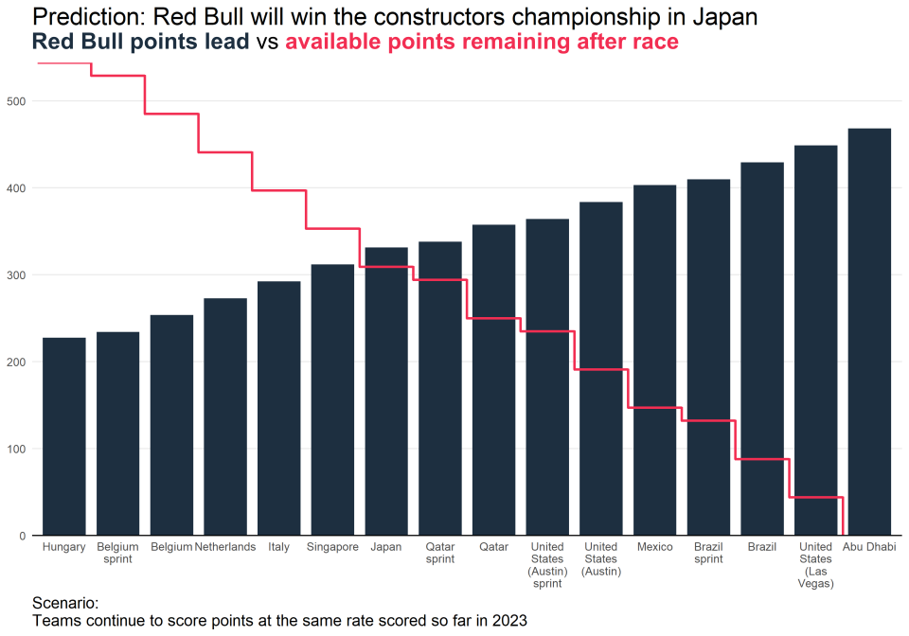

Similarly, the earliest Max can win the wdc is in Singapore. When looking at each driver’s current performance (Max converts 92% of available points, Perez converts 57% in second place) it would be more likely that Max will win the wdc in Qatar.