**INTRODUCTION:**

The AADHAR Card Details Database is designed to store and manage personal information for individuals registered under India's AADHAR system. This database includes details such as the AADHAR number, name, date of birth, gender, nationality, address, and phone numbers. The database ensures relational integrity through primary and foreign keys, linking the main `Person` table to `Address` and `Phone` tables. The goal is to facilitate efficient data storage, retrieval, and management.

Key SQL concepts applied in this project include DDL (Data Definition Language) to define the structure of tables, DML (Data Manipulation Language) for inserting, updating, and deleting data, and TCL (Transaction Control Language) to manage transactions for data consistency. Joins are used to retrieve related data from multiple tables, and views are employed to simplify data access. These concepts work together to maintain data accuracy and integrity in the AADHAR card database.

**CODE:**

mysql> create database aadhar;

Query OK, 1 row affected (0.02 sec)

mysql> use aadhar;

Database changed

mysql> CREATE TABLE Person (

-> Aadhar_Number VARCHAR(12) PRIMARY KEY,

-> Name VARCHAR(50),

-> DOB DATE,

-> Gender VARCHAR(10),

-> Nationality VARCHAR(30)

-> );

Query OK, 0 rows affected (0.04 sec)

mysql> CREATE TABLE Address (

-> Address_ID INT PRIMARY KEY AUTO_INCREMENT,

-> Aadhar_Number VARCHAR(12),

-> Street VARCHAR(100),

-> City VARCHAR(50),

-> Pincode VARCHAR(6),

-> FOREIGN KEY (Aadhar_Number) REFERENCES Person(Aadhar_Number)

-> );

Query OK, 0 rows affected (0.20 sec)

mysql> CREATE TABLE Phone (

-> Phone_ID INT PRIMARY KEY AUTO_INCREMENT,

-> Aadhar_Number VARCHAR(12),

-> Phone_Type VARCHAR(10),

-> Phone_Number VARCHAR(15),

-> FOREIGN KEY (Aadhar_Number) REFERENCES Person(Aadhar_Number)

-> );

Query OK, 0 rows affected (0.05 sec)

mysql> INSERT INTO Person (Aadhar_Number, Name, DOB, Gender, Nationality)

-> VALUES

-> ('123456789012', 'John Doe', '1980-05-15', 'Male', 'Indian'),

-> ('234567890123', 'Jane Smith', '1985-10-20', 'Female', 'Indian'),

-> ('345678901234', 'Alice Brown', '1990-07-25', 'Female', 'Indian');

Query OK, 3 rows affected (0.02 sec)

Records: 3 Duplicates: 0 Warnings: 0

mysql> INSERT INTO Address (Aadhar_Number, Street, City, Pincode)

-> VALUES

-> ('123456789012', '123 Baker Street', 'New York', '10001'),

-> ('234567890123', '456 Elm Street', 'Los Angeles', '90001'),

-> ('345678901234', '789 Oak Street', 'Chicago', '60616');

Query OK, 3 rows affected (0.01 sec)

Records: 3 Duplicates: 0 Warnings: 0

mysql> INSERT INTO Phone (Aadhar_Number, Phone_Type, Phone_Number)

-> VALUES

-> ('123456789012', 'Mobile', '9876543210'),

-> ('234567890123', 'Mobile', '9876543211'),

-> ('345678901234', 'Home', '9876543222');

Query OK, 3 rows affected (0.01 sec)

Records: 3 Duplicates: 0 Warnings: 0

mysql> UPDATE Person

-> SET Nationality = 'American'

-> WHERE Aadhar_Number = '345678901234';

Query OK, 1 row affected (0.01 sec)

Rows matched: 1 Changed: 1 Warnings: 0

mysql> DELETE FROM Address

-> WHERE Aadhar_Number = '345678901234';

Query OK, 1 row affected (0.01 sec)

mysql> START TRANSACTION;

Query OK, 0 rows affected (0.00 sec)

mysql> INSERT INTO Person (Aadhar_Number, Name, DOB, Gender, Nationality)

-> VALUES ('456789012345', 'Bob Martin', '1982-11-13', 'Male', 'Indian');

Query OK, 1 row affected (0.00 sec)

mysql> INSERT INTO Address (Aadhar_Number, Street, City, Pincode)

-> VALUES ('456789012345', '101 Maple Ave', 'San Francisco', '94103');

Query OK, 1 row affected (0.00 sec)

mysql> COMMIT;

Query OK, 0 rows affected (0.00 sec)

mysql> START TRANSACTION;

Query OK, 0 rows affected (0.00 sec)

mysql> INSERT INTO Person (Aadhar_Number, Name, DOB, Gender, Nationality)

-> VALUES ('567890123456', 'Charlie Blue', '1995-09-12', 'Male', 'Indian');

Query OK, 1 row affected (0.00 sec)

mysql> ROLLBACK;

Query OK, 0 rows affected (0.00 sec)

mysql> CREATE VIEW Person_Address_View AS

-> SELECT Person.Name, Person.DOB, Address.Street, Address.City, Address.Pincode

-> FROM Person

-> JOIN Address ON Person.Aadhar_Number = Address.Aadhar_Number;

Query OK, 0 rows affected (0.01 sec)

mysql> SELECT * FROM Person_Address_View;

+------------+------------+------------------+---------------+---------+

| Name | DOB | Street | City | Pincode |

+------------+------------+------------------+---------------+---------+

| John Doe | 1980-05-15 | 123 Baker Street | New York | 10001 |

| Jane Smith | 1985-10-20 | 456 Elm Street | Los Angeles | 90001 |

| Bob Martin | 1982-11-13 | 101 Maple Ave | San Francisco | 94103 |

+------------+------------+------------------+---------------+---------+

3 rows in set (0.00 sec)

mysql> SELECT Person.Name, Address.Street, Address.City

-> FROM Person

-> INNER JOIN Address ON Person.Aadhar_Number = Address.Aadhar_Number;

+------------+------------------+---------------+

| Name | Street | City |

+------------+------------------+---------------+

| John Doe | 123 Baker Street | New York |

| Jane Smith | 456 Elm Street | Los Angeles |

| Bob Martin | 101 Maple Ave | San Francisco |

+------------+------------------+---------------+

3 rows in set (0.00 sec)

mysql> SELECT Person.Name, Phone.Phone_Number, Phone.Phone_Type

-> FROM Person

-> LEFT JOIN Phone ON Person.Aadhar_Number = Phone.Aadhar_Number;

+-------------+--------------+------------+

| Name | Phone_Number | Phone_Type |

+-------------+--------------+------------+

| John Doe | 9876543210 | Mobile |

| Jane Smith | 9876543211 | Mobile |

| Alice Brown | 9876543222 | Home |

| Bob Martin | NULL | NULL |

+-------------+--------------+------------+

4 rows in set (0.00 sec)

mysql> SELECT Phone.Phone_Number, Phone.Phone_Type, Person.Name

-> FROM Phone

-> RIGHT JOIN Person ON Phone.Aadhar_Number = Person.Aadhar_Number;

+--------------+------------+-------------+

| Phone_Number | Phone_Type | Name |

+--------------+------------+-------------+

| 9876543210 | Mobile | John Doe |

| 9876543211 | Mobile | Jane Smith |

| 9876543222 | Home | Alice Brown |

| NULL | NULL | Bob Martin |

+--------------+------------+-------------+

4 rows in set (0.00 sec)

mysql> SELECT Person.Name, Address.Street, Address.City

-> FROM Person

-> LEFT JOIN Address ON Person.Aadhar_Number = Address.Aadhar_Number

-> UNION

-> SELECT Person.Name, Address.Street, Address.City

-> FROM Person

-> RIGHT JOIN Address ON Person.Aadhar_Number = Address.Aadhar_Number;

+-------------+------------------+---------------+

| Name | Street | City |

+-------------+------------------+---------------+

| John Doe | 123 Baker Street | New York |

| Jane Smith | 456 Elm Street | Los Angeles |

| Alice Brown | NULL | NULL |

| Bob Martin | 101 Maple Ave | San Francisco |

+-------------+------------------+---------------+

4 rows in set (0.00 sec)

**ER DIAGRAM:**

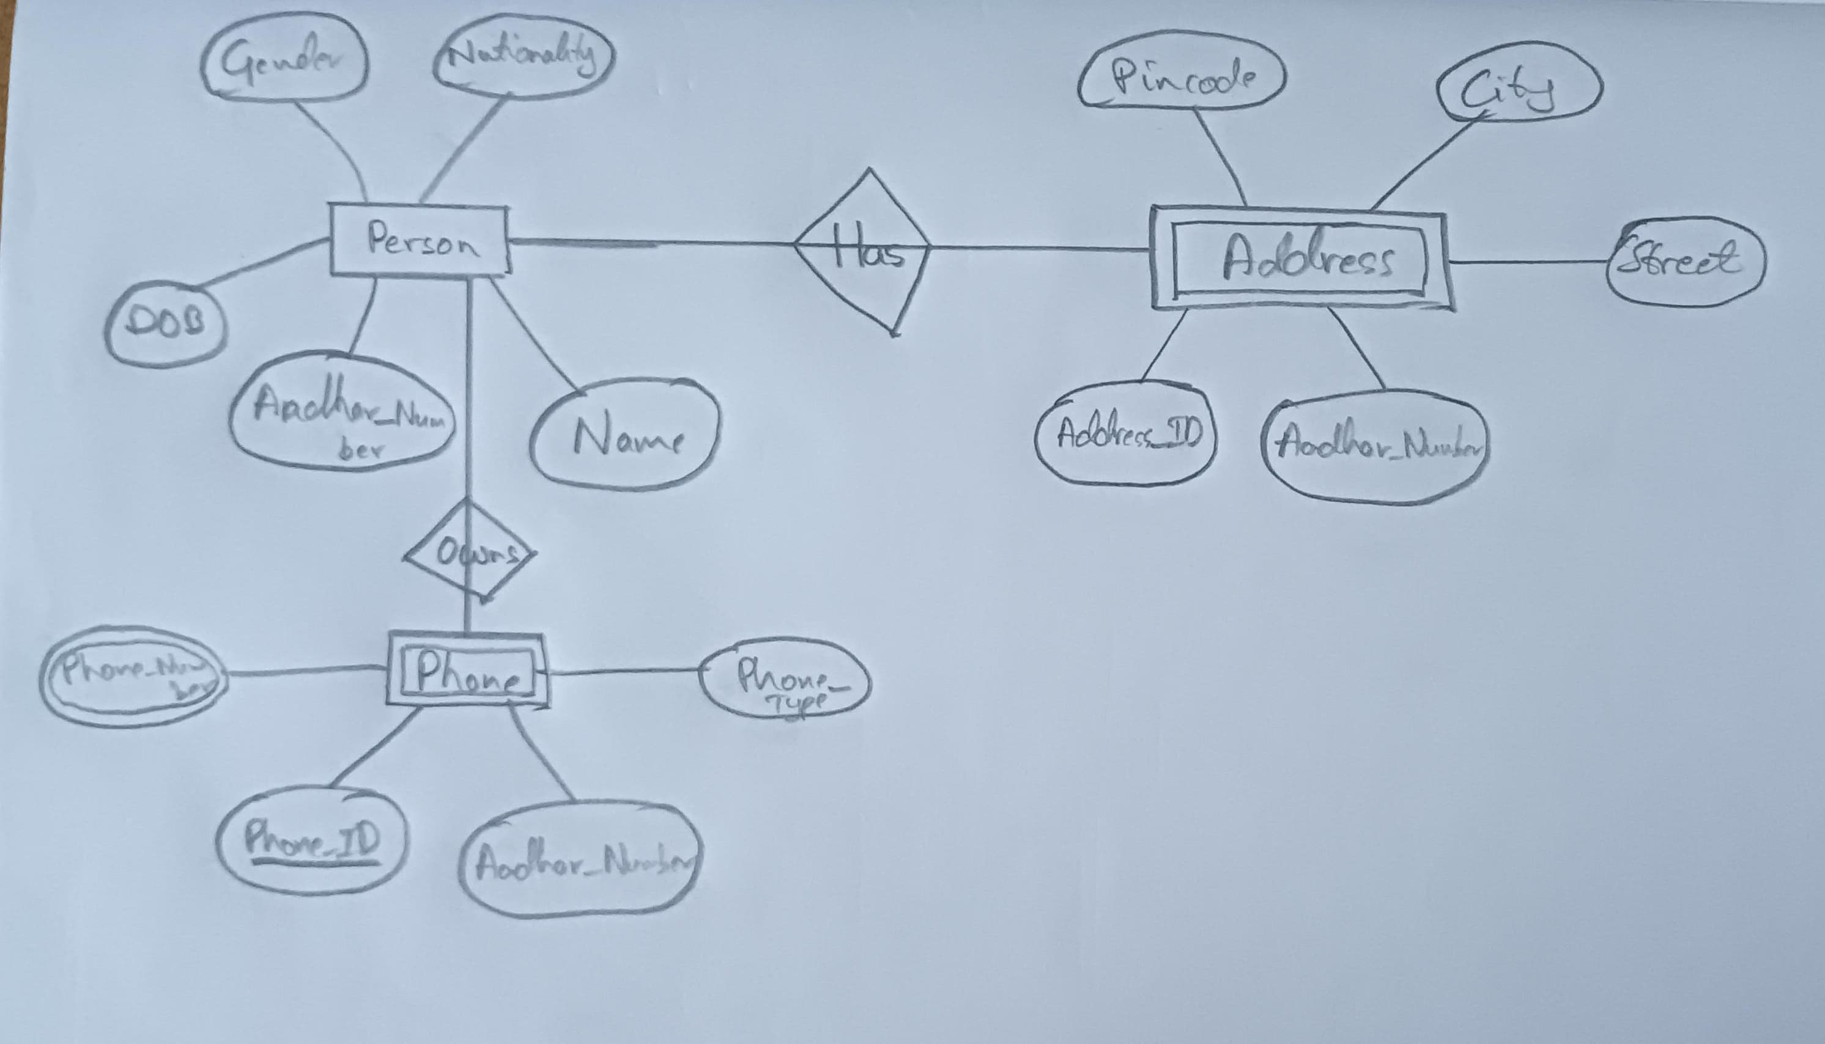

**GITHUB LINK:**

<https://github.com/joeljinjose/2341313_DBMS-Assignment_AadharDatabase.git>