What is Slack?

Slack is a messaging app for business that connects people to the information that they need. By bringing people together to work as one unified team, Slack transforms the way that organisations communicate.

GITHUB repo: <https://github.com/joeljohn159/SlackClone.git>

1. HOME Page Open <https://slack.com/intl/en-in>.

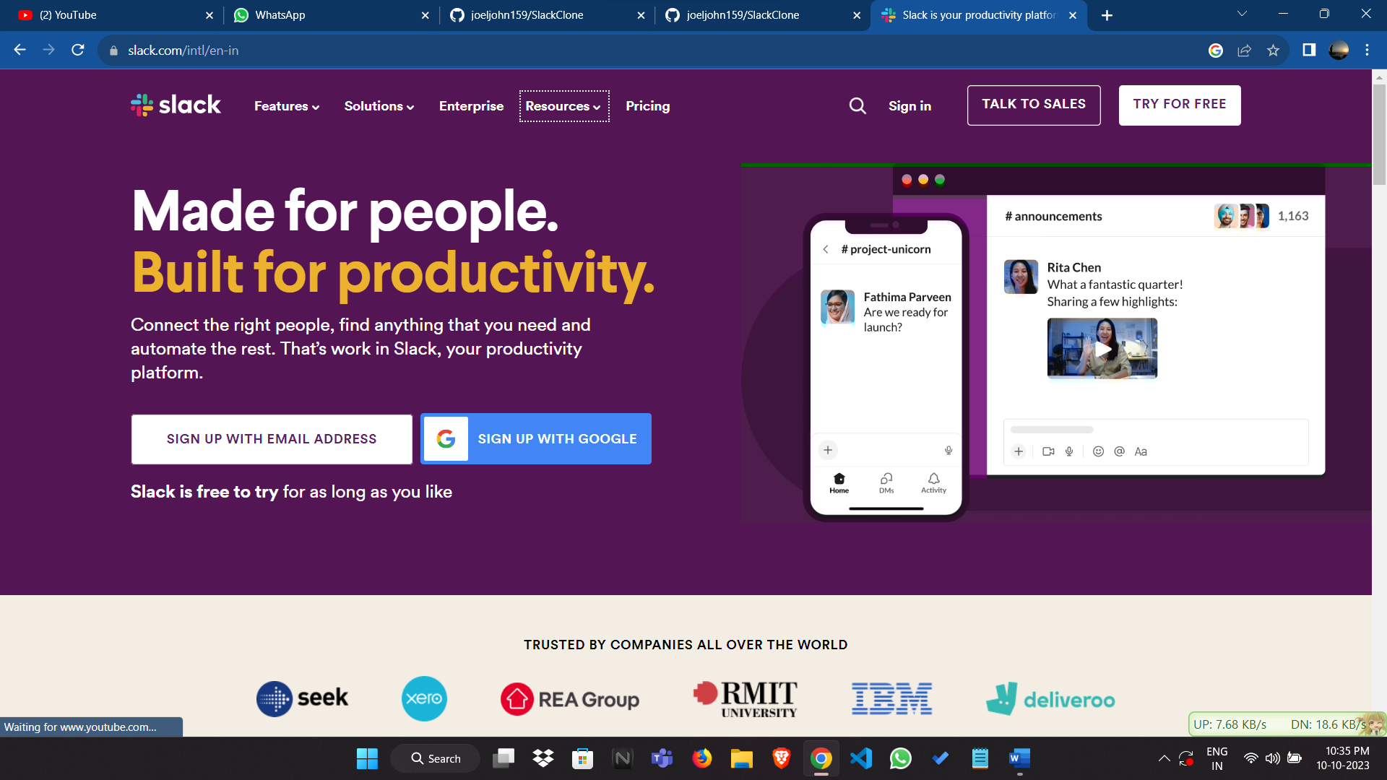

1. Sign In/Log in - <https://slack.com/signin>

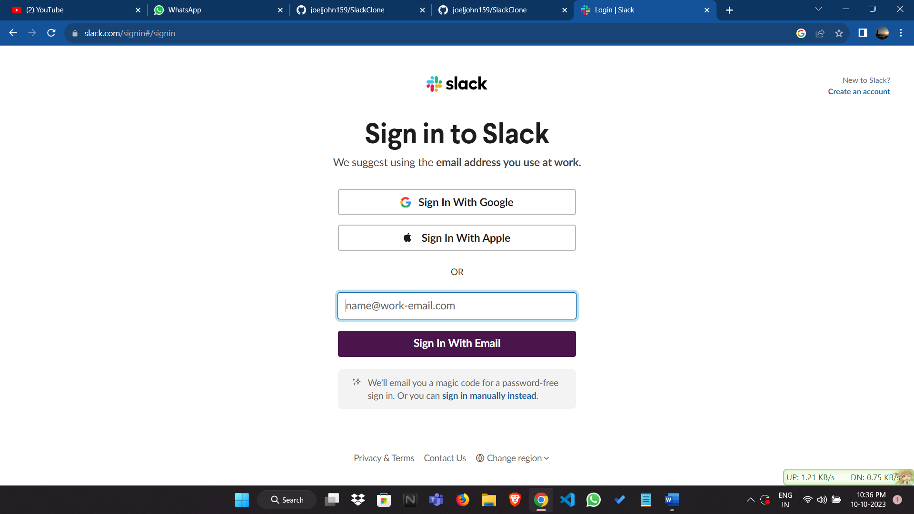 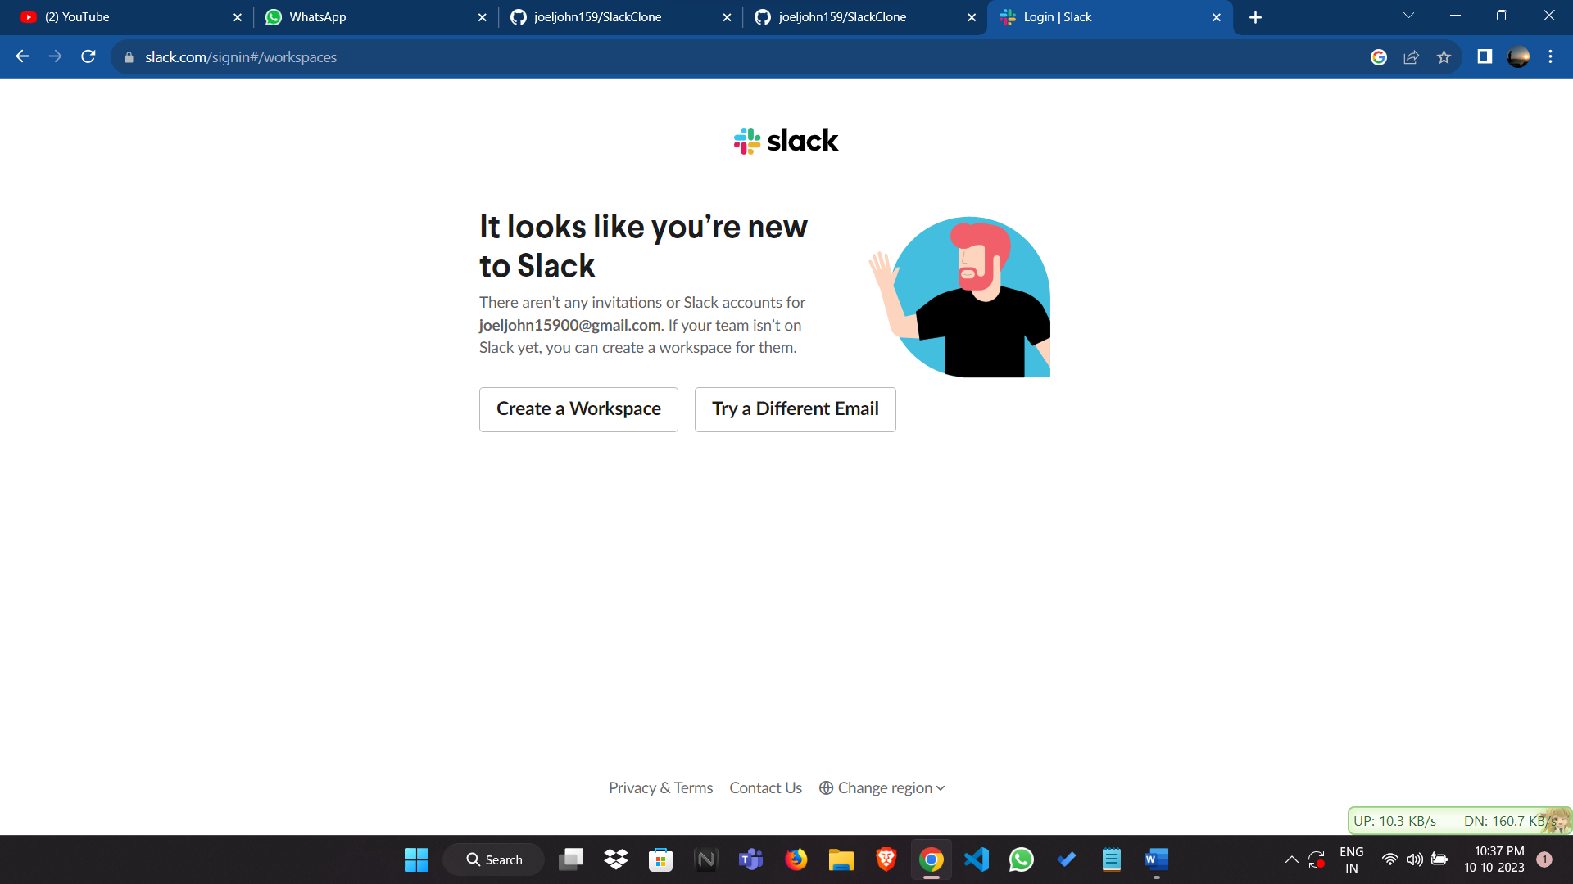

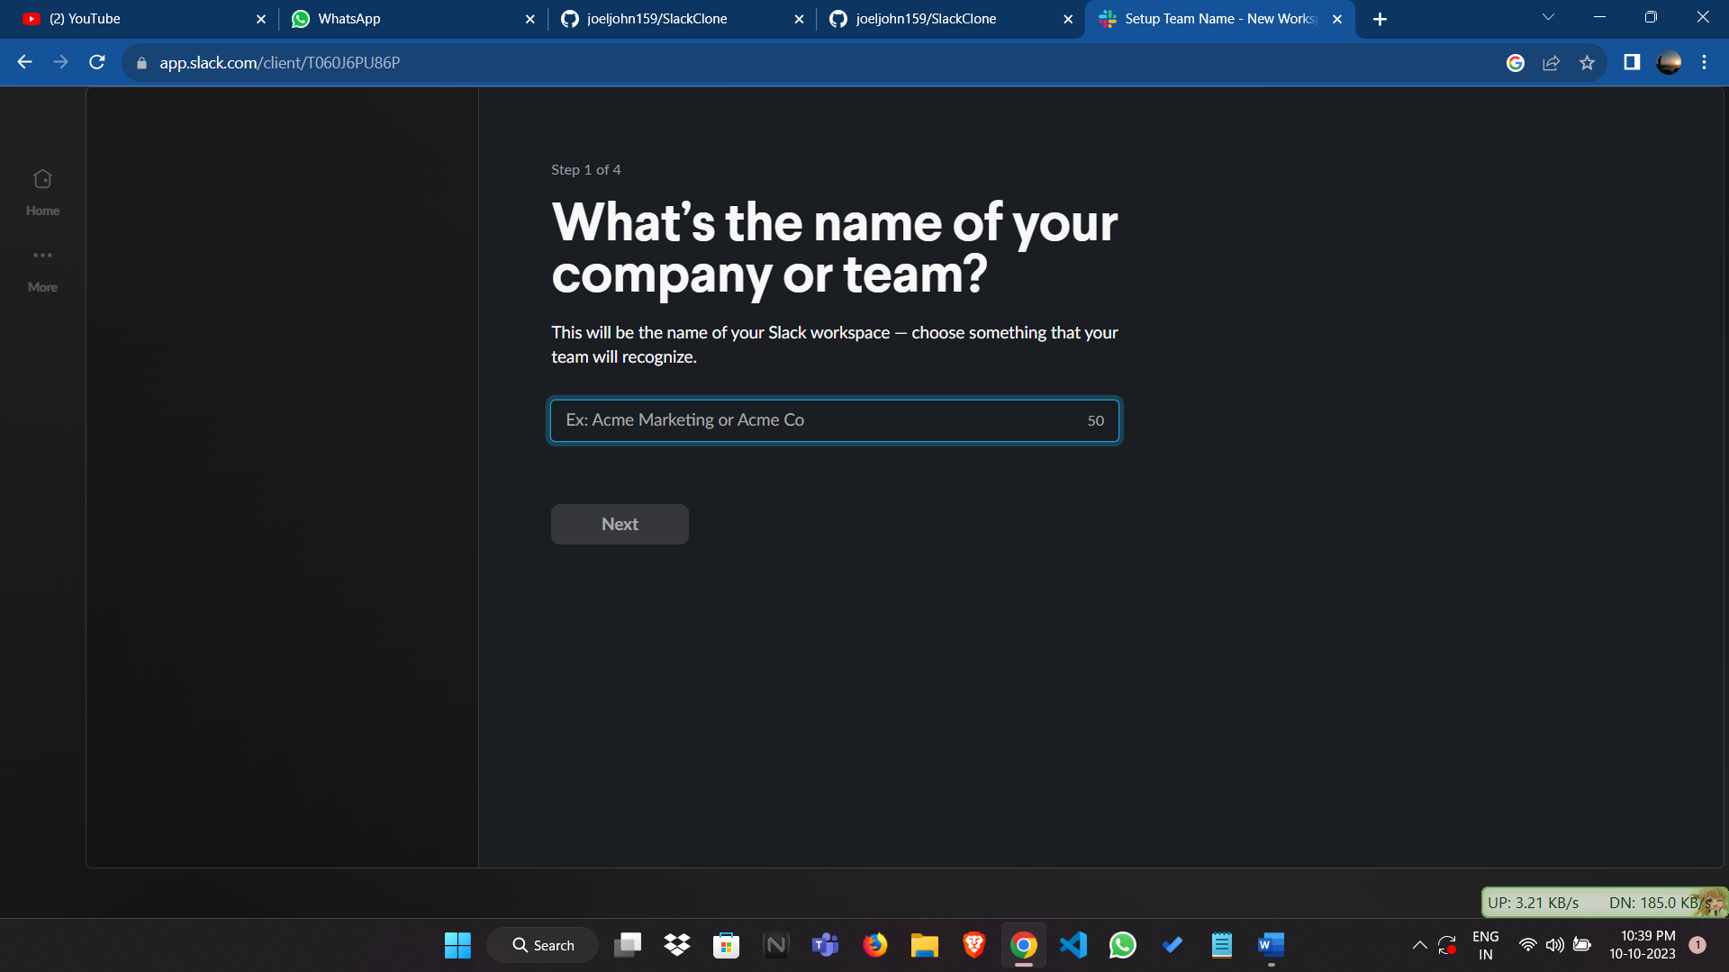

1. Post Login

