CS3223 SimpleDB+ Join Experiments
Oct 23, 2026 · @Joel
Index join was the fastest join algorithm in both experiments: 8 ms for the 2-table join and 41 ms for the 4-table join. Sort-merge join was the slowest, at 805 ms for the 2-table join.

Setup
All timings were measured in Eclipse on the SimpleDB+ engine with its default configuration: 8 buffers of 400 bytes and the heuristic query planner.
Database. The provided student database has only 9 students, too few to tell the algorithms apart. We used a larger copy of the same schema, generated by CreateBigStudentDB with a fixed random seed.
Table | Rows | Blocks | Index
STUDENT | 600 | 47 | hash on MajorId
ENROLL | 900 | 50 | B-tree on StudentId
COURSE | 90 | 9 | none
DEPT | 30 | 2 | none
Restricting join methods. JoinStrategy limits the optimizer to one join algorithm: index, sort-merge, hash (partition-based) or nested loops. Where the allowed algorithm cannot be used for a join, the optimizer falls back to nested loops.
Timing. JoinExperiments runs each configuration once to warm up, then 5 timed runs, each planning the query and reading every result row. We report the median.

Experiment 1: 2-table join
Index join ran the 2-table join in 8 ms and sort-merge in 805 ms. Every algorithm returned the same 900 rows.
select sname, grade from student, enroll where sid = studentid
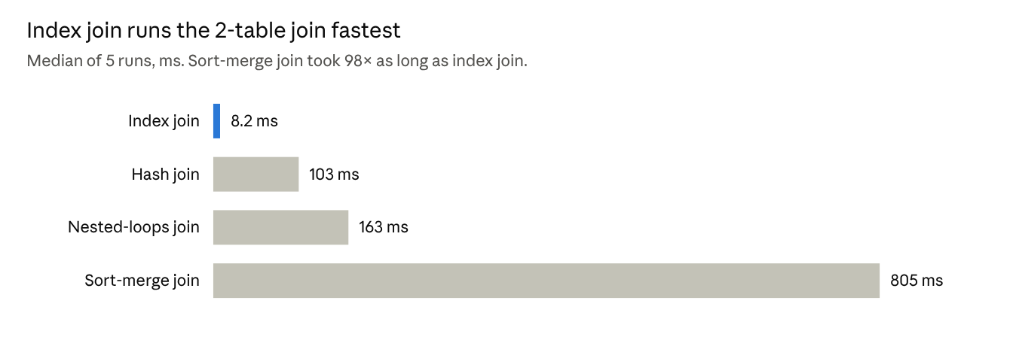
JoinExperiments in Eclipse, 2026-10-23 · median of 5 timed runs after 1 warm-up
Join algorithm | Plan used
Index | for each STUDENT row, look up ENROLL through the B-tree index on StudentId
Sort-merge | sort STUDENT by SId and ENROLL by StudentId, then merge
Hash | partition both tables on the join field, then join each partition pair
Nested loops | scan all of ENROLL once per STUDENT row

Experiment 2: 4-table join
Of the three plans, Plan A (index joins) took 41 ms, Plan B (hash) 316 ms and Plan C (nested loops) 727 ms. Every plan returned the same 2,805 rows. The big database has no SECTION table, so the join links ENROLL, STUDENT, DEPT and COURSE.
select sname, dname, title, grade from student, enroll, dept, course
where sid = studentid and majorid = did and did = deptid
Each plan comes from restricting the optimizer to one join algorithm. The restriction changed the join order as well as the algorithm:
Plan | Join methods allowed | Join order and algorithms (⋈ = join)
A | index only | ((DEPT ⋈ STUDENT by hash index on MajorId) ⋈ ENROLL by B-tree index on StudentId) ⋈ COURSE by nested loops
B | hash only | ((DEPT ⋈ COURSE) ⋈ STUDENT) ⋈ ENROLL, all hash joins
C | nested loops only | ((DEPT ⋈ COURSE) ⋈ STUDENT) ⋈ ENROLL, all nested loops
Plan A has no index for the COURSE join (DeptId is not indexed), so the optimizer fell back to nested loops for that step.
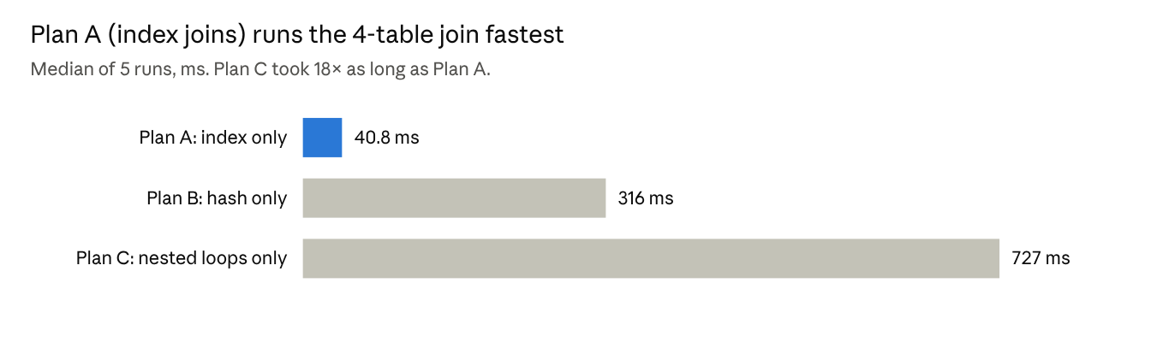
JoinExperiments in Eclipse, 2026-10-23 · median of 5 timed runs after 1 warm-up

Discussion
The ranking was consistent: index join was fastest in both experiments and hash join beat nested loops in both. Sort-merge, measured in Experiment 1, was slowest.
Why sort-merge is slow. Sorting first splits each input into many short sorted runs, each written to its own temporary table, then merges them two at a time until one run is left. With 8 buffers every merge pass writes and re-reads all records through new temporary files, which costs far more than the merge itself.
Why index join is fastest. Each STUDENT row needs one index lookup, which matches on average 1.5 ENROLL rows. The index pages are small and reused by every lookup, so they stay cached, and no temporary files are written.
Hash against nested loops. Hash join reads each input once and writes it into partition files. Nested loops re-reads ENROLL's 50 blocks for each of the 600 students, about 30,000 block reads, yet was only 1.6 times slower in Experiment 1. ENROLL is only 20 KB, so those reads were most likely served from the operating system's file cache.
Join order in Experiment 2. Restricting to index joins also changed the join order. Plan A starts from DEPT (30 rows) and follows the two indexes, touching only matching rows. Plans B and C join DEPT and COURSE first, then STUDENT and ENROLL, so each step processes a larger intermediate result.

