**Unity Assests for Body organs**

1. <https://assetstore.unity.com/packages/3d/characters/humanoids/human-organ-system-urp-204215>

Unity assest store

cost: **€44.40**

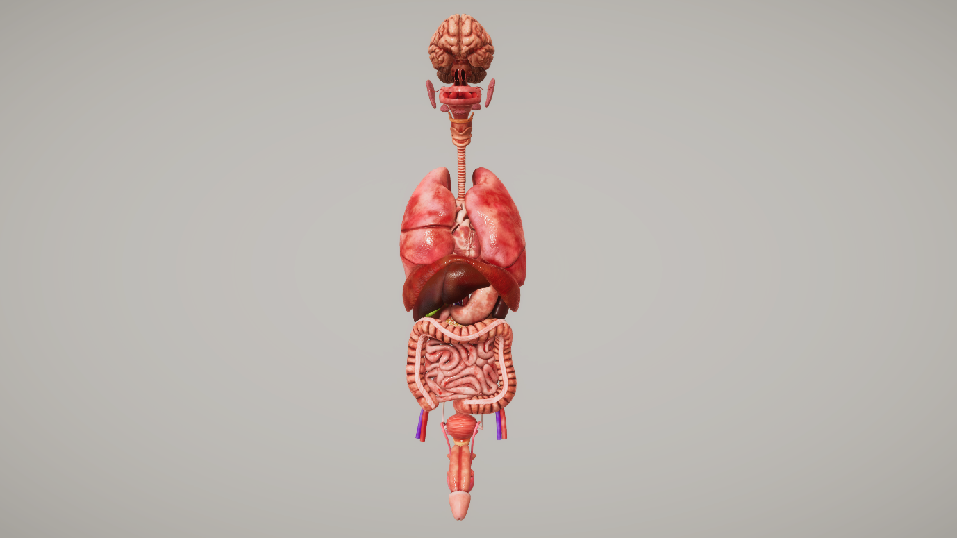

**Description**

This pack consists of a Realistic looking human organ system consisting ofthe**Brain, Heart, Lung, Digestive system, Respiratory system, and Excretory System.**

These models are optimized to be compatible with**AR, VR, Games, and 3D animation purposes.**

Each organ and the above-mentioned system can also be used individually as per the requirement.

**Texture Detail**

The Pack comes with high-quality PBR textures in 2K and 4K resolutions along with the following texture variations for the following

3 texture variations for Brain

2 texture variations for Heart

2 texture variations for Lungs

Pack also consists of a **cross-section view of the heart and the brain** which can be used to demonstrate the internal parts and their functionality.

**The given different textures can be used to show the condition of the body organ from healthy, infected state, critical state.**

**Render pipeline compatibility**

The Built-in Render Pipeline is Unity’s default render pipeline. It is a general-purpose render pipeline that has limited options for customization. The Universal Render Pipeline (URP) is a Scriptable Render Pipeline that is quick and easy to customize, and lets you create optimized graphics across a wide range of platforms. The High Definition Render Pipeline (HDRP) is a Scriptable Render Pipeline that lets you create cutting-edge, high-fidelity graphics on high-end platforms.

License agreement

[Standard Unity Asset Store EULA](https://unity.com/legal/as-terms)

License type

Single Entity

File size

597.0 MB

Latest version

1.0

Latest release date

Nov 4, 2021

Original Unity version

2019.4.0 or higher

Support

<https://www.devdensolutions.com/>

Advantage:

1. Almost covers the body organs.
2. Has more than one texture Variation for Brain, Lungs, and Heart.
3. Comparatively less expensive than other assests available.

Disadvantage:

1. Doesn’t have skeleton structure available.
2. <https://de.3dexport.com/3dmodel-human-anatomy-animated-skeleton-internal-organs-117499.htm>

3D export

Cost: $649

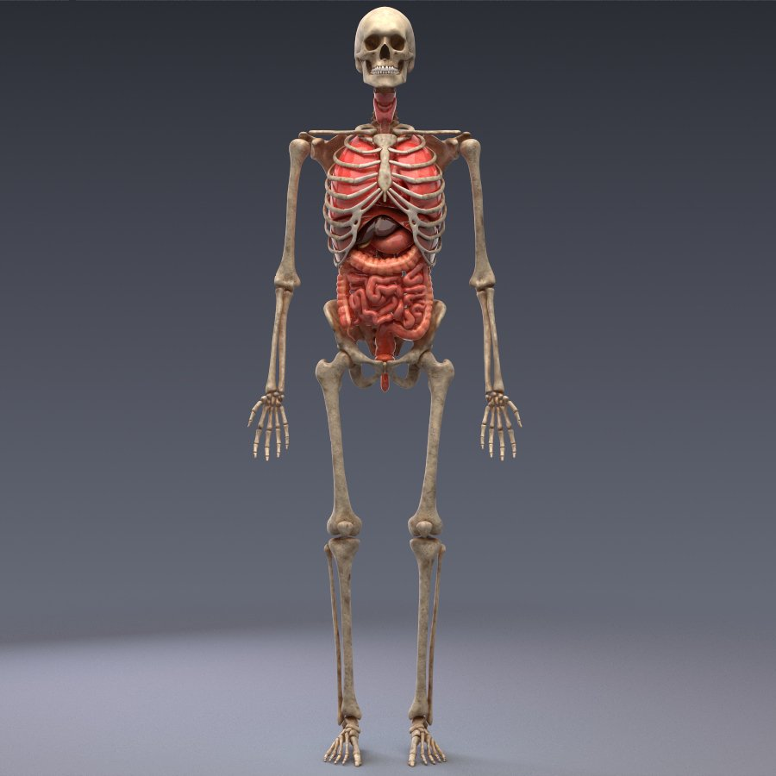

Features:

anatomically accurate, realistic 3d model of human internal organs and skeleton.  
  
all organs are animated and loopable. animation includes:  
- anatomically accurate movement of the chest  
- breathing lungs  
- moving diaphragm  
- beating heart  
- peristaltic waves of colon and small intestine  
- other organs realistically moves depending on the movement of a diaphragm  
  
model have high resolution textures (4k) and materials with sub-surface scattering effect. ready for 3d medical presentations.  
  
model accurately unwrapped.  
  
accurate quad-poly mesh is good for turbosmoothing.  
  
animation, lighting setup, sss-materials and render settings presented 3ds max 2014 format. the scene is using vray renderer and free plugin 'colorcorrect'. other formats do not require the plugins.  
  
  
available formats:  
- 3ds max 2014 with vray renderer  
- 3ds max 2014 scanline renderer  
- 3ds  
- fbx  
- obj  
- cinema4d

Advantage:

1. Can be used to show some simulation with animation
2. Has skeleton structure as well which can we used to show some bone or joint related health issues.

Disadvantage:

1. Very expensive
2. Doesn’t have brain structure included

1. <https://www.turbosquid.com/3d-models/human-anatomy-3d-model/545990>

Turbosquid by shutterstock

Cost:$199

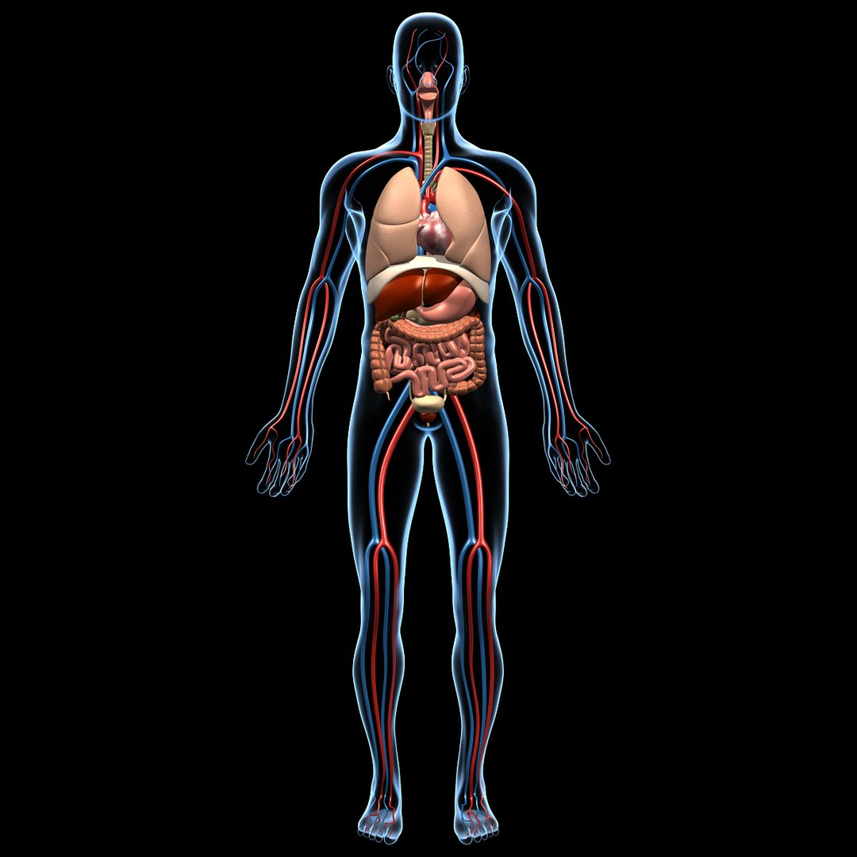

Features:  
1. Heart is animated using morph targets set up appropriately in the respective 3D applications.  
2. A transparent human model is included to give a sense of the organ's location, without cluttering the important details inside.  
3. Optimized subdivision cage gives smooth edges even in high definition. Just step up the subdivision levels.  
4. Heart is textured and bump mapped with 2048 x 2048 image. Materials are applied to all objects.  
5. Clean topology. Only tris & quads used.  
6. Modelled to real world scale.

Format Maya 2018

3D MODEL SPECIFICATIONS

18,168 Polygons17,472 Vertices Subdivision

Animated Textures Materials UV Mapped Non-overlapping Unwrapped UVs

Animated

The original model is smoothened using subdivision, which renders exactly like the preview images, and yet preserving the original low mesh density like the wireframe preview.  
  
The user only need to crank up the subdivision to get a high poly and detailed mesh for rendering, OR crank down the subdivision for a low poly mesh while animating.

Advantage:

1. Modelled the organs with real world scale
2. Covers almost body organs
3. Contains cardio vascular and circulatory system can be used to show arteries veins related symptom.

Disadvantage:

1. Not realistic enough
2. Doesn’t include skeleton structure model
3. Expensive compared to other assests available
4. Brain model not available
5. <https://creazilla.com/nodes/3975-human-organs-3d-model>

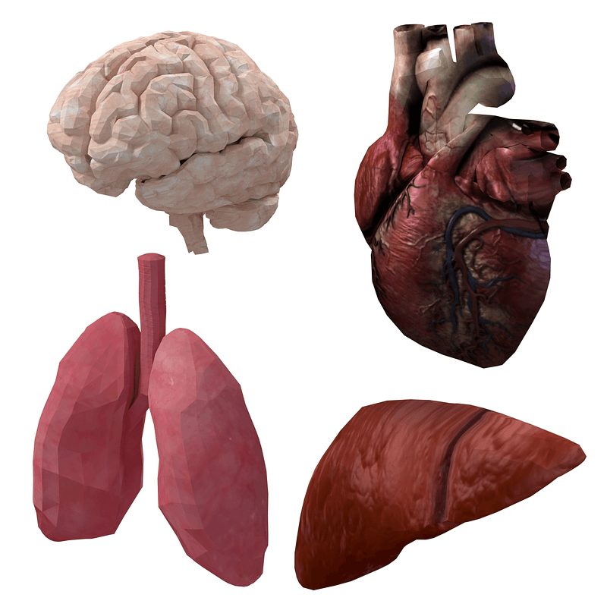

The 3D Pack includes human heart, brain, liver and lungs.

License:

Creazilla Open-Source License. Free for editorial, educational, commercial, and/or personal projects. No attribution required.

Format

FBX, STL, OBJ

Polygons

5287 (Low), 271552 (High)

Vertices

2850 (Low), 135734 (High)

Textures

Yes

UV Mapped

Yes

Size

1.1 (X), 2.4 (Y), 1.5 (Z)

Game Ready

Yes

3D Print Ready

Yes

**For Feedback scene**

Any changes in the organ can be shown in the form of color change from light to dark where light implies healthy and dark implies unhealthy.

**Human Avatar**

1. <https://www.cgtrader.com/3d-model-collections/fat-people-pack>

cost :$18

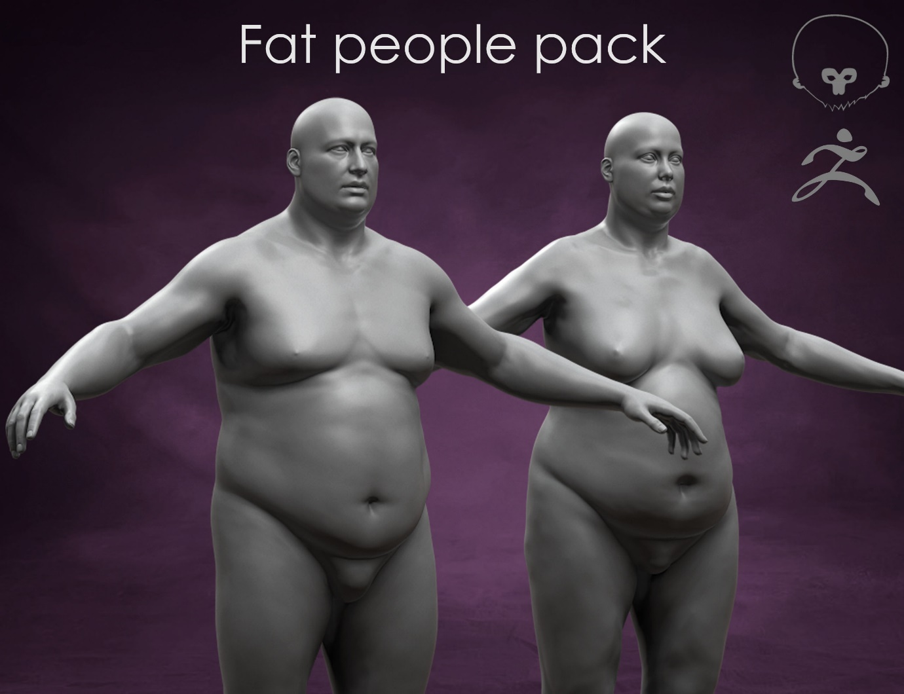

Description:

Originally created with Zbrush.

* High quality 3d models of Fat people.
* Ideal high poly basemeshes for your projects.

Each model has: Polygons: 1kk Vertices : 1kk

Geometry: Polygonal Quads/Tris

File formats:

* FBX
* ZTL
* .tbscene (Marmoset)

All Models and materials have logical names.

Rendered in Marmoset.

1. <https://www.cgtrader.com/3d-model-collections/men-basemeshes-pack>

**cost: $35.00**

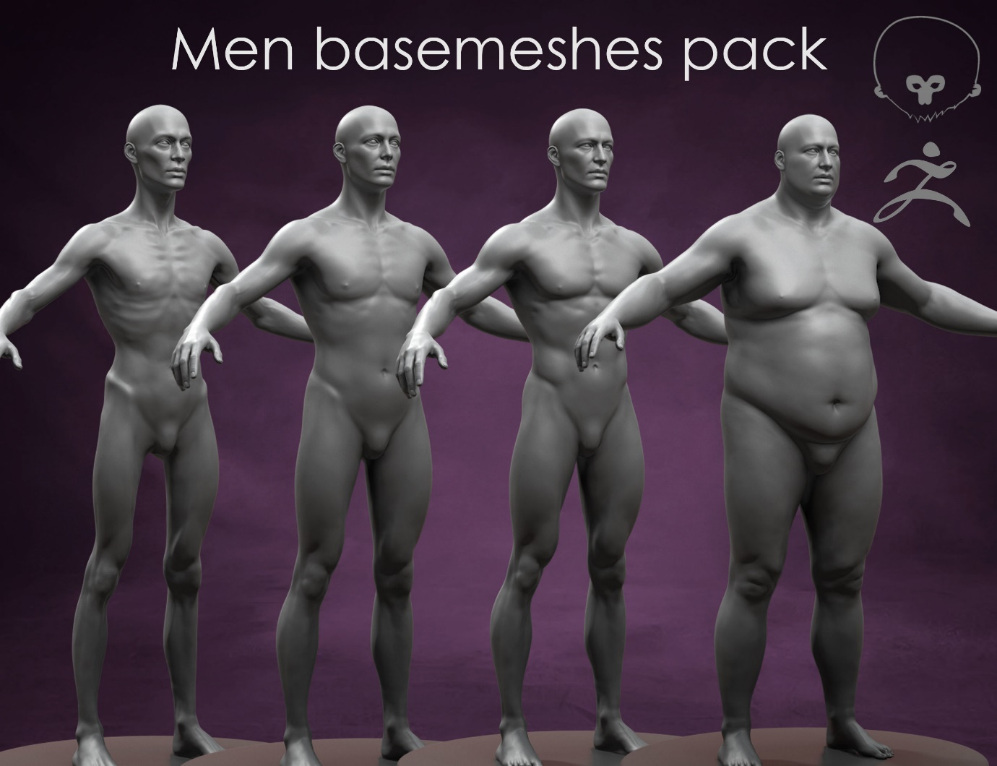

Description:

Originally created with Zbrush.

* High quality 3d models of Different men.
* Ideal high poly basemeshes for your projects.

Each model has: Polygons: 1kk Vertices : 1kk

Geometry: Polygonal Quads/Tris

File formats:

* FBX
* ZTL
* .tbscene (Marmoset)

All Models and materials have logical names.

1. <https://www.cgtrader.com/3d-model-collections/basemeshes-big-pack>

cost: $ 69

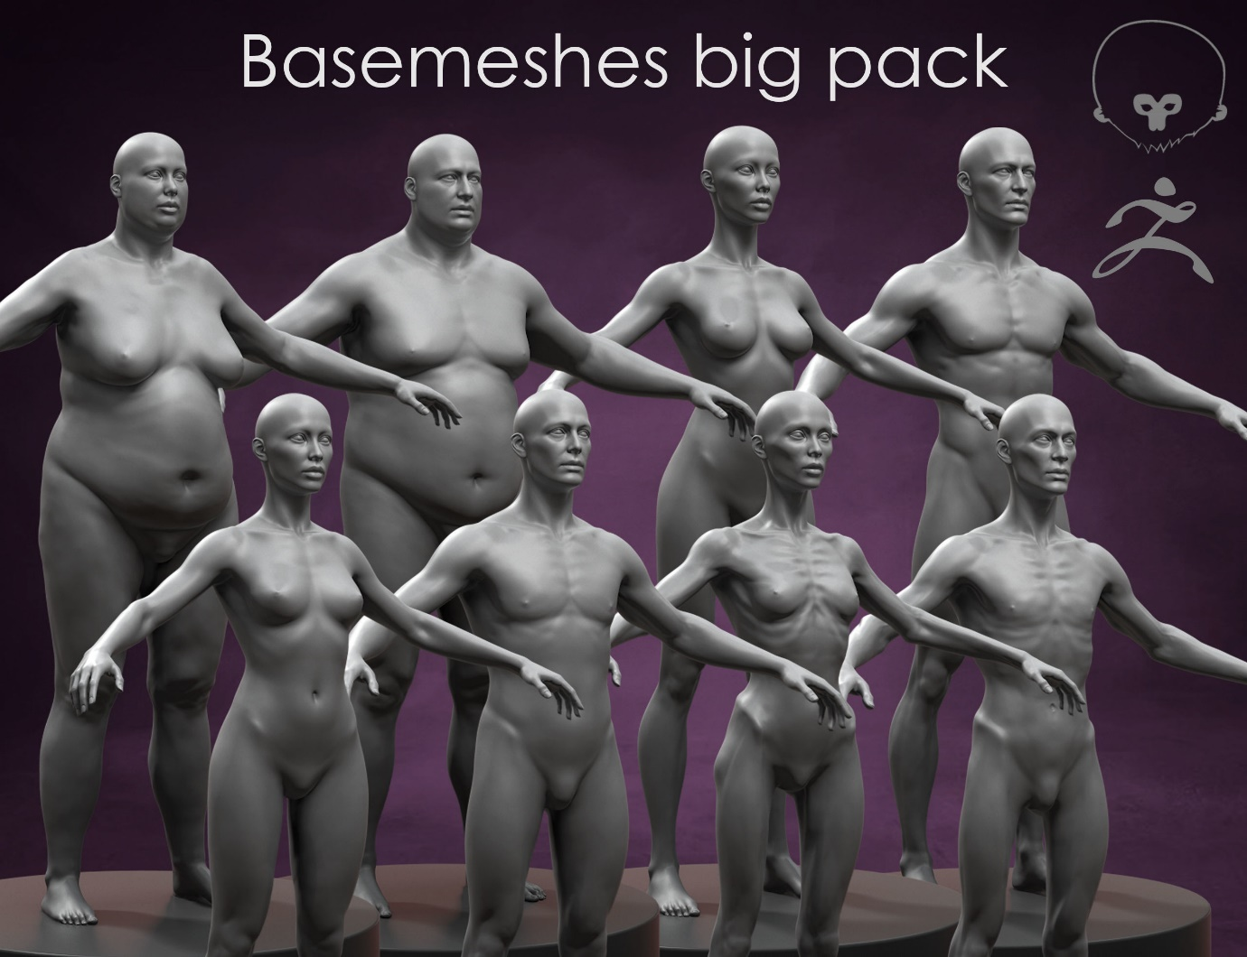

**Description**

Originally created with Zbrush.

High quality 3d models of people. Ideal high poly basemeshes for your projects.

Each model has: Polygons: 1kk Vertices : 1kk

Geometry: Polygonal Quads/Tris

File formats:

FBX ZTL .tbscene (Marmoset)

All Models and materials have logical names.

Rendered in Marmoset.

* [humanoid](https://www.cgtrader.com/3d-models/humanoid)
* [basemesh](https://www.cgtrader.com/3d-models/basemesh)

1. <https://www.cgtrader.com/free-3d-models/character/anatomy/human-basemesh-82a31443-07af-4151-81f9-16bc2ec880f9> (free low poly)

**Description of the model**

* subdivision level : 0 and 1
* The formats included are:
* - 3ds Max
* - OBJ
* - FBX
* 100% quads, clean topology, subdivision ready
* This model consists primarily of quads.
* The number of polygons in the models is 29000

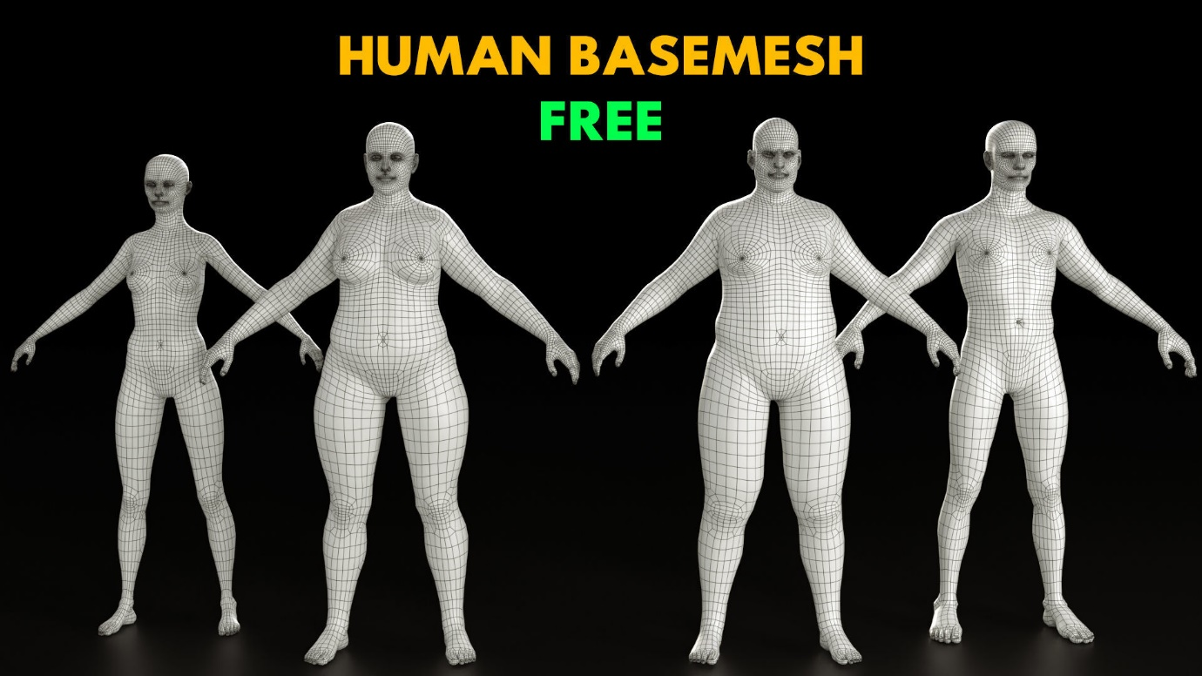

Can be used as a base for human avatar.

Has 2 variations of healthy and unhealthy model of human.

1. <https://www.cgtrader.com/free-3d-models/character/anatomy/topology-bundle>

Description:

Mesh model

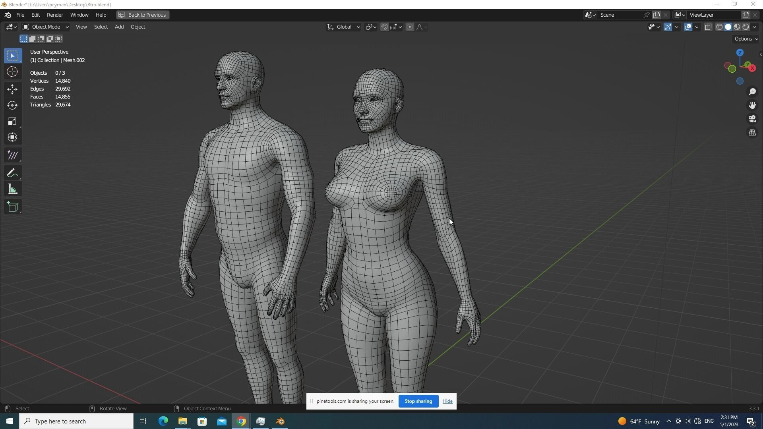

Can be used as a base for Human avatar model.

1. <https://www.cgtrader.com/free-3d-models/character/man/humanoid-template> (Free)

**Description**

The contents include a female and male template character.

No Material or Textures.

This serves as a quick starting point for modelling.

Made with MakeHuman and Blender

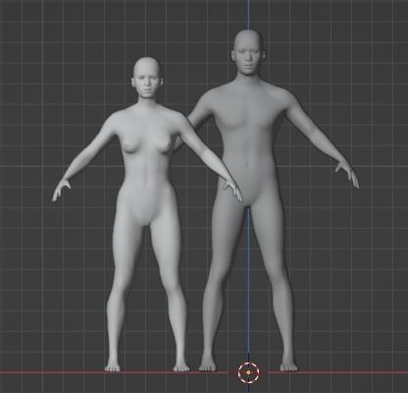

Can be used as a base of human avatar model.

**For Feedback scene**

Any changes in the body can be shown by body area growth ex: stomach enlargement, by scaling certain part of the body which is affected or can be shown by the overall body change from being healthy to unhealthy.