April 18th, 2024

**Comfort Airlines**

**User Manual**

Client: Professor Michael Oudshoorn

Contractors: Byte Me - Joellen A., Kyle B., Hanna Z., Alex H., Joshua T., JR V.

**About User Manual**

The "Comfort Airlines User Manual" is designed and created by the software development team Byte Me. This manual guides users through the installation, setup, and utilization of Docker-based software for managing airline operations. It includes detailed steps for downloading, setting up Docker Desktop, and unpacking project files. Users will learn how to run essential scripts, navigate the website's GUI, and troubleshoot common issues. The manual aims to empower users to efficiently manage flight schedules, monitor daily operations, and access financial reports through the Comfort Airlines system.

**.**

**.**

**.**

**.**

**.**

**.**

**.**

**.**

**.**

**.**

**.**

**.**

**.**

**.**

**.**

**.**

**.**

**.**

**.**

**.**

**.**

**.**

**Table of Content**

Title Page………………………………………………………………….Pg.1

Table of Content…………………………………………………………..Pg.2

Getting Started…………………………………………………………….Pg.3

Before you begin……………………………………………………..Pg.3-4

Setting Up The Project……………………………………………………Pg.4

Unpacking the Project…………………………………………………...Pg.4

MacBook - Setup Continued……………………………………………...Pg.5

Running the project……………………………………………………..Pg.5

Windows - Setup Continued………………………………………………Pg.5

Running the project…………………………………………………...Pg.5-6

Both MacBook and Windows Continue Here…………………………….Pg.6

Using the website / GUI……………………………………………….Pg.6-7

Key Sections Of the Website / GUI………………………………………Pg.7

Four Tabs of the Navigation Bar……………………………………….Pg.7-14

Troubleshoot Issues……………………………………………………...Pg.14

General Navigation Tips…………………………………………………Pg.15

Support…………………………………………………………………..Pg.15

**Getting Started**

Before you begin

We will be installing and running software that will run the docker we created. A docker is basically a box where we put our software (which includes our website and data).

1. Download Docker Desktop software is installed on your computer. Download item here: <https://www.docker.com/products/docker-desktop/>. When clicking on the link, you will be directed to a webpage that looks like image 1 below.
   1. If it is already installed, feel free to skip steps 2-3

Docker Desktop is a software tool that helps us software engineers develop this docker. It works as a manager to ensure our docker and all components of our software smoothly work together.

Image 1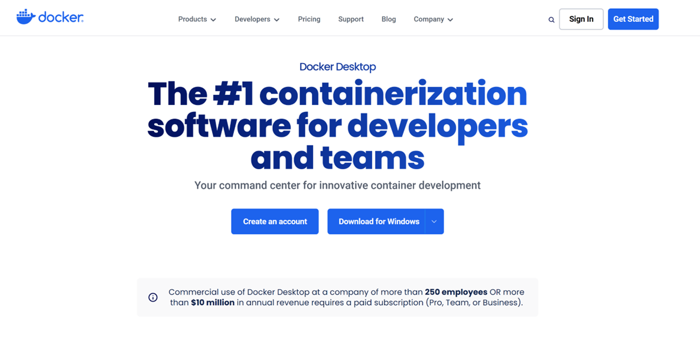

1. Once you arrive at this page follow steps 2a if you have a Windows computer or 2b if you have a MacBook.
   1. 2a (Windows): click the main button in the middle of the screen that says “Download for Windows”
   2. 2b (MacBook): click on the down arrow to the right of the “Download for Windows” button and install either “Download for Mac - Intel Chip” or “Download for mac - Apple Chip” dependent on what chip your computer has
2. Once this downloads, open the file and open up the Docker Desktop on your computer

**Setting Up the Project**

Unpacking the Project

The next step is opening up our tar file, which is a type of compressed folder that contains multiple files. To open it, use the following steps:

1. Download the tar file that was provided, the tar file’s name is **\*insert tar file name here\***, which is provided from the submission on Blackboard that is labeled “Checkpoint 4 - group submission”
2. Next, we will be opening your computer’s command line
   1. Windows: Terminal application
   2. MacBook: Command Prompt application
3. Navigate to the directory in which you downloaded the tar file earlier **(insert tar file name here)**, which is usually default to your computer’s downloads file unless you downloaded into another pathway, then it will be located there. Use the command cd [path to directory - e.g. /username/home/downloads]
4. Now that you are at the specific pathway, type the following command: tar -xvf [filename].tar to extract the files from the tar file
5. For the rest of the set up before reaching the simulation, depending on the computer type you have, follow the specific steps
   1. MacBook: follow steps: 9-12
   2. Windows: follow steps: 13-21

**MacBook - Setup Continued**

**Running the Project**

Scripts and Automation

In this next step, we will be running a script, which is a set of automated commands that we have written. This way, you do not have to run all of these commands and only type in one. The script we have put together sets up and configures the Docker to run the project.

1. Navigate to your the tar file you have just extracted in the terminal application.
2. Type and execute the following code: ./run.sh to start the Docker environment and the project. If this does not work refer to Windows step 13 through step 20
3. This will open a browser tab connected to the website (aka the graphic user interface - GUI). If the browser opens but doesn’t properly show the webpage you may need to refresh the tab. If this does not open, go to your browser, open up a new tab, and enter localhost:8800 into the browser line.

**Windows - Setup Continued**

**Running the Project**

Scripts and Automation

In this next step, we will be running a script, which is a set of automated commands that we have written. This way, you do not have to run all of these commands and only type in one. The script we have put together sets up and configures the Docker to run the project.

1. Navigate to the directory in which your tar file was extracted (which since you extracted within the terminal, you should automatically be at the location, but if you did otherwise, then navigate there with the following command cd [path to directory - e.g. /username/home/downloads])
2. Once there, type in the command docker compose up -d
   1. Setting up may take a few minutes, please do not be alarmed by this
   2. Please wait until the docker is 100% set up before you continue to the next step
3. After this, keep the terminal opened and open up Docker Desktop
4. Once in Docker Desktop, open “Containers”, located in the upper-left hand side of the screen
5. When in “Containers”, click the drop down arrows located to the left of the start of the words “csc-4710-software-engineering-group-project”
6. Three containers should appear. Click the triple vertical circles, located to the left of the container that is titled “php_apache_container”
7. Next, click “Open in terminal”
8. Once the terminal loads, copy and paste the following three lines of code into the terminal (left click on the mouse to paste into the terminal, you cannot ctrl-v in this terminal)
   1. docker-php-ext-install mysqli
   2. docker-php-ext-enable mysqli
   3. apachectl restart
9. After this, go to your browser, open up a new tab, and enter localhost:8800 into the browser line

**Both MacBook and Windows Continue Here**

**Using the Website / GUI**

Navigating the Website / GUI

Once you are navigated into the Graphical User Interface via localhost:8800, you may navigate from page to page utilizing the horizontal navigation bar on the top right corner. Page will be colored in yellow to detail the current page you are on. The Flight Interface is designed to assist in managing and tracking flights, financial summaries, and daily reports. It consists of four main components: Airport Timetable, Routes, Financial Summary, and Daily Report.

The graphic user interface (GUI) is another name for the website that we created. When you complete step 10, our Byte Me’s Comfort Airline’s website will appear.

1. Since the website/GUI is accessible via the web browser, it allows you to interact with the project visually

**Key Sections of the Website / GUI**

#### **1. Airport Timetable**

Features:

* View upcoming flights for selected dates and airports via dropdown menus.
* Filter flights by departure or arrival times.
* Access detailed flight information, including gate numbers and any delays.
* Translation from English to French.
* Showing Ticket Prices if clicked on flight in Departures Toggle

How to Use:

Open the Airport Timetable tab located on the navigation bar, typically positioned at the top or side of the interface. This action will direct you to the page where you can access flight schedules and information.

**Select Airports and Date:**

1. Upon reaching the Airport Timetable page, you will encounter dropdown menus prompting you to select both the departure and destination airports. Choose the desired airports from the dropdown options provided.
2. Next, navigate to the calendar feature and select your preferred travel date. You can do this by clicking on the corresponding date in the calendar interface.

**Display Flights:**

1. Once you have specified the departure and destination airports, as well as the travel date, proceed to click on the "Show Flights" button. This action prompts the system to retrieve and display available flights for the selected date and route.

**Display Ticket Price:**

1. To view detailed information about a specific flight, locate the departure section where flights are listed. Click on the linked Flight Number associated with the desired flight. This action will typically expand or redirect you to a section displaying additional information about the selected flight, including ticket prices.

**French Translation:**

1. To translate the content of the Airport Timetable page into French, locate the language selection dropdown menu typically positioned in the top right corner of the interface.
2. Click on the dropdown menu and select "French" from the available language options. This action will change the language settings for all text and content displayed on the Timetable Page, including headings, labels, and descriptions, from English to French.

Example Input:

* Departure Airport: ATL (Hartsfield–Jackson Atlanta International Airport)
* Destination Airport: CLT (Charlotte Douglas International Airport)
* Date: August 1, 2024

Expected Output:

* A timetable displaying flights from ATL to CLT on August 1, 2024, including details such as flight numbers, departure times, and estimated arrival times.

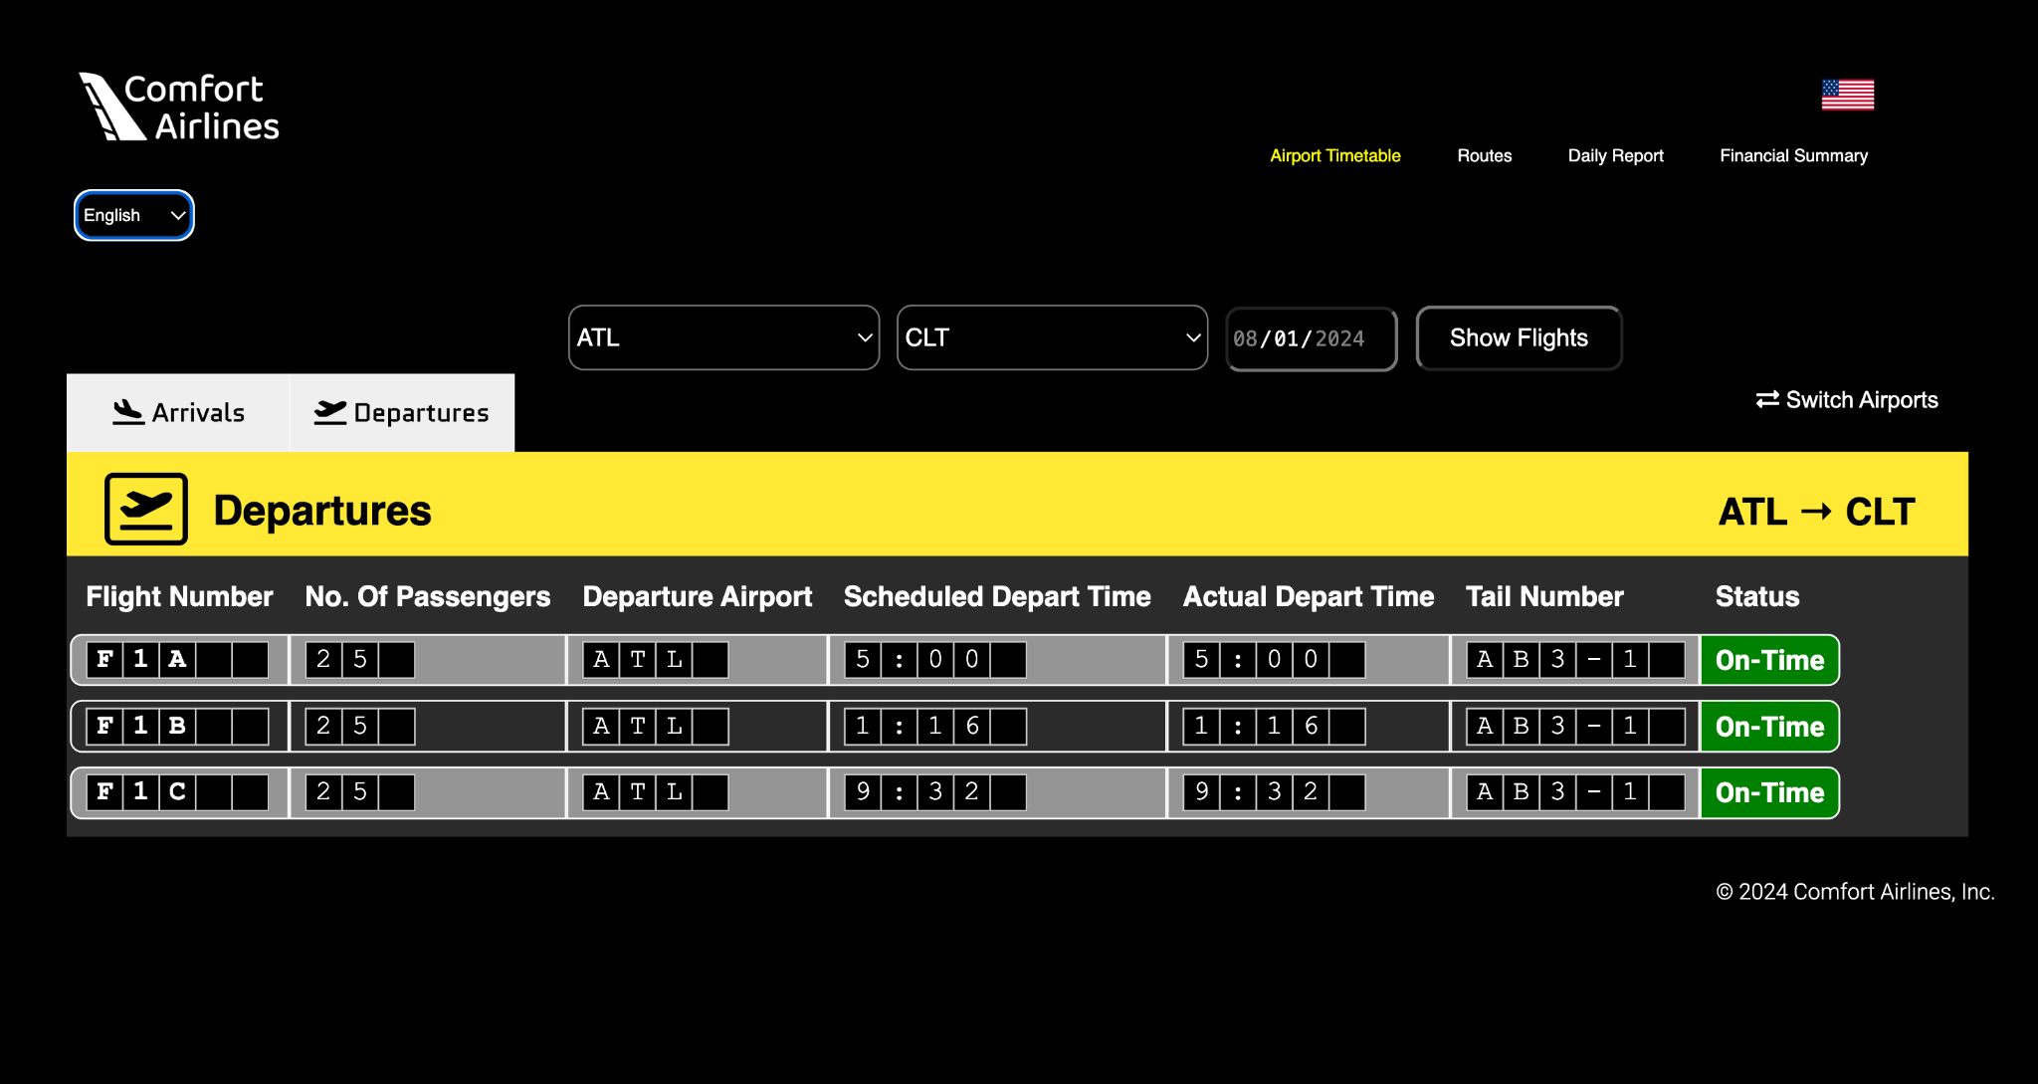

*Screenshot of the Airport Timetable page showing a list of flights from ATL to CLT.*

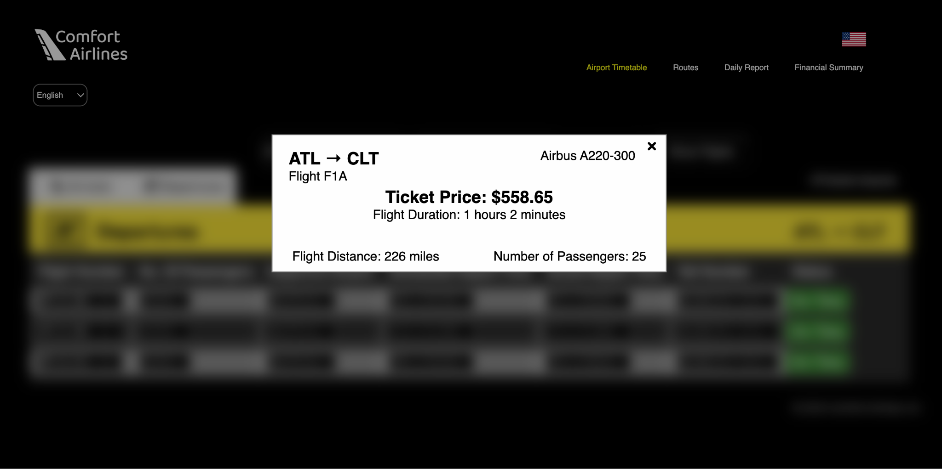

*Screenshot of the Airport Timetable page showing ticket price for an ATL to CLT flight.*

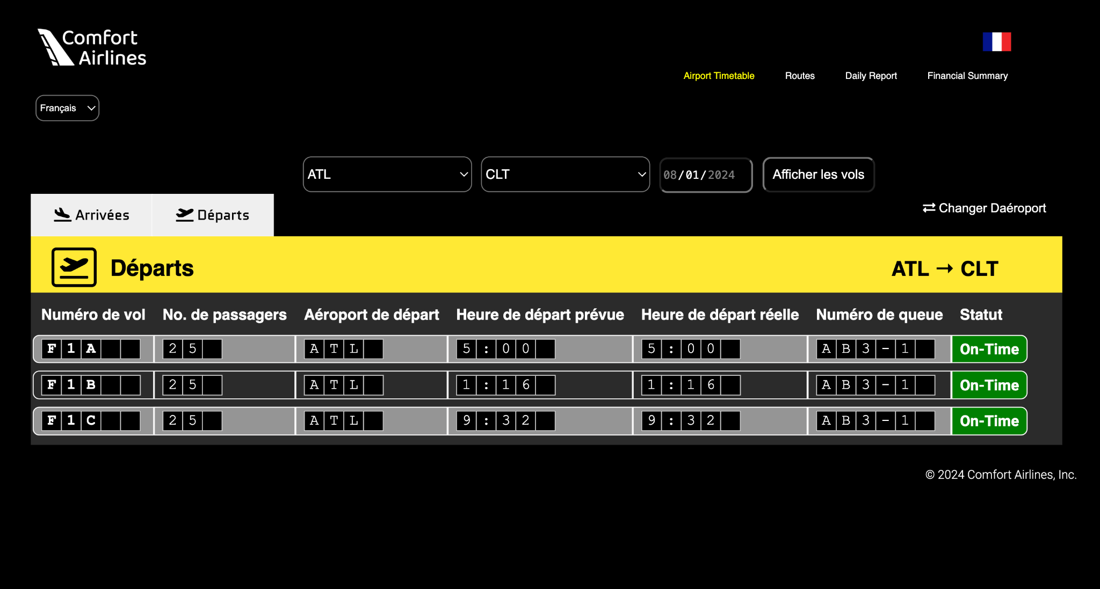

*Screenshot of the Airport Timetable page showing timetable in French.*

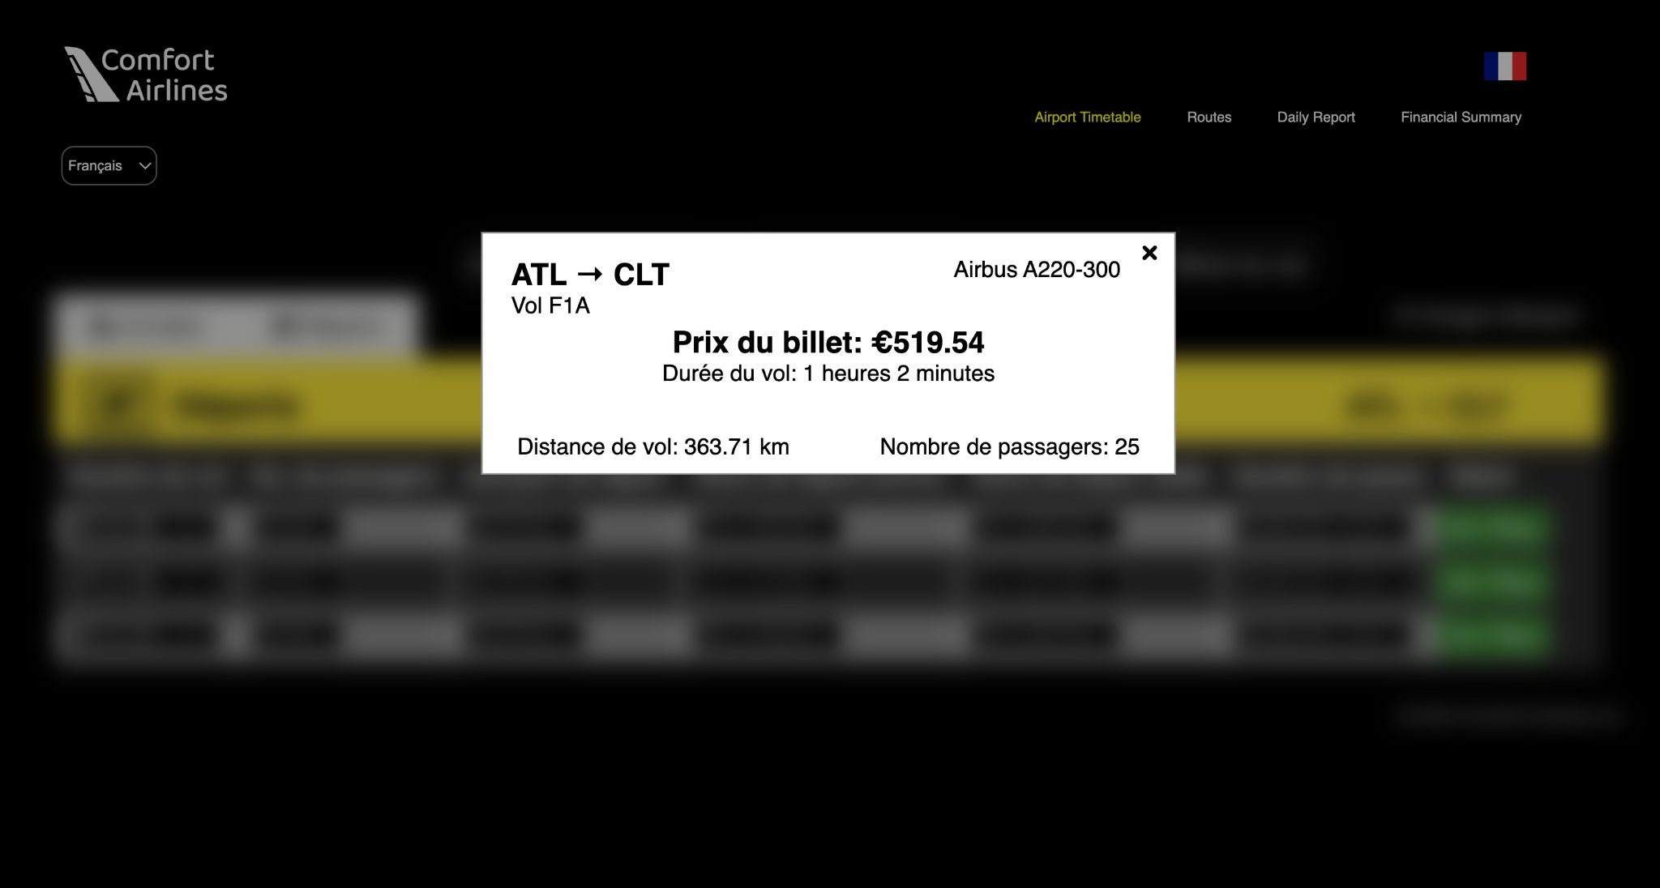

*Screenshot of the Airport Timetable page showing ticket price for an ATL to CLT flight in French.*

Output Explanation: Result of Timetable displays the timetable with the ticket price calculated based on operational cost, flight duration, and the flight distance, as well as the number of passengers.

#### **2. Routes**

Features:

* Search for routes by inputting departure and destination airports.
* View comprehensive route details including stopovers, flight durations, and travel distances.
* Map visualization of the selected route.

How to Use:

Select the Routes tab from the main menu located at the top or side of the screen. This action will direct you to the page where you can input route information.

Input Route Information:

1. Upon reaching the Routes Page, you will encounter fields prompting you to input departure and destination airports. These fields typically appear as dropdown menus, allowing you to select the desired airports from a list of available options.
2. Optionally, you may choose to specify a travel date by selecting it from a calendar or entering it manually. This step enables the system to filter and display available routes based on the selected date.

Generate Routes:

1. After entering the necessary route information, proceed to click the "Generate Routes" button. This action triggers the system to process your inputs and retrieve relevant flight options.
2. Once the routes have been generated, the system will display them on the screen along with detailed information such as flight times, airlines, ticket prices, and any layovers or stopovers.

Clear Routes:

1. To clear the displayed routes and reset the page for a new search or input, locate the option provided for clearing routes.
2. This option is typically represented by a button labeled "Clear Routes" or a similar variation. Clicking on this button will remove all previously generated route information from the screen, allowing you to start afresh with a clean slate for your next query.

Example Input:

* Departure Airport: LAX (Los Angeles International Airport)
* Destination Airport:JFK (John F. Kennedy International Airport)

Expected Output:

* Detailed information on routes from JFK to LAX, including stopovers, flight times, and a map showing the route.

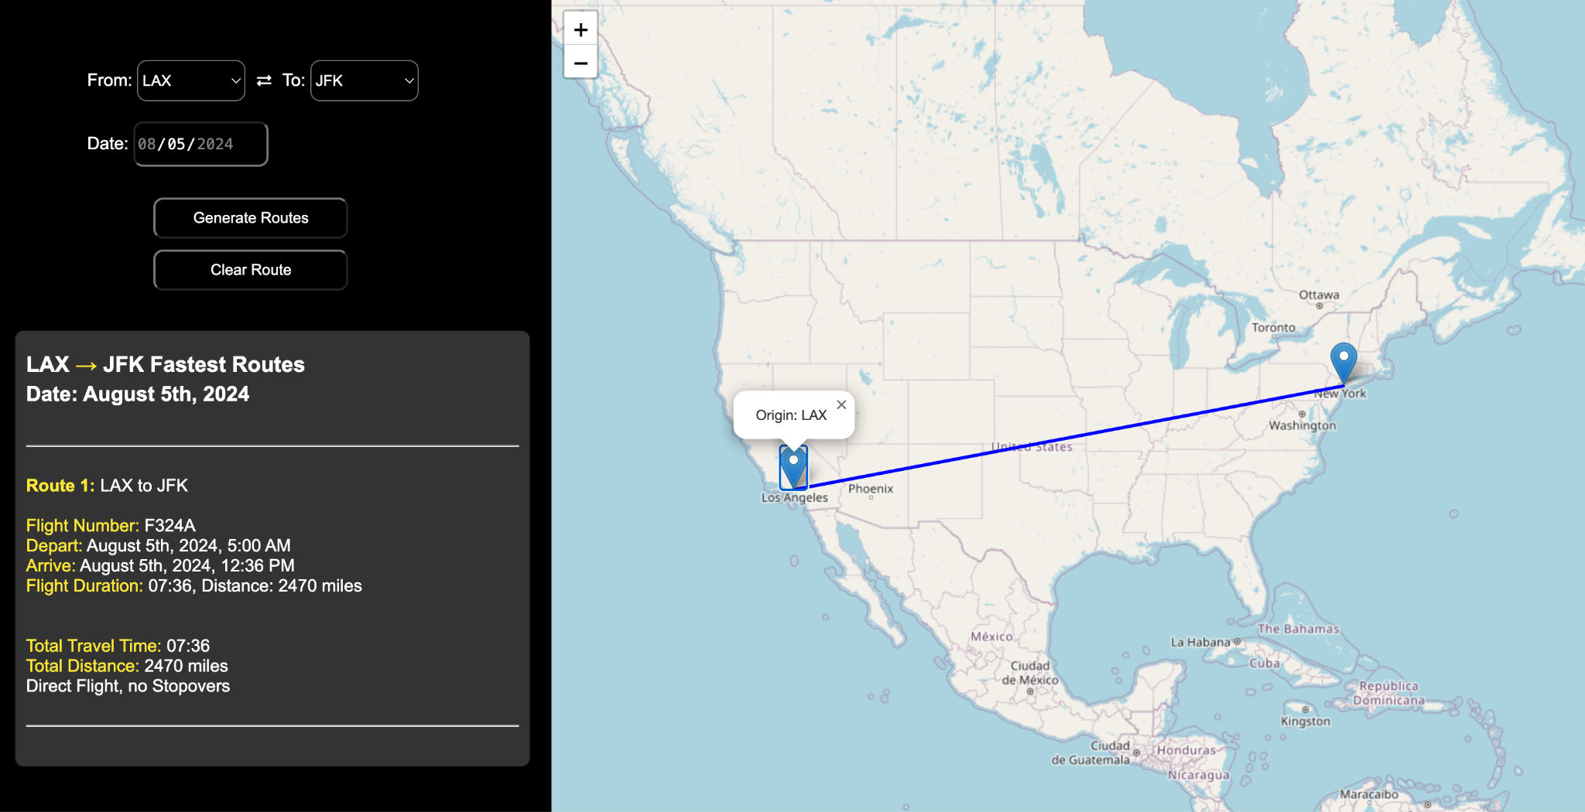

*Screenshot showing the route details from JFK to LAX.*

Output Explanation:

The displayed results indicate that for the specified date of August 5th, 2024, there is a direct flight available from Los Angeles International Airport (LAX) to John F. Kennedy International Airport (JFK). The flight, numbered F324A, is scheduled to depart LAX at 5:00 AM and arrive at JFK at 12:36 PM, totaling a flight duration of 7 hours and 36 minutes to cover a distance of 2,470 miles. The accompanying map provides a visual representation of the direct flight path between the two cities.

#### **3. Daily Report**

Features:

* Summarize daily airline operations including flight numbers, total passengers, and revenue.
* Customize reports for any selected day.

How to Use:

* Access the Daily Report: Click on the Daily Report tab.
* Select a Date: Choose the date for which you want to generate a report using the date picker.
* View Report: Press the "Generate Report" button to display the operations report for the selected day.

Example Input:

* Date: Tail Number: AB3-10

Expected Output:

* A detailed report of all flights on ‘AB3-10’, including the number of flights, total passengers carried, and total revenue generated.

*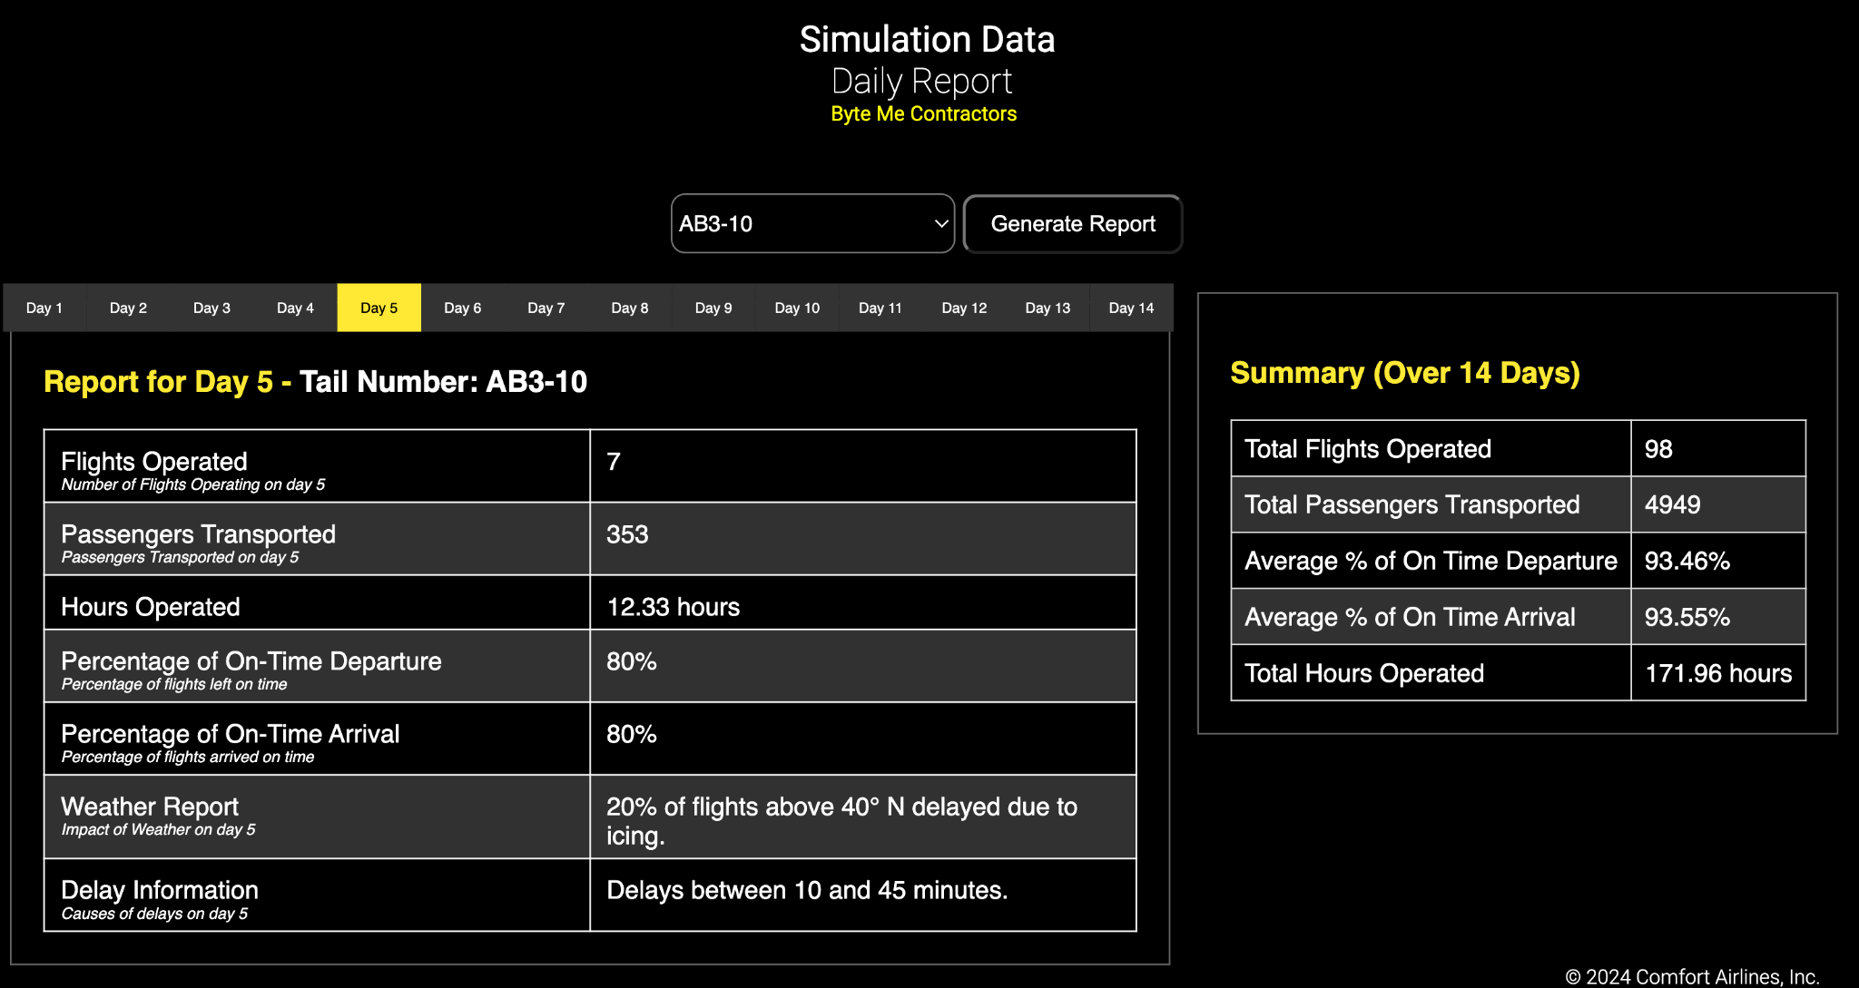Screenshot of the Daily Report for TailNumber AB3-10.*

#### **4. Financial Summary**

Features:

* Display earnings and expenses over a selected timeframe.
* Analyze profitability and operational costs using detailed financial statements and graphical representations.

How to Use:

1. Open the Financial Summary Page: Select the Financial Summary tab.
2. Choose Time Frame: Use the date pickers to select the start and end dates for the financial data you need.
3. Display Data: Click the "Show Data" button to view the financial summary, including graphs and charts.

Example Input:

* Start Date: August 1, 2024
* End Date: August 14, 2024

Expected Output:

* Financial statements including income, expenses, and net profit for August 2024, presented with supporting graphs.

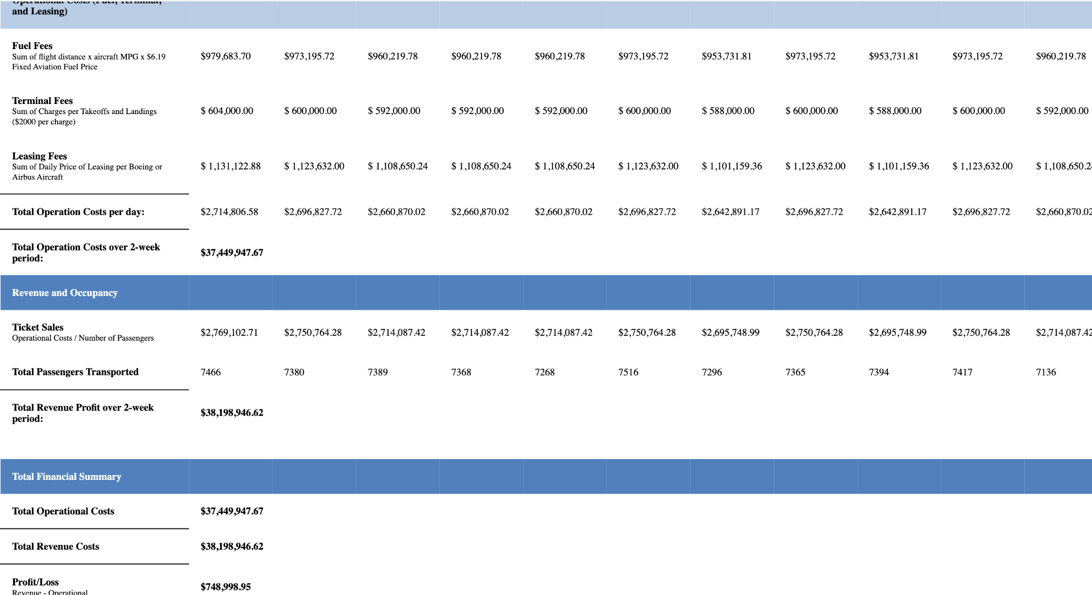

*Graphical representation of the financial summary for August 2024.*

Output Explanation: The image shows a financial report for an airline over a two-week period, detailing daily and total operational costs, including fuel, terminal, and leasing fees. It also shows ticket sales and the number of passengers transported. The bottom section provides a summary, highlighting the total operational costs against the revenue from ticket sales, resulting in a net profit for the two-week period.

### **Additional Information:**

* **Security Features:** Ensure all data is secure and access is restricted to authorized personnel only.
* **Accessibility Features:** The software is designed to be accessible to users with disabilities, incorporating features such as keyboard navigability and screen reader support.
* **Customer Support:** Detailed information on how to contact support for assistance with the software.

**Troubleshoot Issues:**

1. Fatal error: Uncaught Error: Call to undefined function mysqli_connect() in /var/www/html/index.php:136 Stack trace: #0 {main} thrown in /var/www/html/index.php on line 136
   * This error can take slightly different appearances, but all are similar to this

To resolve #1:

1. Open Docker Desktop
2. Navigate to Containers, and expand the list of containers.
3. Navigate to php_apache_container and click on the 3 dots on the right, and select open terminal



1. Paste the following into the terminal by right clicking and clicking paste, then hit enter:
   1. docker-php-ext-install mysqli
   2. docker-php-ext-enable mysqli
   3. apachectl restart
2. Refresh the page after it finishes running, and it should be resolved

2. If a user has XAMPP download make sure no servers are running then start the docker.

* To resolve: Open XAMPP and Switch to Manage Servers stopping all servers

**General Navigation Tips**

* Navigation links are available at the top of each page to switch between the different components of the system.
* Each page has a consistent design for ease of use.
* Use the "Back" button on your browser to return to the previous page if needed.

### **Support**

For additional assistance or to report any issues, contact the system administrator at [[jthomps6@highpoint.edu](mailto:jthomps6@highpoint.edu)].

This manual provides the essential information needed to navigate and utilize the features of the Comfort Airlines Site effectively. For more detailed instructions, users should refer to the help section on each page.