analysis

Joelle Nadeau

Wednesday, December 03, 2014

Here the result of the Multiple (Linear) Regression :

##   
## Call:  
## lm(formula = importValue ~ politicalStability + governmentEffectiveness +   
## ruleOfLaw, data = dataset)  
##   
## Residuals:  
## Min 1Q Median 3Q Max   
## -48993275 -18650718 -6964292 3699790 1293330956   
##   
## Coefficients:  
## Estimate Std. Error t value Pr(>|t|)   
## (Intercept) 14269028 1501753 9.502 < 2e-16 ***  
## politicalStability 2381591 2686222 0.887 0.375   
## governmentEffectiveness -11584096 2117014 -5.472 5.07e-08 ***  
## ruleOfLaw 23130901 2718715 8.508 < 2e-16 ***  
## ---  
## Signif. codes: 0 '***' 0.001 '**' 0.01 '*' 0.05 '.' 0.1 ' ' 1  
##   
## Residual standard error: 63740000 on 1829 degrees of freedom  
## (48 observations deleted due to missingness)  
## Multiple R-squared: 0.07881, Adjusted R-squared: 0.0773   
## F-statistic: 52.16 on 3 and 1829 DF, p-value: < 2.2e-16

You can also embed plots, for example:

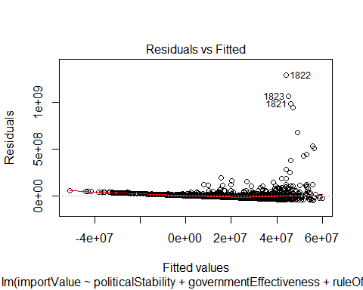 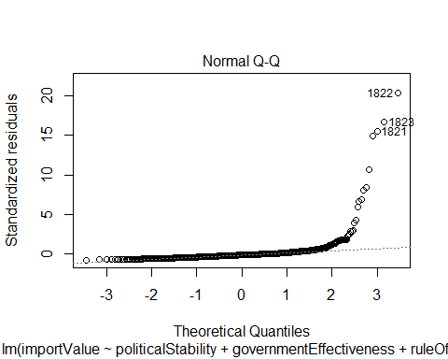 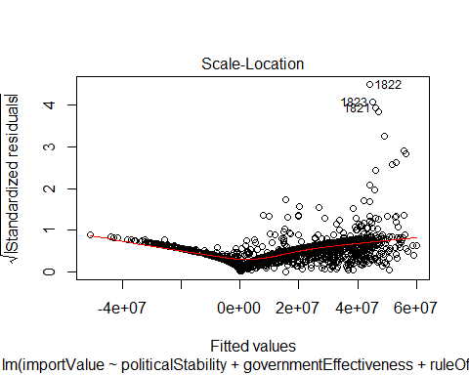 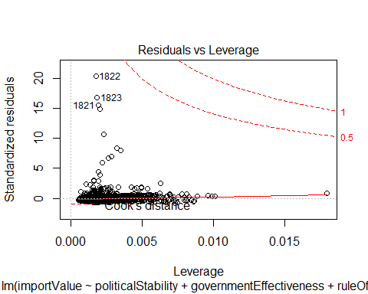

Note: That Result is preliminary and need to be validate.