**README for**

**Dutch Voters in One dimension**

**Source:** Greenacre, Michael andBlasius, Jӧrg, *Correspondence Analysis in the Social Sciences*, Greenacre and Blasius (Ed.) , Academic Press, 1994, p. 80

**Quickstart:**

To map data:

Assuming Python 2.6 and Numpy library for Python 2.6,

navigate to software_setup_and_data.

Command **python2.6 generic_csv_pscriptspan14**

When asked, answer

1. This has to be fixed – it is the only acceptable answer)

Next navigate in the default folder to the **SETUP** file and

Next navigate to data in the file for data, navigate to the to **Dutch_Elections from Greenacre p 80.csv**

4. Let it run for about 3 hours.

5. The default setup runs eight different starting configurations for the attenuation parameter (accepting four possibilities) and the start parameter (acceptiontwo possibilities).

Their output will be written to 8 **job** folder.

The file **Dutch_Elections from Greenacre p 80.txt_scan** keeps track of the best solution in these 8 job files.

In the job folders, there are many files. The file with suffix “aa”, is the primary output file. Deep down it has the fitted values, and the errors.

Search for “err” to find the chi-square error.

The file with suffix “.ps” is a postscript file. If double-clicked, a cooperative computer will show you the visualization corresponding to the goodness of fit.

**Requirements**

The package assumes that Python 2.6 and Numpy for Python 2.6 are already installed. These are available as free downloads. Google them, probably from either SourceForge or Python.org.

Be careful. Python is increasingly incompatible with Python: So it is easy to have a mismatch between your Python version and your Numpy version, and the automatic installers do not catch these things. Try using “python2.6” as a command where you would ordinarily use “python” as a command. When there is a mismatch the “bugs” can mislead you – directing you to specific lines in the code and asking you to fix them. These lines are (usually) not the guilty party.

I hear no reports of problems when my code is run with Python 2.7 and the Numpy for Python 2.7. I stayed with the Python that was working for me.

The code will not run with Python 3.x

**Downloading**

Set your browser to accept cookies. Direct the browser to githup.com/joellevine

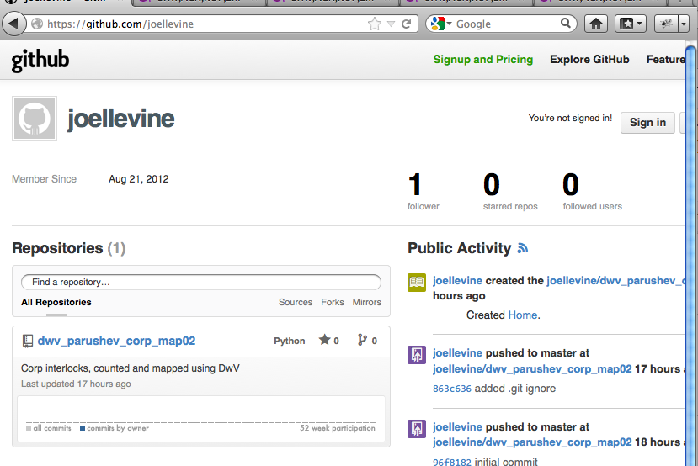

On that web page click/select the repository (known as a “repo”) that you want.

A new window will open. In the new window click/select “ZIP”

As this document is being written – search for something with the name “Election” in it. That was added after the data of the picture below.

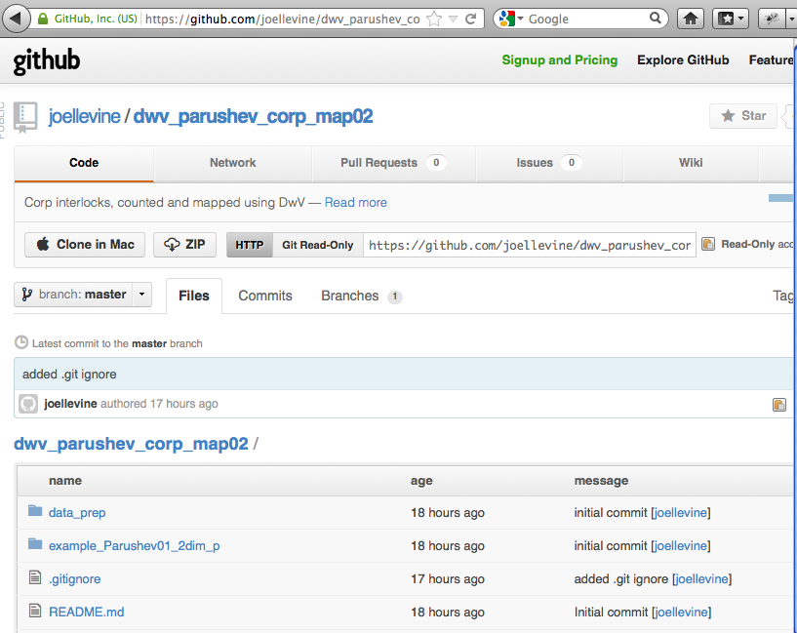

The “zip file” will download to your machine. (If it is not immediately visible, look for a folder named “Downloads” on you machine)

Create a folder somewhere, where you want to work with this. Move the zip folder to this work folder. On a Mac, double click the zip file. It will spill its contents into this work folder, in usable form.

The top most folder for what you have downloaded is **software_setup_and_data.**