ADVANCED DATA ANALYSIS
AND VISUALIZATION IN LOGISTICS

Week 3 Task • Logistics Data Analytics

Prepared as a Python-based exploratory analysis of a simulated logistics dataset

Name: __________________________
Date: __________________________

Executive Summary
This report demonstrates an end-to-end exploratory data analysis (EDA) workflow for logistics operations. A reproducible hypothetical dataset of 500 shipments was generated with shipment identifiers, region, transport mode, distance, shipment volume, delivery time, transport cost, and a delay indicator. Python, pandas, NumPy, and Matplotlib were used to inspect the data, summarize distributions, quantify relationships, and create decision-oriented visualizations.
The sample has 500 shipments. Mean delivery time is 3.42 days (median 3.26); mean transport cost is ₹2,310; and 27.6% of shipments are marked delayed. These values are properties of a simulated dataset—not claims about a real company.
The analysis indicates that transport mode and distance are important operational dimensions. Air shipments are generally faster but substantially more expensive per kilometre, while sea and rail provide lower-cost alternatives with longer transit times. Regional delay rates vary in the simulation and should be treated as diagnostic signals rather than causal evidence. The report closes with recommendations, limitations, reproducibility instructions, and a GitHub-ready project structure.

Contents
1. Introduction and objectives
2. Dataset design and assumptions
3. Methodology and data quality
4. Exploratory data analysis
5. Visualizations and interpretation
6. Operational insights and recommendations
7. Limitations and next steps
8. Conclusion
Appendix A: Python workflow
Appendix B: GitHub publishing guide

1. Introduction and Objectives
Logistics performance depends on balancing speed, cost, reliability, capacity, and customer expectations. Data analysis can reveal where delays accumulate, which transport choices are associated with higher costs, and which operational indicators deserve further investigation. EDA is the first step: it helps analysts understand the structure and quality of the data before building forecasts or optimization models.

Objectives
• Describe the simulated shipment dataset and its variables.
• Calculate central tendency, spread, and distribution summaries.
• Explore correlations and differences across transport modes and regions.
• Build clear visualizations that communicate operational patterns.
• Translate descriptive evidence into practical recommendations.
• Document a reproducible Python workflow.

Questions guiding the analysis
• How are delivery times distributed, and are there long-tail shipments?
• How do average delivery time and cost differ by transport mode?
• Does distance relate to transportation cost?
• Which regions show higher observed delay rates?
• What should an operations team investigate next?

Scope
This is a descriptive analysis of a hypothetical dataset. No predictive model, causal inference, or real-world benchmarking is claimed. The results are intended to illustrate a rigorous workflow and can be replaced with actual operational data.

2. Dataset Design and Assumptions
The dataset contains one row per shipment and eight fields. The 500 records were generated with a fixed random seed (42), allowing the same sample to be reproduced. Values are intentionally plausible for a classroom exercise and are not sourced from a logistics provider.
Field | Type | Meaning
Shipment_ID | String | Unique shipment key
Region | Category | North/South/East/West
Transport_Mode | Category | Road/Rail/Air/Sea
Distance_km | Integer | Route distance
Shipment_Volume | Integer | Units or parcels in shipment
Delivery_Time_days | Float | Elapsed transit time
Transport_Cost_INR | Float | Estimated transport charge
Delayed | Binary | 1=delayed, 0=on time

Simulation logic
Distance and mode jointly influence delivery time. Road is the reference mode; rail, air, and sea receive different time multipliers. Random variation represents handling, route, weather, and scheduling uncertainty. Costs depend on distance, mode-specific rates, shipment volume, and random noise. A delay probability increases with delivery time and includes a road-mode adjustment; a Bernoulli draw creates the binary Delayed field.

Important assumptions
• Shipment volume is a count-like measure, not weight or cubic metres.
• Distance is a single route-level estimate; multi-stop routes are not represented.
• Cost is in Indian rupees (INR) and is simulated.
• Delivery time is measured in days, including decimal fractions.
• Delay is a simplified binary outcome; a real SLA threshold should be defined explicitly.

3. Methodology and Data Quality

Tools
Python provides the analysis environment. pandas handles tabular transformations and group summaries; NumPy supports simulation and numerical calculations; Matplotlib produces plots. The workflow is deliberately transparent and can run in a notebook or as a .py script.

Data quality checks
Check | Result
Rows | 500
Columns | 8
Missing values | 0
Duplicate shipment IDs | 0
Negative distance | 0
Non-positive delivery time | 0
Non-positive cost | 0
Delay values | [0, 1]
The generated data pass the basic checks: IDs are unique, no missing values are present, distances are non-negative, delivery times and costs are positive, and the delay field contains only 0 and 1. These checks should be repeated on any replacement dataset; real data may require imputation, deduplication, unit harmonization, and outlier review.

Analysis sequence
Load data and inspect dimensions, data types, and sample rows.
Validate identifiers, missingness, ranges, and categorical values.
Calculate descriptive statistics and grouped summaries.
Plot distributions, comparisons, relationships, and correlations.
Interpret results with operational context and document caveats.

4. Exploratory Data Analysis

4.1 Central tendency and spread
Delivery time: mean 3.42 days; median 3.26; standard deviation 1.82; range 0.30–9.97 days. The mean being above the median suggests a right-skewed distribution with a tail of slower deliveries.
Transport cost: mean ₹2,309.82; median ₹1,877.05; standard deviation ₹1,816.78. Cost variability is expected because mode rates, distance, volume, and random noise all contribute.

4.2 Numerical summary
Statistic | Distance_km | Shipment_Volume | Delivery_Time_days | Transport_Cost_INR | Delayed
count | 500.0 | 500.0 | 500.0 | 500.0 | 500.0
mean | 943.78 | 39.24 | 3.42 | 2309.82 | 0.28
std | 497.07 | 23.12 | 1.82 | 1816.78 | 0.45
min | 51.0 | 1.0 | 0.3 | 100.0 | 0.0
25% | 508.75 | 19.75 | 2.03 | 1188.43 | 0.0
50% | 970.0 | 38.0 | 3.26 | 1877.05 | 0.0
75% | 1361.25 | 60.0 | 4.57 | 2820.88 | 1.0
max | 1791.0 | 79.0 | 9.97 | 11032.31 | 1.0

4.3 Distribution of delivery times
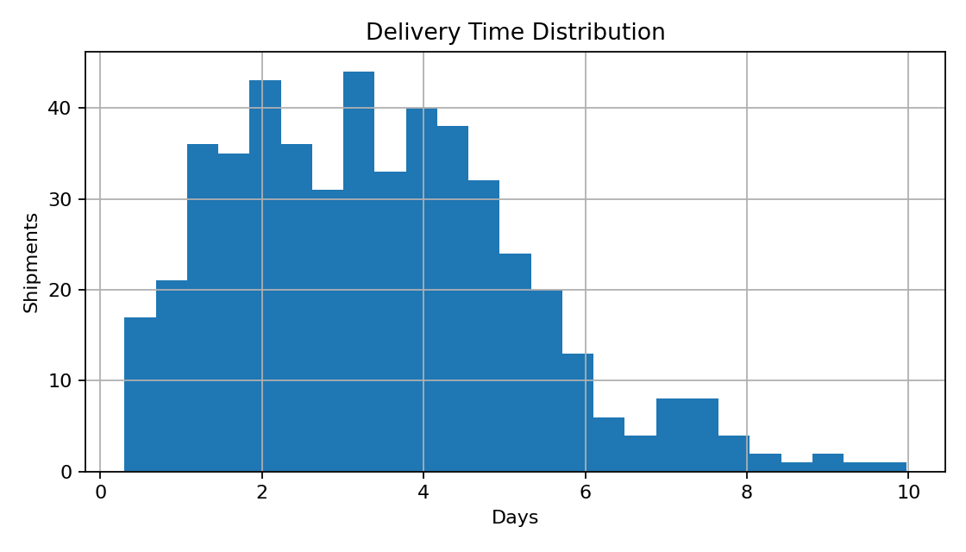
The histogram shows how frequently shipments fall into delivery-time intervals. A concentrated central range with a thinner right tail is useful for setting realistic service expectations: averages alone can hide a small group of very slow shipments. Percentiles (such as P90 and P95) should accompany the mean in operational dashboards.

5. Visualizations and Interpretation

5.1 Delivery time by transport mode
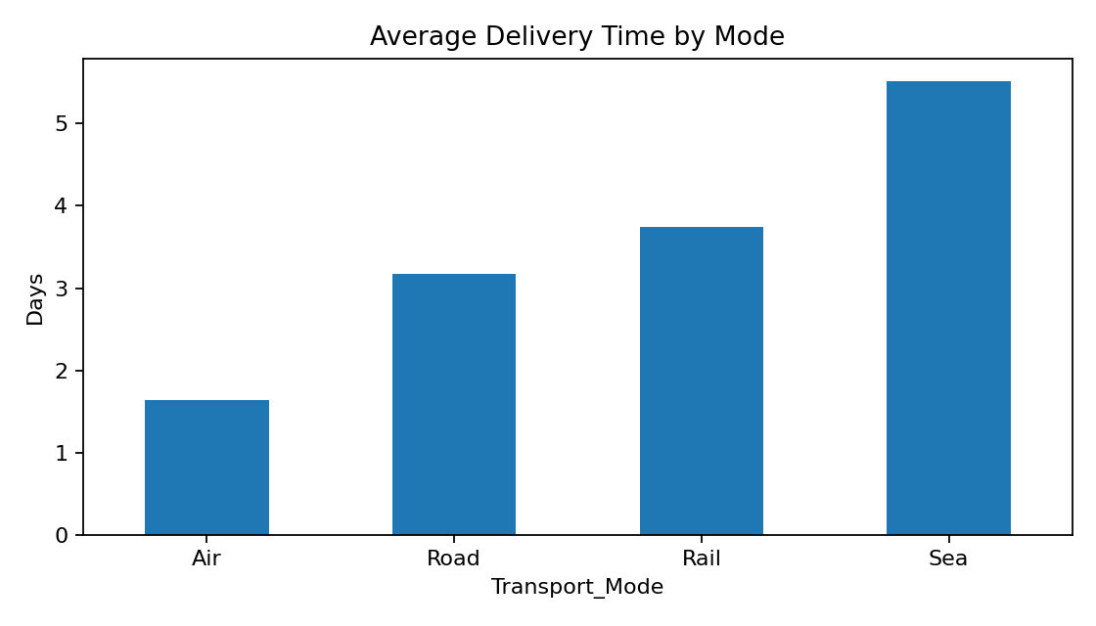
Transport_Mode | Shipments | Avg_Days | Avg_Cost | Delay_Rate
Air | 51 | 1.64 | 6121.19 | 0.12
Rail | 101 | 3.74 | 1492.86 | 0.3
Road | 287 | 3.18 | 2173.83 | 0.28
Sea | 61 | 5.52 | 1115.74 | 0.38
The mode comparison is useful because it puts speed and cost trade-offs into a compact view. In this simulation, air has the shortest average transit time but the highest cost profile; sea is slower and generally economical; rail sits between road and sea in the constructed assumptions. Mode selection should therefore be based on shipment urgency, product value, capacity, and total landed cost—not speed alone.

5.2 Distance and cost relationship
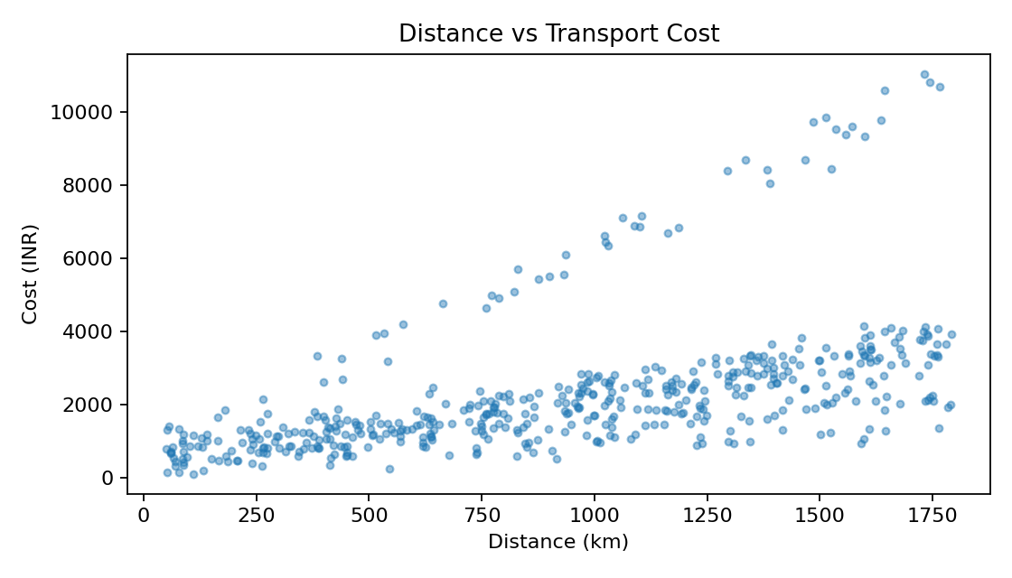
The scatter plot checks whether longer routes tend to cost more and whether the relationship changes in spread. The generated cost formula makes distance a strong driver, but different mode rates create distinct cost bands. A real analysis should color points by mode and fit separate trend lines to avoid interpreting mode mix as a single universal rate.

5.3 Delay rates across regions
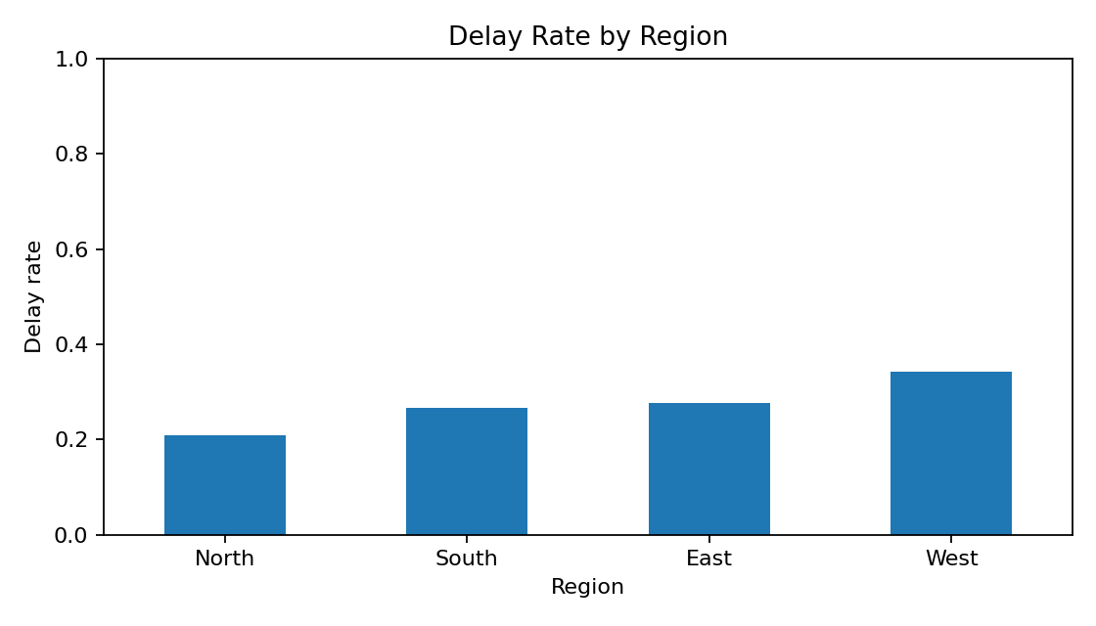
Region | Shipments | Avg_Days | Avg_Cost | Delay_Rate
East | 116 | 3.55 | 2487.19 | 0.28
North | 125 | 3.31 | 2147.97 | 0.21
South | 116 | 3.16 | 2397.67 | 0.27
West | 143 | 3.62 | 2236.15 | 0.34
A regional delay-rate bar chart supports targeted investigation. Higher rates may reflect route length, traffic, weather, carrier mix, hub congestion, or differences in SLA definitions. The chart does not identify causes; it identifies where to ask follow-up questions. Always display shipment counts alongside rates because small samples can make percentages unstable.

5.4 Correlation matrix
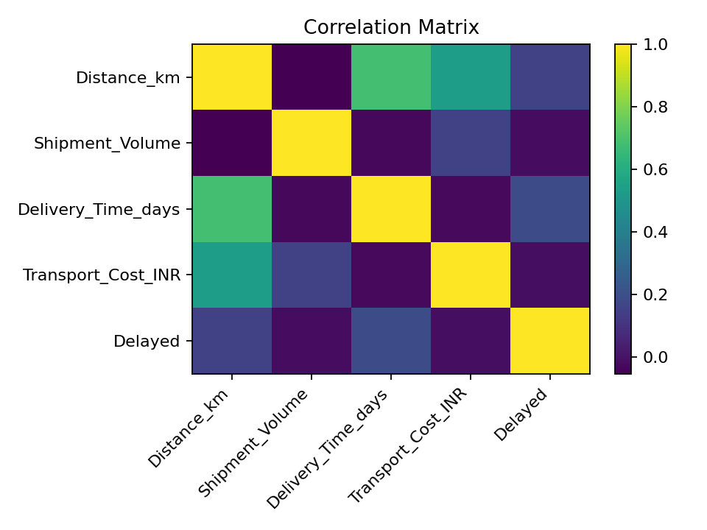
Variable | Distance_km | Shipment_Volume | Delivery_Time_days | Transport_Cost_INR | Delayed
Distance_km | 1.0 | -0.05 | 0.69 | 0.54 | 0.16
Shipment_Volume | -0.05 | 1.0 | -0.03 | 0.15 | -0.02
Delivery_Time_days | 0.69 | -0.03 | 1.0 | -0.03 | 0.19
Transport_Cost_INR | 0.54 | 0.15 | -0.03 | 1.0 | -0.02
Delayed | 0.16 | -0.02 | 0.19 | -0.02 | 1.0
Correlation coefficients summarize linear association between numeric variables. Distance and cost are positively associated by construction. Delivery time and delay also tend to be associated because the simulation makes longer transit times more likely to be delayed. Correlation is not causation and can be distorted by categorical variables, nonlinear patterns, or confounding.

6. Operational Insights and Recommendations

Insight 1 — Use mode-specific service and cost policies
The mode comparison highlights a speed–cost trade-off. Create service tiers (urgent, standard, economy) and define eligible modes for each tier. Air should be reserved for high-value or time-critical consignments; slower modes may suit flexible delivery windows.

Insight 2 — Monitor the tail, not only the average
Track P50, P90, P95 delivery time, on-time-in-full (OTIF), and the share of shipments beyond the SLA. Alerting on tail performance can reveal a small number of serious bottlenecks that an average conceals.

Insight 3 — Investigate high-delay regions
Review region-level results with route-level context. Compare lane distance, carrier, dispatch weekday, warehouse, destination, and shipment mix. Start with a root-cause review rather than penalizing a region based only on a descriptive rate.

Insight 4 — Improve cost visibility
Normalize cost by kilometre, shipment unit, weight, or volume where the data permit. Compare like-for-like lanes and modes, and distinguish fixed surcharges from variable charges. A simple total-cost view can be misleading when shipment sizes differ.

Recommended dashboard KPIs
KPI | Purpose | Frequency
On-time delivery % | Service reliability | Daily/weekly
Mean / P90 transit days | Typical and tail speed | Weekly
Cost per shipment / km | Cost efficiency | Weekly/monthly
Delay rate by lane | Bottleneck detection | Daily/weekly
Volume by mode | Capacity and mix | Daily
Exception count | Operational action queue | Daily

7. Limitations and Next Steps

Limitations
• Synthetic data cannot represent actual network complexity or business seasonality.
• The simulation assumptions create relationships that the analysis then observes; findings are illustrative.
• No explicit promised delivery date or SLA threshold is supplied.
• No fuel, toll, handling, customs, weather, carrier, warehouse, or customer-level attributes are included.
• The analysis is descriptive and does not test statistical significance or estimate causal effects.

Next steps with real data
• Replace the sample with a governed export; document units, definitions, and lineage.
• Add promised delivery timestamps and calculate lateness in hours/days.
• Segment by lane, carrier, warehouse, product, customer, and calendar period.
• Use confidence intervals for regional/mode rates and investigate sample sizes.
• Build a baseline predictive model for delay only after leakage checks and time-based validation.
• Evaluate route or mode optimization with service constraints and total cost.

Ethics and responsible use
Use aggregated operational reporting where possible, restrict personal/customer information, and avoid treating simulated or observational associations as definitive judgments about staff, carriers, or regions. Recommendations should be validated with domain experts before operational deployment.

8. Conclusion
This project demonstrates how Python can turn a logistics table into a structured evidence base. The workflow combines data validation, descriptive statistics, grouped comparisons, distribution analysis, scatter plots, and correlation analysis. The charts show why delivery speed, transportation cost, and delay reliability should be examined together.
The central practical lesson is to use descriptive analysis to prioritize questions—not to claim causes prematurely. Mode-specific service tiers, tail-time monitoring, regional root-cause reviews, and normalized cost metrics are promising next steps. With real shipment records and clear SLA definitions, the same workflow can support a more reliable operational dashboard and subsequent predictive or optimization work.

References / tools
• Python documentation: https://docs.python.org/3/
• pandas documentation: https://pandas.pydata.org/docs/
• NumPy documentation: https://numpy.org/doc/
• Matplotlib documentation: https://matplotlib.org/stable/

Appendix A: Python Workflow
The companion script and CSV file are included with this report. The following core snippets illustrate the main analysis steps.

Load and inspect
import pandas as pd
import matplotlib.pyplot as plt
df = pd.read_csv("logistics_sample_dataset.csv")
print(df.head())
print(df.info())
print(df.isna().sum())
print(df.describe())

Grouped analysis
mode_summary = df.groupby("Transport_Mode").agg(
shipments=("Shipment_ID", "count"),
avg_days=("Delivery_Time_days", "mean"),
avg_cost=("Transport_Cost_INR", "mean"),
delay_rate=("Delayed", "mean")
)
region_delay = df.groupby("Region")["Delayed"].mean()

Visualization and correlation
df["Delivery_Time_days"].hist(bins=25)
plt.xlabel("Delivery time (days)")
plt.ylabel("Shipment count")
plt.tight_layout()
plt.savefig("delivery_hist.png", dpi=160)
corr = df[["Distance_km", "Shipment_Volume",
"Delivery_Time_days", "Transport_Cost_INR",
"Delayed"]].corr()
print(corr)
Reproducibility: install dependencies with `pip install pandas numpy matplotlib`; run `python logistics_analysis.py` from the project directory. The script uses a fixed random seed when generating the sample.

Appendix B: GitHub Publishing Guide
Suggested repository name: logistics-data-analysis-week3

Project files
• logistics_analysis_report.docx — this report
• logistics_sample_dataset.csv — simulated 500-row data
• logistics_analysis.py — reproducible analysis and chart generation
• charts/ — generated visualizations
• README.md — project overview, setup, and outputs

Push using Git (terminal)
# 1) Create a new empty repository on https://github.com
# 2) In this project folder, open Terminal / Git Bash:
git init
git add .
git commit -m "Add logistics data analysis project"
git branch -M main
git remote add origin https://github.com/YOUR-USERNAME/logistics-data-analysis-week3.git
git push -u origin main

Push using GitHub website (no terminal)
• Sign in to GitHub and click New repository.
• Choose the name logistics-data-analysis-week3; create it (README optional).
• Open the repository and select Add file → Upload files.
• Upload the DOCX, CSV, Python script, README, and charts folder contents.
• Add a commit message and click Commit changes.

Before submitting
☐ Confirm the repository visibility matches your instructor's requirements.
☐ Open the uploaded DOCX from GitHub to verify it is readable.
☐ Include a short README explaining that the dataset is simulated.
☐ Do not upload passwords, tokens, or private business data.
☐ Copy the repository URL into your internship/task submission portal.
Note: I can prepare the project files here, but I cannot push to your GitHub account without an authenticated GitHub connection or your own Git client.

