PREDICTIVE MODELING AND
OPTIMIZATION IN LOGISTICS SYSTEMS
Week 4 Task • Logistics Predictive Analytics

A reproducible machine-learning study predicting shipment delivery time
Name: __________________________
Date: __________________________

Executive Summary
This report develops a predictive model for shipment delivery time using a hypothetical dataset of 650 logistics records. The target is Delivery_Time_days, while distance, shipment volume, transport mode, region, and transport cost are predictors. A Random Forest regression pipeline was selected to model nonlinear relationships and interactions while handling mixed numeric and categorical inputs through one-hot encoding.
An 80/20 train-test split and five-fold cross-validation were used. On the held-out test set, the model achieved MAE 0.57 days, RMSE 0.70 days, and R² 0.861; mean cross-validation MAE on training data was 0.57 days. Metrics are illustrative because the dataset is synthetic and the data-generating assumptions influence the apparent performance.
The report documents problem definition, data simulation, feature preparation, model selection, training, validation, evaluation, and optimization recommendations. It emphasizes that predictions should support—not replace—operational judgment. Suggested actions include exception-based monitoring, mode-aware planning, capacity allocation, and scenario analysis. A Python script, dataset, visualizations, and README are supplied for reproducibility and GitHub publishing.

Contents
1. Problem definition
2. Dataset and simulation
3. Data preparation
4. Model selection
5. Training and validation
6. Evaluation results
7. Visual interpretation
8. Logistics optimization strategies
9. Limitations and responsible use
10. Conclusion
Appendix A: Python implementation
Appendix B: GitHub upload guide

1. Problem Definition

Business context
Delivery-time uncertainty affects customer satisfaction, inventory planning, warehouse coordination, and transport costs. A logistics team needs an estimate of transit duration early enough to plan dispatches, set realistic delivery windows, and flag shipments likely to miss service targets. Predictive analytics can help prioritize attention and evaluate alternative transport scenarios.

Prediction objective
The task is supervised regression: estimate continuous delivery time in days for a shipment from available operational features. The target variable is Delivery_Time_days. The intended use is planning support and exception prioritization, not an automatic promise to customers.

Success criteria
• A clearly defined target and predictors.
• A reproducible train/test split with no test-data leakage.
• Error metrics expressed in understandable units (days).
• A baseline and a nonlinear model suitable for mixed features.
• Recommendations connected to model outputs and operational constraints.

Scope
This exercise uses synthetic data. The model demonstrates a process rather than a production-grade forecast. Real deployment would require historical timestamps, agreed definitions of delivery and delay, temporal validation, monitoring, and governance.

2. Dataset and Simulation
The generated dataset contains 650 rows, one per shipment, and eight columns. A fixed seed (42) makes the simulation repeatable.
Feature | Role | Description
Shipment_ID | Identifier | Unique shipment reference
Distance_km | Predictor | Route distance
Shipment_Volume | Predictor | Units/parcels count
Transport_Mode | Predictor | Road/Rail/Air/Sea
Region | Predictor | North/South/East/West
Transport_Cost_INR | Predictor | Estimated charge in INR
Delivery_Time_days | Target | Transit duration in days
Delayed | Auxiliary label | Binary simulated delay

Simulation assumptions
Delivery time is generated from distance divided by a nominal speed, multiplied by a mode-specific factor, plus random variation. Cost uses distance and mode-specific rates, shipment volume, and noise. Delay probability rises with delivery time and includes a road-mode adjustment. These assumptions intentionally create patterns for learning; therefore model performance should not be generalized to actual logistics networks.

Dataset snapshot
Shipment_ID | Distance_km | Shipment_Volume | Transport_Mode | Region | Transport_Cost_INR | Delivery_Time_days | Delayed
LG00001 | 1156 | 90 | Air | East | 7233.54 | 0.75 | 1
LG00002 | 1489 | 90 | Road | South | 3319.56 | 4.16 | 0
LG00003 | 890 | 48 | Road | West | 1891.72 | 2.22 | 0
LG00004 | 1324 | 85 | Road | East | 3079.12 | 2.77 | 0
LG00005 | 1160 | 39 | Air | North | 6651.14 | 2.0 | 0
LG00006 | 1125 | 33 | Road | West | 2196.31 | 3.99 | 0
LG00007 | 1754 | 94 | Rail | South | 2497.66 | 5.5 | 1
LG00008 | 1074 | 23 | Air | South | 6168.99 | 0.25 | 0

3. Data Preparation

Quality checks
Check | Result
Records | 650
Missing values | 0
Duplicate IDs | 0
Negative distance | 0
Delivery time <= 0 | 0
Cost <= 0 | 0
The simulated records pass these basic validation checks. In a real dataset, analysts should also inspect missingness patterns, duplicate business keys, impossible timestamps, unit inconsistencies, outliers, and categorical spelling variations.

Feature and target separation
Shipment_ID is excluded because it is an identifier with no meaningful predictive signal. Delivery_Time_days is separated as y. Distance, volume, mode, region, and cost are retained as X. Categorical variables are one-hot encoded, while numeric variables pass through unchanged. The encoder is fitted inside a scikit-learn Pipeline so category handling is learned from training data only.

Leakage consideration
Transport cost may be known only after a shipment is booked or invoiced. It is included here for demonstration. Before deployment, confirm that every predictor is available at the exact prediction time. Remove post-outcome fields or information derived from delivery completion.

4. Model Selection

Candidate approaches
Model | Strength | Trade-off
Mean baseline | Simple benchmark | No feature learning
Linear Regression | Interpretable linear effects | May miss nonlinearities
Decision Tree | Nonlinear rules | Can overfit
Random Forest | Ensemble reduces variance; interactions | Less transparent; needs tuning

Chosen model: Random Forest Regressor
Random Forest combines many decision trees trained on bootstrap samples and randomized feature subsets. It can represent nonlinear effects and interactions without requiring feature scaling. It is a reasonable educational choice for tabular data and provides feature-importance estimates. It is not necessarily the best model for every logistics dataset; gradient boosting, regularized regression, or domain-specific models should also be tested.

Pipeline configuration
The pipeline contains a ColumnTransformer with OneHotEncoder(handle_unknown='ignore') for Transport_Mode and Region and passthrough for numerical columns. The RandomForestRegressor uses 180 trees, maximum depth 12, minimum leaf size 2, and random_state 42. These settings are a reproducible starting point, not a fully optimized configuration.

Baseline comparison
A useful baseline predicts the training-set mean delivery time for every test shipment. A model should outperform this baseline on MAE or RMSE before it is considered useful. In practice, also compare a simple linear model and a decision tree.

5. Training and Validation

Hold-out evaluation
The dataset is divided into 80% training records and 20% test records using random_state=42. The model learns parameters from the training set; the test set is held back until final evaluation. This provides an estimate of performance on unseen records under the simulation's random sampling assumptions

Cross-validation
Five-fold cross-validation is applied to the training partition. Each fold acts as validation once, and the average MAE is approximately 0.57 days. Cross-validation helps assess stability and reduces reliance on one validation split. For operational forecasting over time, use chronological splits rather than random folds so future records are not used to predict the past

Hyperparameter tuning
A production workflow could use GridSearchCV or RandomizedSearchCV to compare n_estimators, max_depth, min_samples_leaf, max_features, and related settings. Choose the search metric before tuning, perform tuning only on training data, and reserve the test set for a single final check. Avoid excessive search on small datasets

Reproducibility
Set random seeds, record package versions, save the data-generation script, and preserve the model configuration. A deployment artifact should include a schema, preprocessing pipeline, model version, and monitoring plan

6. Evaluation Results
Metric | Value | Interpretation
MAE | 0.571 | Average absolute error in days
RMSE | 0.701 | Penalizes larger errors more strongly
R-squared | 0.861 | Explained variance proportion (relative)
5-fold CV MAE | 0.566 | Average validation absolute error

Metric interpretation
MAE of 0.57 days means predictions differ from actual delivery time by about this amount on average in absolute terms. RMSE of 0.70 days penalizes large misses more heavily. R² of 0.861 summarizes fit relative to predicting the test mean; it can be negative if the model performs worse than that baseline. None of these metrics directly measures SLA compliance

Operational evaluation
Translate errors into business consequences: compare predictions against promised delivery windows, estimate the cost of false alerts and missed delays, and measure calibration of risk bands. A low average error can still conceal poor performance for long-distance routes, rare modes, or particular regions

Subgroup checks
Report MAE by transport mode, region, distance band, and volume band. Check sample sizes and error distributions in each group. If some segment has consistently higher error, improve its data coverage, features, or modeling approach rather than relying only on a global metric

7. Visual Interpretation

Actual versus predicted
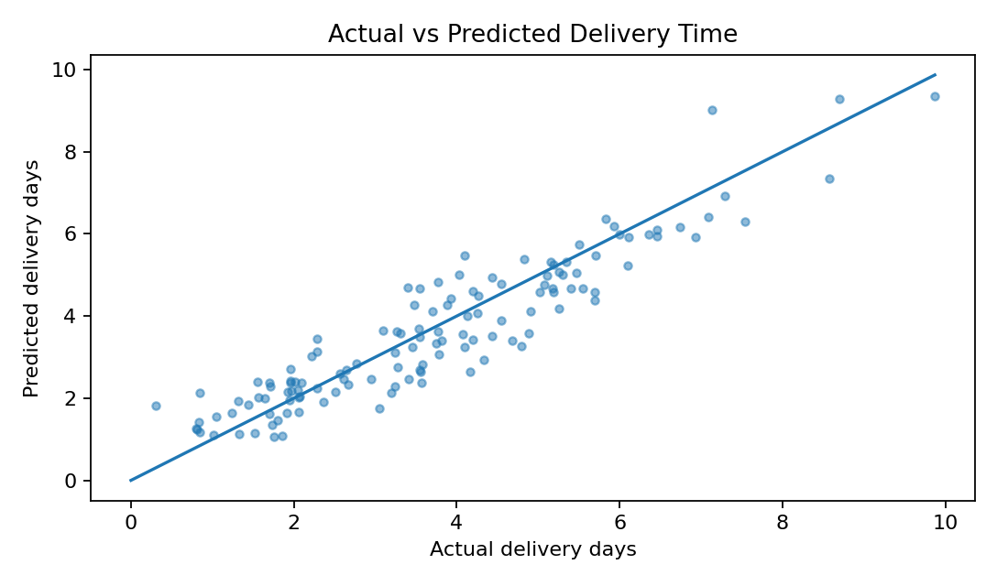
Points close to the diagonal represent accurate predictions. Systematic deviation above or below the line indicates underprediction or overprediction. Spread that increases at larger actual values suggests errors may depend on shipment scale or route length

Residual distribution
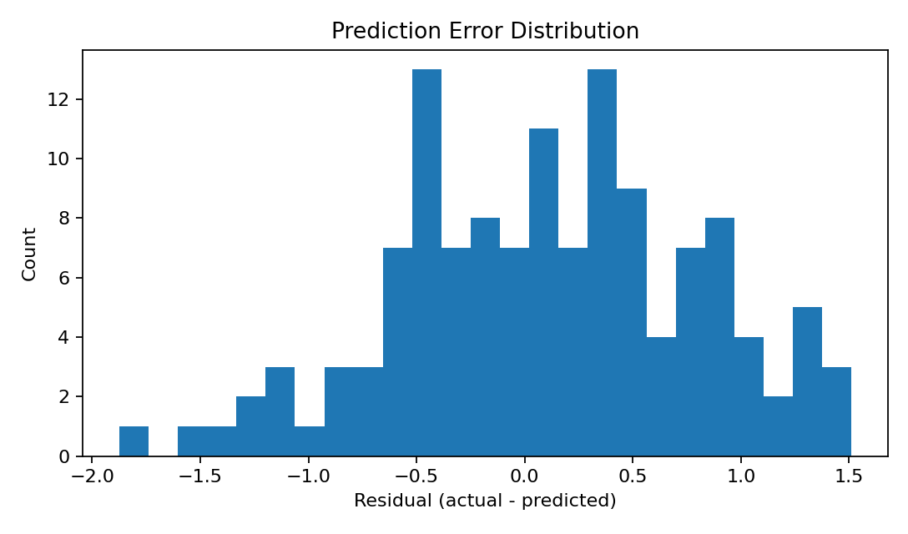
Residuals are actual minus predicted. A distribution centered near zero indicates limited overall bias. Long tails or skewness suggest occasional large misses; residuals should also be plotted against predictions and key features to identify patterns

7. Visual Interpretation (continued)

Feature importance
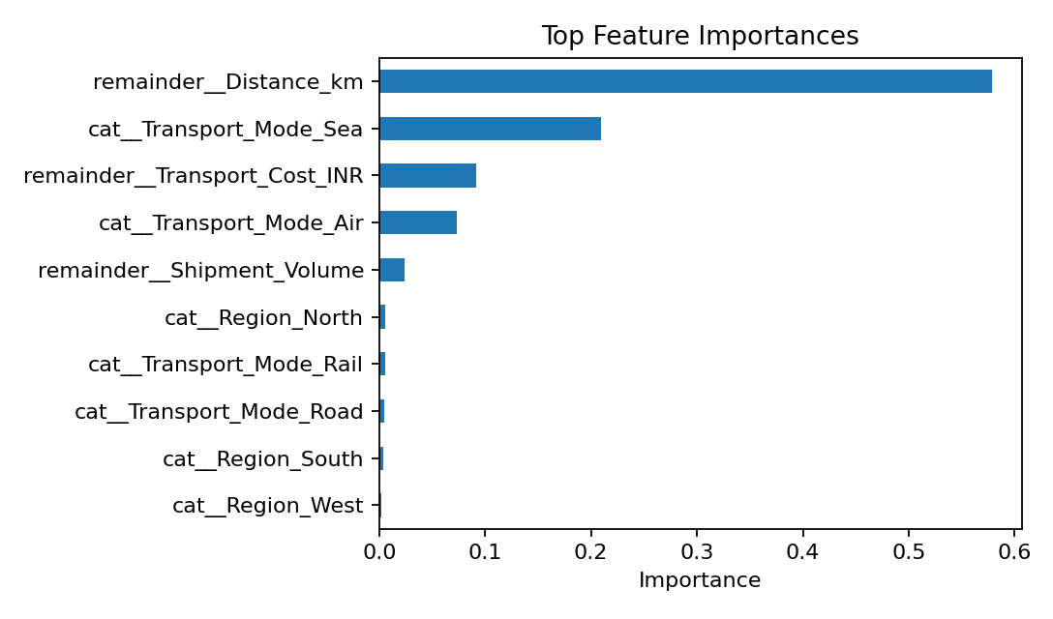
Random Forest importance indicates which encoded features contribute most to splitting decisions in this fitted model. Importance is not causality, and correlated variables can share or distort importance. Permutation importance on held-out data is a stronger complementary diagnostic

Mode context
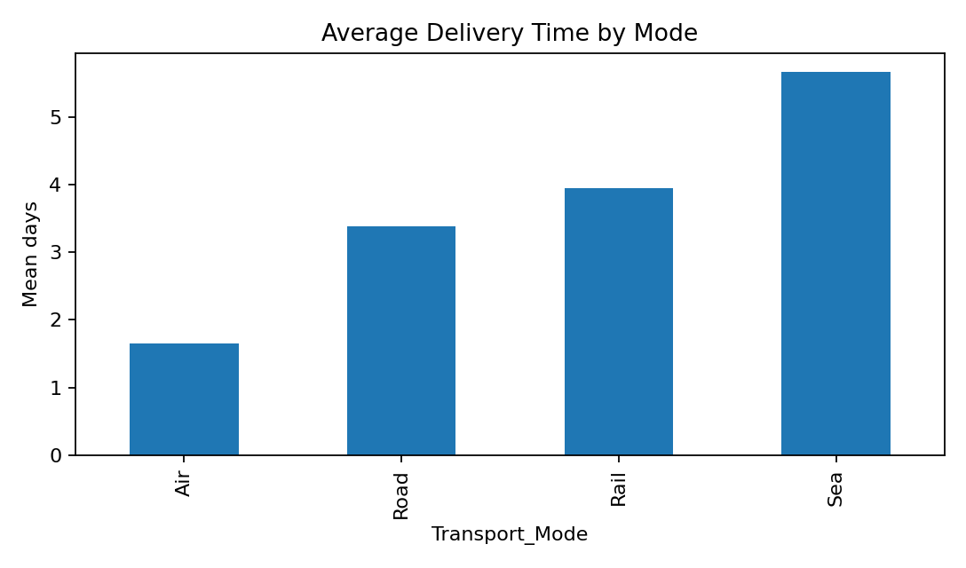
Mode averages provide operational context for predictions. In this simulation, mode factors deliberately affect delivery duration. Use these comparisons to inform service tiers, but validate them with actual carrier performance, lane constraints, reliability, and cost

Reporting recommendations
• Display MAE and P90 absolute error with units.
• Show actual-versus-predicted plots and residual diagnostics.
• Compare model errors across regions, modes, and distance bands.
• Document model version, data date, and prediction-time features.

8. Logistics Optimization Strategies

Exception-based planning
Use predictions to flag shipments whose estimated arrival exceeds the service target or whose uncertainty is high. Route exceptions to planners for review, prioritizing high-value and customer-critical shipments. Predictions should be accompanied by a confidence or uncertainty estimate when possible

Mode and route scenarios
For eligible shipments, compare feasible transport modes using predicted time, quoted cost, capacity, and service constraints. Do not select a mode solely from the shortest prediction: include emissions, reliability, handling, and network availability

Resource allocation
Forecast workload by arrival window to plan dock appointments, warehouse labor, and last-mile capacity. Aggregate predicted arrivals by day and location, then compare against capacity. Keep a buffer for forecast error and sudden demand changes

Cost minimization
Optimization can be formulated as minimizing total cost subject to delivery deadlines, vehicle capacity, mode availability, and customer service constraints. A linear or mixed-integer optimization solver may be appropriate once decision variables and constraints are specified. The prediction model supplies estimated travel times; optimization chooses feasible assignments

Practical implementation loop
• Generate predictions at dispatch or booking time.
• Identify late-risk and capacity-risk shipments.
• Evaluate feasible alternatives with planners.
• Record chosen action and realized outcome.
• Monitor errors and revise features/model periodically.

9. Limitations and Responsible Use
• Synthetic data reflect assumptions embedded in the generator, not actual network behavior.
• Random train/test split assumes independent, similarly distributed shipments.
• Cost may be unavailable at prediction time and could create leakage.
• Feature importance is not causal evidence.
• No prediction intervals or uncertainty calibration are provided.
• Performance may vary across routes, seasons, carriers, and shipment types.
• The model is not connected to live systems and should not automate customer promises.

Deployment checklist
☐ Validate data schema and timestamp definitions.
☐ Use temporal holdout and monitor drift.
☐ Evaluate segment-level performance and fairness.
☐ Set alert thresholds with operations teams.
☐ Keep a human review path for exceptions.
☐ Log predictions, decisions, and actual outcomes securely.

Responsible use
Use predictions as decision support, not as a reason to blame a carrier, employee, or region without contextual investigation. Protect customer and shipment information, limit access, and document model limitations

10. Conclusion
This Week 4 project demonstrates a complete predictive analytics workflow for logistics delivery-time forecasting. It defines a regression problem, simulates a structured dataset, prepares mixed data types, trains a Random Forest pipeline, validates it with cross-validation, and evaluates it on held-out records using MAE, RMSE, and R²
The illustrative test metrics are MAE 0.57 days, RMSE 0.70 days, and R² 0.861. These results show the model's fit to this synthetic sample only. The report recommends subgroup evaluation, temporal validation, feature availability checks, and monitoring before any operational use
Predictive modeling becomes valuable when it is integrated with feasible optimization and human expertise. A logistics organization can use forecasts to anticipate exceptions, plan capacity, compare mode scenarios, and improve service reliability—provided predictions are validated, transparent, and continuously monitored

References
• scikit-learn: https://scikit-learn.org/stable/
• pandas: https://pandas.pydata.org/docs/
• NumPy: https://numpy.org/doc/
• Matplotlib: https://matplotlib.org/stable/

Appendix A: Python Implementation
import pandas as pd
import numpy as np
from sklearn.model_selection import train_test_split, cross_val_score
from sklearn.compose import ColumnTransformer
from sklearn.preprocessing import OneHotEncoder
from sklearn.pipeline import Pipeline
from sklearn.ensemble import RandomForestRegressor
from sklearn.metrics import mean_absolute_error, mean_squared_error, r2_score
df = pd.read_csv("logistics_week4_dataset.csv")
X = df[["Distance_km", "Shipment_Volume", "Transport_Mode",
"Region", "Transport_Cost_INR"]]
y = df["Delivery_Time_days"]
X_train, X_test, y_train, y_test = train_test_split(
X, y, test_size=0.20, random_state=42)
preprocess = ColumnTransformer([
("cat", OneHotEncoder(handle_unknown="ignore"),
["Transport_Mode", "Region"])
], remainder="passthrough")
model = Pipeline([
("prep", preprocess),
("rf", RandomForestRegressor(
n_estimators=180, max_depth=12,
min_samples_leaf=2, random_state=42))
])
model.fit(X_train, y_train)
pred = model.predict(X_test)
mae = mean_absolute_error(y_test, pred)
rmse = np.sqrt(mean_squared_error(y_test, pred))
r2 = r2_score(y_test, pred)
cv_mae = -cross_val_score(model, X_train, y_train,
cv=5, scoring="neg_mean_absolute_error").mean()
print(mae, rmse, r2, cv_mae)

Appendix B: GitHub Upload Guide
Recommended repository: logistics-predictive-modeling-week4
• logistics_week4_report.docx — this report
• logistics_week4_dataset.csv — simulated data
• logistics_week4_model.py — model training and evaluation script
• w4_*.png — generated model charts
• README.md — project overview and run instructions

Git commands
git init
git add .
git commit -m "Add Week 4 logistics predictive modeling project"
git branch -M main
git remote add origin https://github.com/YOUR-USERNAME/logistics-predictive-modeling-week4.git
git push -u origin main
Alternatively, create a repository on GitHub and use Add file → Upload files to upload the DOCX, CSV, script, README, and chart PNGs. Copy the repository URL into the Yuva submission form. Keep the repository public if your assignment requires review access.

