## horizontal line



Joseph Lord, David Castaneda

11/24/2018

**What is TeemIP?** **2**

**Installing TeemIP Normally** **3**

**Installing TeemIP With a Script** **6**

**Finishing Installing TeemIP** **8**

**Configuring Your Network** **14**

**DHCP Leases** **18**

# What is TeemIP?

One of the essential duties of a system administrator is to keep track of all the devices under the control of IT, where they are located, what their network configuration is, and so on. If this is not done properly, it could lead to devices being lost or stolen without the sysadmin ever knowing, which would be a huge problem.

TeemIP Is an easy to use web-based application that provides IP management. TeemIP is a sub-product of iTop, and while iTop has more features than TeemIP, iTop only has a limited free version.

TeemIP incorporates the following:

· Managing multiple organizations at the same time.

· Import tool for transferring settings and data across

· Managing subnets, IP ranges, IPv4 / IPv6 spaces, and domain names.

· A comprehensive help desk to simplify workflow of managing user requests.

· Notification system for administrators

Since this is web-based, nothing needs to be installed on any client machine, on the server must have it installed and configured.

# Installing TeemIP Normally

Since TeemIP is a web-based server, we need to install and setup a LAMP

server for it.

NOTE: TeemIP requires php version 5.6 or higher. We will be using php 7.2.

NOTE: Even though we are using mariadb instead of mysql, the commands are mostly the same.

Install LAMP stack. epel-release and yum-utils will be used for installing php

|  |
| --- |
| [sysadmin@teemip ~]# sudo yum -y install yum-utils httpd mariadb mariadb-server epel-release unzip wget |

Edit the **epel.repo** file and change every instance of **https** to **http**

|  |
| --- |
| [sysadmin@teemip ~]# sudo vim /etc/yum.repos.d/epel.repo |

Enable the **remi-php72** repo using yum-config-manager, then install php modules

|  |
| --- |
| [sysadmin@teemip ~]# sudo yum-config-manager --enable remi-php72 [sysadmin@teemip ~]# sudo yum -y install php php-mysql php-mycrypt php-xml php-soap php-cli php-ldap php-pdo graphviz php-gd php-mcrypt php-mysqli |

Enable and start the apache, mysql, and httpd services:

|  |
| --- |
| [sysadmin@teemip ~]# sudo systemctl enable httpd [sysadmin@teemip ~]# sudo systemctl start httpd [sysadmin@teemip ~]# sudo systemctl enable mariadb.service [sysadmin@teemip ~]# sudo systemctl start mariadb.service |

We will now securely configure the mariadb server. The script will now ask you questions about securing the server. You want to add a root password, remove anonymous users, disable root logins remotely, disable remote test database access, and reload the privilege tables

|  |
| --- |
| [sysadmin@teemip ~]# mysql_secure_installation |

Next, we will create a database and user to access Teemip:

|  |
| --- |
| [sysadmin@teemip ~]# mysql -u root -p |

-----Enter your password that you used for mysql_secure_installation----

|  |
| --- |
| MariaDB [(none)]&gt; create database teemipdb; MariaDB [(none)]&gt; create user 'teemip'@'localhost' identified by 'centos'; MariaDB [(none)]&gt; grant all on teemipdb.* to 'teemip'@'localhost'; MariaDB [(none)]&gt; exit |

NOTE: If you are unable to access mysql due to forgetting the password, you can always reinstall by removing the **/var/lib/mysql** folder and reinstall **mariadb** and **mariadb-server**.

Next, we need to modify the PHP component:

|  |
| --- |
| [sysadmin@teemip ~]# sudo vi /etc/my.cnf |

Add the line:

|  |
| --- |
| max_allowed_packed=32MB |

Restart both the apache and mysql services after.

|  |
| --- |
| [sysadmin@teemip ~]# systemctl restart httpd [sysadmin@teemip ~]# systemctl restart mariadb |

As of this guide, the latest version is 2.3.0, please check before running this. You can download TeemIP directly from: **https://sourceforge.net/projects/teemip/files/**

|  |
| --- |
| [sysadmin@teemip ~]# sudo wget https://sourceforge.net/projects/teemip/files/teemip%20-%20a%20standalone%20application/2.3.0/TeemIp-2.3.0-1808.zip |

Make a new directory, unzip the **TeemIp-2.2.0.zip** there, and change the ownership to apache

|  |
| --- |
| [sysadmin@teemip ~]# sudo mkdir /var/www/html/teemip [sysadmin@teemip ~]# sudo unzip 'TeemIp-2.2.0.zip' -d /var/www/html/teemip/ [sysadmin@teemip ~]# sudo chown -R apache:apache /var/www/html/teemip/ |

TeemIP is now installed!

# Installing TeemIP With a Script

This part is not really necessary, but as this is a scripting class, we made a script to do the installation for us.

|  |
| --- |
| #!/bin/bash # This script installs TeemIP  printf "Installing Softwares....\n" sleep 2s sudo yum -y install epel-release > /dev/null if [ $? == 1 ]; then printf "There was an error. 1.\n"; exit; fi sudo vim /etc/yum.repos.d/epel.repo sudo yum -y install httpd mariadb mariadb-server unzip wget yum-utils > /dev/null  sudo yum-config-manager --enable remi-php72 if [ $? == 1 ]; then printf "There was an error. 2.\n"; exit; fi sudo yum -y install php php-mysql php-mycrypt php-xml php-soap php-cli php-ldap php-pdo graphviz php-gd php-mcrypt > /dev/null if [ $? == 1 ]; then printf "There was an error. 3.\n"; exit; fi  printf "Enabling Services....\n" sleep 2s sudo systemctl start httpd if [ $? == 1 ]; then printf "There was an error. 4.\n"; exit; fi sudo systemctl start mariadb.service if [ $? == 1 ]; then printf "There was an error. 5.\n"; exit; fi sudo systemctl enable httpd > /dev/null sudo systemctl enable mariadb.service > /dev/null  printf "Running Secure Installation....\n" sleep 2s sudo mysql_secure_installation if [ $? == 1 ]; then printf "There was an error. 6.\n"; exit; fi  printf "Creating Database....\n" sleep 2s mysql -u root -p  printf "Modifiying PHP....\n" sleep 2s sudo printf "\n%s\n" "max_allowed_packed=32MB" >> /etc/my.cnf  printf "Restarting Services....\n" sleep 2s if [ $? == 1 ]; then printf "There was an error. 7.\n"; exit; fi sudo systemctl restart httpd if [ $? == 1 ]; then printf "There was an error. 8.\n"; exit; fi sudo systemctl restart mariadb.service if [ $? == 1 ]; then printf "There was an error. 9.\n"; exit; fi  printf "Installing TeemIP....\n" sleep 2s sudo wget https://sourceforge.net/projects/teemip/files/teemip%20-%20a%20standalone%20application/2.3.0/TeemIp-2.3.0-1808.zip if [ $? == 1 ]; then printf "There was an error. 10.\n"; exit; fi sudo mkdir /var/www/html/teemip if [ $? == 1 ]; then printf "There was an error. 11.\n"; exit; fi sudo unzip 'TeemIP-2.3.0-1808.zip' -d /var/www/html/teemip/ if [ $? == 1 ]; then printf "There was an error. 12.\n"; exit; fi sudo chown -R apache:apache /var/www/html/teemip/ if [ $? == 1 ]; then printf "There was an error. 13.\n"; exit; fi  printf "Done!!!!\n\n" sleep 2s exit |

# Finishing Installing TeemIP

NOTE: Make sure that on both the client and server machines, the firewall is configured to allow http and https.

NOTE: This section will be done on the client machine.

On your client machine, open a browser and go to the below website, then click **Continue**.

[http://YOURSERVERIPADDRESS/teemip/web/](http://youripaddress/teemip/web/)

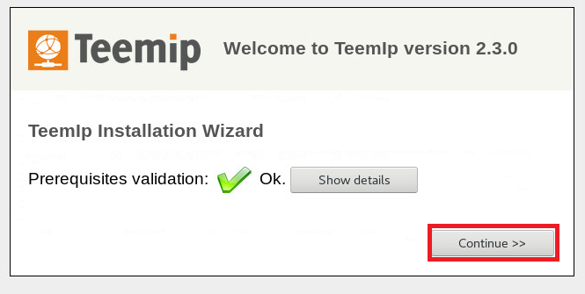

Click **Install a New TeemIP**, then click **Next**.

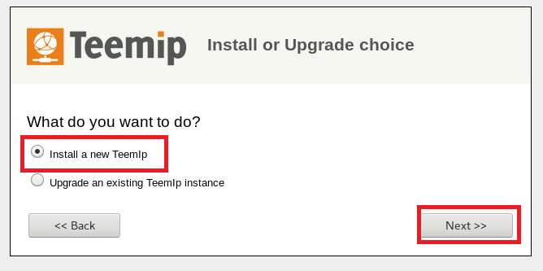

Check the Agree box and click Next.

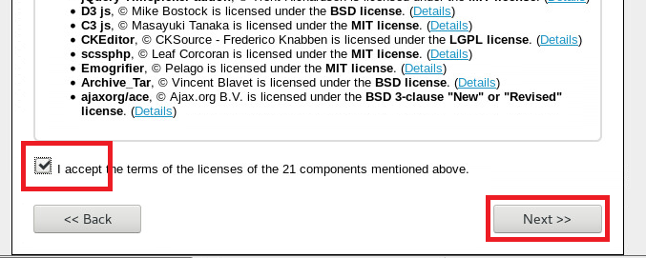

For this part, enter the below information and click Next.

· Server Name: 127.0.0.1

· Login: teemip

· Password: centos

· Use the existing database: teemipdb

· Use a prefix for the tables: tip_

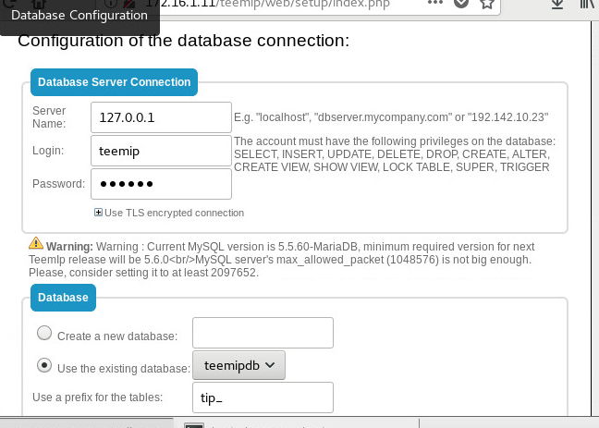

NOTE: If you are using the server machine to access this website, use **localhost** instead of **127.0.0.1** for the server name.

The next page asks you to create an administrator account. Create one and click **Next**, and make sure you remember your account info!

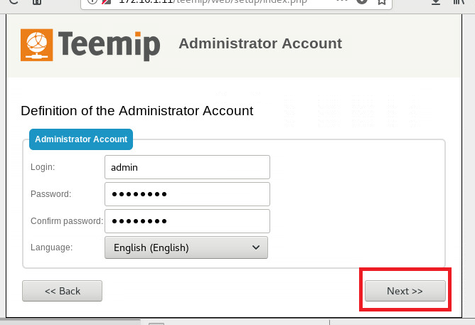

The only thing you change on the next page is to click **I am installing a production instance**, and then click **Next**. 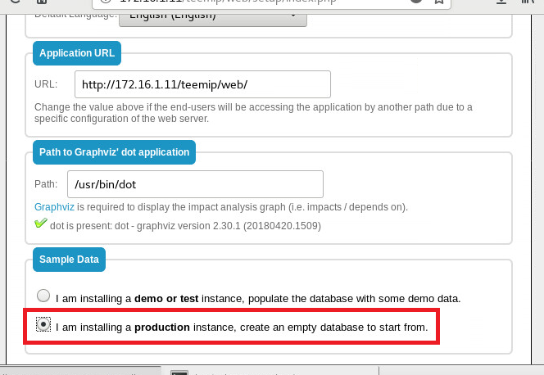

For the next few pages, simply leave the settings alone and click **Next** until you reach the final page, then click **Enter TeemIP**.

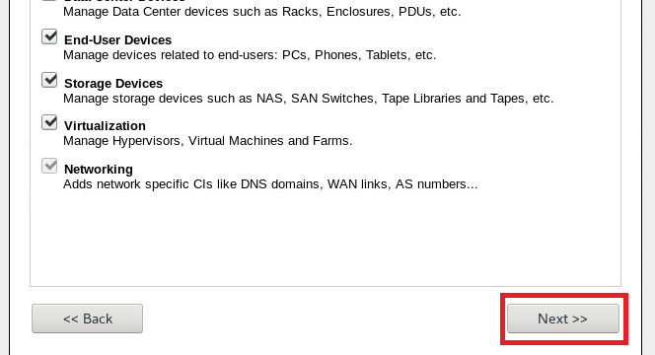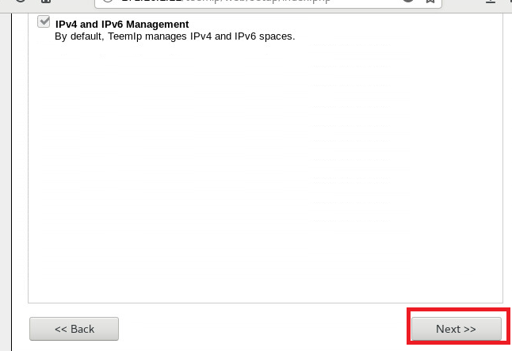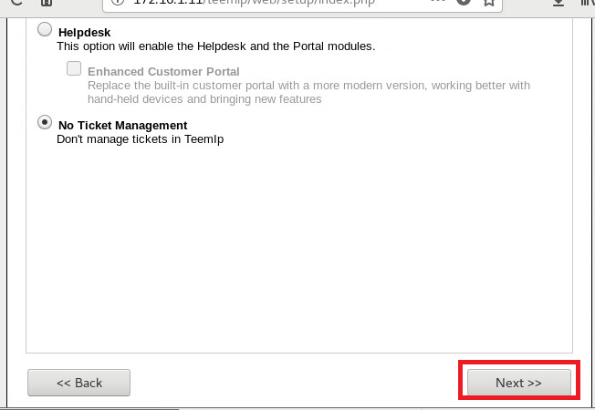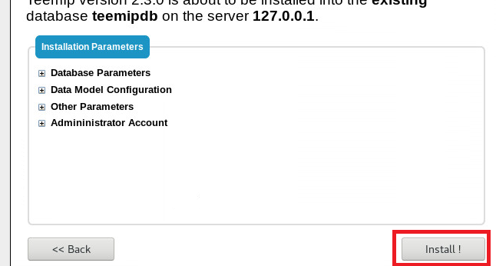

Your Installation of Teemip is complete! In the next following pages, an example is given on how you would set up Teemip for your network.

# Configuring Your Network

For TeemIP, the is a hierarchy of information, Subnet Blocks contain Subnets, Subnets contain IP Ranges, and IP Ranges contain IP Addresses. As an example, we will be showing how to configure our Workstation IP’s from our lab.

First we create a new subnet block. On the left side, click **IP Management -> IP Space -> Create a new IPv4 Subnet Block**.

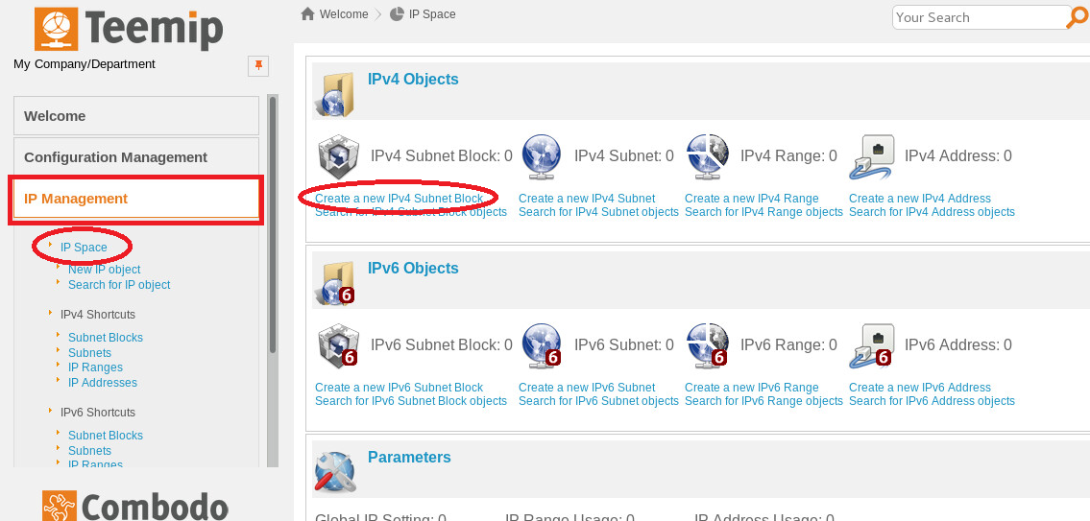

Add our lab info for the subnet block.

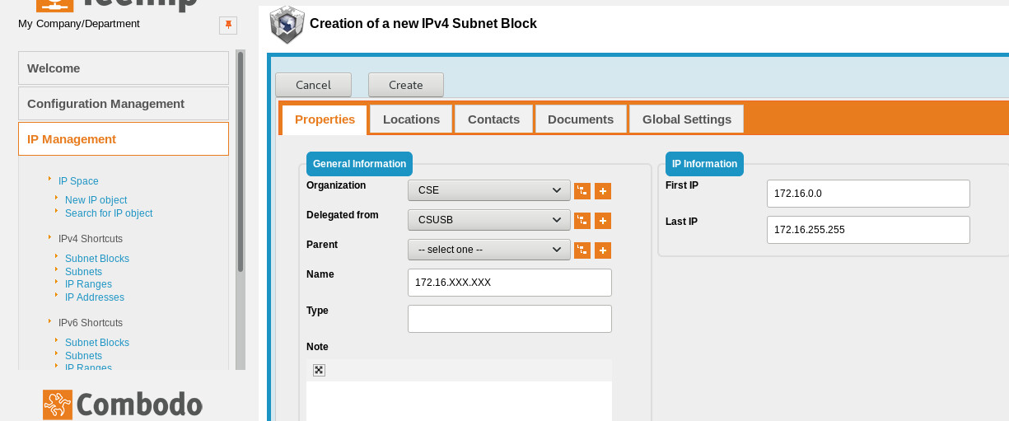

**Next,** create a subnet for our subnet block. Our Hadrian’s subnet is 172.16.1.0. The Gateway IP and Broadcast IP are automatically filled out once this subnet is filled out.

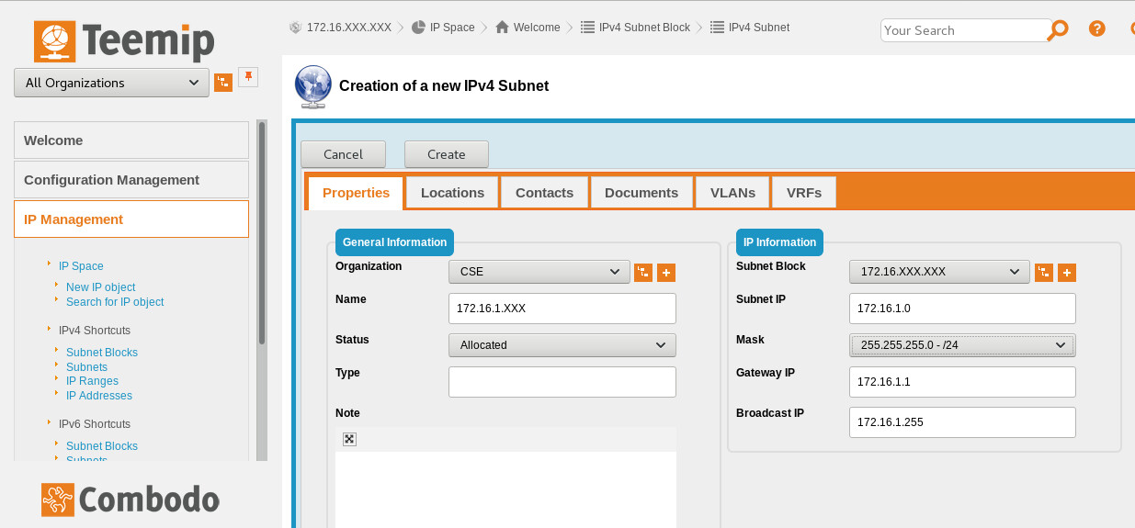

Next, we create an IP range for our subnet block. Our IP ranges for workstations are between 172.16.101 to 172.16.254. Make sure DHCP Range is set to **yes**.

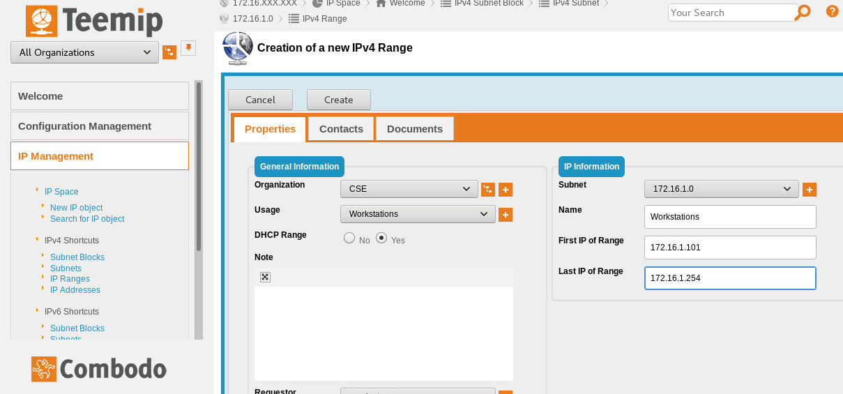

Next, Create a subnet for the workstations.



Lastly, we add our currently leased IPs to our subnet block. Make sure the DNS has the right domain.

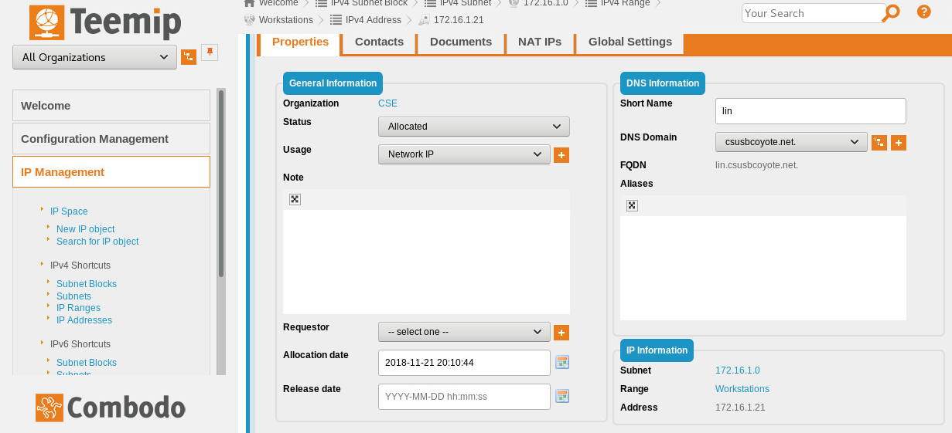

This is all that is needed to add IPs. You can add individual users to the page to let the system know which IP belongs to who.

You can also search for specific IP addresses quickly and easily at the top of the page.

# DHCP Leases

If you do not know what IP’s are being used in your network, one useful tool is the dhcpd.leases file on your DHCP server. This file keeps track of every IP, MAC address, and hostname that has been leased.

This is a simple script for utilizing the dhcpd.leases file.

|  |
| --- |
| #!/bin/bash # Description: Prints a list of IP address leases from DHCP server. # Options: The hostname, IP, or MAC of what you want to find, type "all" for all leased IP's  if [ "$1" = "all" ]; then  egrep "lease|hostname|hardware|\}" /var/lib/dhcpd/dhcpd.leases else  egrep "lease|hostname|hardware|\}" /var/lib/dhcpd/dhcpd.leases | grep -A 1 -B 2 $1    if [ $? == 1 ]; then printf "This input does not have a lease.\n"; fi fi  exit |