|  |  |  |  |  |
| --- | --- | --- | --- | --- |
| |  | | --- | |  | |  | |  | |  | |
| TEACHERBOT  TEACHERBOT is a Catalan teacher who will correct texts written by you or dictated by the robot itself. |
| PROJECT SPRINT #2. DATE: 03 May 2017  Carles Costas Mateu  Marc Cives Trillo  Joel Prat Vilanova  Eric Caballer Jiménez |

Table of Contents

Project description 1

Electronic components 1

Scheme 2

Extra components and 3D pieces 5

Foreseen risks and contingency plan 8

TEACHERBOT

TEACHERBOT is a Catalan teacher who will correct texts written by you or dictated by the robot itself.

# Project description

This robot is a Catalan teacher designed to help you improve your Catalan skills. It is able to understand and highlight syntax errors with great accuracy.  
  
This Catalan teacher robot not only corrects your written texts, but also gives you feedback on your mistakes using a screen, to help you understand why you made the mistake and how to avoid it in the future. Also, it can spell you a brief text in order to write it by yourself and then the robot will correct the mistakes that you have done.  
  
This Catalan teaching robot is an excellent tool for anyone who wants to improve their Catalan skills, whether they are learning the language for academic or professional purposes, or just for fun. It's easy to use and very effective, which means you'll be able to significantly improve your Catalan level in no time.

# Electronic components

This is the list of the proposed components:

* 1 x ARDUINO UNO REV.3
* 1 x PROTOBOARD
* 2 x STEPPER MOTOR
* 1 x SERVOMOTOR
* 1 x MICROPHONE
* 1 x SPEAKER
* 1 x WIFI-MODULE
* 1 x ENGINE CONTROLLER
* 1 x VOLTAGE REGULATOR
* 1 x LCD SCREEN

# Hardware Scheme (optional, in case that you already had this ready)

# Software Architecture (COMPULSORY)

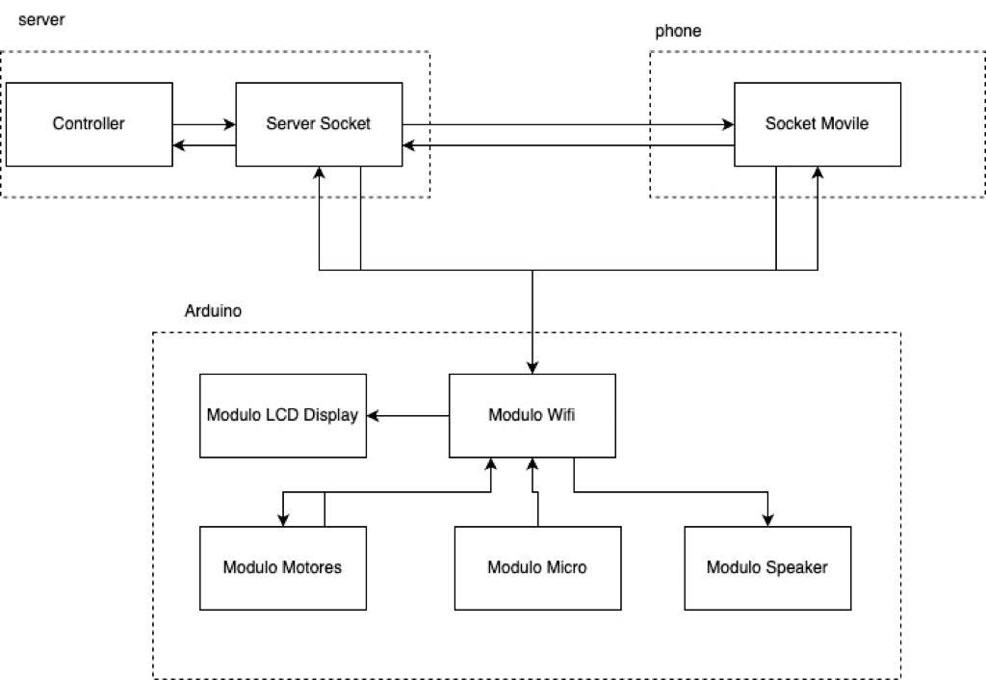

1. In the diagram, there are three different blocks that correspond to different systems, including the server, the phone, and the Arduino board.  
     
   Within the server, there is a block that is responsible for all the logic to compute the OCR and interpret the human speech, as well as generate the sound to be played by the speaker. This module will communicate via UDP socket.  
     
   Secondly, we have the phone, where we should have only one socket to receive the order to take photos and send these photos to the central server.  
     
   Finally, on the Arduino we have the WiFi module that will communicate with the sockets via UDP to send information from its peripherals or receive information that some of its peripherals need to use.

# Amazing contributions (COMPULSORY)

1. Special focus on Catalan: The robot has been specially designed for learning and improving the Catalan language. This makes it a highly specialized and effective tool for anyone who wants to improve their Catalan language skills.
2. Text correction capability: The robot is able to highlight mistakes in Catalan with great precision. This includes the correction of syntax errors, which helps to improve the text quality and, ultimately, the language skills.
3. Instant feedback: The robot not only corrects errors, but also provides feedback on the errors made so that users understand the error and know how to avoid it in the future. This helps to improve language skills effectively and efficiently.
4. Advanced technology: The robot is based on advanced natural language processing technology that allows it to understand and produce Catalan texts with great precision and coherence. This makes it an extremely effective tool for improving language skills in Catalan.

*In case of fulfilling all the objectives our mark should be a 9 out of 10 because it always can be better. We think that* *we cover various aspects of engineering, both software and hardware, including machine learning with OCR, human language recognition, network communication protocols, and the use of various peripherals such as motors, LED screens, microphones, loudspeakers, etc.*

*We are working on the development of a new technology, we deal with the Catalan language and try to give an educational value to the project and integrate it with the Catalan culture. Also, it could be a reproducible and scalable project for different aspects in the educational field.*

# Extra components and 3D pieces (COMPULSORY only a number of them, not all of them are compulsory in this sprint)

* *1 x PAPER HOLDER*
* *1 x MOTOR SUPPORT*
* 2 x MOTOR ARM
* 1 x MOBILE PHONE HOLDER
* 2 x NEMA MOTOR
* 1 x PENCIL HOLDER

PAPER HOLDER: It is used to hold the paper in which the robot will write.

MOTOR SUPPORT: It is used to hold the NEMA motors.

MOTOR ARM: Arm used to write on the sheet, by crossing out the word.

MOBILE PHONE HOLDER: Support in charge of holding the mobile to take photos.

NEMA MOTOR: In charge of moving the motor arms.

PENCIL HOLDER: Support in charge of holding the pencil.

We have a structure with a metal base where we place the paper support. The robotic arm consisting of a base 9.5 cm high and two arms 20 cm long each. At the end we put a servo motor to control the movement of the pen. This robot allows us a wide work space which we will only use a part corresponding to a DIN A4 sheet.

*PAPER HOLDER:*

*MOTOR SUPPORT:*

*MOTOR ARM:*

*MOBILE PHONE HOLDER:*

*PENCIL HOLDER:*

# Strategy for validation, testing and simulation (COMPULSORY, only the strategy, you do not need the tests to be done yet at this stage)

Functional tests: Functional tests can be performed to verify that the robot is performing its assigned tasks. For example, it can be tested whether the robot is able to accurately detect syntax errors in the Catalan language and provide feedback on the errors.  
  
Integration tests: With these tests we ensure that all parts of the robot work together correctly. For example, we can check that the server communicates correctly with the phone and the Arduino board.  
  
Performance tests: Performance tests can be performed to verify that the robot is working properly and efficiently. For example, it can be checked whether the robot is able to detect a syntax error in a reasonable time and provide feedback.  
  
User evaluation: User tests can be performed to provide feedback on the effectiveness and usability of the robot. This can help identify areas for improvement and make adjustments to better meet user needs.

|  |  |  |  |  |
| --- | --- | --- | --- | --- |
| **Risk #** | **Description** | **Probability** (High/Medium/Low) | **Impact** (High/Medium/Low**)** | **Contingency plan** |
| 1 | Bad recognition of text using OCR | M | H | None |
| 2 | Incompatibility of Catalan with some libraries | M | H | Change the language |
| 3 | Shock of the robotic arm with the support of the mobile support | L | H | Change the structure |
| 4 | Failure with Wifi controller communication | M | H | Use Bluetooth instead |
| 5 | Failure with Bluetooth communication | M | H | None |

# Foreseen risks and contingency plan

References

This project has been inspired by the following Internet projects:

AINA: <https://www.csuc.cat/es/noticia/aina-el-proyecto-para-que-la-tecnologia-entienda-y-hable-el-catalan>

TOURING DRAWING: <https://rlpengineeringschooluab2017.wordpress.com/2017/05/30/turing-drawing/>