**the Document Tracking System**

One of the main issues in the operations within most government offices is the delay in the delivery of the services, processing of receivables or being stuck in the traditional ways of processing. The computerization of government offices have allowed these offices to have infrastructure however, computers, are being used like typewriters or only to save data individually. Information systems are being implemented at the national level without consideration of the operations in the local level. Thus, these implementations have added burden to the local offices since they do not support the local operations but are only existent to support the concerns of the national offices.

Reports, submissions or data inquiries from the higher offices always require additional time and effort from local offices since data is usually not organized or no platform have been developed in the storage of these important data.

In an effort to track the efficiency of an office, a document tracking system is designed and developed to achieve this goal.

**Features of the document tracking system:**

1. Add, edit and delete documents
2. Forward, receive and add remarks to documents
3. View document route and current location
4. View reports and analytics by department

**Users of the document tracking system**

The four (4) user types of the document system and with their corresponding capabilities:

1. Administrator/Mastermind –
   1. Track and Add Documents
   2. Accept/Forward Documents
   3. Document List and Management
   4. Analysis and Reporting
   5. User Account Management
   6. Department Management
2. Manager/Management –
   1. Track and Add Documents
   2. Accept/Forward Documents
   3. Document List and Management
   4. Analysis and Reporting
3. Regular User –
   1. Track and Add Documents
   2. Accept/Forward Documents
   3. Document List (View)
4. Guest User –
   1. Track and Add Documents

**Document types of the document tracking system**

To further support in the report generation and analytics for each department. Documents are categorized as:

1. Communication – any document that is received from higher offices and other government agencies.
2. Submission – any document from the field that is requested by or routinely required by the Division Office.
3. Request – any document that is requesting for a particular issuance or is seeking approval from the Division Office.
4. For Processing – any document that ultimately results in payments or refunds and is usually processed by the Cash Section.

Owners of the documents submitted are also categorized either as a document submitted by:

1. District – currently there are 23 districts under the Division of Southern Leyte.
2. School – currently there are 341 schools under the Division of Southern Leyte.
3. Personal – any of the 3000+ personnel or applicant or any person who wishes to submit a document to the division office.
4. Others – any office, not included in the district and school categorization.

**Mockup Design**

Administrator, Management, Regular User and Guest User account all have the same views but only the higher level accounts can have access to certain views. The hierarchy of the accounts is as follows:

Administrator >> Management >> Regular User >> Guest User

The views designed for the system are as follow:

1. Navigation Menu

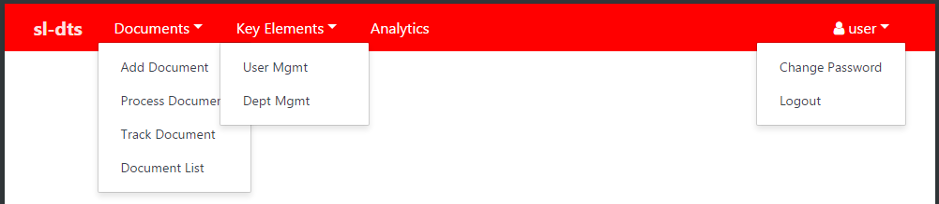

The above view shows the entire menu needed for the system. Under Documents menu, there is Add Document, Process Document (Documents on Hand View), Track Document and Document List.

Under Key Elements menu which is visible only to the Administrator, there is also User Management and Department Management.

The features of the analytics are yet to be discussed with the division management.

1. Add Document View

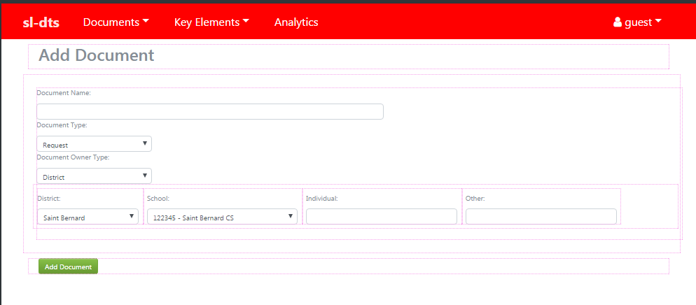

All user accounts can add a document. All documents to be added must be provided with the document name, document type (request, submission, communication and for processing), document owner type (district, school, individual, other). Upon clicking Add Document, a confirmation for successfully adding a document will be displayed together the document’s tracking number. The tracking number of the document is a combination of the current year (18), current month (08) and current day (08) the document is received together with the order in which the document was received on that specific date. For example, 180802001, document was received last August 02, 2018, the first (001) document received during that day.

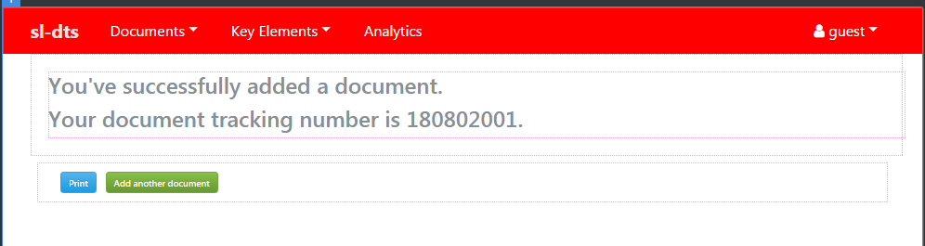

1. Documents on Hand View

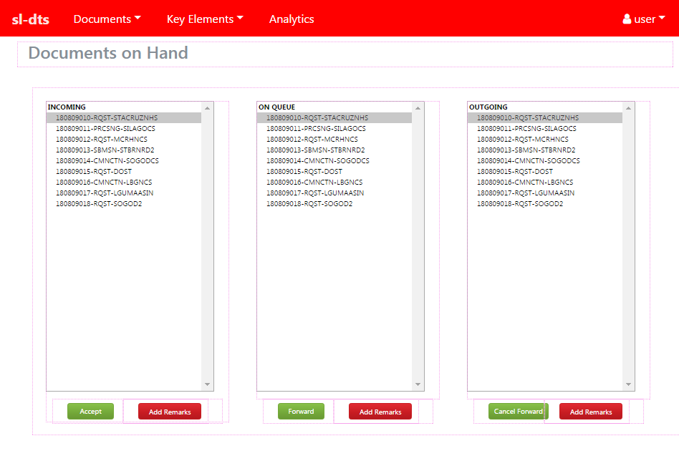

All users except the guest account have a Document on Hand View, it has three select menus:

1. Incoming Documents

All documents forwarded the department of the current user will be displayed here. Meaning that all users under the same department will have the same incoming documents’ list. When a document is accepted by any of the users within that department, the document will be transferred to the current user’s Document On Queue List.

1. Documents On Queue

All documents accepted by the current user will be displayed here. This is to indicate that these documents are currently being processed by the user. When the documents are already processed, they may be forwarded to another department for processing/other concerns.

1. Outgoing Documents

All documents already processed by the current user and forwarded to another department will be displayed here. The current user has the option to cancel the forwarding of the document in the event an erroneous forwarding occurred.

1. Document Management View

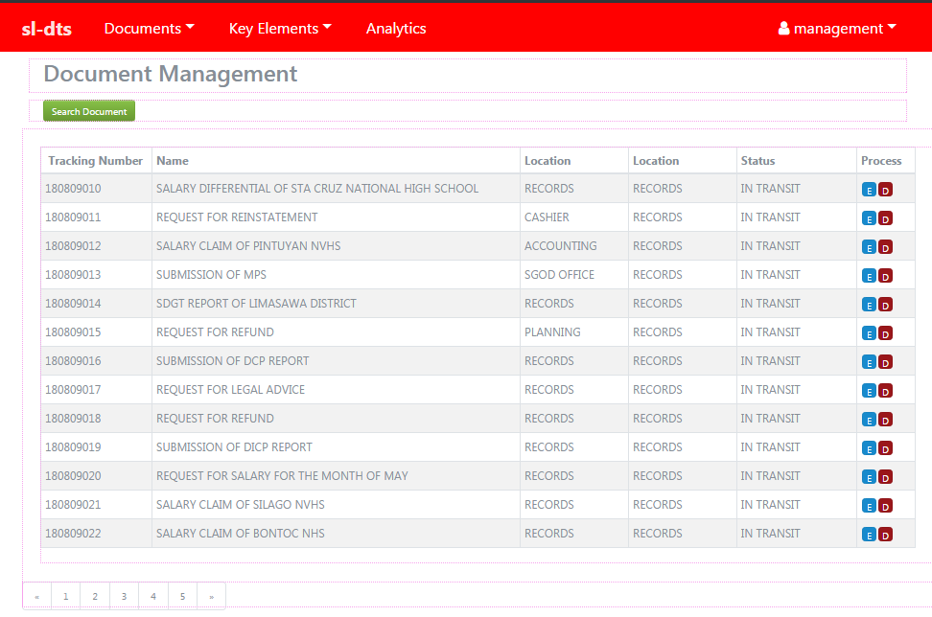

Only the management and the administrator account have access to the Document Management View. This is where basically; all documents previously added will appear, for purposes of locating or searching a document. Documents can be edited and deleted through this view.

1. Department Management View

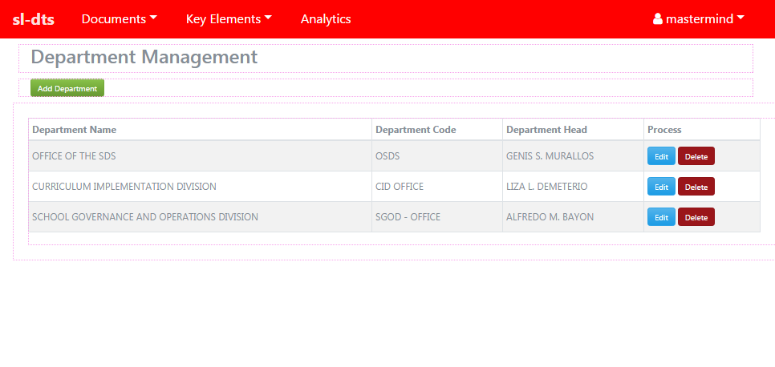

Only the Administrator account has access to this view. Before a user can be added a department must be created to accommodate any user. This view allows the user to add, edit and delete departments.

1. User Management View

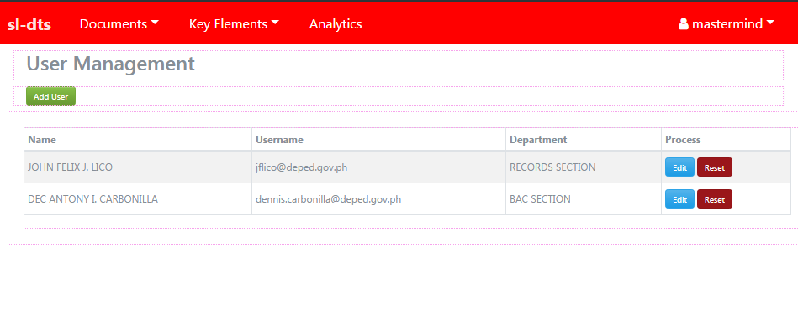

Only the administrator account has access to this view. After creating a department, users may be added to the department. This view allows the administrator to add, edit and reset passwords of the users.

**Class Designs**

During the analysis phase, 4 classes were found to be of use to the system, namely:

1. User Class

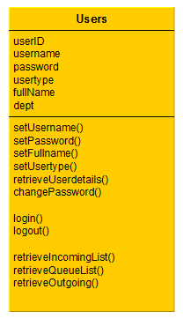The user class has 6 attributes and 11 methods. The attributes are needed details for every user. The methods are for user management, login and logout, and to retrieve the Documents on hand details of the user after logging in.

1. Document Class

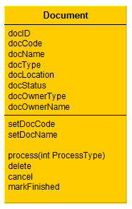

The Document class has 8 attributes and 6 methods. The method for setting the document tracking number can be found here. The method for accepting, forwarding and adding remarks to document is the process method.

1. Document List Class

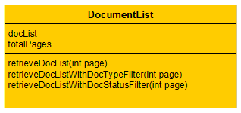

The DocumentList class is a class designed to prepare the data needed in the Document List View.

1. Department Class

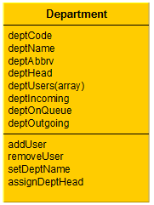

The Department class is the class that is designed to cater all the methods needed in order for the department to be able to add users, and to retrieve the current documents on hand of the entire department.

**Database Design**

During the design phase, 6 tables were identified to be able to cater the needs of the system.

1. the user and department table

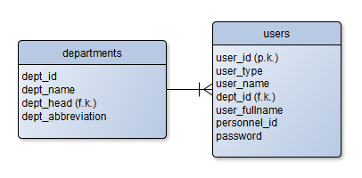

1. the school and district table



1. the document and document_history table

