**Project 2 Rodriguez, Joel.**

**Problem 1:** (a) Neglecting the resistance R for the moment (i.e., temporarily set R= 0), find the resonant frequency of the undamped system as a function of C. Recall that the resonant frequency is the same as the “natural frequency” of the unforced system.

(b) Use your answer from part (a) in order to write the three values of the capacitance C needed to tune the receiver to each of the respective frequencies ω1= 3, ω2= 5, ω3= 7. Your goal here is to find the value of C that makes the resonant frequency of the system match each of the individual frequencies appearing in the forcing function E(t).

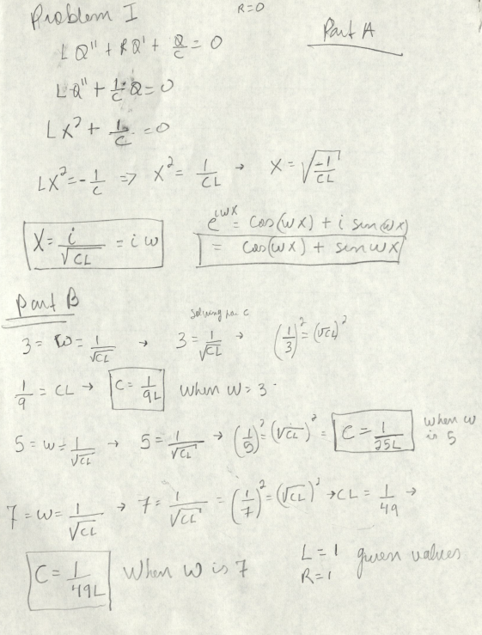

**Problem 2:** Returning to the case with resistance (resetting R= 0.1), rewrite the differential equation as a system of first-order equations (this will be needed for using ode45). We went over this process in class, and it is also explained in the ode45 tutorial. Set C to the value from problem 1 that corresponds toω1, and in preparation for using ode45 create an m-file (as described in the tutorial). Print the code from your m-file (as well as showing your work by hand for rewriting as a system of first-order equations).

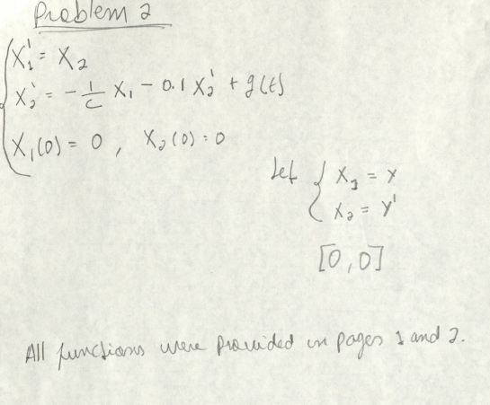

function xp=F(t,x,c)  
  
xp=zeros(2,1); % since output must be a column vector  
  
xp(1)=x(2);  
% Here I am following the standard form that was given in the instructions  
  
xp(2)=-(1/c)*x(1)-0.1*x(2)+((sin(pi*t/25)^2)*cos(3*t)+((sin(pi*t/20)^2)*cos(5*t)+...  
    ((sin(pi*t/10)^2)*cos(7*t))));  
end

% This part of the code is for the purpose of running and getting the  
% graphs instantly.

% The fraction part is the c value

% figure 1

% graph has 4 peaks  
F_ = @(t,x)F(t,x,1/9);  
[t,x] = ode45(F_,[0,100],[0,0]);  
plot(t,x(:,1));

% figure 2  
% figure 1 graph has 5 peaks  
F_ = @(t,x)F(t,x,1/25);  
[t,x] = ode45(F_,[0,100],[0,0]);  
figure  
plot(t,x(:,1));

**Problem 3:** Use ode45 in MATLAB to solve the differential equation with initial conditions Q(0) = 0 and Q′(0) = 0. Plot the solution over the interval [0,100]. Instead of noise, the plot should resemble the first signalE1(t). Print the plot and label it “response tuned to E1”. Repeat this for the second signalE2(choosing a new value of C), labeling the plot “response tuned toE2”.

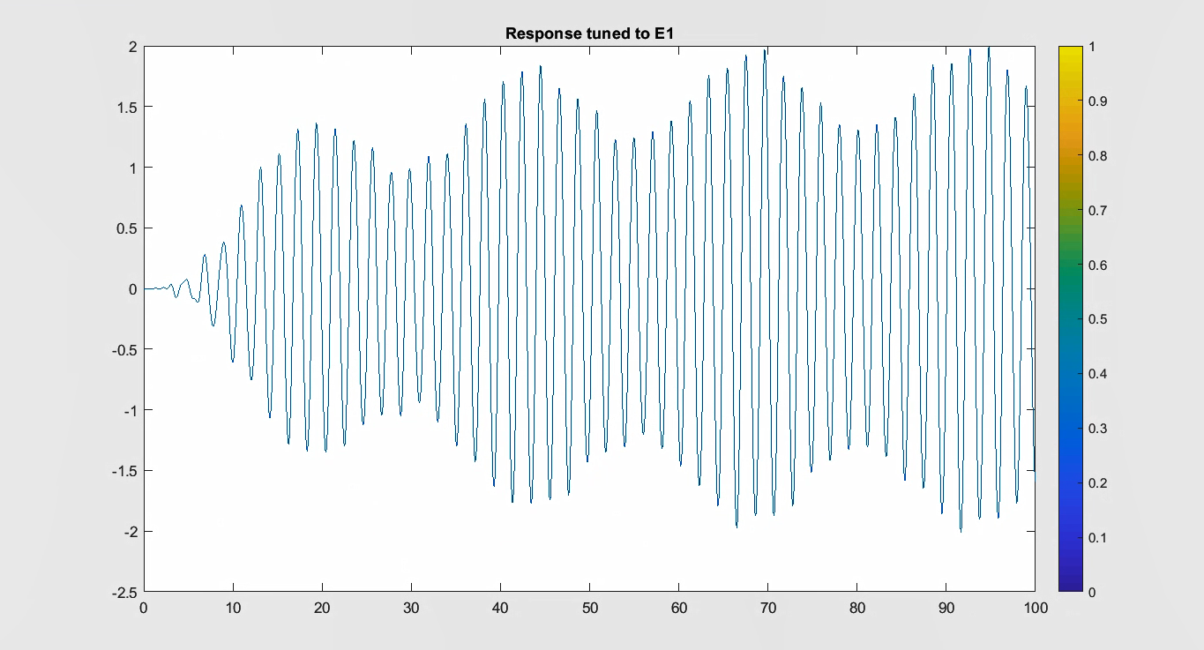

**(Response tuned to E1)**

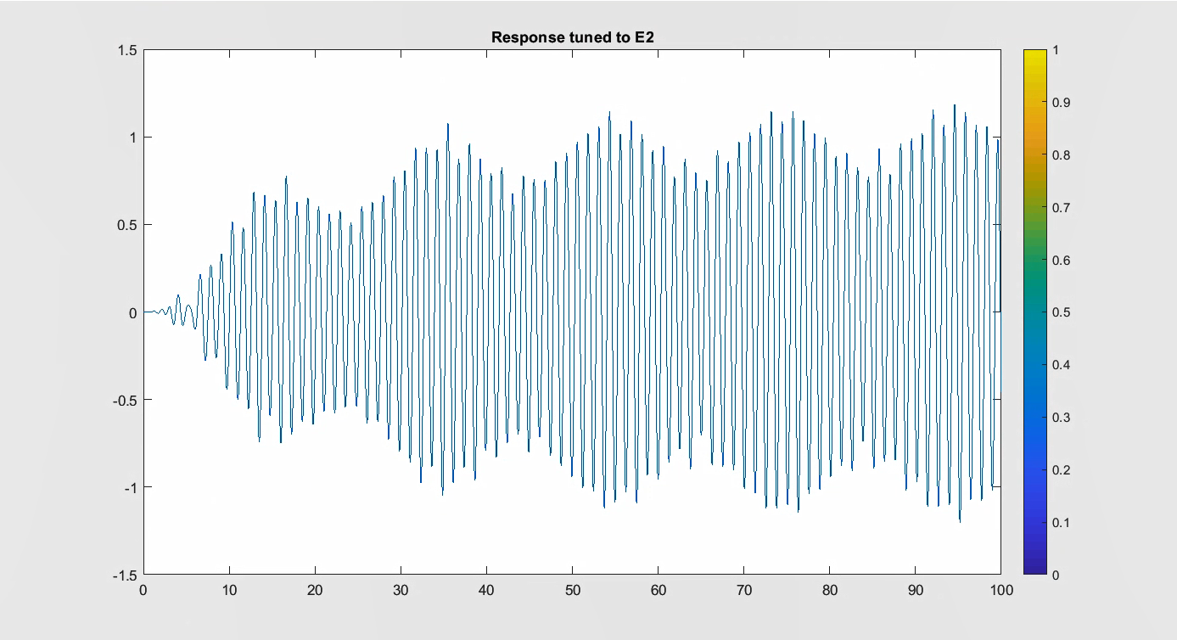

**(Response tuned to E2)**

**Problem 4:** Choose a value of C that leads to a noisy response (something that looks as noisy as the input depicted in Figure 4). You may have to experiment. Plot your solution and label it “noisy response.”

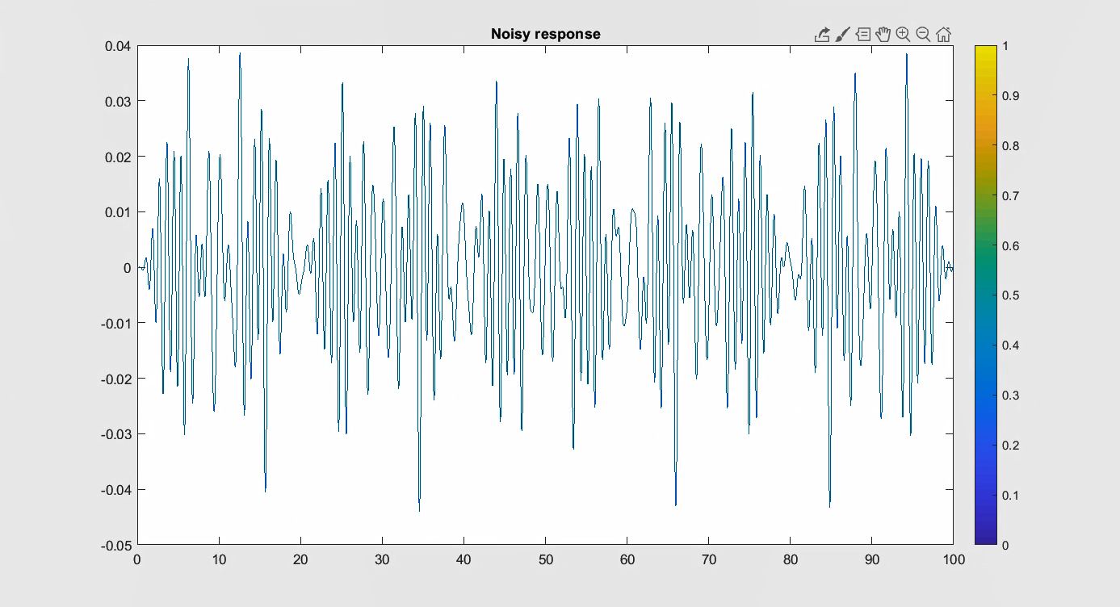

The C value I used to make it match was

Same code as shown in problem 2 but the C value was different.

F_ = @(t,x)F(t,x,1/90);  
[t,x] = ode45(F_,[0,100],[0,0]);  
figure  
plot(t,x(:,1));

**Problem 5:** Add a fourth signalE4(t) =a4(t) cos(11t) withω4= 11 as the frequency, while choosing your own amplitude modulationa4(t) (you can be creative!). Specify your choice here. Use an appropriate value of C to tune to E4 and plot the response of the system—label it “tuned response to my signal.”

My added function was:

**x cos(11t)**

function xp=problem5(t,x,1/2)  
  
xp=zeros(2,1); % since output must be a column vector  
  
xp(1)=x(2);  
% Here I am following the standard form that was given in the instructions  
  
xp(2)=-(1/c)*x(1)-0.1*x(2)+((sin(pi*t/25)^2)*cos(3*t)+((sin(pi*t/20)^2)*cos(5*t)+...  
    ((sin(pi*t/10)^2)*cos(7*t)+(**(tan(pi*t/3)^2)*cos(11*t)))));**  
  
end

% This part of the code is for the purpose of running and getting the  
% graphs instantly.  
% The fraction part is the c value  
% figure 1   
problem5_ = @(t,x)**F(t,x,1/9);**  
[t,x] = ode45(problem5_,[0,100],[0,0]);

plot(t,x(:,1));

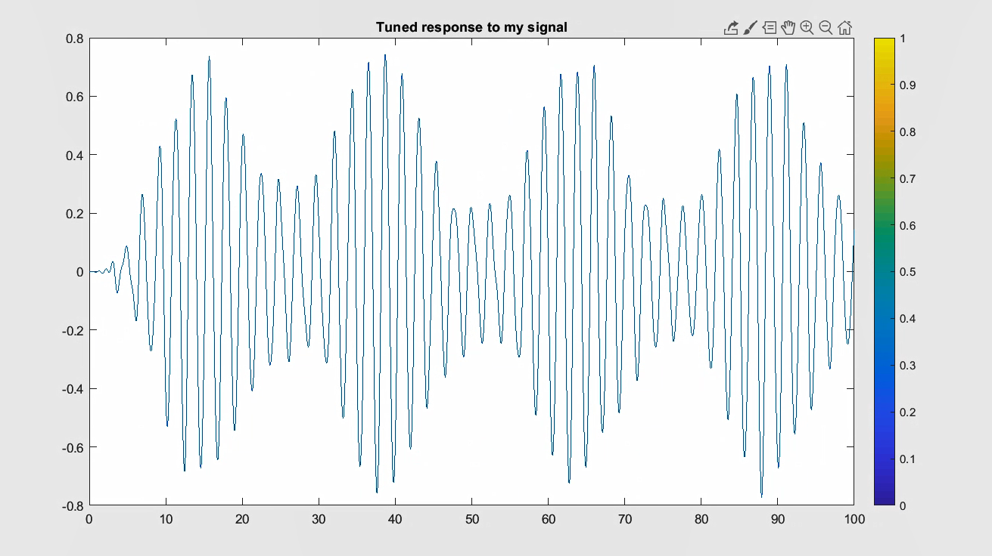

**Problem 6:** In this project, you have seen that a second-order differential equation with a “noisy” forcing function can result in a “not noisy” response. For instance, in problem 2 you saw that for an appropriate choice of the capacitance the response of the system has four organized peaks in the amplitude even though the raw signal given by the forcing function E(t) is quite noisy. In your own words, explain how this can happen.

The way it basically works is that the antenna, in this case, receives multiple signals at the same time (although for this experiment we only limited to 3 or 4). When the Antenna receives multiple signals or harmonic oscillators. The antenna is not going to filter out the different signals, but it is going to keep all of them together making the signals look convoluted when the differential equation is graphed.

On the other hand, When I pick the station I want to listen to, then harmonic oscillators get clear from all the noise and will make the plot and the differential equation look “clean”. The sinusoidal waves in the plots are given by the cosine functions since the sine value is zero in the steady periodic solution and they will vary depending on the ω value, the L value, C value.