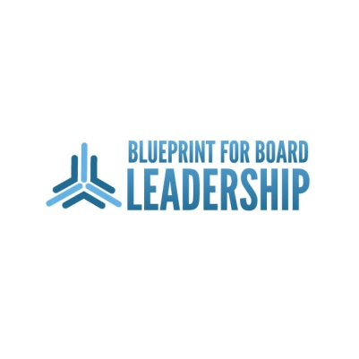

**2012 Blueprint for Board Leadership**

**AGENCY APPLICATION**

***Please Type or Print Legibly and Complete all applicable blanks!***

I. INFORMATION

|  |  |
| --- | --- |
| **Name of the Organization:** | **Web Address:** |
|  |  |
| **Executive Director’s Name** | **E-mail Address:** |
|  |  |
|  | |

II. AGENCY & BOARD

Mission Service: Indicate with an X your Primary Area of Service.

|  |  |  |  |
| --- | --- | --- | --- |
| **Animal Rights** | **Arts** | **Legal Assistance** | **Reading & Literacy** |
| **Senior Adult Services** | **Environment** | **Women’s Issues** | **Domestic Violence** |
| **Children/Youth/Teens** | **Crime Prevention** | **Mental Health** | **Veterans / Military** |
| **Homeless/Housing/Shelter** | **Human Rights** | **Physical Health** |  |

Board Service Data:

|  |  |
| --- | --- |
| **Year Agency Established:** | **Agency’s Annual Budget =** $ |
| **New Board Member Installation Date:** | **Length of Board Term:** |
| **What is the financial expectation you have of your board members?** |  |
| **Do you have new board member orientation?** | Yes  No |
| **If Yes:** please explain the process and timeline: | |

Board Meetings

|  |  |
| --- | --- |
| **Location:** *(list address if different from Agency’s)* | |
| **Day of Week:** | **Week of Month:** |
| **Time of Day:** | **Frequency Held:** |

**Current Board Composition**

|  |  |  |  |
| --- | --- | --- | --- |
| **Total # of Board Members:** | | | |
| **Ethnic & Gender Makeup of Board:*****(Put # of ea.)*** | | | |
| **American Indian/Alaskan Native Male** |  | **American Indian/Alaskan Native Female** |  |
| **Caucasian Male** |  | **Caucasian Female** |  |
| **Hispanic Male** |  | **Hispanic Female** |  |
| **African American Male** |  | **African American Female** |  |
| **Asian American Male** |  | **Asian American Female** |  |
| **Other – *please specify*:** |  | | |

III. BOARD SERVICE NEEDS The following information will be used to assist the Board Matching Committee in finding an appropriate graduate to match your agency’s needs.

Areas of Need: Indicate with an X your agency’s primary areas of need; please limit to top 3:

|  |  |  |  |
| --- | --- | --- | --- |
| **Arts** | **Management & Administration** | **Education** | **Program Development** |
| **Finance** | **Research** | **Fund Raising** | **Strategic Planning** |
| **Law** | **Volunteer Management** | **Marketing & PR** |  |

IV. STATEMENT OF GUARANTEE & COMMITMENT TO A BLUEPRINT GRADUATE

The need for graduates consistently exceeds the number of graduates available for board service in a given year; therefore, the completion of this application does not in anyway guarantee a graduate will be matched with your agency. All reasonable effort is made to ensure that the best candidate is matched with the most appropriate agency based on the data collected on this form and the graduate’s application. The undersigned certifies the above information is complete and accurate to the best of his/her knowledge and that if a graduate is matched with your agency for board service that you will commit to properly orienting and integrating them..

**Applicant’s Signature* Date**

*\*If submitting electronically, typing your name in the signature blank will serve as your commitment to the above statement.*