**TEAM 11**

# Phase1 Document for City of Windsor Open Data Portal (Study Case One)

**Vision and business case** (High-level goals and constraints)

To develop an organized and user-friendly open data portal for the city of Windsor, catered towards developers and users who may need city of Windsor data sets. The database should be easily accessible to whoever needs it with the ability to upload new data, approved by the administrators, if needed.

## Business Case

The city of Windsor’s populations, such as developers and public users, can benefit from accessing real-time data on city public services such as garbage collection, transportation, community centers, etc. The project or system will help reduce staff overhead by automating data updates and providing a centralized data access portal.

**Supplementary specification** (Non-Functional Requirements)

**Security** – implement user authentication and dataset/management permission levels,

**Performance** – ensure the system can handle large dataset and multiple users,

**Accessibility** – ensures that the system meets Web Content Accessibility Guidelines (WCAG),

**Compatibility** – support numerous data formats

**Scalability**- ensures the system handles increased volumes of datasets without performance hindrances

**Reliability**- ensure the system is dependable, with minimal downtime and maximum uptime

**Usability**- The system must be intuitive and easy to navigate for non-technical users.

**Data privacy-** ensures datasets containing private or personal information are restricted from public access.

**Glossary** (Domain terminology and data dictionary)

**Open data** – publicly available data that anyone can access, use, and share

**API (Application Programming Interface)** - rules that allow different software apps to communicate

**Dataset** – a structured collection of data

**Metadata** - info that describes a dataset, like its source, when it was created, and the subject

**Visualization** – the graphical representation of data in charts or maps

**Stakeholder-** individual or group with an interest in the project.

## Risk List and Management Plan Business risks:

* Low adoption – the public may not use the tool which leads to a wasted investment
* Budget overrun – development may exceed the planned budget.

## Technical:

* Data corruption – corrupted dataset being uploaded
* API downtime – extended API downtime could disrupt developers

## Resource:

* Staff shortages – lack of personnel to manage the tools

## Schedule:

* Feature delays – certain features may take longer to implement

## Management Plans

* Frequent progress reviews and updates
* Training and meeting sessions for staff
* Automate data updates and limit manual intervention

## Prototype and Proof of concepts

Prototyping a search and visualization interface can help clarify the vision for the platform. Building

a proof of concept for API access would validate the technical feasibility of the tool’s integration features.

## Iteration Plan

Refine the dataset upload functionality Implement search and basic visualization features Develop a prototype for API access

## Phase Plan and software development planTools:

**Version Control:** Git Lab, OneDrive for sharing and collaboration

**Database:** SǪLPLUS, MYSǪL for data storage and access, Local Storage, Google Drive API.

## Programming Language: java

**People:**

**Roles:** Team roles and duties

Analyst, Owner, project manager, product design, software architect, software testing engineers

**Education:** Training section on how to use the system, updates, scripting language/program that we are using, budgeting

## Development Phase

Use cases:

### Design and initial development: (Development case)

Main task: main page(s) design and coding

*Practices*: Agile modeling, vision box, rapid prototyping and test-driven development for

critical modules

*Artifacts*: Initial use-case model and initial vision document, initial test cases for main site(s), product backlog (for dataset Management)

### Elaboration Phase

Main tasks: product catalogue and system integration

Practices: sprint planning, pair programming, architectural prototype

Artifacts: refined use-case model, initial domain model, initial software architecture documentation, early API prototypes

### Construction Phase

Main tasks: feature development, testing and incremental builds

Practices: continuous integration (CI), pair programming, automated testing

Artifacts: incremental builds, test cases, refined data model, user authentication module

### Transition Phase:

Main task: Comprehensive system testing such as front-end, back-end, and integrations and final approval and adjustment based on the feedback.

*Practices*: Continuous integration, deployment planning for final delivery, user training preparation, stakeholder feedback loop.

*Artifacts*: final test cases for all system components, deployment plan, user training materials, final system documentation, final deliverables.

Maintenance plan: define roles for future system maintenance Actors: Developers for main site and front-end development

Developers – responsible for ongoing front-end and back-end updates

Tester – preform regular system tests to endure functionality remains intact over time

Manager – handles simple maintenance tasks and ensures updates are properly deployed and managed

**Use Case Model** (Functional Requirements)

**Actors**: City officials, developers, public

**Use cases:** dataset upload and management which allows admins to upload, edit and manage datasets.

**Data search:** which allows users to search for a specific dataset

**API access** which allows developers to use API endpoints to integrate data into external apps

**Data visualization** which allows users to view the data in a more organized manner

**Search functionality:** Users can search for datasets by category or keywords, and download them in various formats.

**Data Download:** Users can download data sets in various formats (CSV, JSON, XML).

**Upload Data**: Authorized users can upload new data sets. Dataset Categorization

**User authentication:** Users can register and log in to access personalized features.

Dataset Metadata management

**Access logs:** Admins can view statistics on data usage and access

**Data update notifications:** ensure the system notify users if changes occur in datasets ensuring stakeholders stay informed

NOTE: For a detailed Use case please look at the end of this report.

# Use Case Accompanying Notes

Use Case: User Logging into a municipal Website under the Open Data Policy. Actors: User, Data Administrator, Database, Login System, Uploading System.

Title: Dataset Upload and Management, User Login and Interaction with Municipal Data Use Case 1: Login/Authentication

Primary Actor: Administrator and contributors

Secondary Actor: Authentication System

Description: The user inputs login credentials to access municipal data system

Authentication System Approves or rejects the user’s credentials or prompts the user to create an ID.

Use Case 2: Uploading the data

Primary Actor: Administrator, Contributor Secondary Actor: File Upload System

Description: The user uploads data to the municipal system. The System then validates the file format and data for upload. Usually data is in csv format. The data must then be approved by an

administrator before being published to the public.

Use Case 3: Accessing Data

Primary Actor: Public User, Contributor Secondary Actor: Database Interface

Description: The user browses through the different categories, or searches by keyword. Finds the data they are interested in.

Use Case 4: Downloading the Data Primary Actor: Public User, Contributor

Secondary Actor: Database, File Download System

The user has decided to download a dataset, they choose a format such as csv, xlsx, JSON.

Use Case 5: Logging out of the system

Primary Actor: Administrators and Contributors Secondary Actor: Authentication system, data interface

Description: Once the user is done, he can choose to click the log out button. The system confirms he has logged out and he gets sent back to the homepage.

Use Case 6: Managing Users Primary Actor: Administrator Secondary Actor: Contributor

Description: Administrators should have the ability to manage contributors, and be given the option to restrict upload access and delete accounts

Use Case 7: Managing Files Primary Actor: Administrator

Secondary Actor: Data under review

Description: Administrators should have the ability to view unreviewed data and be able to download, review, and accept/reject the proposed addition with the option of providing additional feedback to the user depicting why the dataset was rejected.

Use Case 8: Viewing Uploaded Files Primary Actor: Contributor Secondary Actor: Uploaded Data

Decription: The contributor should be able to view the data that they have uploaded. This might take from several weeks to months depending on the review period.

See Figure 1.1

# Prototype and Proof of Concepts

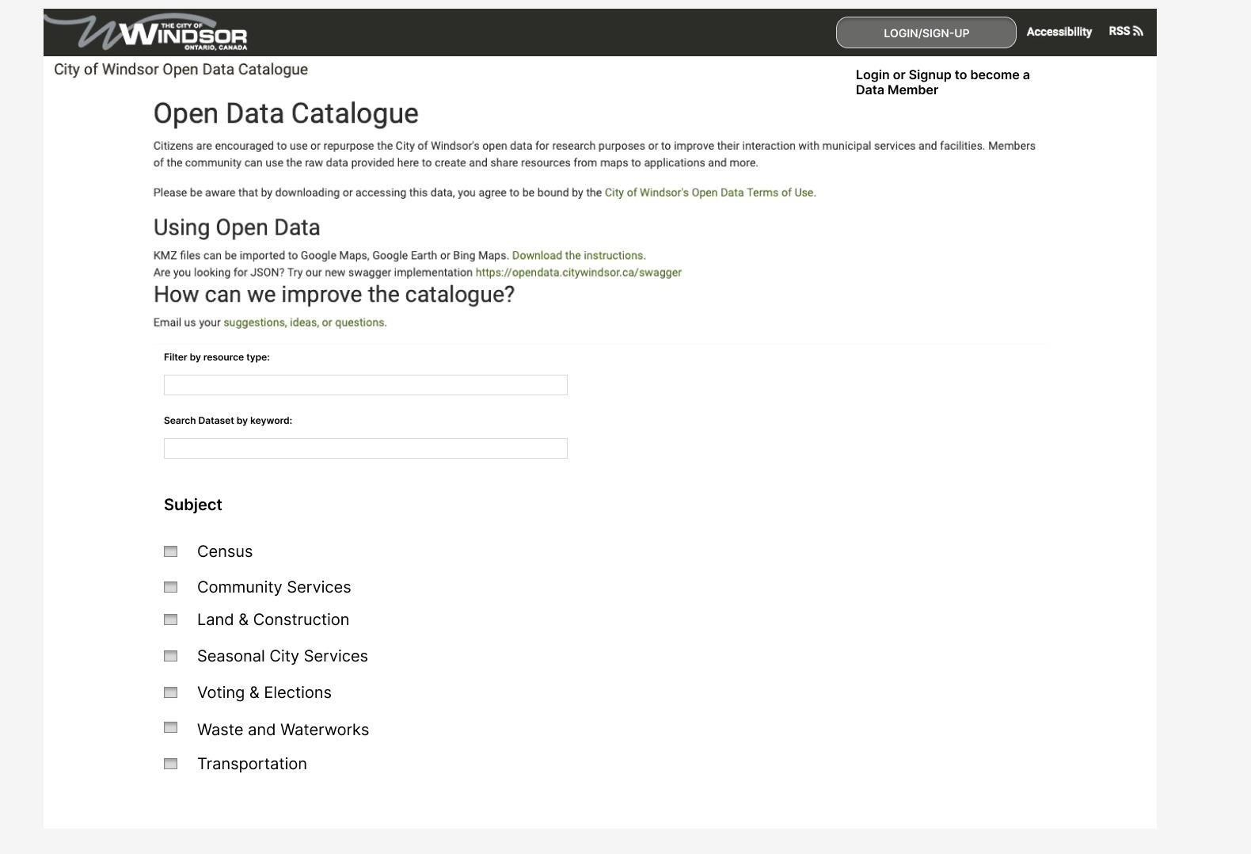

FIG 1.0a Main Page View

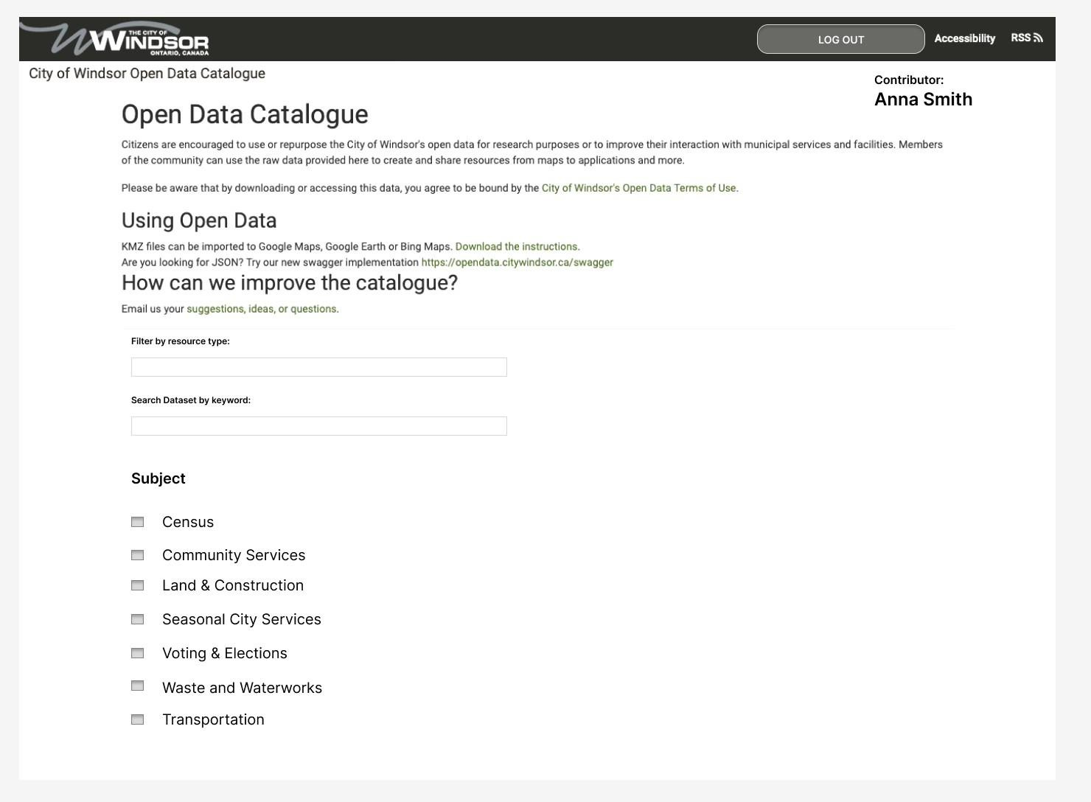

Contributor user’s view

FIG 1.0b

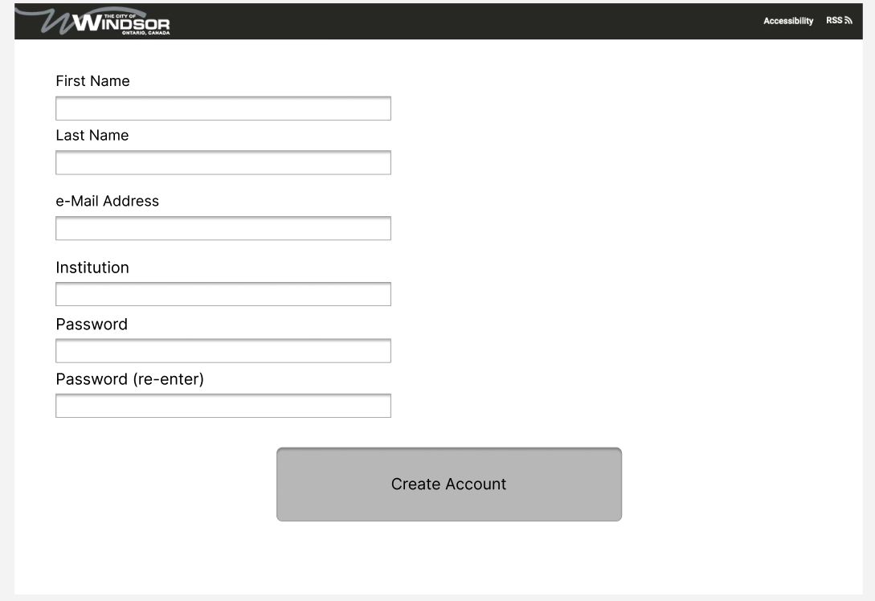

Account creation page for contributors

FIG 1.0c

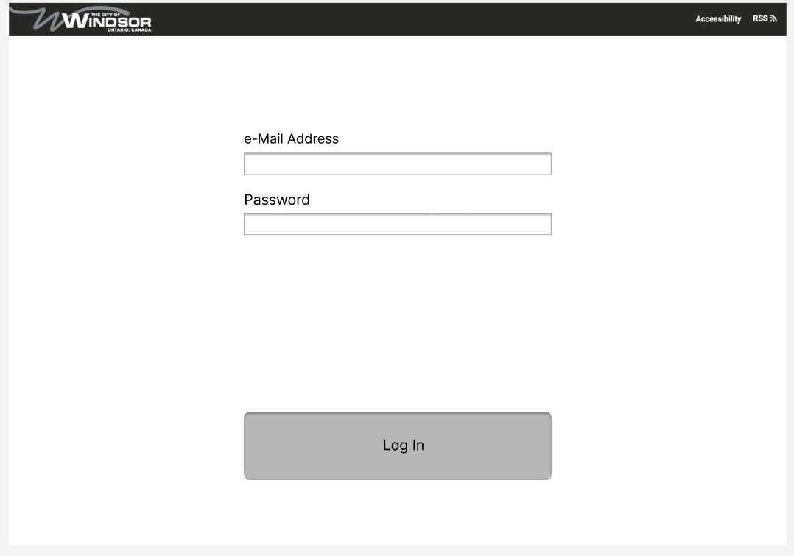

Login page for contributors

FIG 1.0d

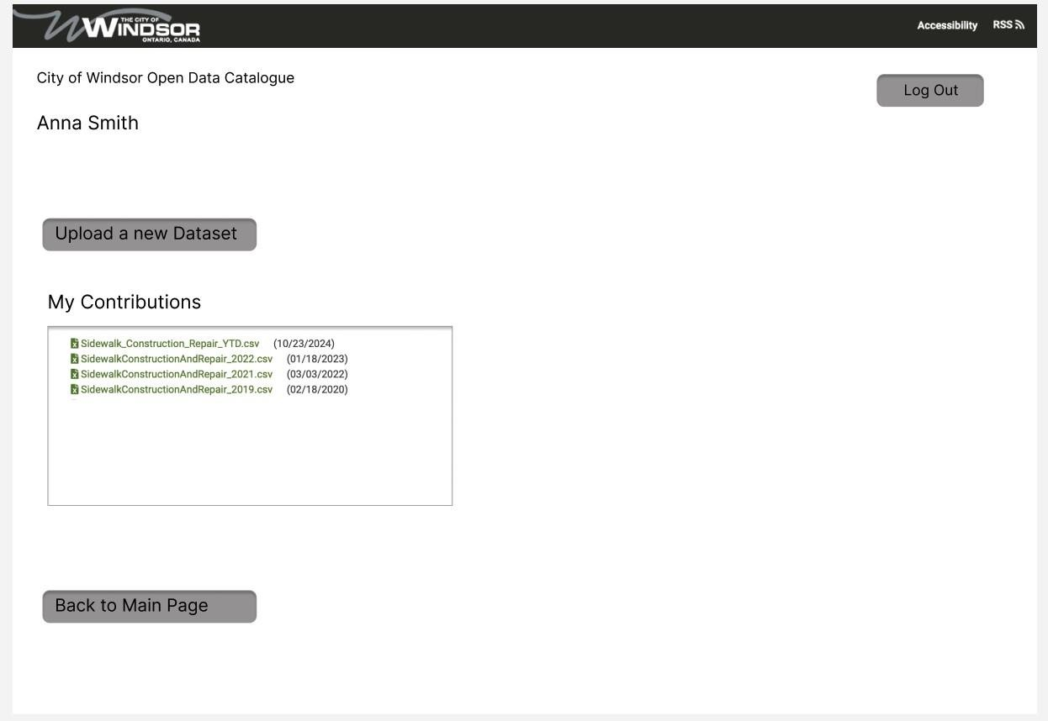

Contributor Dashboard on successful login

FIG 1.0e

9

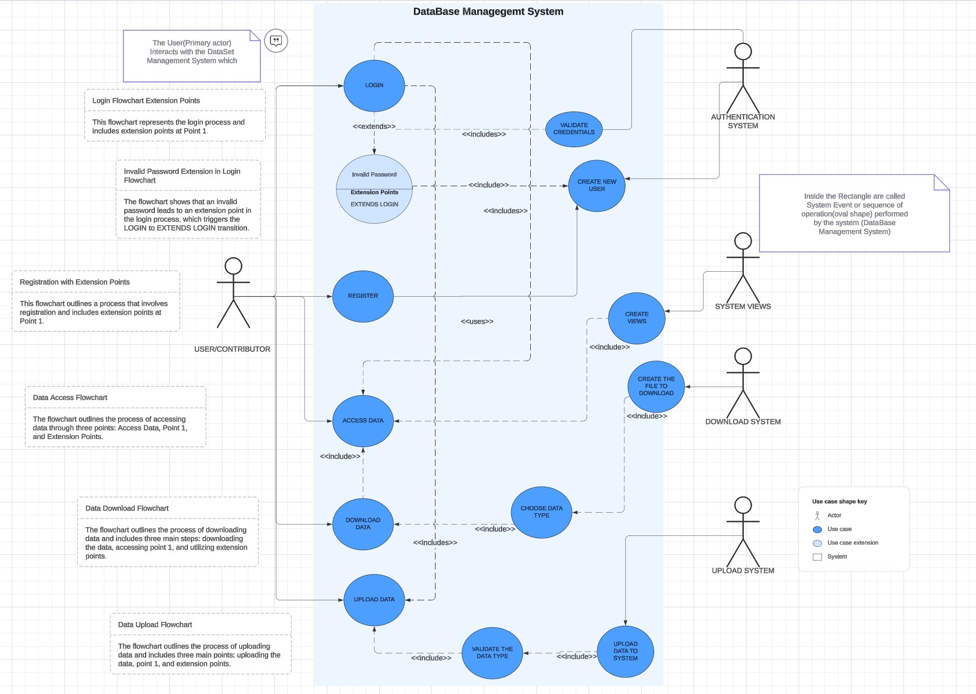

Fig 1.1 Use Case Model

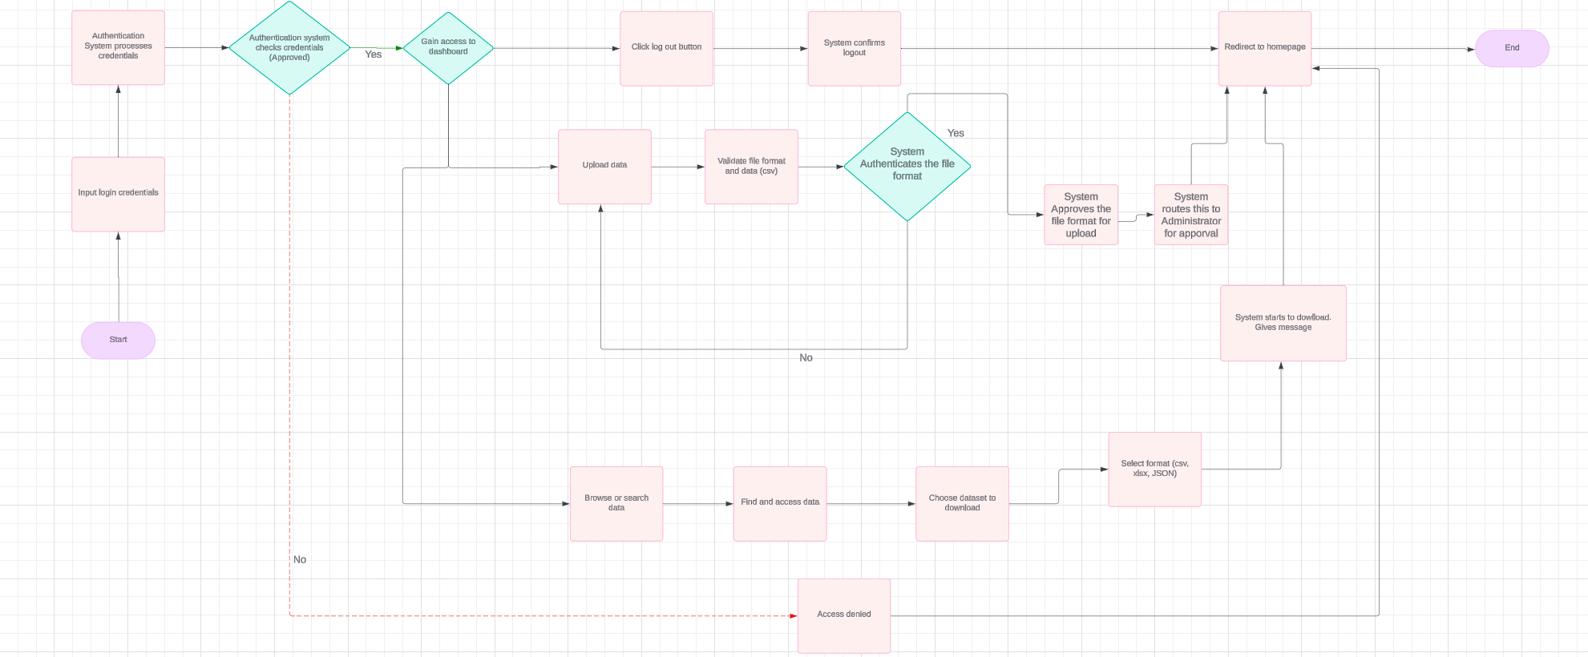

Fig 1.2 System Flow Chart

|  |  |
| --- | --- |
| **Contributors** | **Summary** |
| Paul Osuji | * Directed the phase * Assigned the work   - Contributed in giving ideas. |
| Ingrid Diaz | Worked on the:  - Contributor Flowchart  - Use Case Diagram  - Prototype and Proof of Concept  - Added the “Use Case Accompanying notes” to the inception report |
| Maria Kandikova | - Did the documenting of the inception  phase.  - Contributed in giving ideas. |
| Jonathan Chiu | - Helped edit the documentation to ensure it looks presentable.  - Contributed in giving ideas. |
| Joel Kunjukutty Roy | - Arranged the use cases (made it look presentable) |