ASSIGNMENT

18-07-2022

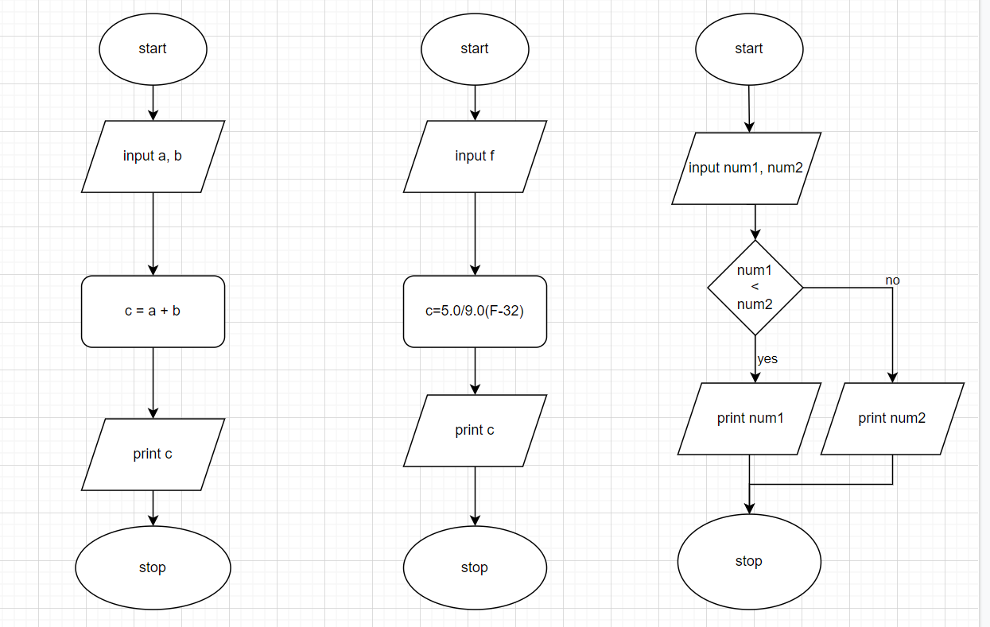

Qn 1

step 01: start

" 02: input a,b

" 03: calculate c=a+b

" 04: print c

" 05: stop

Qn 2

step 01: start

" 02: input f

" 03: c=5.0/9.0(F-32)

" 04: print c

" 05: stop

Qn 3

step 01: start

" 02: input num1, num2

" 03: if num1 < num2 : goto step 04

else: step 05

" 04: print num1, goto step 06

" 05: print num2

" 06: stop