INDEPENDENT PROJECT DESIGN PORTFOLIO
Inventory and Sales Management System
Relational Database, ERD and AdminLTE 3 Interface Design
Student Name: __________________________________________
Registration Number: _____________________________________
Course / Class: __________________________________________
Instructor: ______________________________________________
Submission Date: ________________________________________
Note: This is a design portfolio. Replace the illustrative values with your own if required, and make sure you can explain the design during the supervised review.

1. Project Selection and Brief
Selected option: B — Inventory and Sales.

Problem statement
Small shops need a reliable way to organize product details, categories, suppliers, stock quantities and sales. Keeping these records manually can cause stock-count errors, difficulty identifying low-stock products, and slow sales-history reviews.

Purpose
The proposed system will centralize product and sales information and provide staff with a clear dashboard and searchable lists.

Intended users
Administrator: manages system records and user access. Shop staff: searches products, records sales and checks stock. A simplified version may use one authorized staff role for the assignment.

Core features
Manage categories, suppliers and products; display current stock and low-stock products; record sales and their line items; calculate sale totals; review recent sales and basic summaries.

Boundaries and assumptions
This portfolio covers design only, not a deployed application. It does not include barcode scanning, online payments, tax integration, multiple branches or automatic supplier ordering. Prices are stored in Tanzanian shillings (TZS). Each product has one main supplier in this simplified model. A sale contains one or more sale items.

2. Project Scope
Included in scope | Outside the current scope
Product, category and supplier records; stock-level visibility; recording sales and sale items; recent activity; basic sales and low-stock summaries. | Barcode scanning; online payment gateway; tax integration; multiple branches; automated purchasing; live deployment and database implementation.

3. Relational Database Design and Data Dictionary
The proposed database uses five tables. Primary keys identify records. Foreign keys connect related tables and preserve referential integrity. Data types are illustrative and suitable for a relational database such as MySQL.

Categories
Purpose: Groups products into types.
Fields and data types: category_id INT PK; category_name VARCHAR(80) NOT NULL UNIQUE; description VARCHAR(255) NULL
Rules / constraints: Category name must be unique.

Suppliers
Purpose: Stores supplier contact details.
Fields and data types: supplier_id INT PK; supplier_name VARCHAR(120) NOT NULL; phone VARCHAR(25) NULL; email VARCHAR(120) NULL; address VARCHAR(255) NULL
Rules / constraints: Email is optional; validate format when provided.

Products
Purpose: Stores sellable product and stock details.
Fields and data types: product_id INT PK; sku VARCHAR(40) NOT NULL UNIQUE; product_name VARCHAR(120) NOT NULL; category_id INT FK; supplier_id INT FK NULL; unit_price DECIMAL(12,2) NOT NULL; quantity_in_stock INT NOT NULL DEFAULT 0; reorder_level INT NOT NULL DEFAULT 0; description VARCHAR(255) NULL; is_active BOOLEAN NOT NULL DEFAULT TRUE
Rules / constraints: unit_price >= 0; quantity_in_stock >= 0; reorder_level >= 0. category_id references Categories. supplier_id references Suppliers and may be NULL.

Sales
Purpose: One transaction header per sale.
Fields and data types: sale_id INT PK; sale_datetime DATETIME NOT NULL; staff_name VARCHAR(120) NOT NULL; payment_method VARCHAR(30) NOT NULL; sale_status VARCHAR(20) NOT NULL DEFAULT 'COMPLETED'; total_amount DECIMAL(12,2) NOT NULL DEFAULT 0
Rules / constraints: total_amount >= 0. payment_method should be one of CASH, MOBILE_MONEY, CARD, OTHER. Status may be COMPLETED or VOID.

SaleItems
Purpose: Products and quantities included in each sale.
Fields and data types: sale_item_id INT PK; sale_id INT FK; product_id INT FK; quantity INT NOT NULL; unit_price DECIMAL(12,2) NOT NULL; line_total DECIMAL(12,2) NOT NULL
Rules / constraints: quantity > 0; unit_price >= 0; line_total = quantity × unit_price. sale_id references Sales; product_id references Products. Save the selling price at sale time.

4. Relationships, Cardinality and Optionality
Relationship | Cardinality | Explanation
Categories to Products | One-to-many (1:M) | Each product must belong to one category. A category can contain zero or many products.
Suppliers to Products | One-to-many (1:M) | A product may have zero or one main supplier; a supplier can be linked to zero or many products.
Sales to SaleItems | One-to-many (1:M) | Each sale must contain one or more sale items. Each sale item belongs to exactly one sale.
Products to SaleItems | One-to-many (1:M) | A product can appear in zero or many sale items. Each sale item refers to exactly one product.

Optionality summary: every Product must reference one Category; a Product may have no Supplier or one Supplier. A Category or Supplier may exist before any products are linked to it. Each Sale must have one or more SaleItems. A Product may not yet have appeared in a sale.

5. Entity Relationship Diagram (ERD)
The diagram below shows the five entities, their primary and foreign keys, and the one-to-many relationships.
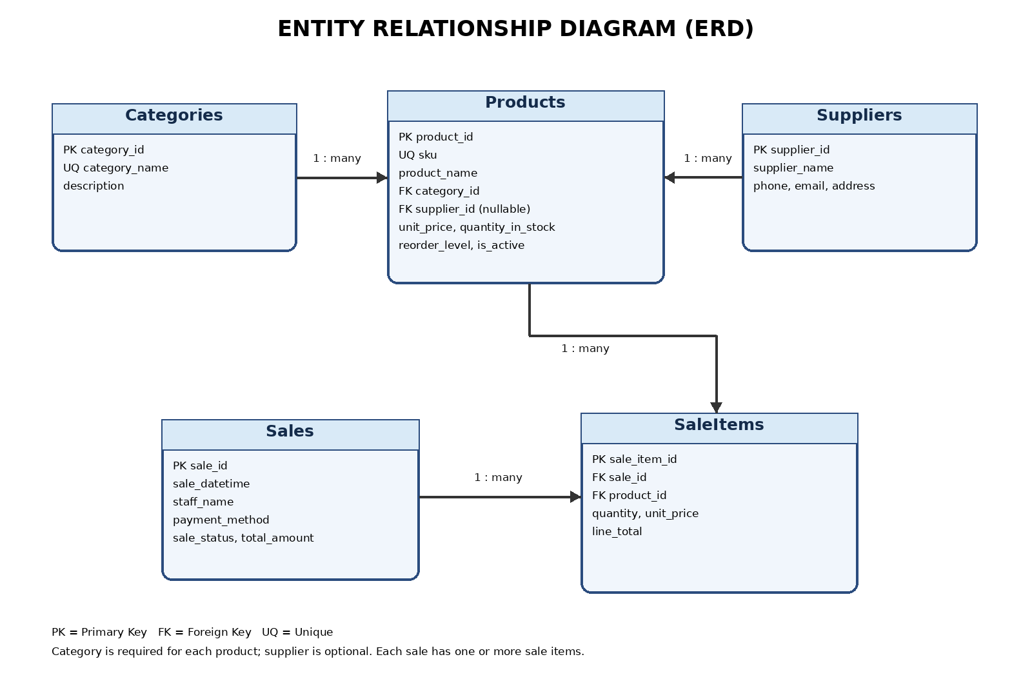
Legend: PK = Primary Key; FK = Foreign Key; UQ = Unique. The supplier reference in Products is nullable.

6. Relational Schema Outline
- Categories(category_id PK, category_name UNIQUE NOT NULL, description)
- Suppliers(supplier_id PK, supplier_name NOT NULL, phone, email, address)
- Products(product_id PK, sku UNIQUE NOT NULL, product_name NOT NULL, category_id FK → Categories.category_id, supplier_id FK → Suppliers.supplier_id NULL, unit_price, quantity_in_stock DEFAULT 0, reorder_level DEFAULT 0, description, is_active DEFAULT TRUE)
- Sales(sale_id PK, sale_datetime, staff_name, payment_method, sale_status DEFAULT 'COMPLETED', total_amount DEFAULT 0)
- SaleItems(sale_item_id PK, sale_id FK → Sales.sale_id, product_id FK → Products.product_id, quantity, unit_price, line_total)

7. Illustrative Sample Records
The records below are examples only; they are not real business records.
product_id | sku | product_name | category_id | supplier_id | unit_price | quantity_in_stock | reorder_level
1 | P001 | USB Mouse | 1 | 1 | 15000.00 | 4 | 10
2 | P002 | Keyboard | 1 | 1 | 25000.00 | 22 | 5
3 | P003 | HDMI Cable | 2 | 2 | 10000.00 | 3 | 8

sale_id | sale_datetime | staff_name | payment_method | sale_status | total_amount
104 | 2026-10-18 10:30 | Sample Staff | CASH | COMPLETED | 85000.00

For SaleItems, each line records sale_id, product_id, quantity, unit_price and line_total. The sale total should equal the sum of its line totals.

8. AdminLTE 3 Interface Plan
The interface is designed with a consistent header, sidebar navigation, page titles, breadcrumbs, cards, tables, form controls and feedback. The wireframes below are labelled planning sketches rather than screenshots of a running application.

8.1 Main Navigation
Navigation item | Purpose
Dashboard | Stock summaries, today's sales and recent activity.
Products | Search, view, add and edit product records.
Categories | Maintain product categories.
Suppliers | Maintain supplier contact details.
Sales | Review sales and their item details.
Reports | Review basic stock and sales summaries.

8.2 Screen A — Dashboard Wireframe
Wireframe area | Planned content
HEADER: Inventory & Sales Management System | User menu | Notifications
SIDEBAR | Dashboard | Products | Categories | Suppliers | Sales | Reports
BREADCRUMB | Dashboard > Home
SMALL BOX 1 | TOTAL PRODUCTS: 128
SMALL BOX 2 | STOCK UNITS: 845
SMALL BOX 3 | TODAY'S SALES: TZS 450,000
SMALL BOX 4 | LOW-STOCK ITEMS: 7
CARD: RECENT SALES | Sale ID | Date | Total | Status
Example rows | S-104 | 18 Oct | 85,000 | Completed; S-103 | 18 Oct | 42,000 | Completed
CARD: LOW-STOCK ITEMS | Product | Quantity | Reorder level
Example rows | USB Mouse | 4 | 10; Keyboard | 2 | 5; HDMI Cable | 3 | 8
FOOTER | System name / version

Annotations: 1) Header and user menu. 2) Sidebar provides module navigation. 3) Breadcrumb shows location. 4) Four small boxes summarize product and sales data. 5) Recent Sales card displays latest transactions. 6) Low Stock Items card identifies products needing attention. All displayed figures are illustrative.

8.3 Screen B — Product List Wireframe
Wireframe area | Planned content
PAGE TITLE | Products
BREADCRUMB | Home > Products
SEARCH INPUT | Search by product name or SKU...
FILTERS | Category [Select v] | Stock status [Select v] | [Search]
PRIMARY BUTTON | [ + Add Product ]
RESPONSIVE TABLE | SKU | Product | Category | Supplier | Qty | Unit Price | Status | Actions
EXAMPLE ROW 1 | P001 | USB Mouse | Accessories | ABC Supplies | 4 | 15,000 | LOW STOCK | View / Edit
EXAMPLE ROW 2 | P002 | Keyboard | Accessories | ABC Supplies | 22 | 25,000 | IN STOCK | View / Edit
EXAMPLE ROW 3 | P003 | HDMI Cable | Cables | Tech Distributors | 3 | 10,000 | LOW STOCK | View / Edit
TABLE FOOTER | Showing 1–10 of 128 products | [Previous] 1 2 3 [Next]

Annotations: 1) Search by name or SKU. 2) Filters narrow results by category and stock condition. 3) Add Product opens the entry form. 4) Responsive table displays records. 5) Badges show stock status. 6) View/Edit actions open the selected record. 7) Pagination handles long lists.

8.4 Screen C — Add/Edit Product Wireframe
Field / area | Label or control
PAGE TITLE | Add / Edit Product
BREADCRUMB | Home > Products > Add Product
Product Name * | [ Enter product name ]
SKU / Product Code * | [ Enter unique SKU ]
Category * | [ Select category v ]
Main Supplier | [ Select supplier v ]
Unit Price (TZS) * | [ 0.00 ]
Quantity in Stock * | [ 0 ]
Reorder Level * | [ 0 ]
Description | [ Optional notes ]
ACTIONS | [ Save Product ] [ Cancel ]
FEEDBACK | Alert: Product saved successfully / Please correct highlighted fields.

Annotations: fields marked * are required. SKU must be unique. Category is selected from Categories. Supplier may be left blank. Price, stock quantity and reorder level must not be negative. Save should validate inputs and show an alert; Cancel returns to the list without saving.

9. AdminLTE Component-use Matrix
No. | Component | Screen | Purpose | Related data / task
Small Boxes / Info Boxes | Dashboard | Show key counts: products, stock units, today's sales and low-stock items. | Products, stock and sales summaries
Sidebar Navigation Menu | All screens | Provide consistent links to Dashboard, Products, Categories, Suppliers, Sales and Reports. | Navigation between modules
Breadcrumbs | Product list and product form | Show the current page and its parent location. | Current screen / navigation
Responsive Table | Product list | Present product records in clear columns and adapt to narrower screens. | SKU, name, category, supplier, quantity, price and status
Search Form / Input Group | Product list | Find a product by name or SKU. | Product search
Select / Filter Controls | Product list | Filter records by category or stock condition. | Category and stock status
Badges | Product list and dashboard | Display IN STOCK or LOW STOCK status at a glance. | Quantity compared with reorder level
Buttons / Button Groups | List and product form | Provide Add Product, View, Edit, Save and Cancel actions. | Create, view and update actions
Form Controls | Add/Edit Product | Collect product name, SKU, category, supplier, price and stock levels. | Product record entry
Alerts | Add/Edit Product | Show a success message or explain validation errors. | Save feedback
Cards | Dashboard | Group recent sales and low-stock items under clear headings. | Recent transactions and warnings
Pagination | Product list | Split a large product list into pages. | Long result sets
Modal / Confirmation Dialog | Product list | Ask for confirmation before deactivating a product. | Safe deactivation

10. Explanation of Important Design Choices
- Separate Categories and Suppliers tables reduce repeated text and help keep names consistent.
- Products stores category_id and supplier_id as foreign keys rather than repeating full category and supplier details in every product row.
- Sales and SaleItems are separate because one sale can contain multiple products. SaleItems stores the unit price at the time of sale so a later price change does not rewrite sales history.
- Quantity, unit price and reorder level have validation rules to prevent negative values. SKU and category_name are unique to avoid duplicate identifiers or category names.
- The Dashboard summarizes data, while the Product List supports search and actions. The Add/Edit form uses the same field names and rules as the Products table, keeping the interface aligned with the data model.
- Products that appear in sales history should normally be deactivated rather than permanently deleted, so historical sale details remain understandable.

11. Final Design Review Checklist
☐ One project option and its scope are stated.
☐ Data dictionary includes table purposes, fields, data types, keys and rules.
☐ ERD shows entities, keys, labelled relationships, cardinality and optionality.
☐ Relational schema matches the ERD and data dictionary.
☐ Wireframes include Dashboard, List and Entry/Edit screens.
☐ At least eight distinct AdminLTE 3 components are mapped to screens and tasks.
☐ Screen labels and fields match the proposed data design.
☐ Examples are labelled illustrative, and this submission is clearly described as design-only.

12. Conclusion
This portfolio proposes a coherent Inventory and Sales Management System design. The relational schema organizes products, categories, suppliers, sales and sale items. The ERD explains how the records connect, while the AdminLTE 3 wireframes show how users would navigate, search, review stock and enter product data. The proposed interface and database use matching fields and validation rules.

