**Install Mule with Eclipse in the KCX - project:**

Eclipse → Help

Choose menu to install new software (dependant of Eclipse Version)

Helios: „ Install new Software“

Add Update Site of Mule:

[**http://dist.muleforge.org/mule-ide/updates/3.4/**](http://dist.muleforge.org/mule-ide/updates/3.4/)

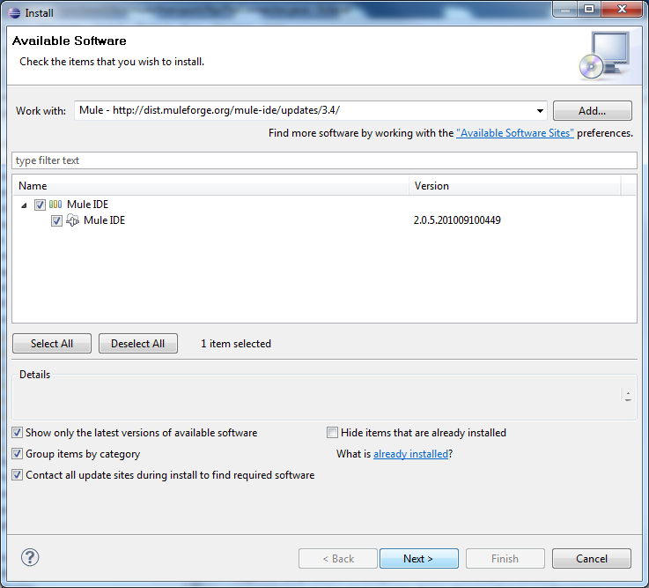

installieren this package and restart Eclipse.

Save Mule folder here : c:\develop\java ablegen zur Zeit mule-2.2.1

* c:\develop\java\mule-2.2.1\

Next work: Window → Preferences define Path for Mule

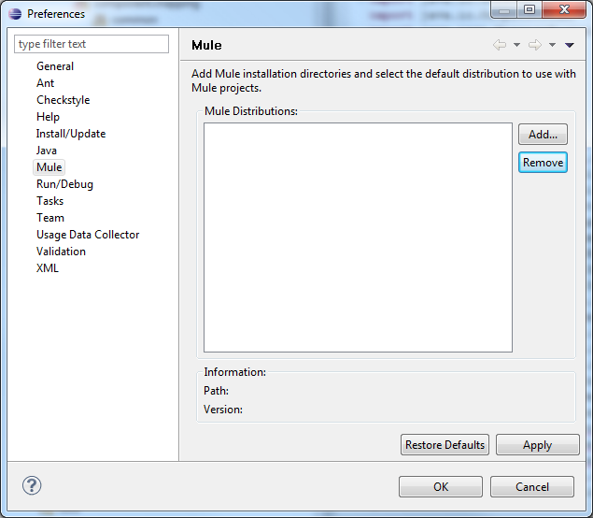

Add - choose Path then the next window should look like this:

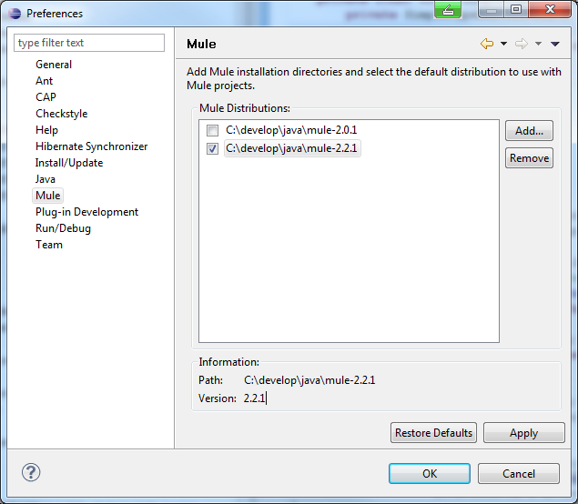

Click right on the KCX-Mapping Project – Java-BuildPath

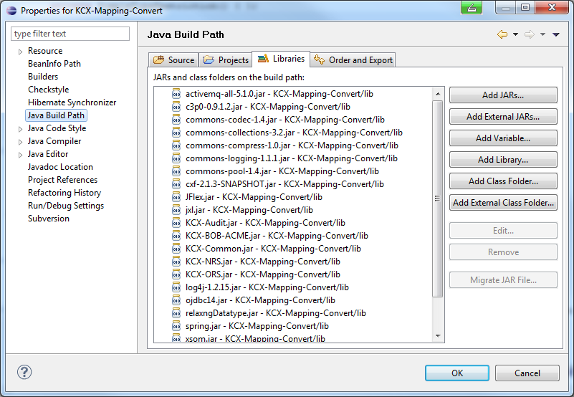

Configure Buildpath if mule librarie not present please add with “add Library” and choose Mule Classpath

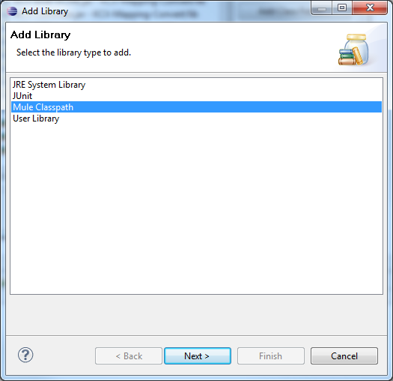

 Set Classpath Mule like the one we defined above

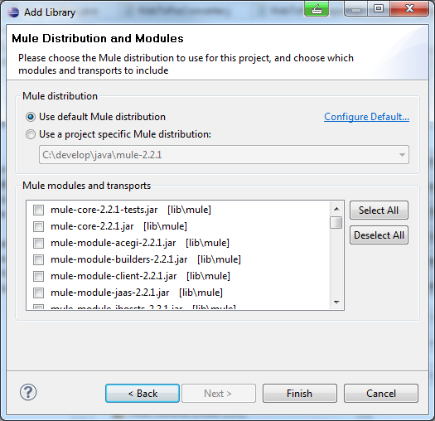

…should look like this:

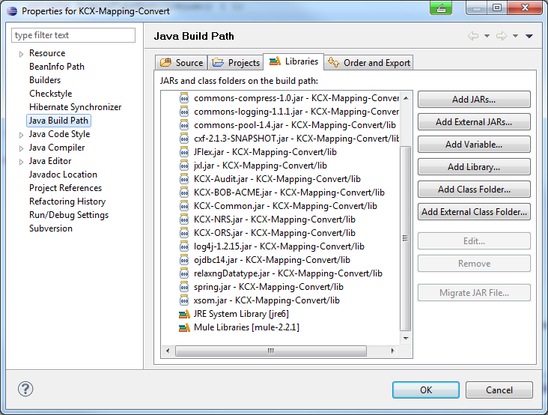

done!