5133 COMP – Data Structures and Algorithms

CW 1 – CVE Database System

Group (Ethan Bennett, Joel Spencer, James Chapman, Lewis Wooding)

1) Data Sets =

Before creating anything, we need to think about the types of datasets and figure out plans and the look of the code before we execute as a group. The very start we will be looking at the data sets that have been given to us from the SAMPLEDATASET-CVE.csv file and figuring what needs splitting and worked with for the code. The table below is like the one in the coursework brief, but we feel can be used and be of use showing in our design of the split of sets and how we look and will execute them.

|  |  |
| --- | --- |
| Attributes | Purpose/Description |
| cve_id | CVE Identifier |
| mod_date | Entry showing the last modified date |
| pub_date | Entry showing the last published date |
| cvss | Measuring the severity of one or more vulnerabilities |
| cwe_code | Identifying the weaknesses and the type of weaknesses |
| cwe_name | The name linked and associated with the cwe_code |
| summary | Summary of the text vulnerability |
| access_authentication | {NONE, SINGLE, MULTIPLE} |
| access_complexity | {LOW, MEDIUM, HIGH} |
| access_vector | {LOCAL, NETWORK, ADJACENT NETWORK} |
| impact_availability | {NONE, PARTIAL, COMPLETE} |
| impact_confidentiality | {NONE, PARTIAL, COMPLETE} |
| impact_integrity | {NONE, PARTIAL, COMPLETE} |

Analysis of Problem –

Entity Diagram/UML Diagram –

Solution Design –

Flow Diagrams –

Pseudocode –

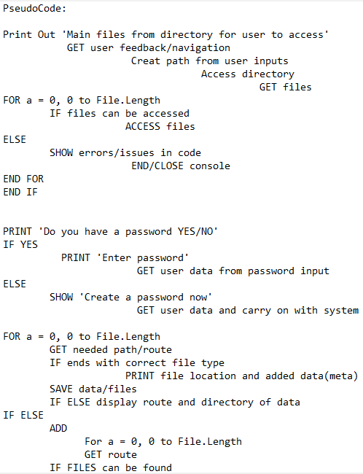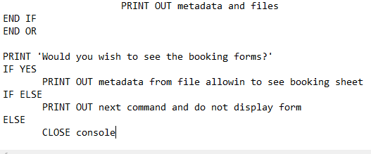

**(Example Pseudocode)**

Security Analysis –

Testing Plan –

|  |  |  |  |
| --- | --- | --- | --- |
| Test: | Expected Result of Test: | Potential Issues when Testing: | How to overcome the issue when testing: |
|  |  |  |  |
|  |  |  |  |
|  |  |  |  |
|  |  |  |  |
|  |  |  |  |
|  |  |  |  |
|  |  |  |  |