**5118 COMP – Secure Software Development**

**Ethan Bennett, James Taylor Chapman, Joel Spencer, Luke Kelly, Lewis Wooding**

**Report –**

**Application Design (Use of case diagrams):**

**Security Modelling:**

**SSD details and secure coding practices:**

**Application testing (with evidence):**

**Research for all 4 vulnerabilities:**

**1st and 2nd vulnerabilities explanations(fixed):**

Database storage*

Login token*

**3rd vulnerability evidence and explanation(unfixed):**

User input for images*

**4th vulnerability evidence and explanation(unfixed):**

User input for video*

**Source control repository usage and logging (GitHub):**

GitHub usage:

For the side of the project of which involved collaborative working and source control examples and usage we used GitHub due to the features, techniques and ease of access to work on the code and use the feature effectively how we wanted. We used GitHub for multiple reasons for its quality of features and the way we were able to easily communicate and operate on the project effectively.

Branching:

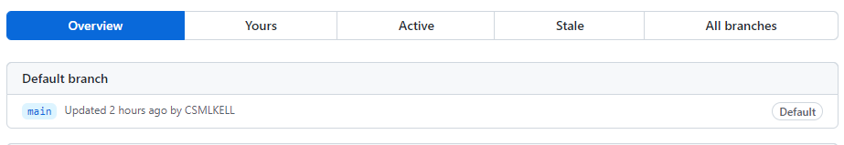The image above is an example of the branching technique in GitHub which allows users within the repository to view and edit the files in the repository. There are different examples of branches from the default to the protected branches which offer different rules and the way things be stored and edited in the repository. The initial and first branch is the default and then added branches can be added and created after.

Fuzzy Finder:

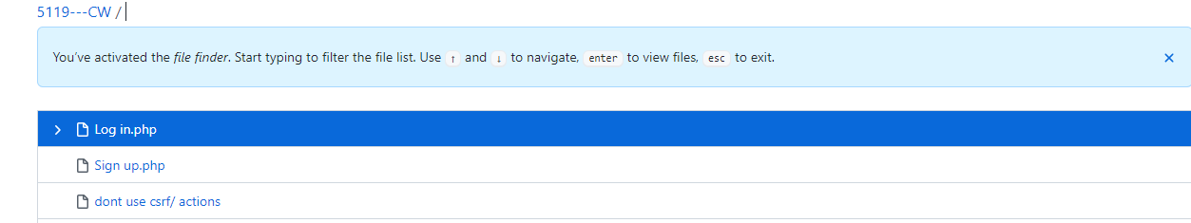

GitHub commands and functions: