Railway Reservation System
Project Status and Engineering Report
Table 1: Document control
Field | Value
Course | UE24CS341A Software Engineering
Team | Team 2
Authors | Anishwar Rajaram (PES2UG24CS068)  Ankirapalle Joel Suhas (PES2UG24CS069)  Ankit Uttarakar (PES2UG24CS070)  Ankit Verma (PES2UG24CS071)
Course Coordinator | Asha Kumari A
Version | 2.0
Date | 12-11-2026
Status | Final
Repository | github.com/joelsuhas7-jpg/Railway-Reservation-System-RRS-
Baseline | Release tag v1.0.0 on branch main (commit 10f6ba5); source and tests identical to commit dd4b8ae

Table 2: Revision history
Version | Date | Description
1.0 | 31-10-2026 | Issued for review at the end of Sprint 1; baseline commit f6135c8
2.0 | 12-11-2026 | Final issue at the development freeze; baseline release tag v1.0.0

Table of Contents
1. Introduction
1.1 Purpose
1.2 Scope
1.3 Problem Statement
1.4 Definitions
2. Software Development Life Cycle
2.1 Selected Model
2.2 Rationale
3. Phase Summary
3.1 Requirements Engineering
3.2 Architecture and Design
3.3 Test Planning
3.4 Implementation
3.5 Verification
4. Agile Practice
4.1 Backlog and Board
4.2 Sprint Cadence
4.3 Working Agreements
4.4 Review and Retrospective Observations
5. Implementation Language and Modular Development
5.1 Choice of C++17
5.2 Modular Structure
6. Implementation Status
6.1 Delivered Behaviour
7. Testing
7.1 Approach
7.2 Test Design Techniques
7.3 Validation Results and Known Gaps
8. Continuous Integration and Delivery
9. Live Demonstration Procedure
9.1 Build
9.2 Run
9.3 Demonstration Script
9.4 Container Run
10. Changes from the Original Design
10.1 Requirements Baseline: SRS v1.0 to SRS v2.0
10.2 Design to Implementation
10.3 Test Plan and Process
11. Implementation-Level UML
11.1 Component Diagram
11.2 Class Diagram
11.3 Sequence Diagram
11.4 State Diagram
11.5 Deployment Diagram
12. Sprint Plans
12.1 Sprint 1
12.2 Sprint 2
13. Schedule Status
13.1 Assessment
13.2 Mitigation
14. Final Status
15. Team Contributions
16. Alignment with Course Units
17. Appendices
17.1 Glossary
17.2 References

Update the table of contents field after opening the document to refresh page numbers.

1. Introduction

1.1 Purpose
This report records the final state of the Railway Reservation System project at the development freeze. It describes the problem the system solves, the life cycle the team followed, the work completed in each phase, the implementation and its verification, the delivery pipeline and the deviations from the submitted documents. It serves the course coordinator, the evaluators and the team as a single reference for the delivered system.

1.2 Scope
The report covers the requirements baseline in SRS v2.0, the architecture in the Software Architecture and Design Specification v1.0, the Software Test Plan v1.0 and the source code on the main branch at release tag v1.0.0. It covers two sprints: Sprint 1 from 19-10-2026 to 31-10-2026 and Sprint 2 from 01-11-2026 to 07-11-2026, followed by validation and the development freeze on 12-11-2026.

1.3 Problem Statement
Railway reservation requires a reliable record of seats, fares and bookings. A reservation system fails in its core purpose when it sells the same seat twice, quotes a fare that has no recorded source, leaves partial records after a failure or exposes passenger credentials. The Railway Reservation System addresses these failures in a single-process console application written in ISO C++17.
- Passengers register, log in, search trains, view per-class availability and fares, book up to six passengers under one PNR, retrieve tickets and cancel bookings for a slab-based refund.
- Administrators configure trains, schedules, travel classes, class fares and seat inventory, reset passenger passwords and review reports and the audit log.
- Seat allocation runs inside an advisory-locked critical section so that two application instances cannot allocate the same seat.
- Every fare traces to a fare record that an administrator created before the booking. Money is held as integer paise.
- Passwords are stored only as salted SHA-256 digests iterated 10,000 times. Security-relevant actions are written to an append-only audit log.

1.4 Definitions
Table 3: Definitions and acronyms
Term | Meaning
SRS | Software Requirements Specification
SAD | Software Architecture and Design Specification
STP | Software Test Plan
PNR | Passenger Name Record: the ten-character reference of one confirmed booking
FR, NFR, SR | Functional, non-functional and security requirement
Tier | A build layer of the SRS module dependency graph (Tier 0 to Tier 5)
CI | Continuous integration: automated build and verification on every push
Paise | The integer monetary unit used for all fares and refunds
Slab | A refund band selected by the time remaining before departure (S1 to S4)

2. Software Development Life Cycle

2.1 Selected Model
The project followed a hybrid life cycle. The requirements, design and test planning phases ran in sequence and each produced a baselined document. Implementation and verification then ran as an incremental agile process in two time-boxed sprints. Each increment delivered a vertical slice of one SRS tier with its tests.
Table 4: Life cycle phases and outputs
Phase | Period | Output
Requirements | August to September 2026 | SRS v1.0 (18-08) and SRS v2.0 (03-09)
Test planning | September 2026 | Software Test Plan v1.0 (16-09)
Architecture and design | September to October 2026 | SAD v1.0 (03-10)
Implementation and verification, Sprint 1 | 19-10-2026 to 31-10-2026 | Build, CI, Tier 0 and Tier 1 modules
Implementation and verification, Sprint 2 | 01-11-2026 to 07-11-2026 | Tier 2 to Tier 5 modules, non-functional tests
Validation and freeze | 08-11-2026 to 12-11-2026 | Usability trial, final reports, release tag v1.0.0

2.2 Rationale
The course fixes the document deliverables and their order. The SRS, SAD and Test Plan therefore form plan-driven stages with formal outputs. A sequential approach suits these stages because each document is the input to the next one and the evaluators review each one separately.
Implementation suits an incremental approach for three reasons. The SRS dependency graph fixes a build order in which no module can be tested before the tier beneath it exists. Four developers work in parallel and need small, independently reviewable units of work. Fixed course deadlines require a visible measure of progress at short intervals, and time-boxed sprints provide that measure.
The hybrid model also manages risk. The requirements were stabilised early, so changes during implementation affect the code and not the baseline. The tier order places the highest-risk component, the seat-allocation critical section, at a defined point on the critical path.

3. Phase Summary
Each phase faced one central difficulty. This section states that difficulty and the resolution that the team adopted.

3.1 Requirements Engineering
Central difficulty. SRS v1.0 described a desktop application and also required authenticated network connections. It left travel classes, fare sources and concurrency undefined, and several acceptance criteria referred back to the requirement they verified.
Resolution. SRS v2.0 removed the contradiction in favour of a single-process desktop model with no network access. It introduced travel class as a first-class concept and separated fare configuration (RRS-F-008) from fare calculation (RRS-F-014), which removed the circular acceptance criteria. It added an explicit out-of-scope list, a concurrency model based on advisory record locking, measurable NFRs, ten assumptions, six external dependencies and five use-case specifications.

3.2 Architecture and Design
Central difficulty. Eighteen modules must be built by four people without circular dependencies and without blocking each other.
Resolution. The design separates the console interface, the application modules and persistence. The SRS module dependency graph arranges modules M0 to M17 in six tiers and is acyclic by construction. The SAD maps each requirement and each security requirement to an owning module. The critical path runs from Tier 0 through Tiers 1 and 2 to the Tier 4 booking module.

3.3 Test Planning
Central difficulty. The plan must verify every requirement against its own acceptance criterion and must make the defining failure of a reservation system, a double-allocated seat, impossible to miss.
Resolution. The Test Plan orders test execution by tier. It assigns a test case identifier to every requirement and marks TC-CONC-01 and TC-INT-01 as blocking. It defines a known-answer fixture (train 12345, classes SL 72 and 3A 64, fare 45,000 paise) so that numeric assertions are exactly reproducible.

3.4 Implementation
Central difficulty. Parallel work on shared files produced merge conflicts, and a late skeleton commit overlapped modules already under review.
Resolution. The team adopted one issue per requirement, one branch per issue and one pull request per branch. Dependent pull requests were stacked and conflicts were resolved by merge commits that preserved history. A shared CMake configuration collects new source and test files automatically, so feature pull requests never edit the build files. In Sprint 2 a menu router replaced the single console dispatch function. Each feature registers its own console flow unit, so features no longer edit one shared file.

3.5 Verification
Central difficulty. Verification must keep pace with implementation and must not depend on manual checks.
Resolution. Every pull request carries Catch2 tests named after Test Plan identifiers. The CI pipeline builds with warnings treated as errors on Linux and on Windows and runs the tests, coverage, static analysis, sanitizers, the include-graph check, the binary size limit and a container build on every push. Checks that cannot run in CI, namely the usability trial and the start-up and memory measurements, were performed manually and are recorded in the System Validation Report.

4. Agile Practice

4.1 Backlog and Board
The product backlog consists of 64 GitHub issues. Each functional, non-functional and security requirement in the SRS has its own issue, titled with its requirement identifier. Enabler issues (ENB) cover the build, the console framework and fixtures, and documentation issues (DOC) cover demonstrations and final documents. For Sprint 2 the team grouped the remaining requirement issues into eight user stories (US-01 to US-08), each with acceptance criteria taken from the Test Plan. A GitHub Projects board tracks 28 items with a status, a story-point estimate on a Fibonacci scale and a sprint iteration. At the freeze all 64 issues are closed and all 28 board items are Done.

4.2 Sprint Cadence
Table 5: Sprint iterations
Sprint | Dates | Items | Goal
Sprint 1 | 19-10-2026 to 31-10-2026 (13 days) | 20 items, 65 points, all Done | Build, CI and test framework; Tier 0 foundation; Tier 1 authentication, authorisation and audit
Sprint 2 | 01-11-2026 to 07-11-2026 (7 days) | 8 user stories, 104 points, all Done | Tier 2 master data; Tier 3 search, fare and payment; Tier 4 booking; Tier 5 retrieval, cancellation and reporting; NFR verification; final documentation

4.3 Working Agreements
- Each issue has one assignee who owns its branch and pull request.
- Branch names follow the pattern feature/<issue>-<topic>. Commit messages follow a conventional prefix such as feat, fix, test, docs or ci, with the module identifier.
- Every pull request links its issue, lists the test cases it adds and states what remains untestable.
- A pull request merges only when all CI checks pass. Dependent pull requests are stacked on their base branch and merged in order.
- Merge conflicts are resolved by the author of the later pull request with a merge commit, never by rewriting published history.

4.4 Review and Retrospective Observations
Sprint 1 produced 40 merged pull requests: 26 in the first three days of integration and 14 on 31-10-2026, including the Tier 2 and Tier 3 modules. Some pull requests merged before their CI run completed, and one merge broke the main branch until a corrective pull request restored it. The team agreed that every merge waits for a green CI run and one approving review.
Sprint 2 and the freeze produced 13 further merged pull requests, for a project total of 53. The menu router merge left the include-graph check without the new flow headers, and pull request 105 restored the check. The approving review was not recorded on GitHub: the pull requests merged without a formal approval. The stacked booking, ticket, cancellation and reporting pull requests (106 to 109) merged on one day because each depended on the previous one. The team kept the scope of SRS Section 9 and reduced no module.

5. Implementation Language and Modular Development

5.1 Choice of C++17
The course constraint names C/C++ as the implementation environment. The team selected ISO C++17 within that constraint and evaluated the choice against the language selection criteria of Unit 3.
Table 6: Language selection criteria applied to C++17
Criterion | Assessment
Ecosystem and longevity | ISO standardised language with mature compilers (g++, clang, MinGW-w64) on both target platforms
Environment and deployment | Native console executable with no runtime or interpreter; the stripped binary is 317,976 bytes on Linux and 293,376 bytes on Windows against the 10 MB target
Required libraries | The standard library supplies containers, streams, chrono and filesystem; OpenSSL libcrypto supplies SHA-256
Performance | Direct fixed-length binary record access with seekg and seekp meets the latency targets for search and seat allocation
Systems access | Direct use of POSIX fcntl record locking and fsync for the seat-allocation critical section, isolated in the platform shim
Safety and correctness | Strong static typing, enum class, std::optional and RAII; integer paise avoid floating-point fare errors
Team capability | All four members studied C and C++ in earlier courses
Tooling | CMake, Catch2, gcovr, cppcheck and the AddressSanitizer and UndefinedBehaviorSanitizer support every CI quality gate

5.2 Modular Structure
Each SAD module maps to one header and one source file in src/. The header declares the public interface and the source file holds the implementation. Internal helpers live in anonymous namespaces, so other modules cannot depend on them. This arrangement applies information hiding and keeps coupling to declared interfaces.
- Low coupling. Modules depend only on modules in the same or a lower tier. Authentication depends on persistence, validation and the password digest, and has no knowledge of the console.
- High cohesion. Each module owns one concern. The audit module only appends entries. The validation module only checks presence, type, length and range.
- Separation of policy and presentation. Authentication functions return a status value. A separate console flow translates that value into one of the four outcome messages defined in SRS Section 3.1.
- Testability. Every module function takes its dependencies as parameters, including the clock where time matters, so unit tests run without a terminal and without waiting.
- Uniform build. CMake compiles every source file into one core library. The application and the test executable link the same library.

6. Implementation Status
The following table lists every module of the SAD with its state on the main branch at release tag v1.0.0. Every module is implemented. The pull request column names the pull requests that delivered the behaviour.
Table 7: Module implementation status
Module | Tier | State | Requirements | Pull requests
M0 PlatformShim | 0 | Implemented | File locking, fsync, platform conditionals (RRS-NF-POR-001) | 74, 101
M1 PersistenceModule | 0 | Implemented | Fixed-length records, atomic journal (RRS-NF-ROB-003), recovery | 63, 83, 100
M2 ValidationModule | 0 | Implemented | RRS-SR-003, RRS-NF-ROB-002 | 66, 99
M3 AuditModule | 1 | Implemented | RRS-F-023, RRS-SR-005 | 71, 82
M4 AuthenticationModule | 1 | Implemented | RRS-F-001 to RRS-F-005, RRS-SR-004, RRS-SR-006 | 67, 68, 70, 73, 78, 81
M5 AuthorizationModule | 1 | Implemented | RRS-SR-001, RRS-SR-002, RRS-SR-007 | 75, 76, 80
M6 TrainCatalogueModule | 2 | Implemented | RRS-F-006 | 84
M7 ClassFareConfigModule | 2 | Implemented | RRS-F-007, RRS-F-008 | 95, 98
M8 SeatInventoryModule | 2 | Implemented | RRS-F-009 | 96
M9 SearchModule | 3 | Implemented | RRS-F-010 to RRS-F-012 | 93, 94, 97
M10 PassengerModule | 3 | Implemented | RRS-F-013 | 69
M11 FareCalculationModule | 3 | Implemented | RRS-F-014 | 106
M12 PaymentModule | 3 | Implemented | RRS-F-015 | 79
M13 BookingModule | 4 | Implemented | RRS-F-016, RRS-F-017 | 106, 116
M14 TicketRetrievalModule | 5 | Implemented | RRS-F-018 | 107
M15 CancellationRefundModule | 5 | Implemented | RRS-F-019 to RRS-F-021 | 108
M16 ReportingModule | 5 | Implemented | RRS-F-022 | 109
M17 ConsoleUIModule | UI | Implemented | SRS 3.1 menu trees, outcome messages, help frames | 61, 104, 110

6.1 Delivered Behaviour
- First-run bootstrap: an empty data directory requires exactly one administrator account before any other function is available.
- Passenger registration with a unique identifier of 3 to 32 characters, case-insensitive uniqueness, a password policy of at least eight characters with a letter and a digit, and validated contact details.
- Login with a role-bound session. Wrong passwords and unknown identifiers produce the same message, and an unknown identifier costs the same digest work as a real one.
- Account lockout for 15 minutes after five consecutive failures, and a session idle timeout of 15 minutes with an audit entry.
- Password change by any user and passenger password reset by an administrator. A reset also clears an active lockout.
- Role-based authorisation enforced inside the module boundary, with each refused administrator operation recorded in the audit log.
- Append-only audit log with five tab-separated fields: ISO 8601 UTC timestamp, actor, role, action code and affected record identifier.
- Fixed-length binary persistence for all seven record files and a write-ahead journal that commits multi-record writes atomically and recovers after a crash.
- Passenger detail validation for one to six passengers and payment outcome recording with a mandatory reference.
- Train catalogue maintenance with a running-days mask, travel classes SL, 3A, 2A, 1A, CC and 2S with per-class capacity, and per-class fares in paise with an effective-from date.
- Seat inventory created on first reference for a train, class and journey date, with audited seat blocking by an administrator.
- Train search by source, destination and journey date through a route index, sorted by departure, with per-class fare and free seats. A class without a fare is shown as not open for booking.
- Booking of one to six passengers under one ten-character PNR. Seat allocation re-reads the inventory inside an advisory file lock and commits the inventory and booking records in one journal commit.
- Ticket retrieval by PNR for its owner or an administrator. An unknown PNR and another passenger's PNR produce the same message.
- Cancellation with a refund by slab: 90 per cent at 48 hours or more before departure, 50 per cent at 12 hours or more, 25 per cent at 4 hours or more, and no cancellation below 4 hours. The seats return to the inventory in the same journal commit.
- Refund disbursement: the passenger may enter the disbursement reference at cancellation, otherwise the refund stays pending until the administrator settles it from the report.
- Booking and cancellation report by train and date range with totals and outstanding refunds.
- A help frame for every menu, shown on request without leaving the menu.

7. Testing

7.1 Approach
Tests use Catch2 v3.5.4. Unit tests reside in tests/unit with one file per module. Integration tests reside in tests/integration with one file per cross-module flow and drive the console through scripted input streams. Each test case name begins with its Test Plan identifier, so the test report traces directly to the plan. Tests that read or write files run against a fresh temporary data directory.
The suite on the main branch contains 245 test cases: 176 unit test cases in 23 files and 69 integration test cases in 18 files. All 245 pass in the Linux CI jobs. The Windows job runs 242 test cases and all pass; the three remaining cases start competing processes with POSIX fork() and are compiled only on POSIX targets. Line coverage of src/ is 88 per cent and branch coverage is 69 per cent.
Table 8: Unit and integration tests per file
Module or flow | Test file | Cases | Test Plan and backlog identifiers
Application information | unit/test_app_info.cpp | 2 | SMOKE-01, SMOKE-02
Atomic journal (M1) | unit/test_atomic_journal.cpp | 3 | TC-ROB-03
M3 AuditModule | unit/test_audit_log.cpp | 6 | TC-AUDIT-01, TC-AUDIT-02, TC-AUDIT-03, TC-AUDIT-04, TC-AUDIT-05, TC-AUDIT-06
M4 AuthenticationModule | unit/test_authentication.cpp | 27 | RRS-F-002, RRS-F-004, TC-AUTH-01, TC-AUTH-03, TC-AUTH-04, TC-REG-01, TC-SEC-02, TC-SEC-04, TC-SEC-06
M5 AuthorizationModule | unit/test_authorization.cpp | 3 | TC-SEC-02
M13 BookingModule | unit/test_booking.cpp | 5 | ENB-07, TC-BOOK-02
M15 CancellationRefundModule | unit/test_cancellation_refund.cpp | 4 | TC-CAN-01, TC-CAN-02, TC-CAN-03
M7 class configuration | unit/test_class_fare_config.cpp | 14 | TC-CLASS-01
M17 ConsoleUIModule | unit/test_console_ui.cpp | 8 | ENB-04, TC-ROB-01
M17 help frames and redisplay | unit/test_console_usability.cpp | 5 | TC-PERF-04, TC-UX-02
M11 FareCalculationModule | unit/test_fare_calculation.cpp | 2 | TC-FARE-02
M7 fare configuration | unit/test_fare_config.cpp | 22 | TC-FARE-01
Fixture generator | unit/test_fixture_generator.cpp | 3 | ENB-06
Seed fixtures | unit/test_fixtures.cpp | 8 | ENB-05, TC-PERF-02, TC-SEARCH-01
Menu router (session_context) | unit/test_menu_router.cpp | 5 | ENB-08
M10 PassengerModule | unit/test_passenger.cpp | 9 | TC-BOOK-01
Password digest (M4) | unit/test_password_digest.cpp | 3 | TC-SEC-04
M12 PaymentModule | unit/test_payment.cpp | 4 | TC-PAY-01
M1 PersistenceModule | unit/test_persistence.cpp | 7 | TC-ROB-03
M9 SearchModule | unit/test_search.cpp | 7 | TC-PERF-02, TC-SEARCH-01
M8 SeatInventoryModule | unit/test_seat_inventory.cpp | 8 | TC-SEAT-01
M6 TrainCatalogueModule | unit/test_train_catalogue.cpp | 15 | TC-ADMIN-01
M2 ValidationModule | unit/test_validation.cpp | 6 | RRS-SR-003, TC-ROB-02
Crash recovery | integration/test_atomic_journal_crash.cpp | 1 | TC-ROB-01
Cross-process booking | integration/test_booking_concurrency.cpp | 4 | TC-CONC-01, TC-PERF-03
Booking flow | integration/test_booking_flow.cpp | 6 | RRS-F-016, TC-BOOK-01, TC-FARE-02, TC-PAY-01
Cancellation flow | integration/test_cancel_flow.cpp | 6 | TC-CAN-01, TC-CAN-02, TC-CAN-03, UC-02
Class configuration flow | integration/test_class_fare_config_flow.cpp | 3 | TC-CLASS-01
Fare configuration concurrency | integration/test_fare_config_concurrency.cpp | 3 | TC-FARE-01
Fare configuration flow | integration/test_fare_config_flow.cpp | 4 | TC-FARE-01
Fixture generator and consistency check | integration/test_fixture_generator_flow.cpp | 2 | ENB-06
Login, logout and idle timeout | integration/test_login_flow.cpp | 9 | TC-AUTH-01, TC-AUTH-02, TC-SEC-05, TC-SEC-07, TC-UX-02
Password change and reset flow | integration/test_password_flow.cpp | 3 | RRS-F-005, TC-AUTH-04
Bootstrap and registration flow | integration/test_registration_flow.cpp | 6 | TC-AUTH-03, TC-REG-01, TC-SEC-05
Reliability soak | integration/test_reliability_soak.cpp | 1 | TC-REL-02
Report flow | integration/test_report_flow.cpp | 4 | TC-REPORT-01
Search after catalogue change | integration/test_search_catalogue_flow.cpp | 1 | TC-SEARCH-01
Search flow | integration/test_search_flow.cpp | 4 | TC-SEARCH-01, TC-SEAT-01
Seat inventory flow | integration/test_seat_inventory_flow.cpp | 1 | TC-SEAT-01
Ticket retrieval flow | integration/test_ticket_flow.cpp | 4 | TC-VIEW-01
Train catalogue flow | integration/test_train_catalogue_flow.cpp | 7 | TC-ADMIN-01

7.2 Test Design Techniques
- Boundary value analysis on identifier lengths, contact lengths, passenger counts, names and ages.
- Equivalence partitioning of passwords into policy-compliant, too short, letter-only and digit-only classes.
- Known-answer tests for the password digest and for UTC timestamps, including a leap day and an instant before the epoch.
- Negative and security tests that confirm no plaintext password reaches users.dat or audit.log and that a passenger session cannot reach an administrator operation even through a direct function call.
- Fault injection that terminates a child process with SIGKILL at 100 points inside journal commits and verifies that every record reads as the complete post-state after recovery.
- Cross-process concurrency tests in which two and four processes compete for the last seats over repeated rounds and the test asserts that no seat is allocated twice.
- A 10,000-operation reliability soak and latency measurements at the 95th percentile for search, the seat-allocation critical section and menu redisplay.
- Deterministic fixtures: a known-answer dataset and a seeded generator of 2,000 trains for the search performance test.

7.3 Validation Results and Known Gaps
The System Validation Report traces all 47 Test Plan cases to SRS v2.0. Forty-five cases pass in full and two pass in part. No case fails. The usability trial TC-UX-01 met its acceptance criterion: four of five first-time users completed the search and booking task unaided within 10 minutes.
- TC-REL-01 passes in part. The soak test asserts the TC-REL-02 failure rate and does not assert a zero failure count separately.
- TC-INT-01 passes in part. Inventory and booking records are checked for agreement after concurrent booking, and no standalone cross-record checker runs over a full dataset.
- TC-CONC-01 runs on POSIX targets only, because the Windows toolchain has no fork().
- TC-PERF-01 and TC-SIZE-02 were measured with /usr/bin/time on the seeded trial dataset and not on the 2,000-train fixture.
- On macOS developer workstations three TC-FARE-01 cases fail because they locate the test executable through /proc/self/exe. The SRS target platforms are Linux and Windows, where these cases pass.

8. Continuous Integration and Delivery
A GitHub Actions workflow runs on every push to main and to feature branches and on every pull request to main. A newer push to the same branch cancels the run in progress. Figure 5 in Section 11 shows the deployment view of the pipeline.
Table 9: CI/CD jobs
Job | Function | Failure condition
build-and-test | Release build with -Wall -Wextra -Werror on Ubuntu 24.04 and GCC 13.3.0; include-graph check against the SRS edge set; stripped binary size check; ctest | Any compiler warning, back edge, oversized binary or failing test
windows-mingw | Release build with MinGW-w64 and -Werror on windows-latest; stripped binary size check; ctest | Any compiler warning, oversized binary or failing test
coverage | Instrumented build; gcovr 8.3 reports line and branch coverage of src/ on the run page and as an HTML artifact | Build or test failure
static-analysis | cppcheck over src/ with warning, performance and portability checks | Any warning-level finding; style findings are advisory
sanitizers | Full suite under AddressSanitizer and UndefinedBehaviorSanitizer | Any memory or undefined-behaviour error
docker | Two-stage image build on ubuntu:24.04 that compiles and tests inside the container, then a smoke run of the image | Build, test or smoke failure
release | On pushes to main only, after the five Linux jobs pass: publishes the Linux binary and the Docker image as workflow artifacts | Any upstream job failure

The CMake configure step also counts platform-specific statements outside the platform shim and fails when they exceed 2 per cent of production statements. The final count is 38 of 3,321 statements. Continuous delivery stops at a verified artifact. The project has no production environment, so the release job publishes the binary and the image for download and demonstration rather than deploying them.

9. Live Demonstration Procedure
The procedure below runs against release tag v1.0.0. It follows the passenger and administrator use cases end to end. The Sprint 2 demonstration video in docs/videos shows the passenger part of the same procedure.

9.1 Build
git clone https://github.com/joelsuhas7-jpg/Railway-Reservation-System-RRS-.git
cd Railway-Reservation-System-RRS-
git checkout v1.0.0
cmake -S . -B build -DCMAKE_BUILD_TYPE=Release
cmake --build build --parallel
ctest --test-dir build
On Linux the test step reports 245 of 245 tests passed. On macOS the configure step needs -DOPENSSL_ROOT_DIR=$(brew --prefix openssl@3), and the three TC-FARE-01 cases described in Section 7.3 fail.

9.2 Run
RRS_DATA_DIR=demo ./build/railway_reservation
The RRS_DATA_DIR variable selects the data directory. The default is data in the working directory. A new directory gives a clean first run.

9.3 Demonstration Script
Table 10: Demonstration steps and expected results
Step | Input | Expected result
1. First-run bootstrap | User id admin, a policy-compliant password, a contact | OK: administrator account created (ref: admin)
2. Train set-up | Administrator menu 1, 2 and 3: add a train from SBC to NDLS running daily, add class SL with capacity 72, configure a fare of Rs 450.00 | Each step reports OK with the train or class reference
3. Register passenger | Main menu 1; user id alice, password, contact | OK: passenger account created (ref: alice)
4. Search | Passenger menu 1; SBC, NDLS and a journey date | The train appears with class SL, fare Rs 450.00 and 72 free seats
5. Book | Passenger menu 3; the train, class SL, two passengers, a payment reference | A ten-character PNR and a total fare of Rs 900.00
6. View ticket | Passenger menu 4; the PNR | The booking with both passengers and status CONFIRMED
7. Cancel | Passenger menu 5; the PNR, confirm, leave the disbursement reference empty | Slab S1 for a journey 48 hours or more ahead; refund Rs 810.00 is PENDING settlement
8. Report and settlement | Administrator menu 5; the train and date range; settle the refund | One booking, one cancellation and one outstanding refund; the refund becomes SETTLED
9. Lockout | Five logins as alice with wrong passwords, then one correct login | Five times: user id or password is incorrect; then: account locked; try again in 900 seconds
10. Audit evidence | Administrator menu 6, or inspect demo/audit.log | Entries for the bookings, cancellation, settlement and lockout with timestamp, actor, role and record identifier, and no password
11. Credential storage | Inspect demo/users.dat with a hex viewer | Salts and digests only; no plaintext password

9.4 Container Run
docker build -t rrs .
docker run --rm -it rrs
The image build compiles the application and runs the full test suite before it produces the runtime image. The CI docker job verifies this path on every push.

10. Changes from the Original Design
The file docs/Design_Deviations.md in the repository records every deviation from the submitted SRS, SAD and Test Plan with its reason. This section summarises it.

10.1 Requirements Baseline: SRS v1.0 to SRS v2.0
Table 11: Changes between SRS v1.0 and SRS v2.0
Area | SRS v1.0 | SRS v2.0
Deployment | Desktop or server; local or networked database; authenticated network connections where used | Single-process console application; no sockets, no threads, no network
Scope boundary | Not stated | Explicit out-of-scope list: waitlist, RAC, Tatkal, dynamic fares, concessions, seat preference, ticket modification, real payment gateway
Travel class | Not modelled | First-class concept with codes SL, 3A, 2A, 1A, CC and 2S and per-class capacity
Fares | Fare calculation only | Fare configuration by an administrator separated from fare calculation; integer paise
Concurrency | Not specified | Advisory record lock over the inventory record; re-read inside the lock; fsync before release
NFRs | General statements | Measurable targets with metrics and reference hardware
Security | General statements | Seven security requirements including salted iterated SHA-256, lockout and idle timeout
Models | Use-case diagrams | Use-case diagrams extended; five use-case specifications; booking state model; module dependency graph

10.2 Design to Implementation
The implementation keeps the eighteen modules M0 to M17 of the SAD. Each module maps to one header and one source file in src/. The following refinements add units or details that the SAD does not describe.
Table 12: Implementation refinements of the SAD
Element | SAD v1.0 | Implementation
Console flows | One console UI module, M17 | M17 provides the menu loop and help frames. A menu router in session_context dispatches each action to a flow unit: auth_flow, admin_flow, inventory_flow, search_flow, booking_flow, ticket_flow, cancel_flow and report_flow
Persistent storage | File or database interface | Fixed-length binary record files plus an append-only audit log
Crash safety | Failed operations leave no partial records | atomic_journal commits multi-record writes through a write-ahead journal and recovers an interrupted commit at start-up
Password digest | Part of M4 | Separate password_digest unit used by M4
Audit module | M3 AuditModule | Implemented as audit_log; the AuditModule class in audit.hpp remains an empty placeholder
Authorisation | Role check | Wrapper that checks the role and audits refusals before calling the action handler
Session and time | Not specified | session_context supplies the session, an ISO 8601 UTC clock and an injectable clock for the idle timeout and refund slabs
Seat inventory record | Seat availability and allocation | Total, blocked and allocated counts in one record that the lock protects
Refund disbursement | Cancellation and refund processing | Pending refund at cancellation; reference entered by the passenger at cancellation or by the administrator from the report
Test data | Not described | fixtures holds the known-answer dataset; fixture_generator builds reproducible large datasets
Traceability numbering | SRS v1.0 requirement numbers | The code, tests and validation report use SRS v2.0 numbers

10.3 Test Plan and Process
Table 13: Deviations from the Test Plan and course plan
Area | Plan | Delivered
Test execution schedule | Tier tests from 01-10-2026; acceptance on 02-11-2026 | Tier tests from 28-10-2026 to 06-11-2026; usability trial and freeze on 12-11-2026
TC-CONC-01 targets | Linux and Windows | POSIX targets only; fork() is unavailable on Windows
TC-PERF-01, TC-SIZE-02 | Automated measurement | Measured with /usr/bin/time on the trial dataset
TC-REL-01, TC-INT-01 | Dedicated test cases | Partial evidence, as Section 7.3 records
TC-UX-01 procedure | Isolated sessions on a fixed task card | Sessions in succession in one setting; one participant chose different ticket details and is excluded from the verdict
Sprint dates | 19-10 to 23-10 and 26-10 to 30-10-2026 | 19-10 to 31-10 and 01-11 to 07-11-2026, then validation until 12-11-2026
Sprint 1 video | Recorded at the end of Sprint 1 | Recorded on 12-11-2026 from a build of commit f6135c8, the last Sprint 1 merge

11. Implementation-Level UML
The SAD contains a component diagram and two sequence diagrams for booking and cancellation. The diagrams in this section describe the system as implemented. Figures 1 and 5 show the final state. Figures 2 to 4 show the Tier 1 security modules, whose public interfaces did not change after Sprint 1.
Table 14: Views added by this report
View | Gap in the SAD | Figure
Component view as built | The SAD component diagram omits the flow, router, digest, journal and fixture units | Figure 1
Class view of Tier 1 | The SAD has no class diagram, no data types and no interface signatures | Figure 2
Authentication sequence | The SAD has no sequence for login, authorisation, idle timeout or password reset | Figure 3
Account state machine | The SAD has no state model for lockout | Figure 4
Deployment view | The SAD has no deployment or delivery view | Figure 5

11.1 Component Diagram
Dashed arrows show header include dependencies taken from docs/include-graph.json after transitive reduction. The eight flow units are drawn as one node. Every arrow points to the same or a lower tier, which confirms that the implemented graph of 35 headers and 96 edges remains acyclic. The platform shim has no incoming header edge because the persistence module includes it in its source file only.
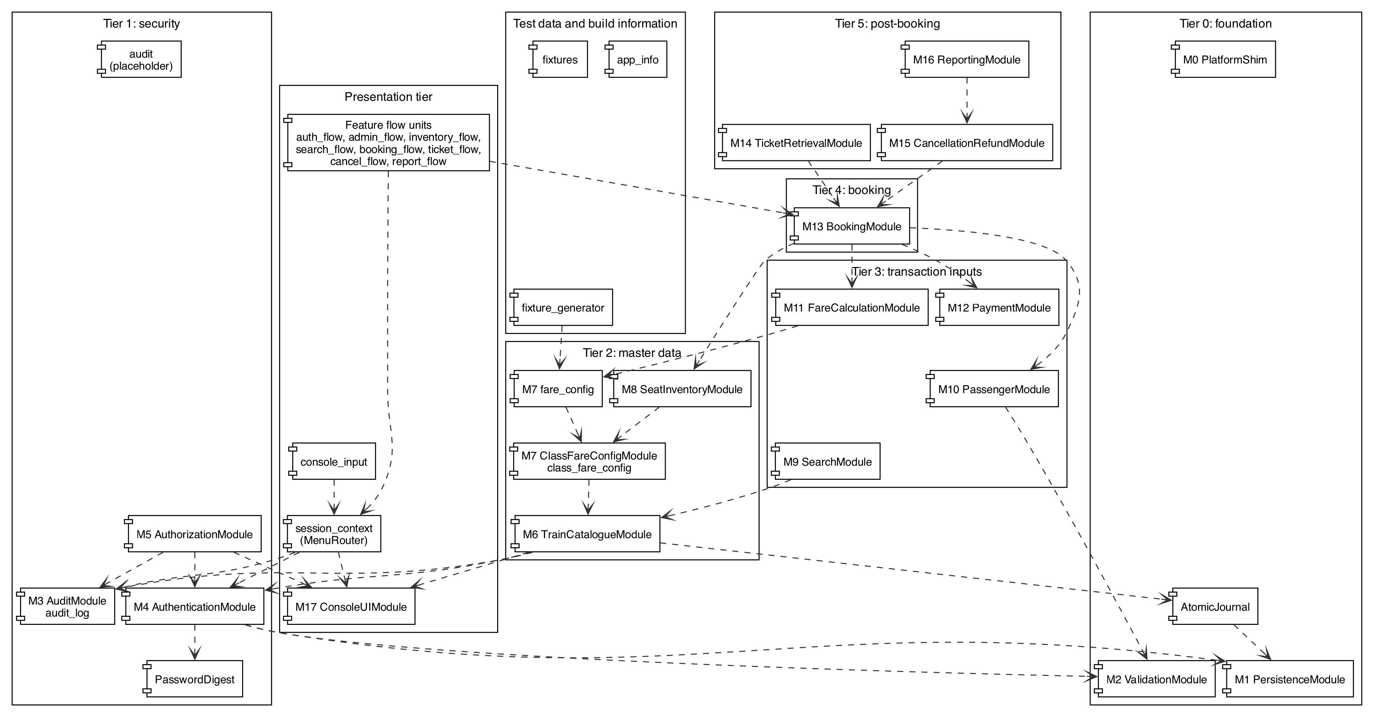
Figure 1: Component diagram of the implementation

11.2 Class Diagram
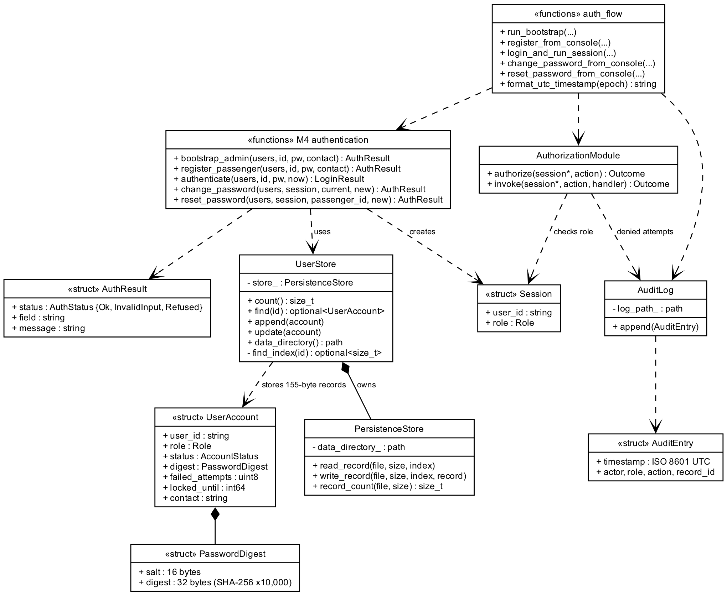
Figure 2: Class diagram of the Tier 1 security modules

11.3 Sequence Diagram
The sequence shows an administrator login followed by a passenger password reset. The idle check runs before every menu action. The menu router passes the action to the authorisation wrapper, which runs before the handler executes.
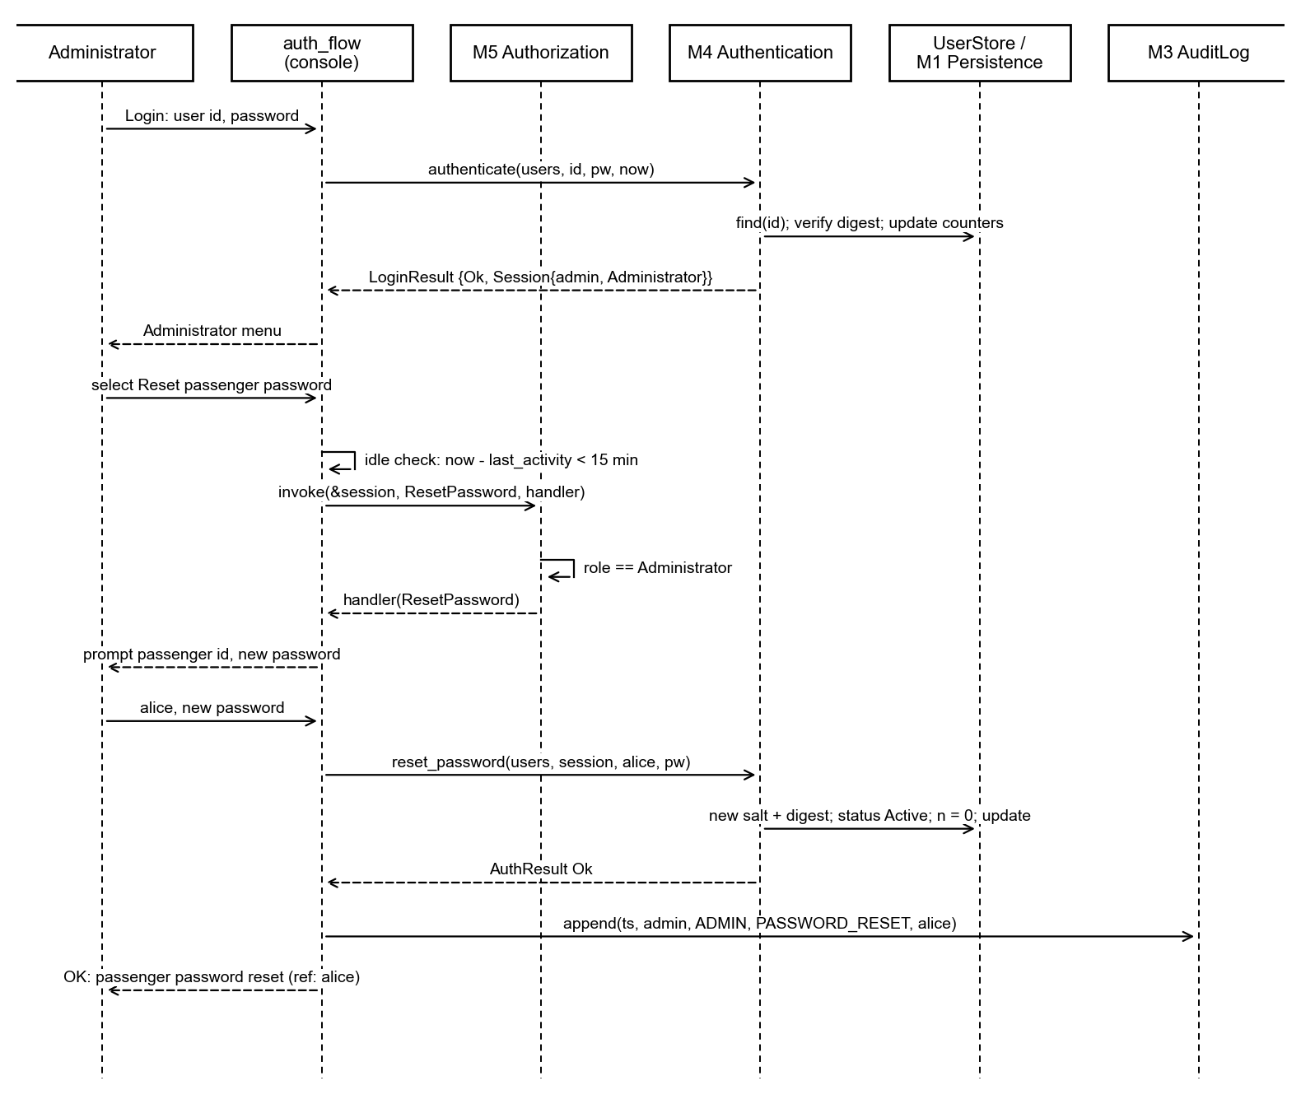
Figure 3: Sequence diagram for login and administrator password reset

11.4 State Diagram
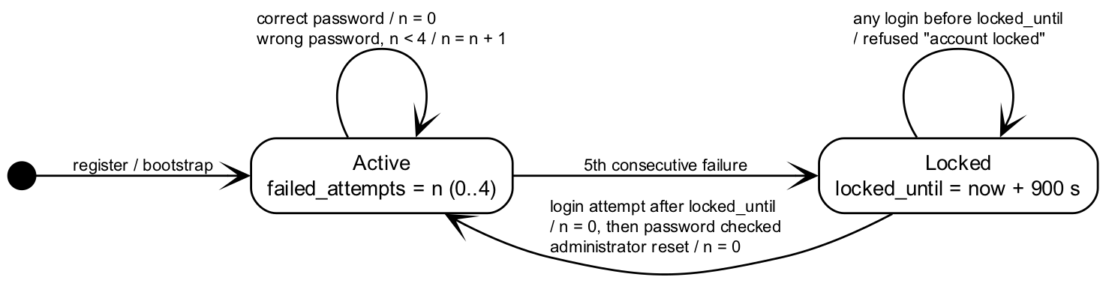
Figure 4: State diagram of the account lockout

11.5 Deployment Diagram
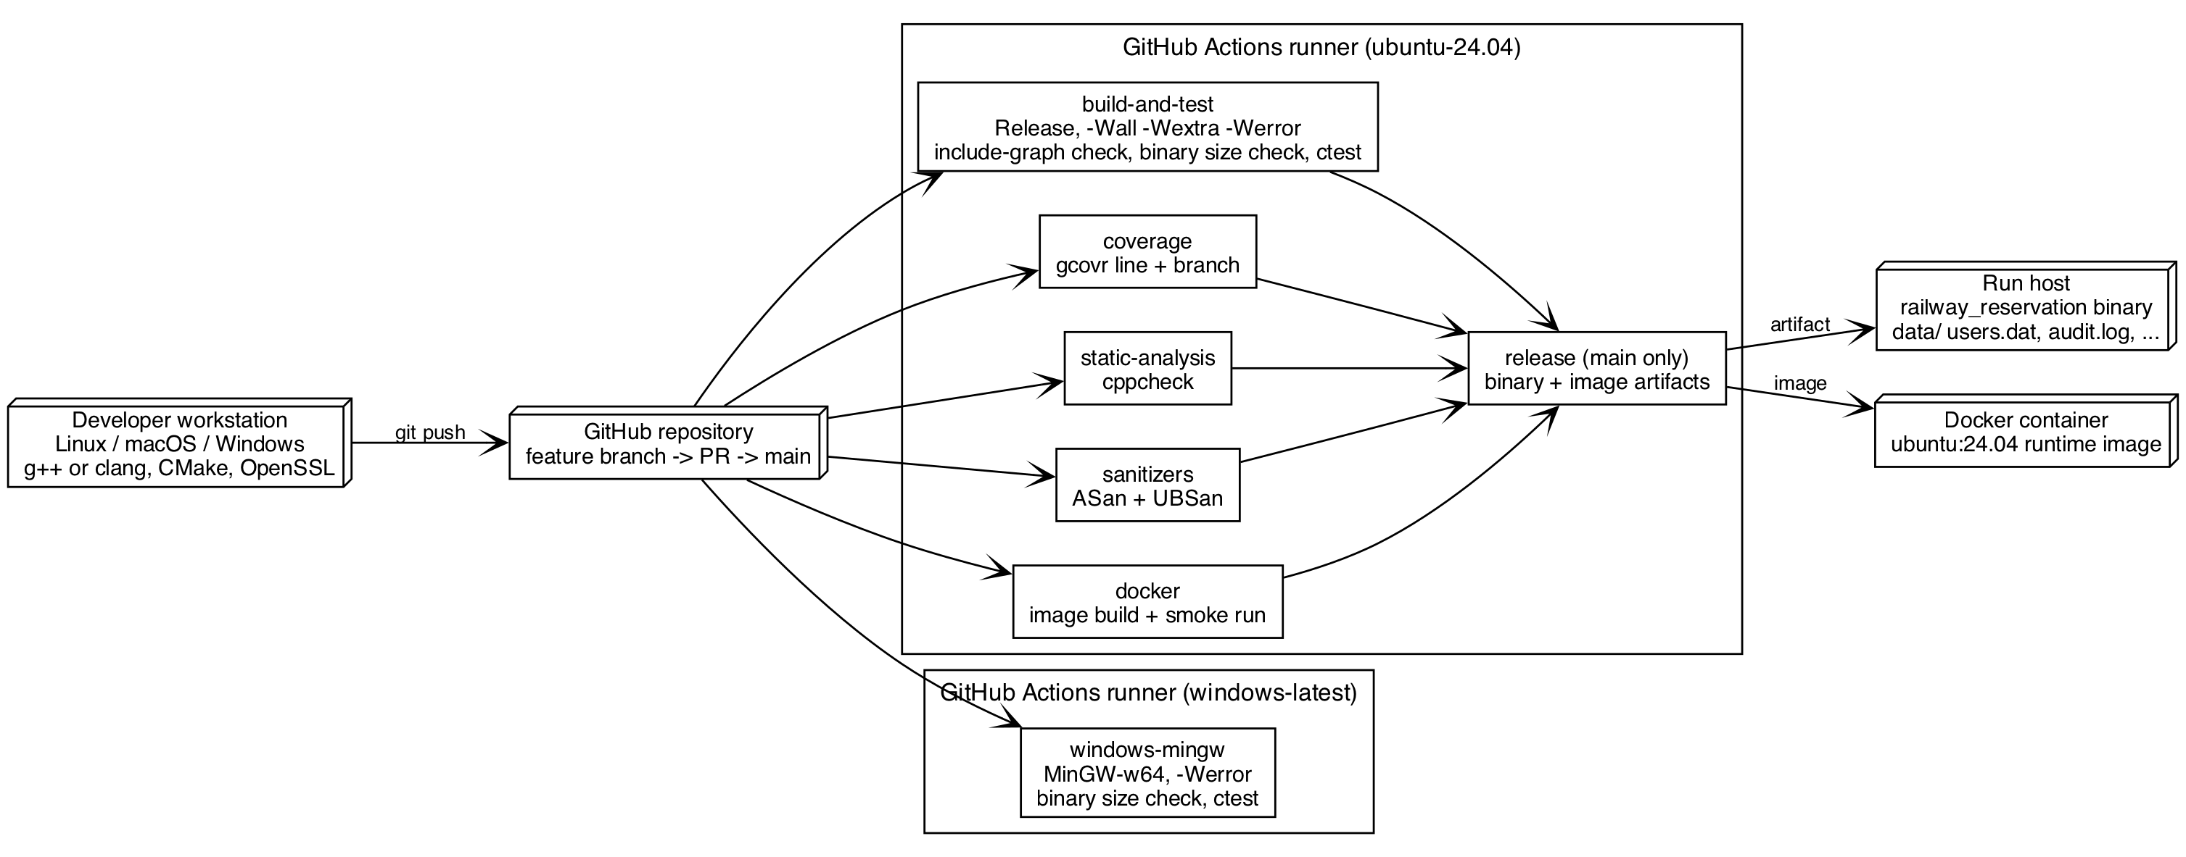
Figure 5: Deployment diagram of the build and delivery pipeline

12. Sprint Plans

12.1 Sprint 1
Sprint 1 ran from 19-10-2026 to 31-10-2026. Its goal was a working, verified foundation: the build and CI pipeline, the Tier 0 modules and the Tier 1 security modules. The sprint completed all 20 board items and 65 points. The four security items RRS-SR-001, SR-002, SR-006 and SR-007 were planned for Sprint 2 and completed in Sprint 1. The Sprint 1 demonstration video (issue 27) moved to user story US-08 and closed at the freeze.
Table 15: Sprint 1 backlog
Issue | Item | Points | Owner | State
1 | ENB-01 Repository skeleton, CMake, Catch2, CI | 3 | Verma; build and CI by Rajaram | Done
2 | ENB-02 M0 PlatformShim | 3 | Verma | Done
3 | ENB-03 M1 PersistenceModule | 5 | Uttarakar | Done
4 | ENB-04 M17 ConsoleUIModule | 5 | Rajaram | Done
5 | ENB-05 Seed fixtures | 3 | Uttarakar | Done
6 | RRS-NF-ROB-003 Atomic journal commit | 5 | Joel | Done
7 | RRS-SR-003 M2 ValidationModule | 3 | Verma | Done
8 | RRS-SR-004 Salted iterated password digest | 3 | Verma | Done
9 | RRS-F-023 M3 AuditModule | 5 | Joel | Done
10 | RRS-F-001 Passenger registration | 3 | Rajaram | Done
11 | RRS-F-002 Authentication and role-bound session | 5 | Rajaram | Done
12 | RRS-F-003 Logout | 1 | Rajaram | Done
13 | RRS-F-004 First-run administrator bootstrap | 2 | Rajaram | Done
14 | RRS-SR-001 Authentication gate | 2 | Verma | Done
15 | RRS-SR-002 M5 AuthorizationModule | 3 | Verma | Done
16 | RRS-SR-006 Password policy and lockout | 3 | Verma | Done
17 | RRS-SR-007 Session idle timeout | 2 | Verma | Done
19 | RRS-F-005 Password change and reset | 3 | Rajaram | Done
24 | RRS-F-013 Passenger details validation | 3 | Joel | Done
26 | RRS-F-015 Payment outcome recording | 3 | Joel | Done

12.2 Sprint 2
Sprint 2 ran from 01-11-2026 to 07-11-2026. Its goal was a complete booking and cancellation path with verified non-functional targets. The team organised the sprint as eight user stories. Each story groups the requirement issues that deliver it as sub-issues. All eight stories and 104 points are Done.
Table 16: Sprint 2 backlog
Issue | User story | Sub-issues | Points | Owner | State
85 | US-01 Administrator sets up trains, classes, fares and seats | 20 to 23 | 14 | Uttarakar; Joel | Done
86 | US-02 Passenger searches trains and sees availability | 28 to 31, 41 | 18 | Uttarakar; Verma | Done
87 | US-03 Passenger books tickets without double allocation | 25, 32 to 34, 42, 50 | 23 | Joel (lead); Rajaram; whole team | Done
88 | US-04 Passenger views and cancels a booking | 35 to 38 | 13 | Rajaram; Joel | Done
89 | US-05 Administrator reviews reports and the security audit trail | 18, 39 | 7 | Uttarakar; Rajaram | Done
90 | US-06 Users operate the console quickly without help | 43, 46, 47 | 5 | Rajaram | Done
91 | US-07 Release build meets quality targets | 40, 44, 45, 48, 49, 51 to 55 | 20 | Verma; Uttarakar | Done
92 | US-08 Team delivers final documentation and demonstration | 27, 56 | 4 | Rajaram | Done

13. Schedule Status
The Test Plan scheduled test execution by tier from 01-10-2026 to an acceptance demonstration on 02-11-2026. Implementation began on 28-10-2026 after the design baseline. The following table compares the plan with the actual completion dates, taken from the merge dates of the delivering pull requests.
Table 17: Planned and actual schedule
Milestone | Planned | Actual
Tier 0 tests: persistence, validation, platform shim | 01-10-2026 | 30-10-2026
Tier 1 tests: audit, authentication, authorisation | 06-10-2026 | 31-10-2026
Tier 2 tests: catalogue, class and fare configuration, inventory | 08-10-2026 | 31-10-2026
Tier 3 tests: search, passenger, fare, payment | 12-10-2026 | 04-11-2026
Tier 4 tests: booking, PNR, TC-CONC-01 | 15-10-2026 | 06-11-2026
Tier 5 tests: retrieval, cancellation, refund, reporting | 19-10-2026 | 04-11-2026
System and use-case tests | 21-10-2026 | 04-11-2026
Non-functional runs and soak | 23-10-2026 | 06-11-2026
Portability on Windows/MinGW | 26-10-2026 | 31-10-2026
Usability trial with five users | 27-10-2026 | 12-11-2026
Defect fix and regression | 29-10-2026 | Continuous through CI
Acceptance demonstration | 02-11-2026 | Final demonstration on release tag v1.0.0

13.1 Assessment
The project finished later than the Test Plan schedule, which assumed that implementation would start in September. Measured from the actual start on 28-10-2026, every tier was implemented and verified within the two sprints. The validation activities that need people or a finished build, namely the usability trial and the final measurements, completed on 12-11-2026.

13.2 Mitigation
- The team applied the scope rule of SRS Section 9 as a fallback. No reduction of search (M9) or reporting (M16) was needed.
- The Tier 2 master-data modules merged on the last day of Sprint 1, so the Tier 3 to Tier 5 modules had their dependencies at the start of Sprint 2.
- The booking, ticket, cancellation and reporting modules were developed as stacked pull requests and merged in dependency order on 04-11-2026.
- The non-functional suites ran in CI as soon as the booking path existed, using the deterministic fixture generator.

14. Final Status
Development is frozen. Release tag v1.0.0 marks the final state of the main branch. No functional work remains open. The following table lists the deliverables in the repository.
Table 18: Deliverables at the freeze
Deliverable | Location
Source code and tests | src/, tests/unit/, tests/integration/
Unit Test Report | docs/reports/Unit_Test_Report.md
System Validation Report | docs/reports/System_Validation_Report.md
Code and branch coverage reports | docs/reports/Code_Coverage_Report.md, docs/reports/Branch_Coverage_Report.md, docs/reports/coverage/
Usability trial record | docs/reports/Team_2_RRS_Usability_Trial_TC-UX-01.docx
Deviation record | docs/Design_Deviations.md
Module design notes | docs/M6-train-catalogue-design.md, docs/M7-class-config-design.md, docs/M7-fare-config-design.md, docs/M9-search-design.md, docs/fixture-generator-design.md
Demonstration videos | docs/videos/RRS_Sprint1_Demo.mp4, docs/videos/RRS_Sprint2_Demo.mp4
Project report | docs/reports/Team_2_RRS_Project_Report.docx

The known limitations are those listed in Section 7.3. They are recorded in the System Validation Report and in the deviation record.

15. Team Contributions
Table 19: Contributions by member
Member | Role | Delivered work
Anishwar Rajaram (PES2UG24CS068) | QA Lead; owner of M4 and M17 | CI workflow and its quality gates (PR 57, 65); README and testing guide (PR 58, 62); Catch2 framework and application skeleton (PR 59, 60); M17 console menus, menu router and help frames (PR 61, 104, 110); M4 bootstrap, registration, login and logout, password change and reset (PR 68, 70, 73, 81); main branch repairs (PR 77, 105); M11 fare calculation and M13 booking (PR 106); M14 ticket retrieval (PR 107); M15 cancellation and refund (PR 108); M16 reporting (PR 109); cross-process concurrency and latency tests (PR 116); usability trial, final reports, deviation record and videos (PR 117)
Ankirapalle Joel Suhas (PES2UG24CS069) | Test Engineer, core transaction path | M3 audit log (PR 71); M10 passenger validation (PR 69); M12 payment recording (PR 79); atomic journal with SIGKILL recovery test (PR 83); M8 seat inventory and audited seat blocking (PR 96)
Ankit Uttarakar (PES2UG24CS070) | Test Engineer, data, search and non-functional | M1 persistence (PR 63); deterministic seed fixtures (PR 64); security audit integration (PR 82); M6 train catalogue (PR 84); M9 train search (PR 93); M7 class and fare configuration (PR 95, 98); fixture generator (PR 115)
Ankit Verma (PES2UG24CS071) | Developer, build and security | M2 validation (PR 66); password digest (PR 67); module stubs (PR 72); M0 platform shim (PR 74); M5 authorisation and audited refusals (PR 75, 76); lockout (PR 78); idle timeout (PR 80); search result and availability display (PR 94, 97); malformed-input validation tests (PR 99); transaction recovery (PR 100); platform shim check (PR 101); Windows MinGW job (PR 102); include-graph check (PR 103); binary size limits (PR 111, 114); reliability soak (PR 112); search performance fixtures (PR 113)

The requirements specification and the Test Plan were authored jointly by all four members.

16. Alignment with Course Units
Table 20: Mapping of project activities to course units
Unit | Course topic | Project application
Unit 2 | Project planning, work breakdown and estimation | Backlog of 64 issues derived from the SRS; eight user stories; story points; tiered build order as the work breakdown
Unit 2 | Scheduling and Gantt charts | Test Plan schedule by tier; sprint iterations on the project board; Section 13 comparison
Unit 2 | Risk management | SRS assumptions with impact; Test Plan risks; scope reduction rule for M9 and M16
Unit 2 | Software architecture, views and documentation | SAD component and sequence views; layered console, application and persistence design; Section 11 views
Unit 2 | Coupling, cohesion, modularity and information hiding | One header and source per module; acyclic tier graph checked in CI; anonymous-namespace helpers
Unit 2 | Security design and architecture | Salted iterated digests, lockout, idle timeout, role checks inside modules, audit log
Unit 2 | Technical debt and anti-patterns | Placeholder audit file recorded in Section 10; no shared global state; deviations recorded
Unit 2 | Test-driven development | Tests written with each feature and named after Test Plan identifiers
Unit 3 | Choice of programming language | Section 5.1 assessment of C++17 against the unit criteria
Unit 3 | Coding standards and code review | Conventional commits and a pull request template
Unit 3 | Version control and branching | Feature branches per issue, stacked pull requests, merge commits for conflicts, release tag v1.0.0
Unit 3 | Static and dynamic testing | cppcheck static analysis; unit, integration and sanitizer runs
Unit 3 | Cyclomatic complexity and white-box testing | Branch coverage of 69 per cent reported by gcovr, with analysis of files below 60 per cent
Unit 3 | DevOps, continuous integration and DevSecOps | Seven-job GitHub Actions pipeline on Linux and Windows with sanitizers and static analysis
Unit 3 | Release and configuration management | Release job publishes the verified binary and container image from main; release tag v1.0.0
Unit 4 | Unit, integration and system testing | 176 unit and 69 integration test cases; scripted console sessions drive the use cases for both roles
Unit 4 | System test types: smoke, recovery, destructive, soak | Docker smoke run; SIGKILL crash recovery; 10,000-operation soak; cross-process contention
Unit 4 | Coverage and its limits | Line coverage of 88 per cent and branch coverage of 69 per cent reported without a numeric target, in line with the coverage paradox
Unit 4 | Fuzz testing | Reproducible malformed-input cases for TC-ROB-02 (RRS-NF-ROB-002)
Unit 4 | Usability testing | Usability trial TC-UX-01 with five first-time users
Unit 4 | Measurement and metrics | Story points and sprint progress; 95th-percentile latency measurements against the NFR targets
Unit 4 | Privacy and confidentiality | No plaintext credentials; synthetic test data only; data directory protected by host permissions

17. Appendices

17.1 Glossary
Table 21: Glossary
Term | Meaning
Advisory lock | A POSIX fcntl record lock that cooperating processes honour
Bootstrap | The first-run creation of the single administrator account
Critical path | The dependency chain Tier 0, Tier 1, Tier 2, Tier 4 that fixes the earliest completion
Journal | A write-ahead record that makes a multi-record update atomic
Known-answer test | A test that compares output with a value fixed in advance
Menu router | The session_context component that dispatches a menu action to its flow unit
Soak test | A long scripted run that measures the failure rate over many operations

17.2 References
- Team 2. Software Requirements Specification, Railway Reservation System, Version 1.0, 18-08-2025.
- Team 2. Software Requirements Specification, Railway Reservation System, Version 2.0, 03-09-2026.
- Team 2. Software Test Plan, Railway Reservation System, Version 1.0, 16-09-2026.
- Team 2. Software Architecture and Design Specification, Railway Reservation System, Version 1.0, 03-10-2026.
- Team 2. Unit Test Report, docs/reports/Unit_Test_Report.md, 12-11-2026.
- Team 2. System Validation Report, docs/reports/System_Validation_Report.md, 12-11-2026.
- Team 2. Code Coverage Report and Branch Coverage Report, docs/reports/, 12-11-2026.
- Team 2. Usability Trial TC-UX-01, docs/reports/Team_2_RRS_Usability_Trial_TC-UX-01.docx, 12-11-2026.
- Team 2. Deviations from the Submitted Documents, docs/Design_Deviations.md, 12-11-2026.
- UE24CS341A Software Engineering course material, Units 2, 3 and 4.
- Project repository and issue tracker, github.com/joelsuhas7-jpg/Railway-Reservation-System-RRS-.

