Eurex Platform

SOA Architecture

Brainstorming

Unique reference key of this document (Version V1.0)

Contents of the document

This document is a spiritual ownership of STABILIT Informatik AG, and must not be used or copied without a written allowance of this company. Unauthorised usage is illegal in terms of Chapter 23 / 5 UWG / Swiss law.

The information in this document is subject to change without notice and should not be construed as a commitment by STABILIT Informatik AG.

Copyright © by STABILIT Informatik AG

All rights reserved.

All other logos, product names are trademarks of their respective owners.

This Document has been created with Microsoft Word 2003 (11) with template file and printed at .

# Identification

|  |  |
| --- | --- |
| ***Project:*** | Project |
| ***Title:*** | Title |
| ***Subtitle:*** | Subtitle |
| ***Version:*** | V1.0 |
| ***Reference:*** | Unique reference key of this document |
| ***Classification:*** | Unrestricted / For Internal use only / Confidential / For Personal use only / Secret |
| ***Keywords:*** | Keywords related to this document |
| ***Comment:*** | Contents of the document |
| ***Author(s):*** | Jan Trnka |
| ***Approval (Reviewed by):*** | Signature Jan Trnka |
| ***Audience:*** | Who should read this document |
| ***Distribution:*** | Who will get this document |
| ***Filename*** |  |

# Revision History

|  |  |  |  |
| --- | --- | --- | --- |
| ***Date*** | ***Version*** | ***Author*** | ***Description*** |
| 01.01.2006 | D1.0 | Jan Trnka | Initial draft |
|  |  |  |  |

# Table of Contents

1 Preface 2

1.1 Purpose & Scope of this Document 2

1.2 Definitions & Abbreviations 2

1.3 External References 2

1.4 Outstanding Issues 2

1.5 Typographical Conventions 2

2 Chapter title 2

2.1 Header_1 2

2.1.1 Header_2 2

3 Glossary 2

Appendix 2

Index 2

# Tables

**Error! No table of figures entries found.**

# Figures

**Error! No table of figures entries found.**

# Preface

## Purpose & Scope of this Document

This section is intended for describing the purpose and scope of this document.

## Definitions & Abbreviations

|  |  |
| --- | --- |
| ***Item / Term*** | ***Definition / Description*** |
| Abbreviation used | Explanation |
|  |  |

## External References

|  |  |
| --- | --- |
| ***References*** | ***Item / Reference to other Document*** |
| [1] | External reference |
| [2] |  |

## Outstanding Issues

The "Outstanding Issues" section is intended for recording known outstanding points that will be dealt with by the next version of the document, as information to the reader.

## Typographical Conventions

|  |  |
| --- | --- |
| ***Convention*** | ***Meaning*** |
| *text in italics* | features not implemented in the actual release |
| text in Courier font | code example |
| [ phrase ] | In syntax diagrams, indicates that the enclosed values are optional |
| { phrase1 | phrase2 } | In syntax diagrams, indicates that multiple possibilities exists. |
| … | In syntax diagrams, indicates a repetition of the previous expression |

The terminology used in this document may be somewhat different from other sources. The chapter Glossary includes a list of often used terms with the explanation of their meaning in this document..

# Basic Idea

## Internet is the template

The Internet is the biggest service oriented application in the world. Millions of users (clients) access thousands of services. All this internet services use standard protocols like http and smtp based on tcp/ip and dns. The IETF (Internet Engineering Taskfoce, [www.ietf.org](http://www.ietf.org)) is responsible for all this protocols, but not for the content itself.

Responsible for the most visible content in the World Wide Web (WWW) is the World Wide Web Consortium, www.w3.org). A web server is e.g. the most important service in the internet.

IETF and W3C do not realize any real software, they define the standards only, say paper). The software itself is develop by thousands of free developers (say open source) or companies like IBM, Oracle, Microsoft, Google, etc..

This famous network is the biggest service oriented architecture gowing up and up. New services like Facebook and Twitter change our way of live. It is a big community, everybody can bring in own ideas and concepts. The market decides which standards and services are successful or not.

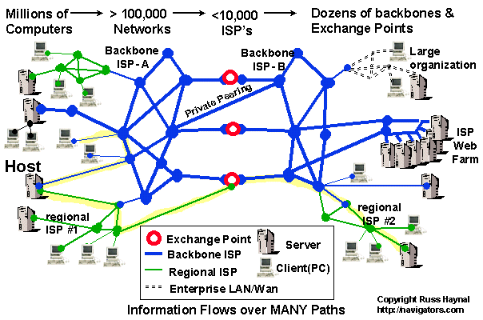

### EUREX Standard Consortium

If it works in a huge environment, why not to use it in a small environment?

# Glossary

Glossary item

glossary text

1. Appendix

text



**Error! No index entries found.**