|  |  |  |  |  |  |
| --- | --- | --- | --- | --- | --- |
| **RJIL IDC**  **Standard Operating Procedure**  **KDUMP crash management**  **Document No. R4G-84-TNA-SOP-PR-026** | | | | | |
|  |  |  |  |  |  |
|  |  |  |
| **Rev. No.** | **Date** | **Reason for Issue** | **Prepared by** | **Reviewed by** | **Approved by** |
| **1** | **10 August 2016** | **SOP for KDUMP Crash** | **Joel** | **Babu jayaraj** | **Manish Dhote** |

Printouts of this document shall be deemed uncontrolled.

10 Aug 2016

|  |  |
| --- | --- |
| **Document Title** | Standard Operating Procedure for KDUMP |
| **Document ID** | RJIL/IDC Automation/SOP-006 |
| **Location in RJIL network** | IDC GITLAB |
| **Published Date** | 10 August 2016 |
| **Published By** | IDC Automation |
| **Classification** | Confidential |
| **Document Owner** | Babu jayaraj, Joel |

**Document Version Control**

|  |  |  |  |
| --- | --- | --- | --- |
| **Document Version** | **Revision Date** | **Revised By** | **Sections revised /updated** |
| 1.0 | 10 August 2016 | Joel | Initial document |

**Approval History**

|  |  |  |
| --- | --- | --- |
| **Document version** | **Approver Name** | **Approval Date** |
| 1.0 | Babu Jayaraj | 10 August 2016 |
|  |  |  |

Table of Contents

1 Purpose 5

2 Scope 5

2.1 Intended Audience 5

2.2 Relevant Activities Error! Bookmark not defined.

3 Definitions / Abbreviations 5

4 Responsibilities 5

4.1 IDC Tools & Automation Team 5

5 Work process/procedures 6

5.1 Prerequisites 6

5.2 Steps to scan BAVA for Linux OS (Redhat / CentOS) Error! Bookmark not defined.

5.3 Troubleshooting Error! Bookmark not defined.

5.4 FAQ – Frequently Asked Questions Error! Bookmark not defined.

6 References Error! Bookmark not defined.

7 Attachments Error! Bookmark not defined.

8 List of Records Error! Bookmark not defined.

8.1 Development History Error! Bookmark not defined.

1. Purpose
2. Whenever the kernel is crashed, It is good to know the reason behind the crash.
3. This document provides an overview and technical knowledge on whether KDUMP is installed, running, etc. Also the requirement is to place the crash file not from the original directory as /var/crash.

Req in taiga: <http://idctaiga.rjil.ril.com/project/nssankara-compute/us/522>.

1. Scope

Scope is to validate whether Kdump is installed? Kdump is configured? Kdump is operational? along with that it place the crash file in the specific folder

* 1. Intended Audience

SOP is prepared for OPS team.

* 1. Supported Hardware/Software

This utility requires python 2.4 environment to trigger the automated script.

1. **Definitions / Abbreviations**

RJIL - Reliance Jio Infocomm Limited

SOP - Standard Operating Procedure

HPSA - HP Server Automation

1. **Responsibilities** 
   1. **IDC Tools & Automation Team**
2. OPS team are responsible for executing the script in HPSA
3. For preparing & updating this document.
4. **Work process/procedures**

a) The script will be present in HPSA

b) Run the python scripts and execute for all the VM associated with it.

* 1. **Prerequisites**

Python 2.4 with following packages available in the script execution environment sys, os, process

* 1. **Script flow**

***Scripts:***

***kdump-validator.py***

***kdump-config.py***

***Step by step flow:***

***kdump-validator.py***

1. When kdump in not installed and no space of greater than 10G

It will show the hostname, Not installed, Not Configured, Not Operational, Space compliant

Test: (run “yum remove kexec-tools” to uninstall and run the program)

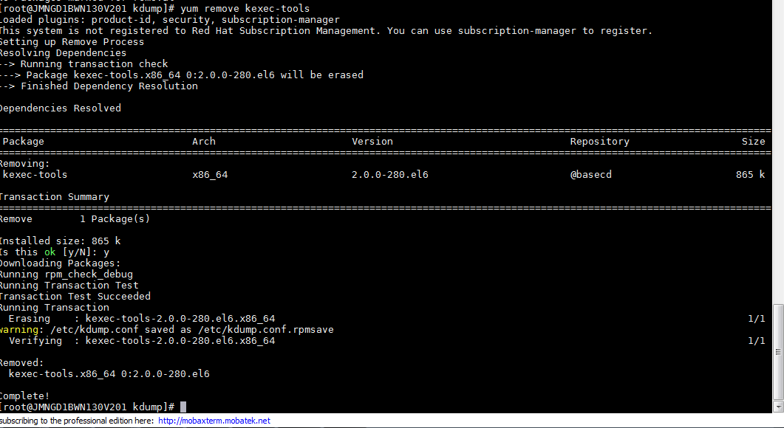

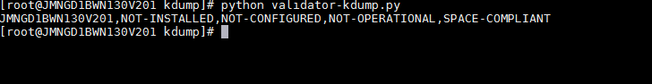

1. When kdump is installed and not configured and no space of greater than 10G

It will show the hostname, Installed, Not Configured, Not Operational, Space compliant

Test: (remove “crashkernal = auto” from /boot/grub/grub.conf)





1. When kdump is installed and configured and operational and no space of greater than 10G

It will show the hostname, installed, Configured, Operational, Space compliant

Test: (run “service kdump stop” )

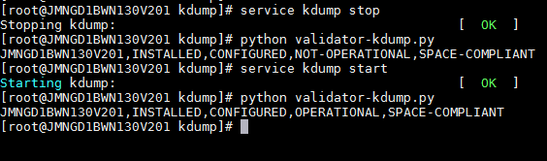

***Step by step flow:***

***Config-kdump.py***

1. When kdump is not installed, or not operational, or not configured

It will install, configured, make the service run set file in /etc/kdump-conf as

Default path in /etc/kdump-conf

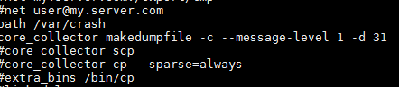

After config-kdump.py

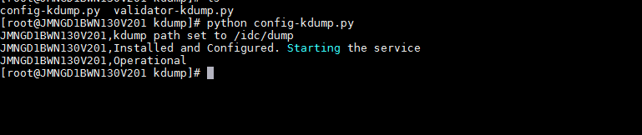

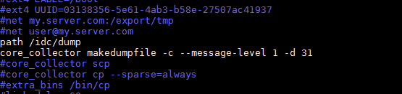

1. When VM is crashed:

The crash file will be there in the “/idc/dump”

Test: ( run “echo 1 > /proc/sys/kernel/sysrq ; echo c > /proc/sysrq-trigger” to crash the vm)

(This is example, when the path was set to /tmp/dmp )



Execute: python config-kdump.py, it will install, configure everything.



1. Grub.conf setting

Memory setting:

If /idc/dump should have 10GB space

If the free space is >=10G, it is Space-not compliant

If the free space is <10G, it is Space compliant



Running the script on HPSA

For testing the script is place in the IDC tools and automation UAT environment

10.144.100.83

1. HPSA screen:

In HPSA there will be multiple devices attached to HPSA. We can select across the device we want to run.

Right click on it and select the script we want to run.

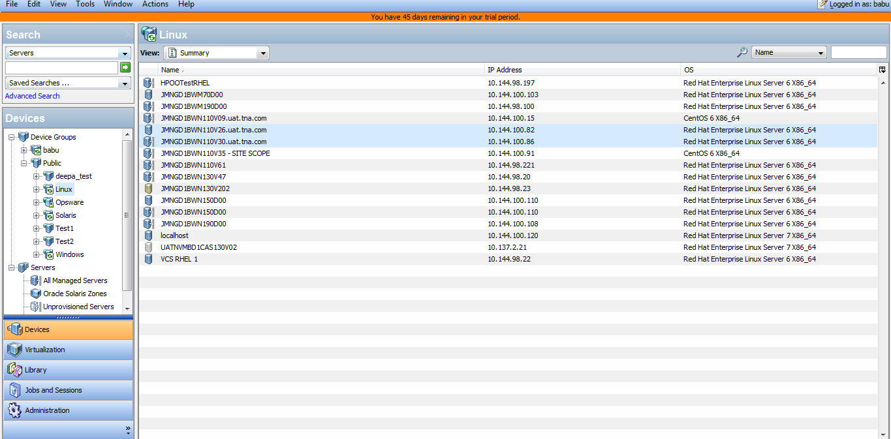

2. The screen shows: We can keep the script in the HPSA using winscp and place it in the HPSA installed VM. From HPSA we can browse and select those script.

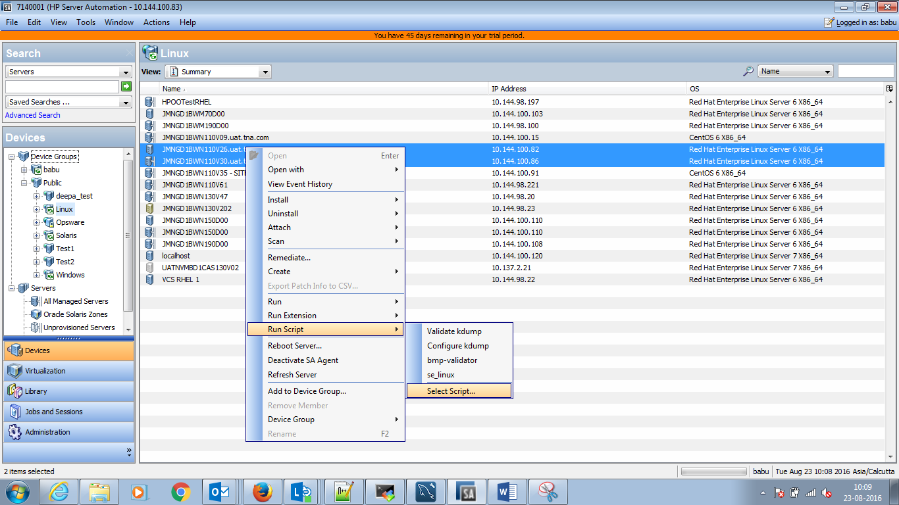

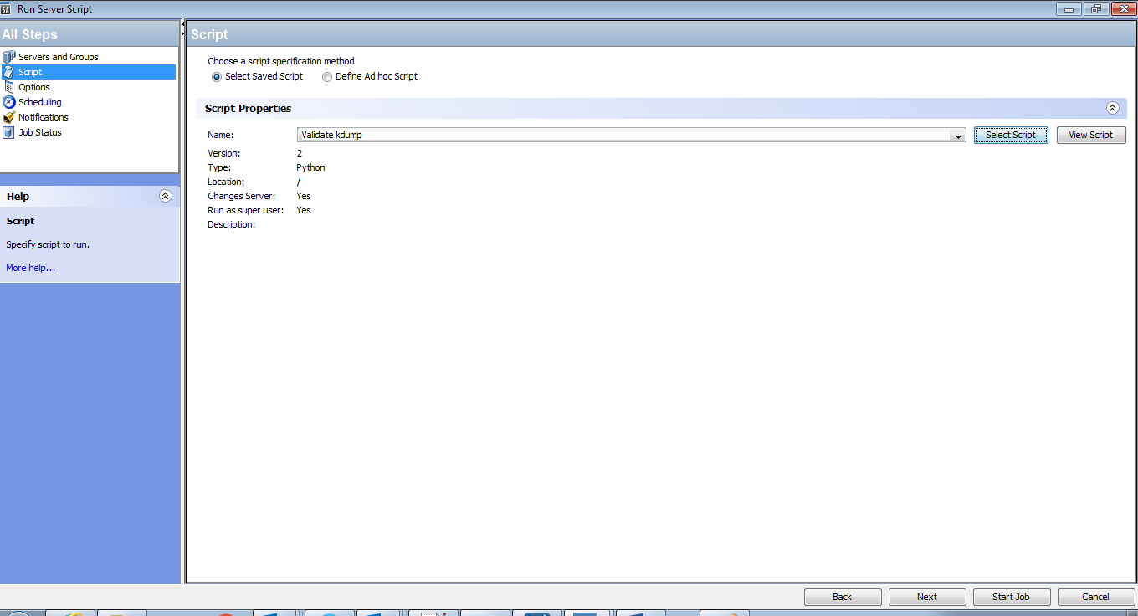

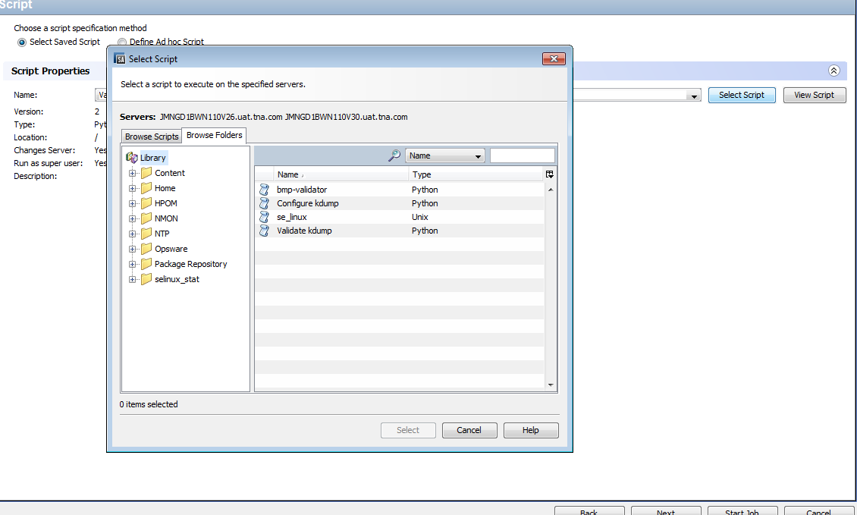

Running the script:

Select the list of devices we want to run across and then right click and select the “validate kdump”

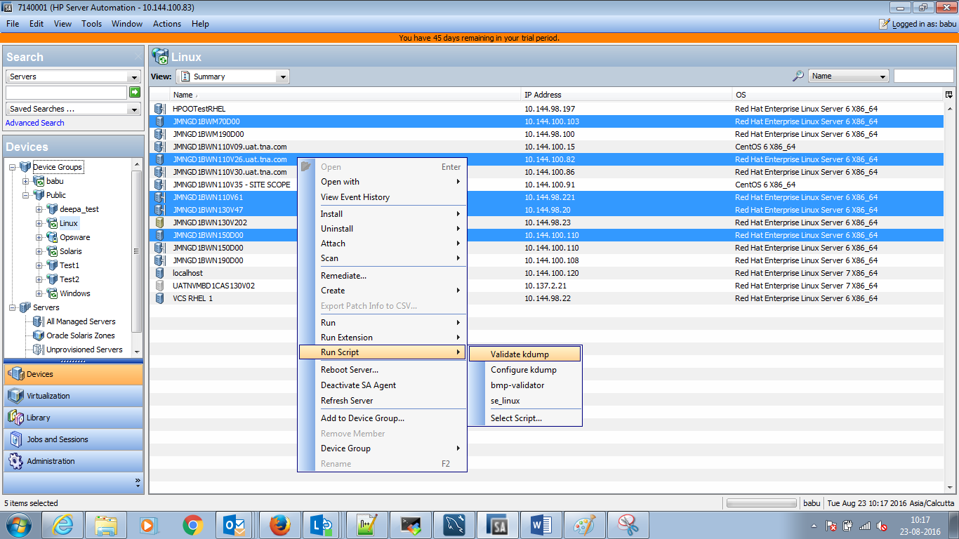

Run time option:

Select how you want to run:, by default, just click on next.

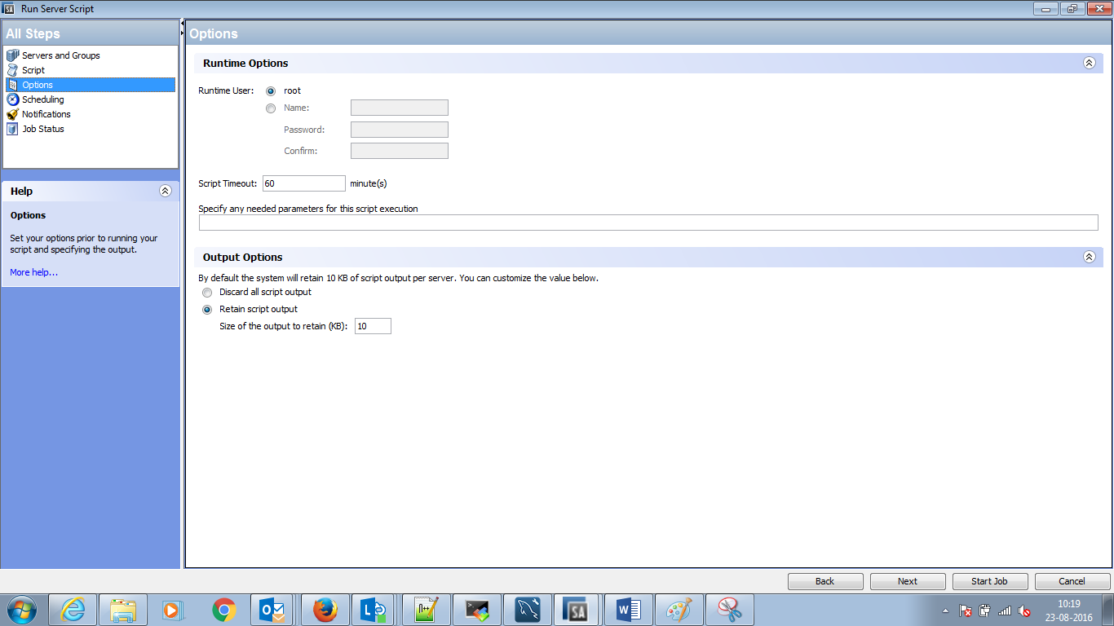

Add notifier and click on startjob

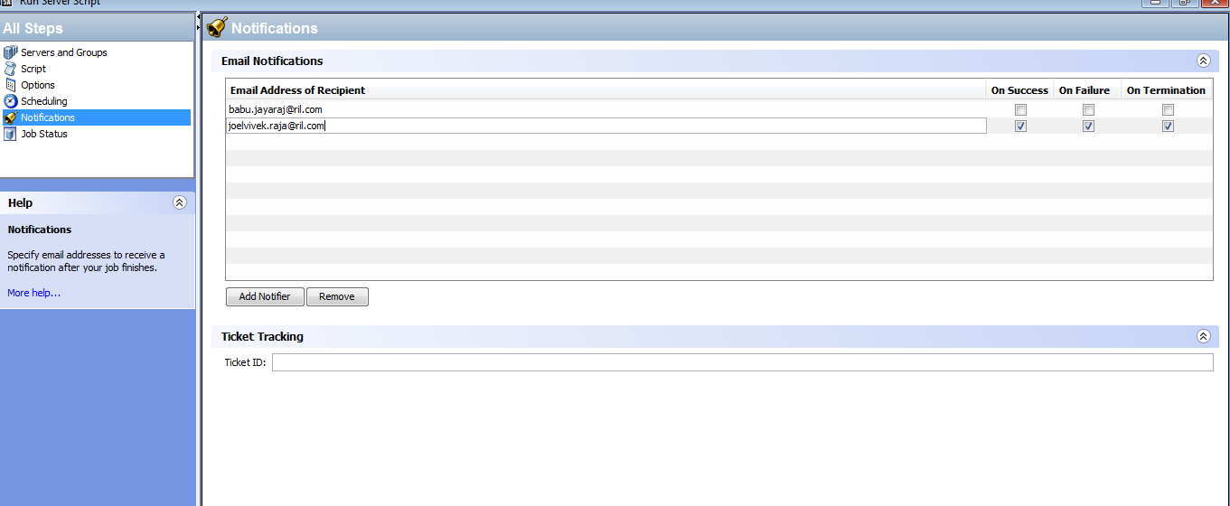

Status: pending, In progress, Succeeded, Failed.

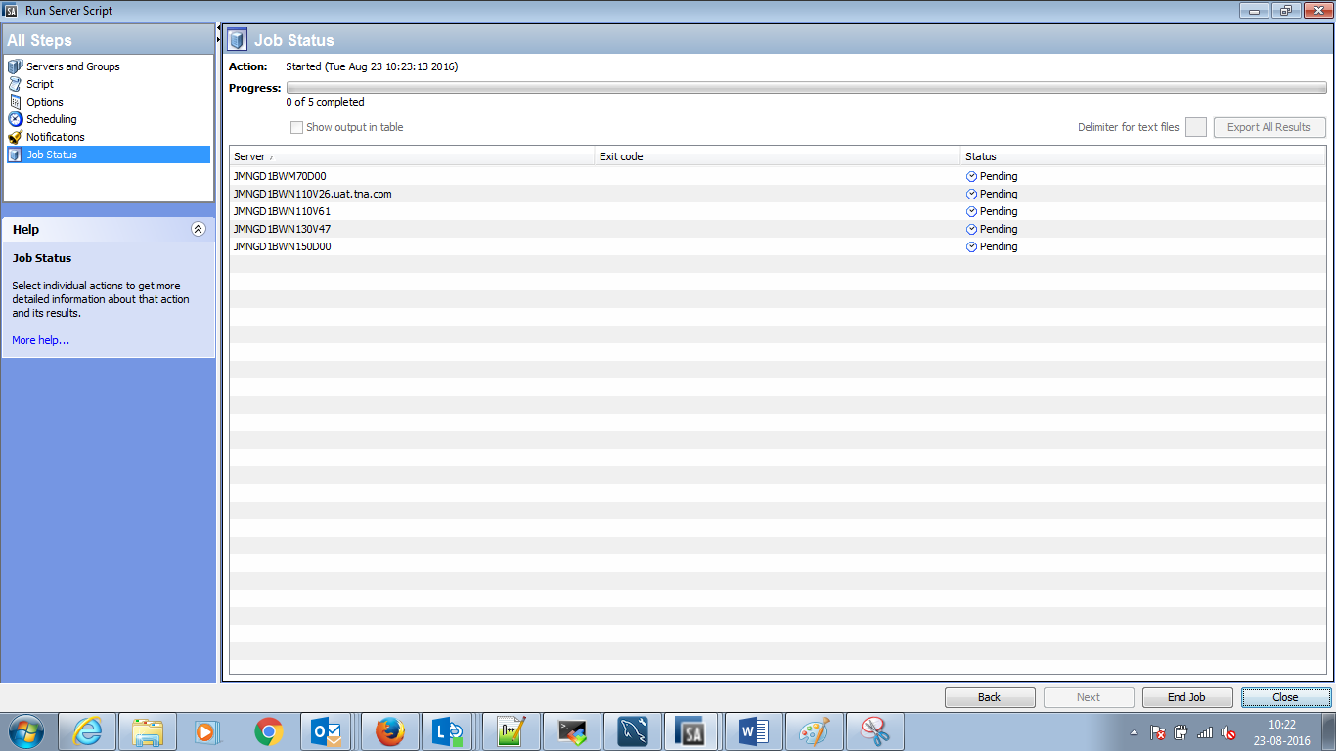

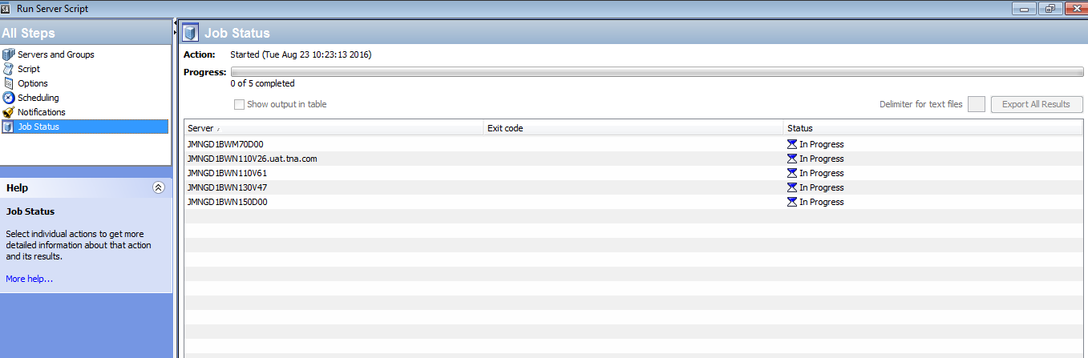

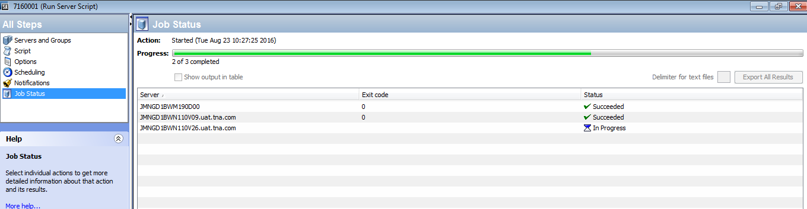

Export the result: click on Export All Result button and save it, it will be a zip file when I save it.

Open the file and take a look for the result in “stdout.txt”

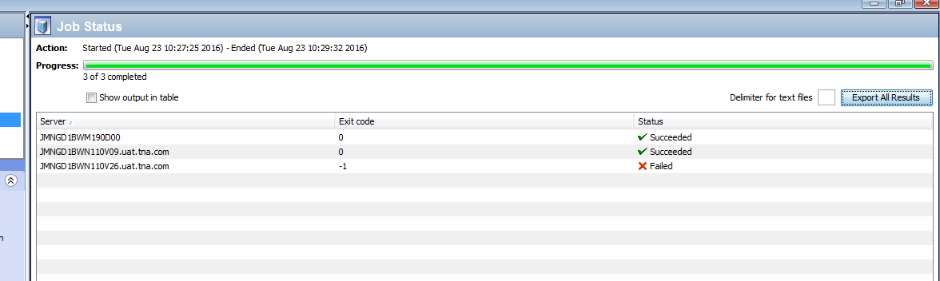

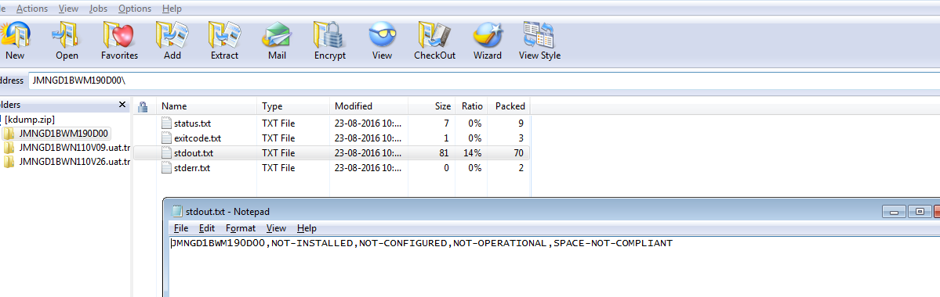

In the same way, run the script for “configure KDump”

