

**Stock Selection & Analysis**

Select Stock Tickers

AAPL

Select Timeframe

5y

LSTM Model Training

Train LSTM Model

Epochs

100

Batch Size

32

LSTM Units

50

Training LSTM model for AAPL...

PL: Epoch 100/100, Loss: 0.000

LSTM Model Trained Successfully for AAPL!

Run Backtest

AI TradeMaster - Comprehensive Stock Dashboard

# Candlestick Chart for Selected Stocks

Data for AAPL

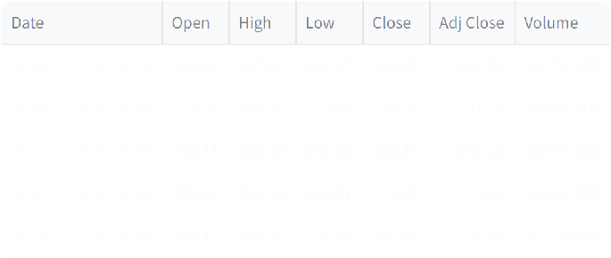

**Candlestick chart for AAPL**

200

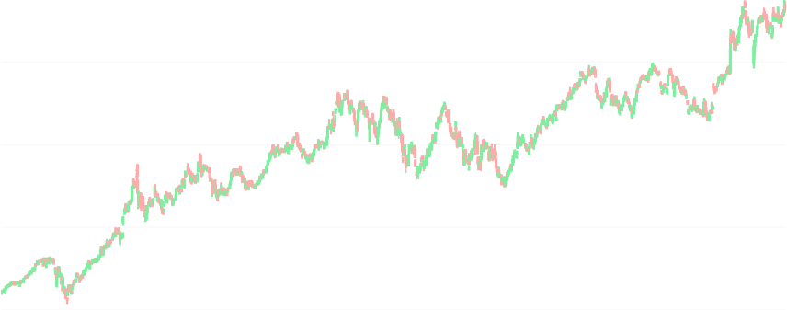

Date

150

Price

100

50

2020 2021 2022 2023 2024

# Technical Indicators Comparison

Technical Indicators for AAPL

**RSI for AAPL**

100

80

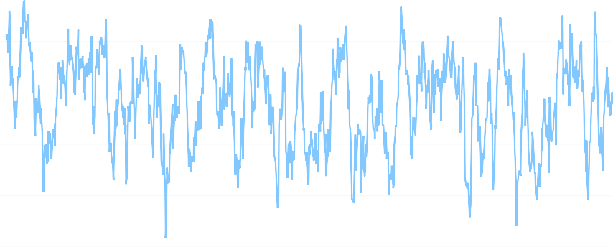

Date

60

RSI

40

20

0

2020 2021 2022 2023 2024

## Bollinger Bands for AAPL

250

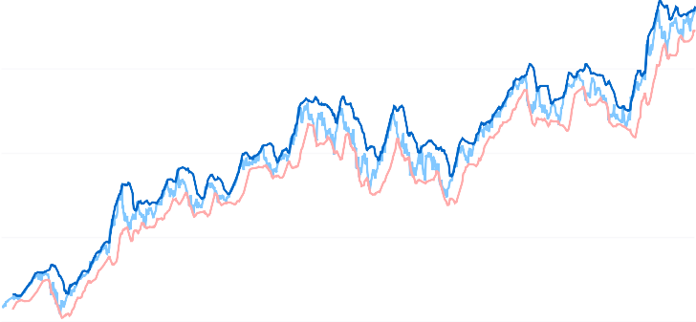

Date

200

Adj Close Upper Ba Lower Ba

150

Price

100

50

2020 2021 2022 2023 2024

## MACD for AAPL

MACD

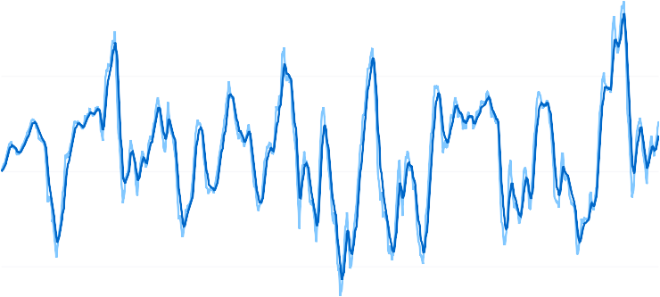

Date

Signal Li

5

0

MACD

−5

2020 2021 2022 2023 2024

# Model Performance Metrics and Predictions

## Results for AAPL:

Predicted Price: $227.86

Training RMSE: 3.59

Testing RMSE: 5.11

Training MAE: 2.73

Testing MAE: 4.10

## Actual vs Predicted Values for AAPL

240 Predict

Date

Actual

220

200

180

Price

160

140

Apr 2023 Jul 2023 Oct 2023 Jan 2024 Apr 2024 Jul 2024 Oct 2024

# Predicted Stock Prices

**Predicted Price for AAPL:** 227.86

# Backtesting Results

Initial Capital: $10000

Final Portfolio Value: $12393.54 Total Return: 23.94%

