

**Stock Selection & Analysis**

Select Stock Tickers

AAPL

Select Timeframe

5y

LSTM Model Training

Train LSTM Model

Epochs

100

Batch Size

32

LSTM Units

50

Training LSTM model for AAPL...

AAPL: Epoch 100/100, Loss: 0.0

LSTM Model Trained Successfully for AAPL!

Run Backtest

AI Trade-master - Comprehensive Stock Dashboard

# Candlestick Chart for Selected Stocks

Data for AAPL

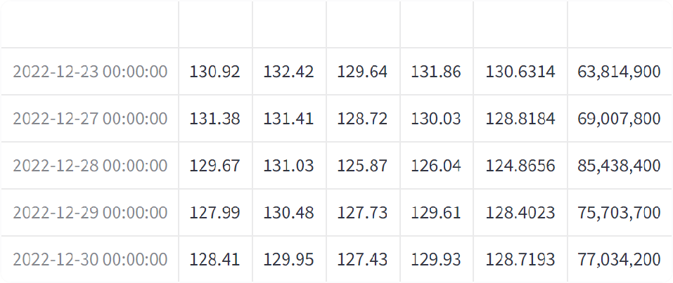

## Candlestick chart for AAPL

200

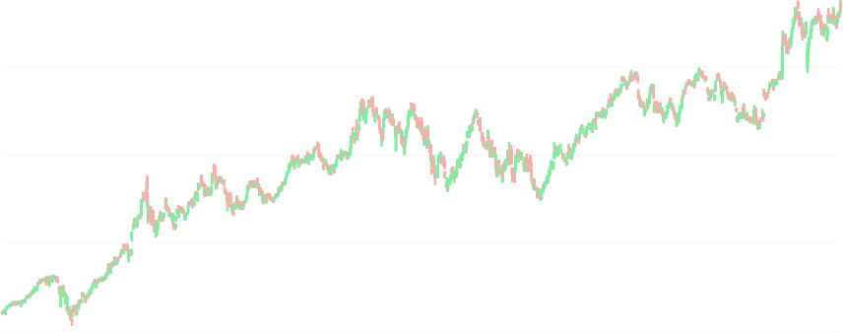

Date

150

Price

100

50

2020 2021 2022 2023 2024

# Technical Indicators Comparison

Technical Indicators for AAPL

## RSI for AAPL

100

80

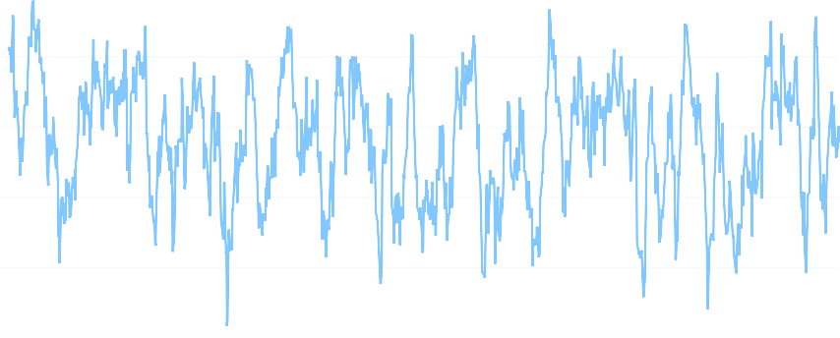

Date

60

RSI

40

20

0

2020 2021 2022 2023 2024

## Bollinger Bands for AAPL

250

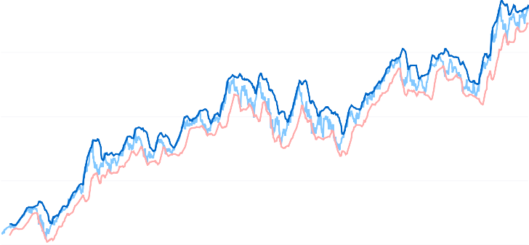

Date

200

Adj Close Upper Ba Lower Ba

150

Price

100

50

2020 2021 2022 2023 2024

## MACD for AAPL

MACD

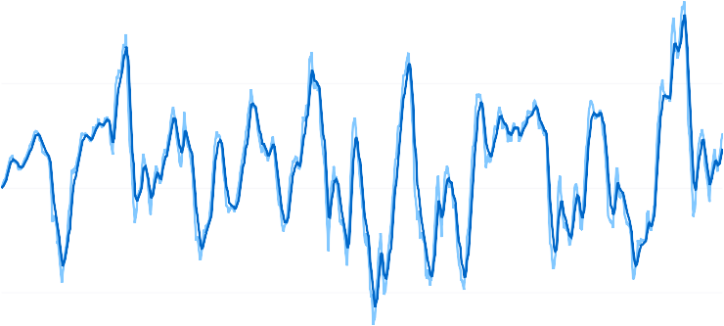

Date

Signal Li

5

0

MACD

−5

2020 2021 2022 2023 2024

# Model Performance Metrics and Predictions

## Results for AAPL:

**RMSE:** 0.8552193070614056, **MAE:** 0.647605590079376

## Actual vs Predicted Values for AAPL

240

220

200

180



160

140

Predict Actual

# Predicted Stock Prices

**Predicted Price for AAPL:** 229.49

# Backtesting Results

Initial Capital: ₹ 100000

Final Portfolio Value: ₹ 123930.54 Total Return: 23.94%

