frrrrrrrrrrrrr


frrrrrrrrrrrrr


swwwwwwwww

1. dddddddddddd

Implement content fitting logic.
If text is too long for the designated area:
• Continue the text to the next page.
• Preserve the same formatting.
• Avoid overlapping images.
• Avoid cutting text in the middle of paragraphs.
• Maintain readable spacing.
Do NOT simply reduce the font size to make everything fit on one page.

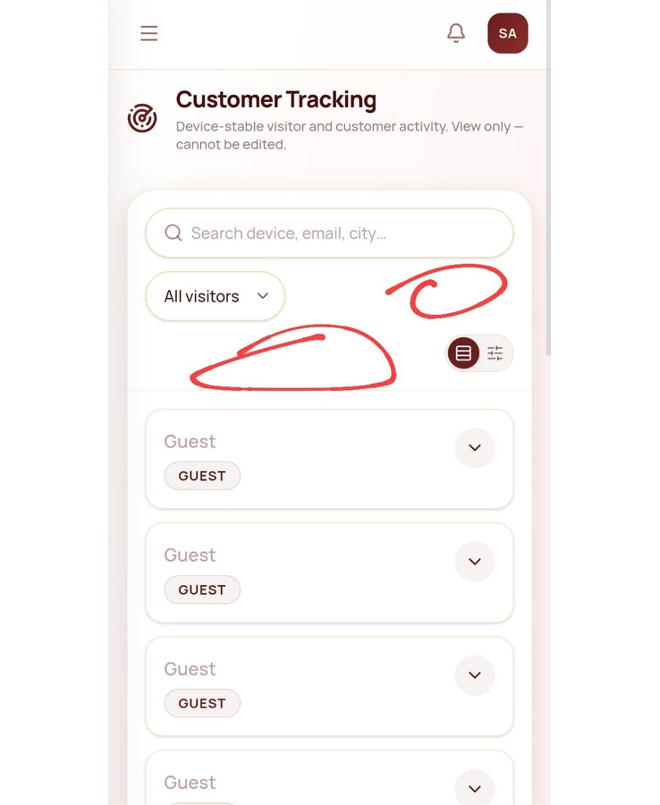

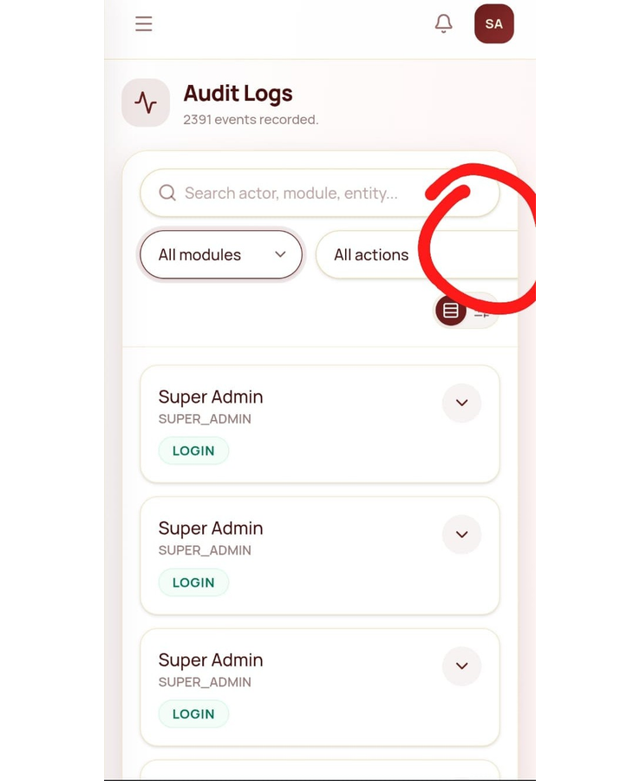

PARTICIPATION LIST OF ORIENTATION ON HEALTH AWARENESS FOR II UG STUDENTS
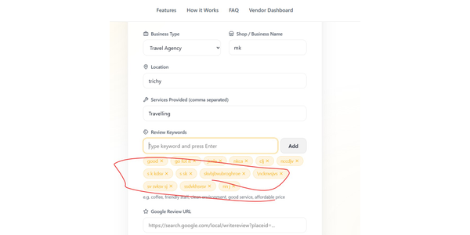
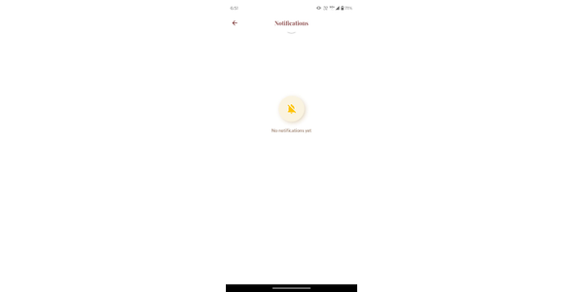

NEWS PAPER CLIPINGS OF ORIENTATION ON HEALTH AWARENESS FOR II UG STUDENTS

