Comparing Feature Extraction Methods for Peripheral Blood Cell Classification
Chung Yan Yu (Joel)
2026-06-02

Cover Page


MSt Healthcare Data Science

Authentication of practice
I confirm that I have fully read and understood the assignment brief for this module. | Y

Details
Name: Chung Yan | Surname: Yu
Submission Date | 02 – 06 – 26
Word Count: whole assignment including codes | 6,725
Word Count: main body excluding abstract, references and supplementary materials | 2,863

Permission to share your assignment
I do give permission to share my assignment with future MSt participants.

University statement of originality
This assignment is the result of my own work and includes nothing which is the outcome of work done in collaboration except as declared in the Preface and specified in the text. It is not substantially the same as any that I have previously submitted for a degree or diploma or other qualification at the University of Cambridge or any other university or similar institution, or that is being concurrently submitted, except as declared in the Preface and specific in the text. I further state that no substantial part of my Portfolio has already been submitted, nor is being concurrently submitted for any such degree, diploma or other qualification at the University of Cambridge or any other university or similar institution except as declared in the Preface and specified in the text.
I confirm the statement of originality as above | Y

Questions for reflection
Self-assessment is an important aspect of feedback literacy, which is, in turn, key to the development of expertise. As you proceed through the MSt Healthcare data science programme, we hope that you will make use of the following prompts to assess your own work on assignments. Specific assignment briefs will likely indicate which of these to address for which assessments, but, in general, we expect you to respond to one or two for each assignment on your course.
For each of the questions, do not spend too long answering – keep it brief. For each question you answer, limit yourself to no more than three items. And please remember, this is optional and developmental: these cover sheets are designed to create space for self-assessment and feedback dialogue, rather than additional assignment workload.
- Which aspects of this assignment are you most uncertain about and/or would most like to receive feedback on?
- Was the scope too ambitious? I felt this was a complete narrative/story, so I really struggled to cut down on areas.
- What elements are you left pondering after this assignment that you would like to discuss further?
- How vision transformers work in detail, especially when compared with CNNs and on their positional embeddings and classifier tokens.
- How have you incorporated feedback from peers and tutors into this assignment?
- Peers sugggested I add linear probe/logistic regression as a baseline
- And to compare models besides just looking at performance metrics
- How, and to what extent, have you been able to incorporate feedback on previous course work into this assignment?
- The nature of previous coursework is quite different to this one, so hard to translate.
- Using the wording in the rubric, how would you describe the quality of the different aspects of your work?
- Discussion might be too brief, but I really struggle to lower the word count elsewhere.

Declaration of the use of generative AI
Which permitted use of generative AI are you acknowledging? | Code generation, informed feedback
Which generative AI tool did you use (name and version)? | Claude Code Opus 4.6
What did you use the tool for? | Code generation, informed feedback, note curation and semantic search
How have you used or changed the generative AI’s output? | Notes are kept in point form so I can write in my own voice. LLMs often defer to older package versions when newer versions are available.

Abstract
PURPOSE Automated peripheral blood cell classification supports haematological diagnosis, but the relative merits of pretrained deep learning backbones, handcrafted features and end-to-end fine-tuning remain unclear, particularly on generalisability and computational cost.
METHODS The three approaches were compared and trained on the KU-Optofil dataset (31,484 images, 13 classes, 276 patients): pretrained deep learning (DinoBloom-S, ResNet-50, EfficientNet-B0, ViT-S/16) with XGBoost and linear probe classifiers; 65 handcrafted morphological features using convex hull or CellPose segmentation; end-to-end fine-tuning of ResNet-50 and EfficientNet-B0. Models were externally validated on the Acevedo dataset (17,092 images, 6 shared classes). SHAP values and attention maps provided interpretability.
RESULTS DinoBloom-S with XGBoost run on consumer hardware achieved the best performance among feature extraction approaches (macro F1 0.710 ± 0.007), comparable to fine-tuned models (macro F1 ~0.720) that required 40X more compute time on A100 GPUs. DinoBloom-S significantly outperformed ViT-S/16 (bootstrap Δ macro F1 95% CI excludes 0), highlighting the importance of domain-specific pretraining. On external validation, CellPose-based handcrafted features outperformed convex hull by 0.16 macro F1, thanks to better cell segmentation.
CONCLUSION Domain-specific self-supervised pretraining (DinoBloom-S) paired with a lightweight classifier provides near fine-tuned performance at a fraction of the computational cost. Segmentation quality plays a role for handcrafted feature generalisability.

Introduction
The classification of peripheral blood cells is a fundamental task in haematology, and the starting diagnostic step for 80% of haematological diseases¹. Manual classification methods that are prone to inter-observer variability^{2,3} have been gradually replaced by automated methods with the advent of classical and deep machine learning. One approach is radiomics inspired, relying on classical computer vision to engineer handcrafted features guided by haematological expertise⁴, often requiring fewer computational resources. A second approach is leveraging pretrained models as backbones, including convolutional neural networks (CNNs) and vision transformers (ViTs), to extract learned features that can be fed into classifiers¹, with this paradigm further expanding with the emergence of domain-specific foundational models such as DinoBloom⁵. Finally, there is the end-to-end fine-tuning approach that optimises the entire model for blood cell classification⁶, a method requiring substantial computational resources from graphics processing units (GPUs).
Commercial automated analysers are available, but their high cost and closed-source nature limit their accessibility, particularly in low-resource settings^{2,7}. With nearly half (47%) of the world population lacking access to diagnostics⁸, there is a need for affordable, open-source solutions regardless of the technological approach. This study compares the three abovementioned approaches on the recently released KU-Optofil dataset⁹, evaluating their performance and trade-offs, and validating the models on an external dataset from another centre¹⁰.

Methods

Dataset
The KU-Optofil dataset⁹ contains 31,484 images of peripheral blood cells of 13 classes, from 276 patients. The images are stained using the May-Grünwald-Giemsa method and collected with the Sysmex DI-60 system, and the 13 classes are band neutrophils, basophils, blasts, eosinophils, erythroblasts, giant platelets, lymphocytes, metamyelocytes, monocytes, myelocytes, platelet clusters, reactive lymphocytes, and segmented neutrophils (Figure 1a). The metadata provided patient level splits of training (193 patients, 23,057 images), validation (27 patients, 2,662 images) and test (56 patients, 5,765 images), the implementation of which prevented patient level leakage. The images, sized 368 × 368 pixels, were labelled by two expert haematologists with a third expert resolving disagreements, with all classes achieving a Cohen’s kappa (κ) of at least 0.85, most classes ≥ 0.94, and several classes in perfect agreement (κ = 1.00). There is however a severe class imbalance (Figure 1b), with segmented neutrophils making up more than half of the dataset (51.6%) and lymphocytes (18.3%), while band neutrophils (0.6%), metamyelocytes (0.8%), myelocytes (0.3%), and erythroblasts (0.8%) each represent less than 1%.
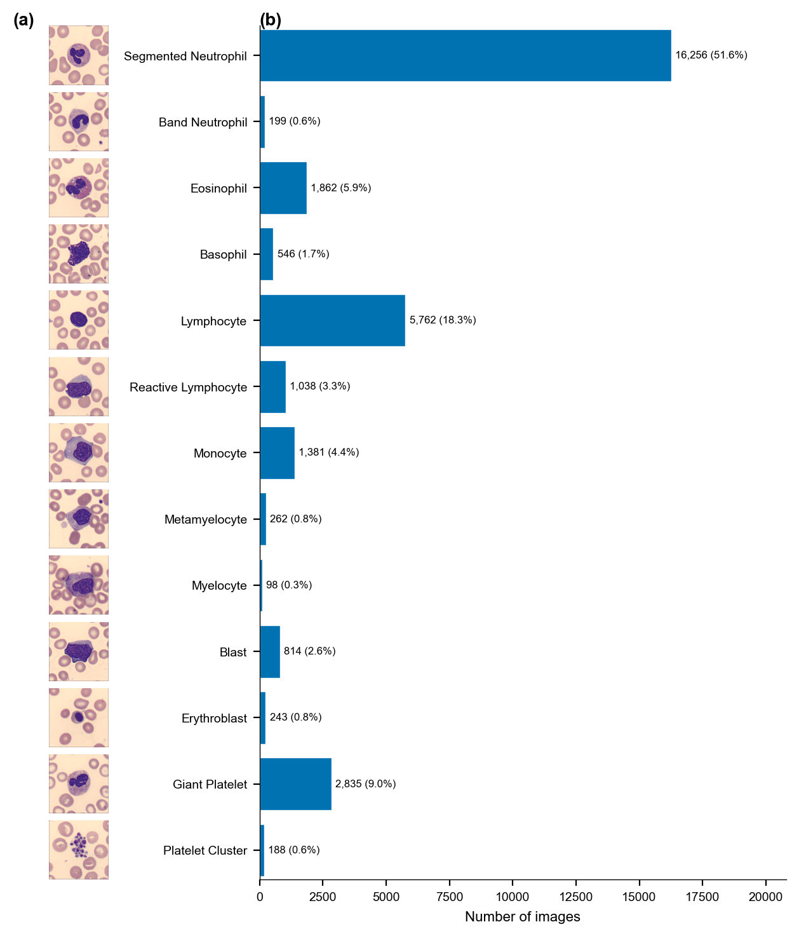
Figure 1: KU-Optofil dataset overview. (a) Representative images for each of the 13 cell classes, sampled from the training set. (b) Class distribution across the full dataset.
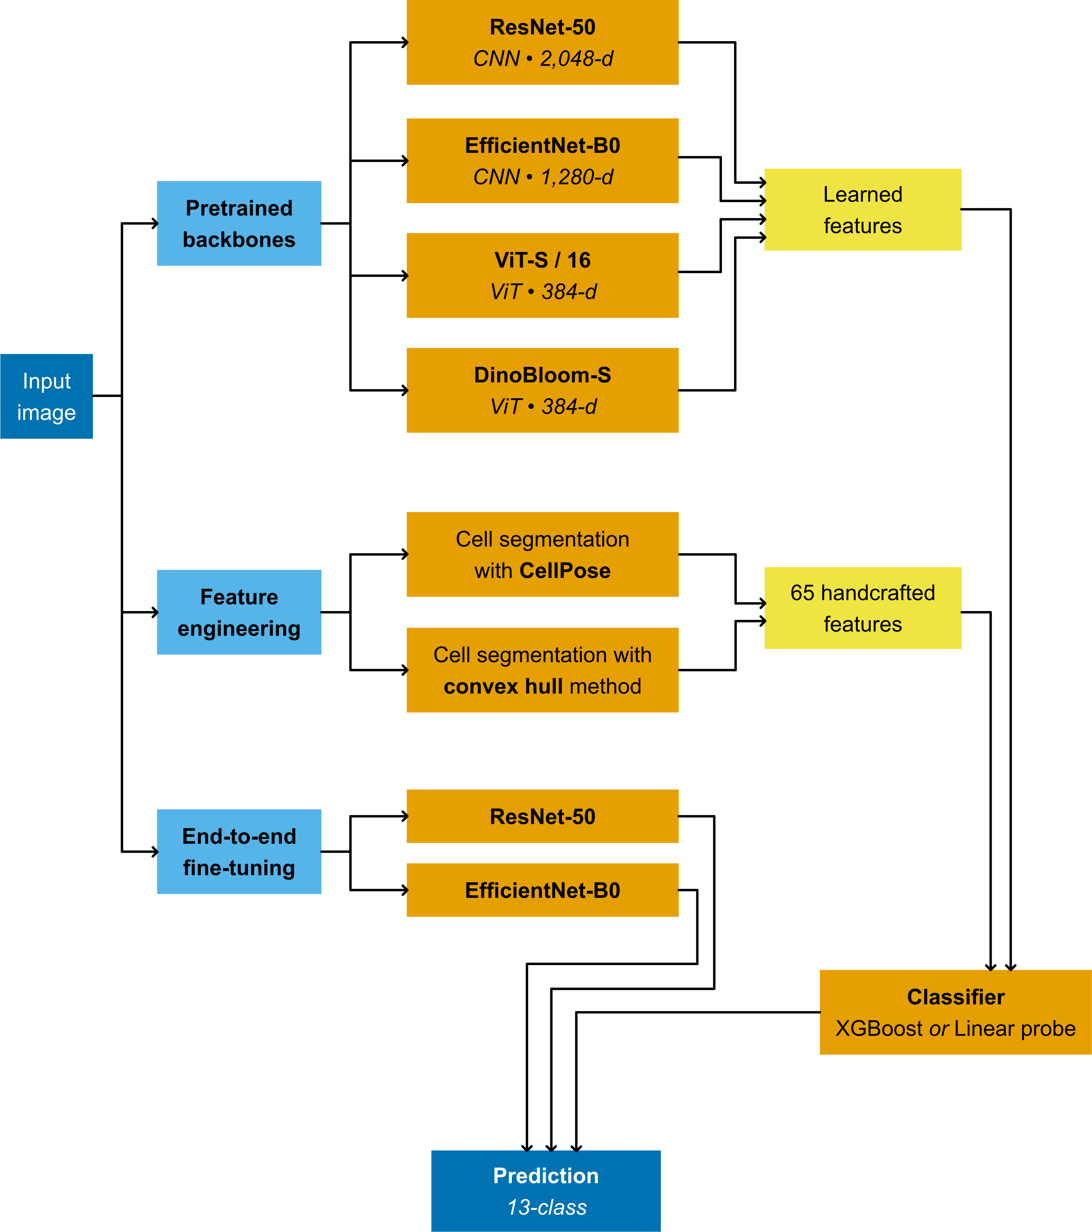
Figure 2: Modelling pipeline. Input images are processed through three parallel paths: (i) frozen pretrained backbones producing learned feature vectors, (ii) handcrafted morphological feature extraction using cell segmentation, and (iii) end-to-end fine-tuning. Paths (i) and (ii) feed the same lightweight classifiers.

Feature Extraction and Classification
Four pretrained deep learning models were used as feature extractors. Two CNNs, ResNet-50 (2048 dimensions) and EfficientNet-B0 (1280 dimensions), served as general-purpose baselines. DinoBloom-S (384 dimensions), a ViT-based foundational model self-supervised on haematological images⁵, provided domain-specific features. ViT-S/16 (384 dimensions), from the same ViT family as DinoBloom-S, served as a non-domain ViT baseline. All images were resized to 224 × 224 pixels and normalised with ImageNet statistics.
To create handcrafted features, 65 morphological features were engineered based on existing literature^{4,11}. These features were created using the ratios in sizes, colours and textures (grey level co-occurrence matrix: GLCM) between cell, cytoplasm and the nucleus, along with shape metrics such as circularity and solidity. To obtain these ratios, the nucleus and the cell both required segmentation (Figure 8). The nucleus was segmented using the same multi-Otsu thresholding method throughout, while the cell was segmented using two approaches: the convex hull of the nucleus⁴ and the CellPose SAM model¹². Both approaches were compared to assess the effect of segmentation quality on downstream classification.
Two classifiers were used on the features generated by the abovementioned feature extractors: XGBoost using Optuna¹³ via the tree-structured Parzen Estimator (TPE) to tune nine hyperparameters with 100 trials; linear probe using logistic regression with L2 regularisation. XGBoost captures non-linear feature interactions; linear probe serves as a baseline. Another two models were fine-tuned end-to-end using the ResNet-50 and EfficientNet-B0 backbones, using Optuna with TPE again for 30 trials with HyperbandPruner for hyperparameter tuning, with a maximum of 50 epochs and early stopping. All three approaches are visualised in the Figure 2 flowchart.
To account for the class imbalance within the dataset, all classifiers used inverse-frequency class weighting to ensure consistent handling of this severe imbalance across all paradigms, and the macro F1 score was used as the optimisation metric for all hyperparameter tuning.

Evaluation
As with hyperparameter tuning, the macro F1 score was the primary evaluation metric, as it is sensitive to rare-class performance. Accuracy and weighted F1 score were also reported for literature comparability. XGBoost and fine-tuned models were evaluated across five different random seeds for stability; linear probes are deterministic and require no seed variation. All metrics are reported in Table 1. For model-model comparison, deltas (Δ) in macro F1 were bootstrapped with 2,000 resamples to obtain 95% confidence intervals (CIs), along with Holm-corrected p-values from McNemar’s test.
An external dataset from Acevedo et al.¹⁰ containing 17,092 images with eight classes obtained via the CellaVision DM96 system and stained with May-Grünwald-Giemsa was used for external validation. Six shared classes between KU-Optofil and Acevedo were evaluated, with “neutrophil” in Acevedo mapped to “segmented neutrophil” in KU-Optofil, and immature granulocytes and platelets dropped. Classifiers were re-trained on KU-Optofil restricted to the six shared classes, reusing best hyperparameters from the 13-class tuning; no Acevedo data was used for training. The two datasets were carefully chosen to avoid data leakage. The KU-Optofil dataset postdates DinoBloom’s publication by two years, and while the Acevedo dataset was used for DinoBloom work, it was only for external validation, not training⁵.

Reproducibility and Hardware
The code for this project is available on GitHub in this repository. Package versions are listed in requirements.txt. The run_all.sh script reproduces the full pipeline. Datasets and model weights are auto-downloaded via scripts from Zenodo, Mendeley, Hugging Face and torchvision.
All models except the fine-tuned models were trained on an M4 Max Mac Studio with 14-core CPU, 32-core GPU, 36GB RAM. The fine-tuned models were trained on the University of Cambridge CSD3 cluster on NVIDIA A100 GPUs, with a 12-hour wall-time limit.

Results
Table 1 presents the classification performance of all models on the KU-Optofil test set. DinoBloom-S achieved the highest macro F1 (0.710 ± 0.007 with XGBoost, 0.705 with linear probe), with insignificant bootstrapped Δ macro F1 (95% CI crosses 0), indicating no significant advantage provided by the nonlinear XGBoost classifier on balanced performance. McNemar’s test was, however, significant (Holm-adjusted p < 0.001), reflecting XGBoost’s higher per-image accuracy on majority classes that macro F1 downweighs. DinoBloom-S also significantly outperformed all other models on bootstrapped Δ macro F1 (95% CIs all exclude 0). However, McNemar’s tests were insignificant against EfficientNet-B0 (p = 0.186) and handcrafted CellPose (p = 0.177) individually, indicating DinoBloom-S’s advantage lies in rare classes rather than the majority classes. That DinoBloom-S significantly outperformed ViT-S/16 (Holm-adjusted p < 0.001), a model sharing the same ViT architecture, suggests the importance of domain-specific pretraining.
End-to-end fine-tuning of ResNet-50 and EfficientNet-B0 led to comparable macro F1 scores (~ 0.720), but took 6 and 7 hours respectively to train on A100 GPUs, compared to 10.5 minutes for DinoBloom-S with XGBoost on consumer-grade hardware, a ~40X difference. Fine-tuning attempts were also made for ViT-S/16 and DinoBloom-S, but were unsuccessful due to exceeding the maximum wall time of 12 hours. Thus DinoBloom-S with XGBoost was able to deliver near fine-tuned performance with a fraction of the computational resources.
Table 1: Classification performance on the KU-Optofil test set (13-class). XGBoost and end-to-end fine-tuned models report macro F1 mean ± STD across 5 seeds; mean shown for weighted F1 and accuracy only as STD were all below 0.002. Best results among pretrained models are bold; fine-tuned models shown for comparison.
Feature source | Classifier | Macro F1 | Accuracy | Weighted F1
DinoBloom-S (ViT) | XGBoost | 0.709 ± 0.007 | 0.948 | 0.953
 | Linear probe | 0.705 | 0.932 | 0.942
EfficientNet-B0 (CNN) | XGBoost | 0.656 ± 0.004 | 0.944 | 0.945
 | Linear probe | 0.654 | 0.924 | 0.933
Handcrafted (CellPose) | XGBoost | 0.626 ± 0.005 | 0.944 | 0.945
 | Linear probe | 0.616 | 0.862 | 0.901
Handcrafted (convex hull) | XGBoost | 0.624 ± 0.007 | 0.935 | 0.936
 | Linear probe | 0.544 | 0.841 | 0.883
ViT-S/16 (ViT) | XGBoost | 0.609 ± 0.005 | 0.936 | 0.936
 | Linear probe | 0.612 | 0.904 | 0.920
ResNet-50 (CNN) | XGBoost | 0.591 ± 0.005 | 0.934 | 0.932
 | Linear probe | 0.568 | 0.898 | 0.907
End-to-end fine-tuning
ResNet-50 (fine-tuned) | End-to-end | 0.720 ± 0.008 | 0.945 | 0.952
EfficientNet-B0 (fine-tuned) | End-to-end | 0.720 ± 0.022 | 0.947 | 0.952

On a per-class level, the confusion matrices in Figure 3 show that band neutrophils were frequently misclassified as segmented neutrophils across all models, consistent with the low Cohen’s κ (0.85) from the dataset’s haematologists themselves. However, segmented neutrophils recall remained extremely high. Myelocyte recall was poor across all models, as it is the rarest class (n=98, 0.3%). ResNet-50 completely failed to recall any band neutrophils, with an overall much weaker diagonal that is consistent with its lower macro F1. DinoBloom-S maintained measurable recall across all 13 classes, shining in certain rare classes such as metamyelocytes (n=262, 0.8%) and platelet clusters (n=188, 0.6%).

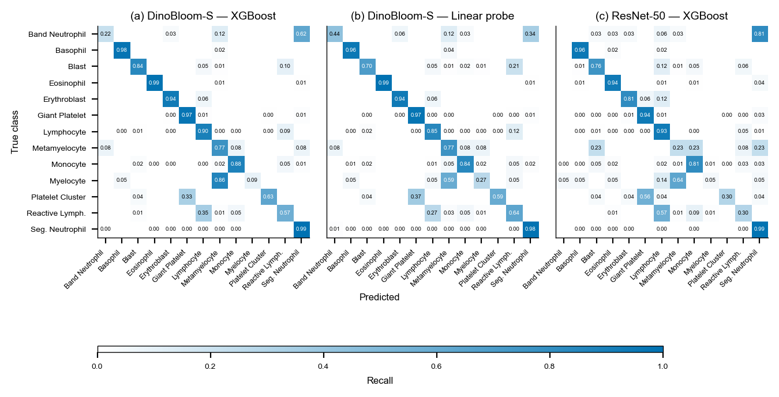
Figure 3: Test assessment confusion matrix on the KU-Optofil dataset, values are row-normalised. (a) DinoBloom-S with XGBoost, (b) DinoBloom-S with linear probe, (c) ResNet-50 with XGBoost.
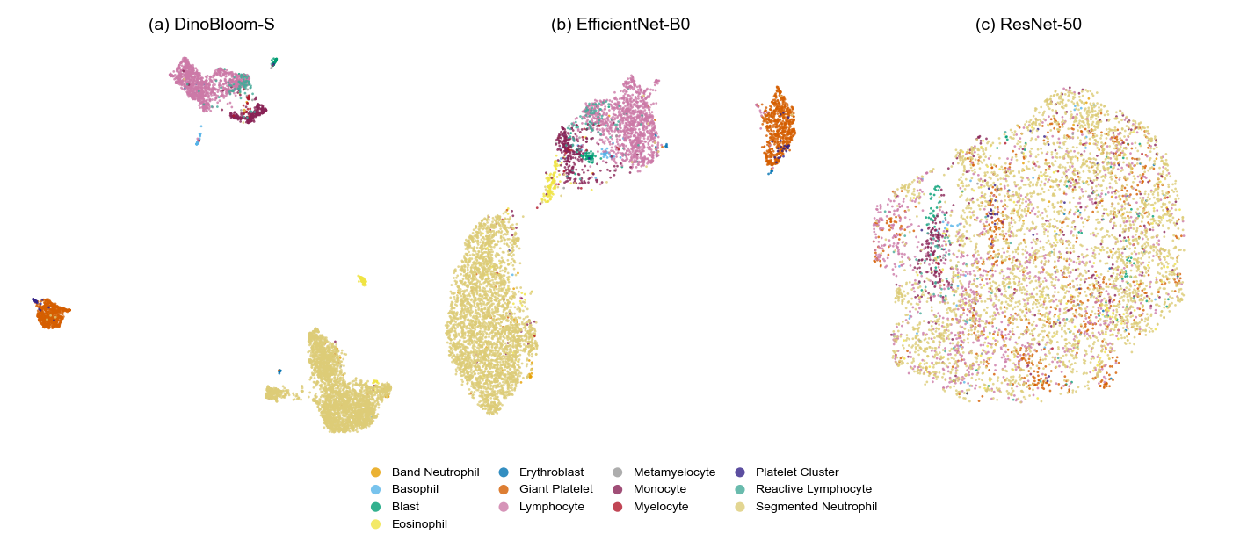
Figure 4: UMAP embeddings of test-set features (n = 5,765) in KU-Optofil dataset, coloured by cell class. (a) DinoBloom-S, (b) EfficientNet-B0, (c) ResNet-50.
To understand the feature space of the pretrained models, Figure 4 visualises the UMAP embeddings of their features. DinoBloom-S produced well-separated clusters for most classes, while EfficientNet-B0 showed general separation but with several classes still overlapping. ResNet-50’s features lacked separation, appearing as an amorphous cloud that is again consistent with its lower macro F1. Further scrutinising where DinoBloom-S was attending, Figure 5 shows clear separation of the target cell in the center, the background, and neighbouring cells in the PCA of patch tokens. Even the nucleus and cytoplasm showed some degree of separation. The token norm heatmaps present a more complicated picture, with the attention often focused on neighbouring cells and the background rather than the target cell itself. However, there is still some level of separation between the nucleus of the target cell and the cytoplasm. This suggests that differentiating between the nucleus and cytoplasm could play a role in DinoBloom-S’s performance. Yet, that the model attends to the background raises the possibility of learning scanner-specific artefacts.
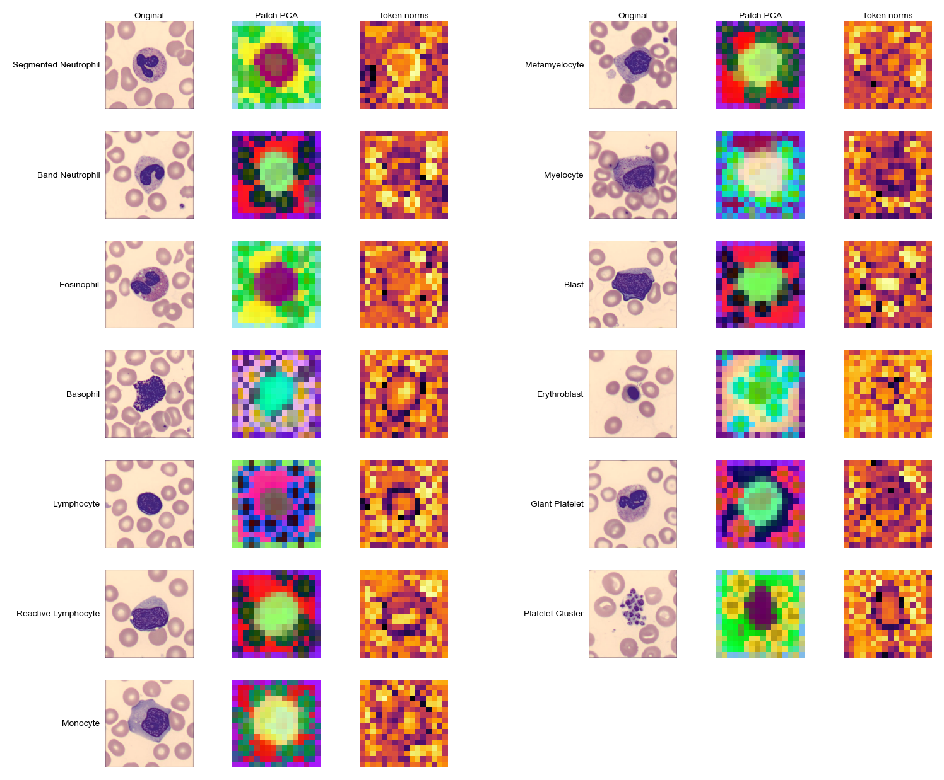
Figure 5: DinoBloom-S attention visualisations for 13 classes. Left: original image (resized to 224 × 224). Centre: PCA of patch tokens, top 3 components mapped to red, green and blue colors. Right: token-norm heatmap (brighter = higher activation).
When validated with the Acevedo dataset¹⁰ (6-class), Table 2 shows DinoBloom-S kept its edge over other models (XGBoost macro F1 = 0.919, linear probe macro F1 = 0.908), with higher absolute macro F1 than on KU-Optofil, while the rankings of the other models shifted compared to Table 1. These higher scores are not directly comparable, as the external set has fewer than half the classes. Digging deeper into per-class performance in Figure 6, the erythroblast class saw a notable drop in recall for all models. This may reflect sensitivity of erythroblast morphology to scanner variations (Sysmex DI-60 vs CellaVision DM96).
Table 2: Classification performance on the Acevedo external validation set (6-class). XGBoost rows report macro F1 mean ± SD across 5 seeds; fine-tuned models were not validated. Best values per metric are bold.
Feature source | Classifier | Macro F1 | Accuracy | Weighted F1
DinoBloom-S (ViT) | XGBoost | 0.919 ± 0.001 | 0.936 | 0.936
 | Linear probe | 0.908 | 0.928 | 0.931
EfficientNet-B0 (CNN) | XGBoost | 0.672 ± 0.008 | 0.713 | 0.713
 | Linear probe | 0.599 | 0.635 | 0.650
Handcrafted (CellPose) | XGBoost | 0.788 ± 0.003 | 0.849 | 0.827
 | Linear probe | 0.593 | 0.703 | 0.664
Handcrafted (convex hull) | XGBoost | 0.629 ± 0.007 | 0.708 | 0.688
 | Linear probe | 0.461 | 0.560 | 0.499
ViT-S/16 (ViT) | XGBoost | 0.685 ± 0.010 | 0.744 | 0.737
 | Linear probe | 0.792 | 0.816 | 0.814
ResNet-50 (CNN) | XGBoost | 0.743 ± 0.004 | 0.773 | 0.773
 | Linear probe | 0.660 | 0.683 | 0.684

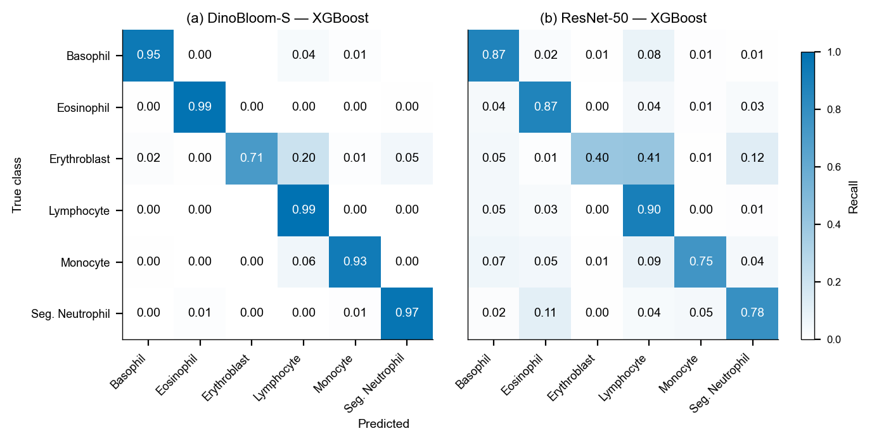
Figure 6: External validation confusion matrices on the Acevedo dataset (6-class). (a) DinoBloom-S with XGBoost. (b) ResNet-50 with XGBoost. Values are row-normalised.
The unexpected finding during external validation was the effect of cell segmentation on handcrafted features (Table 2). On KU-Optofil, CellPose and convex hull segmentation performed similarly (|Δ macro F1| < 0.001, bootstrap CI crosses 0), but on the Acevedo dataset CellPose outperformed convex hull by +0.16 macro F1 (0.788 vs 0.629), with a stronger diagonal in Figure 7 (a, b). SHAP analysis (Figure 7 c, d) shows that both approaches shared nucleus GLCM texture features in their top 10, as expected given identical nucleus segmentation. The difference is that convex hull leaned more on cytoplasm-to-cell colour ratios, while CellPose leaned more on nucleus-to-cell colour ratios and shape features such as solidity. This could be due to the convex hull of the nucleus underestimating the true cell boundary, yielding a thin cytoplasmic region surrounding the nucleus. Colour ratios computed from this small region are sensitive to boundary detection and lack the averaging effect of a larger sample of pixels. In contrast, CellPose traces the actual cell membrane, providing a fuller cytoplasm region where pixel-level noise is averaged out, producing more stable colour ratios that generalise across scanners.
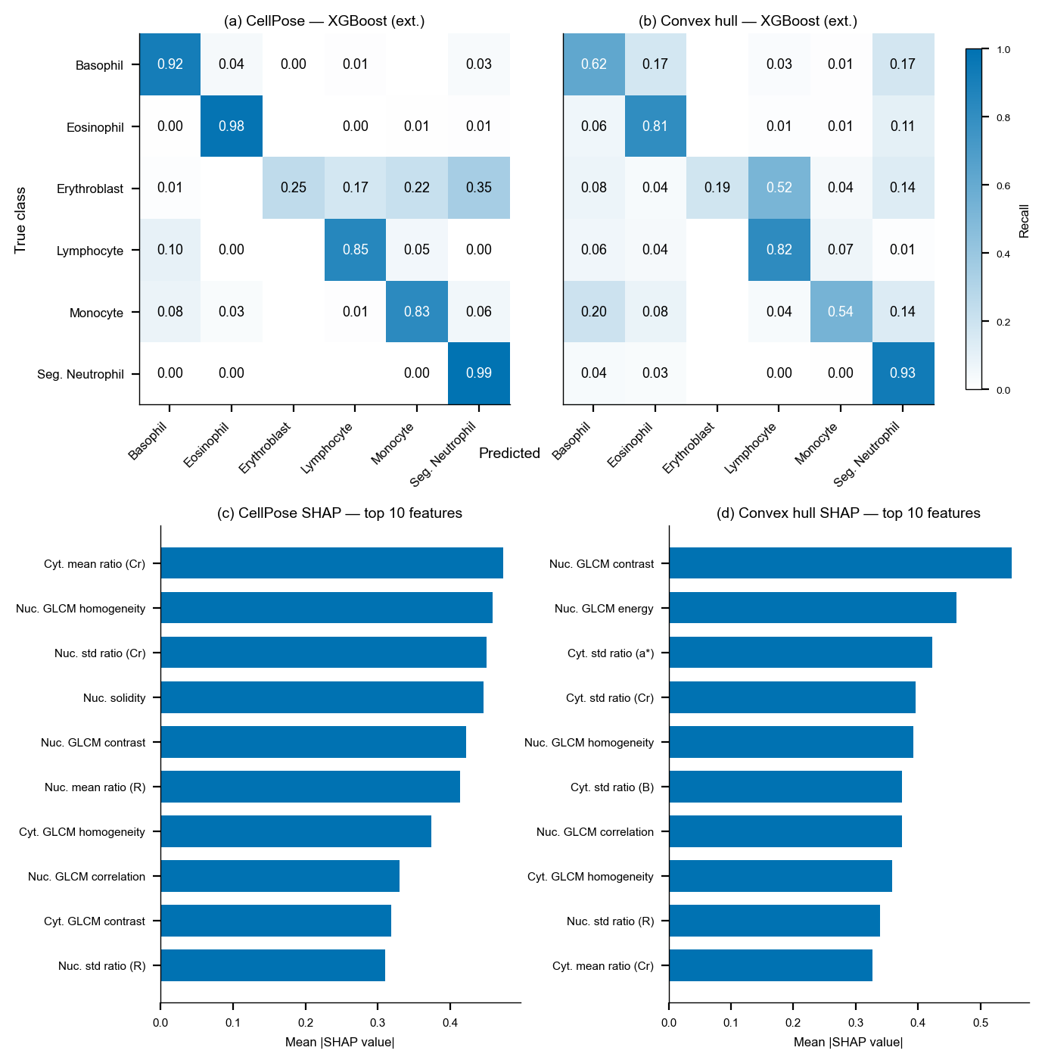
Figure 7: Segmentation method impacts handcrafted feature performance and importance. (a, b) External validation confusion matrices (row-normalised) on the Acevedo dataset (6-class, XGBoost) for CellPose and convex hull segmentation. (c, d) SHAP feature importance (mean |SHAP| across all classes) for the top 10 features in the KU-Optofil internal test set (13-class, XGBoost, subsample of 1,000) for CellPose and convex hull segmentation. Nuc. = nucleus, Cyt. = cytoplasm, GLCM = grey-level co-occurrence matrix. Ratios all refer to colour ratios of mean or standard deviation (std), and use the whole cell as the denominator, brackets denote the color channel and colour space. (Cr) = red chrominance in YCrCb colour space; (a*) = green-red in LAB colour space, (B) = blue, (R) = red in RGB colour space.

Discussion
DinoBloom-S outperforming other ImageNet-pretrained models could be attributed to its in-domain pretraining with 380,000 white blood cell images⁵. Through self-supervised learning, it captured haematological morphological features that ImageNet models lack. This improvement via in-domain training exceeded the gains reported by Glüge et al.¹⁴, although the group used supervised learning with adjacent domains (cervical cells and histopathology) rather than self-supervised learning on haematological images. That linear probes were comparable classifiers to XGBoost when used with DinoBloom-S suggests that DinoBloom-S’s pretraining produces representations where cell types are already well-separated, as substantiated by UMAP embeddings (Figure 4). For deployment, this means classification requires only feature extraction with DinoBloom-S followed by logistic regression, both runnable on consumer hardware, bypassing GPU training. Inference, however, still benefits from GPU hardware acceleration, as does CellPose segmentation for the handcrafted features. As shown in the external validation (Table 2), CellPose was likely the difference for handcrafted feature generalisation, but it replaces a computationally near-zero-cost convex hull operation with a transformer inference step. This creates a deployment conundrum: the convex hull handcrafted pipeline is lightweight enough to run on affordable processors such as a Raspberry Pi⁴, but its poor generalisation (Table 2) could limit utility, while approaches that generalise better (DinoBloom-S, CellPose) require hardware that might not be available in the low-resource settings where they are needed most.
Another trade-off is that of performance and interpretability. Handcrafted features are morphologically transparent, with SHAP (Figure 7 c, d) indicating which colour ratios and textures drive prediction. DinoBloom-S’s extracted features are abstract, relying on attention maps to show where the model attends (Figure 5) and in this case revealed that attention focused on areas other than the target cell. To allay concerns that the model is learning background noise rather than cell morphology, future work could segment the target cell with CellPose before the feature extraction step, to see if the model’s classification power resides in the target cell.

Limitations and Ethical Considerations
Blast identification is the most clinically consequential classification, as missed blasts can delay leukaemia diagnosis. DinoBloom-S with XGBoost blast recall was only 0.84, leaving a 16% miss rate that is insufficient for unsupervised deployment. Other limitations include training on a single centre (Koç University Hospital, Turkey) only, and the pipeline assumes pre-cropped single-cell images rather than whole blood smears. CellPose segmentation was only validated on a sample of images (Figure 8) and by fallback rates (<0.1%), but exhaustive manual verification was not performed. The lack of demographic metadata (e.g. age, sex) also precluded bias auditing.
Both datasets originate from European/Mediterranean centres (Istanbul, Barcelona), yet the diagnostic gap is most acute in low- and middle-income countries⁸, where such models would be needed most but their performance remains untested. Looking at existing commercial systems (e.g. CellaVision), they operate as screening aids requiring human review⁷. Any deployment of these models should similarly augment rather than replace clinical judgement, with documented failures (e.g. blast recall, myelocyte classification) communicated clearly to end users.

Conclusion
A domain-specific foundation model (DinoBloom-S) paired with a lightweight classifier (logistic regression) can approach fine-tuned performance at a fraction of the computational cost, offering an accessible and generalisable pipeline for peripheral blood cell classification.

References
1. Acevedo, A., Alférez, S., Merino, A., Puigví, L. & Rodellar, J. Recognition of peripheral blood cell images using convolutional neural networks. Computer Methods and Programs in Biomedicine 180, 105020 (2019).
2. Fan, B. E. et al. From microscope to micropixels: A rapid review of artificial intelligence for the peripheral blood film. Blood Reviews 64, 101144 (2024).
3. Schelonka, R. L. et al. Differentiation of segmented and band neutrophils during the early newborn period. The Journal of Pediatrics 127, 298–300 (1995).
4. Tavakoli, S., Ghaffari, A., Kouzehkanan, Z. M. & Hosseini, R. New segmentation and feature extraction algorithm for classification of white blood cells in peripheral smear images. Scientific Reports 11, 19428 (2021).
5. Koch, V. et al. DinoBloom: A foundation model for generalizable cell embeddings in hematology. in Medical image computing and computer assisted intervention – MICCAI 2024 vol. 15012 520–530 (Springer Nature Switzerland, 2024).
6. Asghar, R., Kumar, S., Shaukat, A. & Hynds, P. Classification of white blood cells (leucocytes) from blood smear imagery using machine and deep learning models: A global scoping review. PLOS ONE 19, e0292026 (2024).
7. Kratz, A. et al. Digital morphology analyzers in hematology: ICSH review and recommendations. International Journal of Laboratory Hematology 41, 437–447 (2019).
8. Fleming, K. A. et al. The Lancet Commission on diagnostics: Transforming access to diagnostics. The Lancet 398, 1997–2050 (2021).
9. Yarıkan, A. E. et al. A large-scale peripheral blood cell dataset for automated hematological analysis. Scientific Data 13, 417 (2026).
10. Acevedo, A. et al. A dataset of microscopic peripheral blood cell images for development of automatic recognition systems. Data in Brief 30, 105474 (2020).
11. Dasariraju, S., Huo, M. & McCalla, S. Detection and classification of immature leukocytes for diagnosis of acute myeloid leukemia using random forest algorithm. Bioengineering 7, 120 (2020).
12. Pachitariu, M., Rariden, M. & Stringer, C. Cellpose-SAM: Superhuman generalization for cellular segmentation. bioRxiv https://doi.org/10.1101/2025.04.28.651001 (2025) doi:10.1101/2025.04.28.651001.
13. Akiba, T., Sano, S., Yanase, T., Ohta, T. & Koyama, M. Optuna: A next-generation hyperparameter optimization framework. in Proceedings of the 25th ACM SIGKDD international conference on knowledge discovery and data mining (2019).
14. Glüge, S., Balabanov, S., Koelzer, V. H. & Ott, T. Evaluation of deep learning training strategies for the classification of bone marrow cell images. Computer Methods and Programs in Biomedicine 243, 107924 (2024).

Appendix
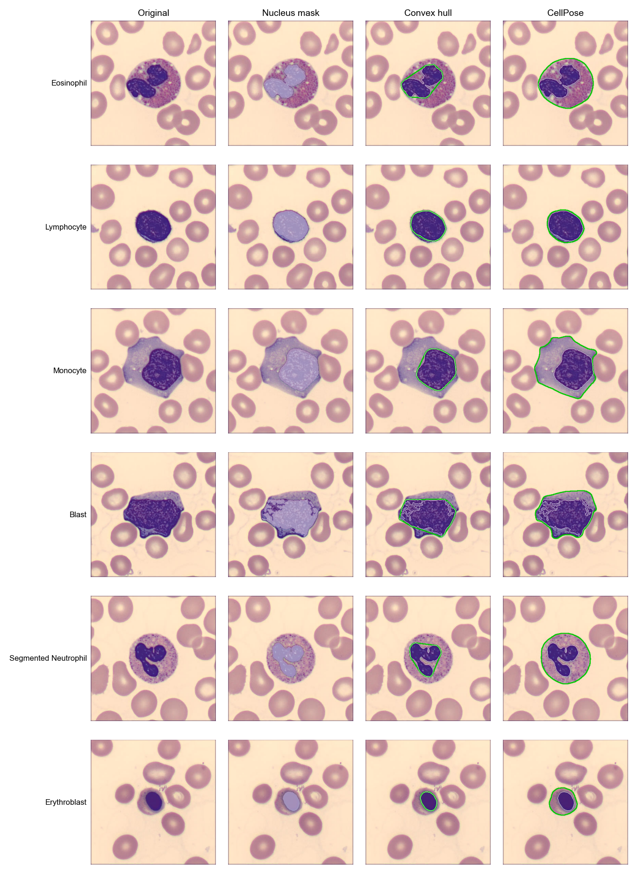
Figure 8: Cell segmentation comparison for six representative cell types. Each row shows (left to right): the original image; nucleus mask from multi-Otsu thresholding (white); convex hull cell boundary (green outline — the convex envelope of the nucleus); and CellPose cell boundary (green outline).

