**CMPE-250 Laboratory Exercise 7**

**Circular FIFO Queue Operations**

By submitting this report, I attest that its contents are wholly my individual writing about this exercise and that they reflect the submitted code. I further acknowledge that permitted collaboration for this exercise consists only of discussions of concepts with course staff and fellow students; however, other than code provided by the instructor for this exercise, all code was developed by me.

Joel Yuhas

Performed 3/24/16

Submitted 4/4/16

Lab Section L2

Instructor: Shaaban, Muhammad

TA: Peter Muller

Stephen Moore

Connor Goss

Lecture Section 01

Professor: Sarra, Alessandro

**Documentation:**

Screen Capture With:

* Uppercase and lower case commands
* Commands with an empty queue
* Commands with a full queue
* Commands with a circular buffer operation

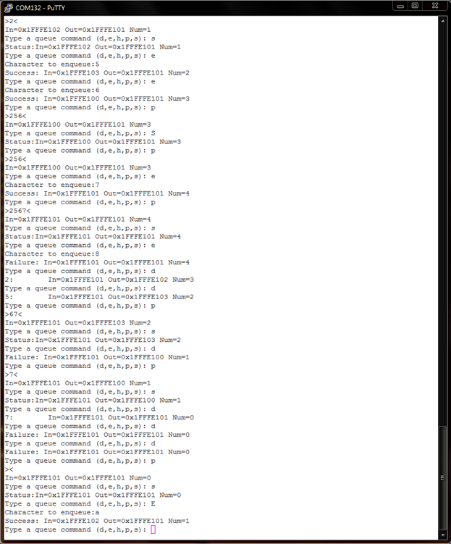

List exact memory range (starting address and the address of the last byte) for these components

* Executable code
* Constants in ROM
* RAM used
  + Queue record structure
  + Queue buffer

**Memory Map**

|  |  |  |
| --- | --- | --- |
| **Type** | **Starting Address** | **Last Byte** |
| Executable Code | 0x00000410 | 0x000085F |
| Constants in ROM | 0x00000204 | 0x0000002BB |
| Queue record structure | 0x1FFFE104 | 0x1FFFE115 |
| Queue buffer | 0x1FFFE100 | 0x1FFFE103 |