Development of a Destination Choice Model for Ontario

Joseph Molloy

Supervisor: Prof. Rolf Moeckel

Introduction

Standard socioeconomic variables are not always accurate indicators of destination attractiveness in destination choice models. For example, areas such as ski resorts are significant attractors of long distance trips, yet have small populations and little employment. The **objective** of this thesis is to develop a destination choice model for long distance travel in Ontario that uses data from the location based social network, Foursquare, to address this issue. Points of interest and their historical check-in counts are collected and processed to define measures of destination attractiveness based on common long distance trip activities.

**Methodology**

1. Zone system was defined based on the Travel Survey of Residents of Canada (TSRC) data
2. Check-in counts collected from public Foursquare API for all of Canada in 1-degree blocks
3. Check-ins aggregated by common long distance categories

* Hotels, Skiing, Outdoor, Airports, Nightlife and Medical

1. Singly constrained gravity model constructed as a baseline
2. A Multinomial logit model was designed, estimated, implemented and calibrated for destination choice
3. Scenario Analysis of a hypothetical new ski resort

**Zone system for Ontario defined from TSRC Resolution**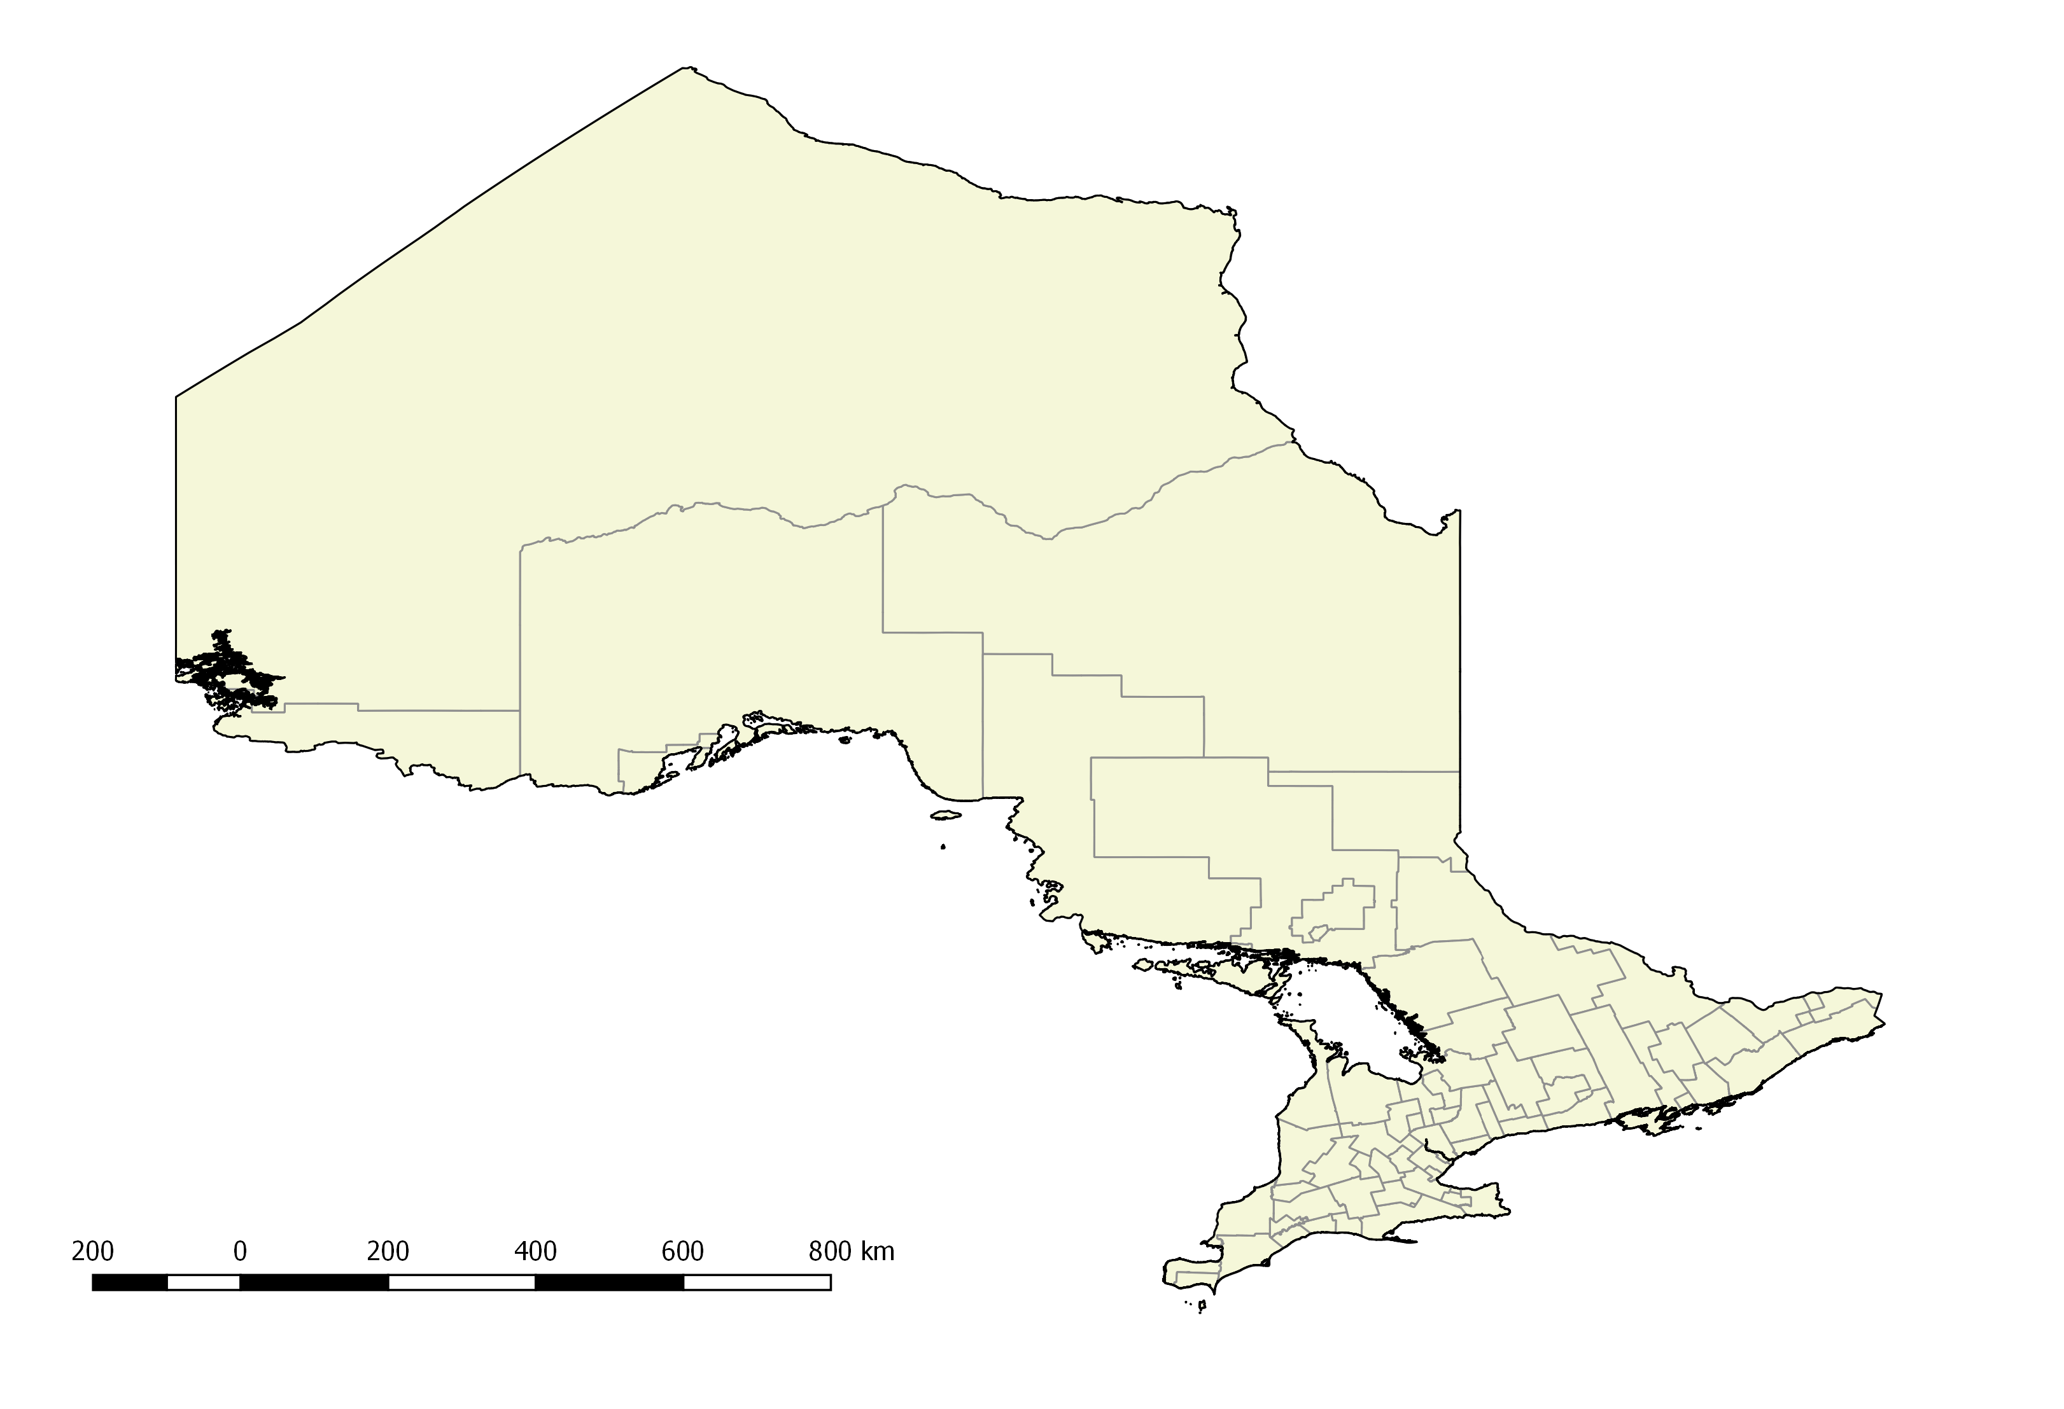

**Estimation**

Foursquare variables reduced errors for popular Origin-Destination pairs

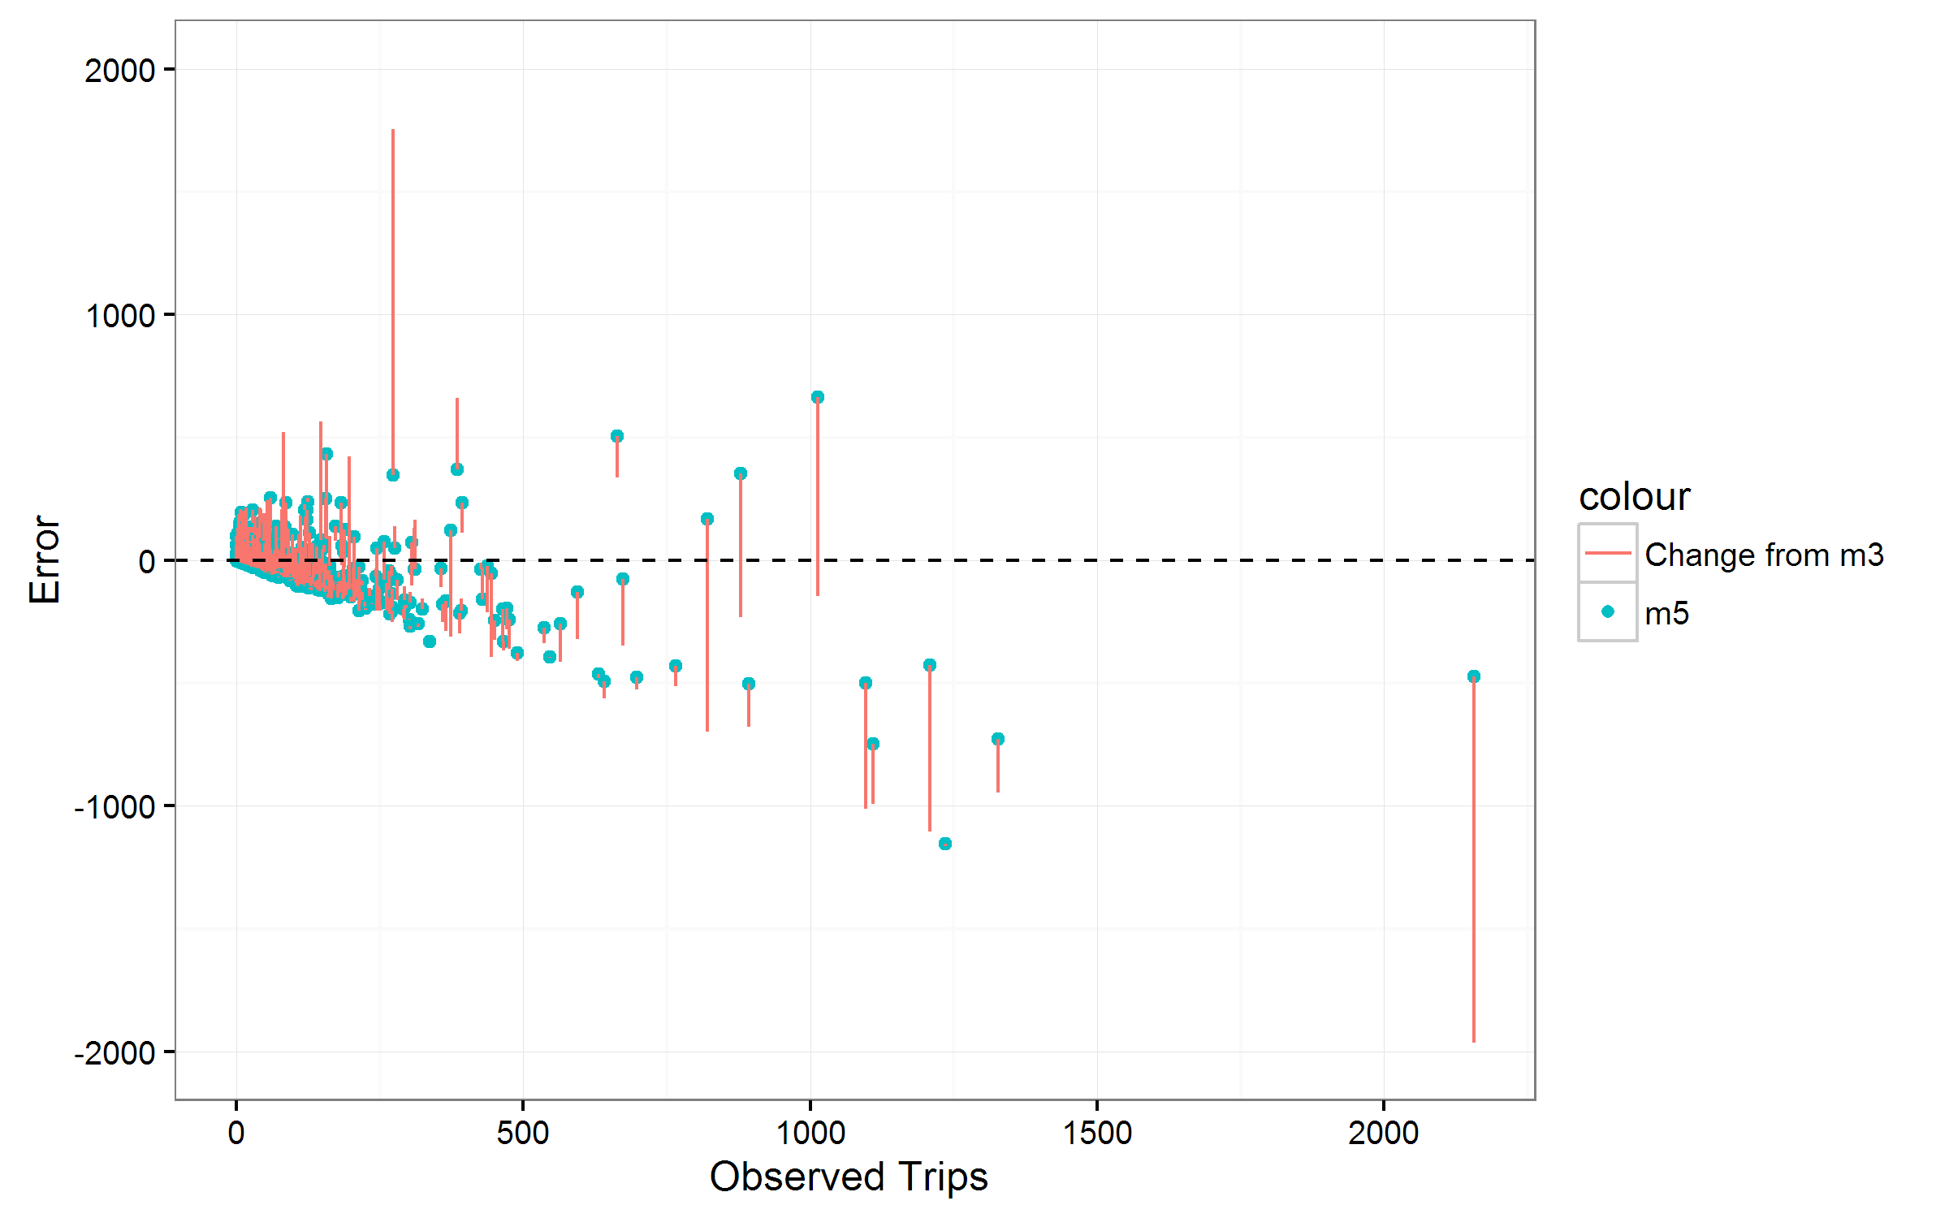

Improvement

With foursquare-based paramters

Shape

**Effect of foursquare data on important destinations**

Scenario Analysis

Toronto Intra-zonal

Toronto 🡪 Niagara

* Hypothetical new ski area in Dufferin
* Impact on destination attractiveness variables predicted from foursquare data
* Shows reasonable sensitivity across variables

**Impact of new Ski resort on visitors to Dufferin (Toronto)**

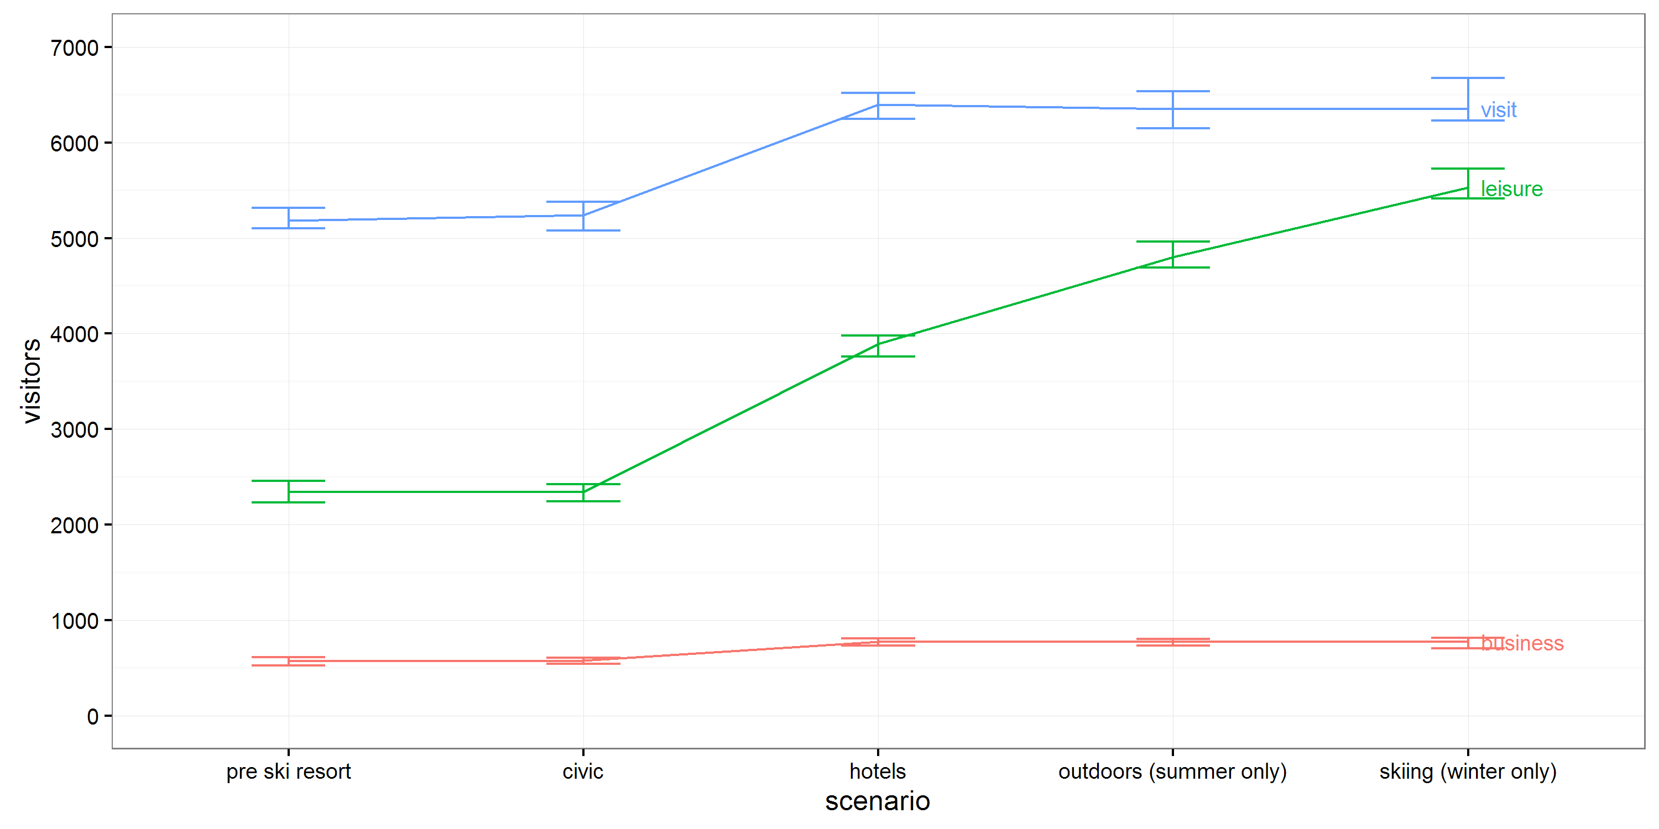

**Results & Further Work**

* Foursquare-based parameters resulted in a more accurate and powerful model.
* Particularly effective for reflecting destination attractiveness for leisure travel
* Feedback from mode-choice model would improve model
* Work shows potential of big data approaches to destination choice modeling

**Improvement over model estimation iterations**

References

Statistics Canada (2014). “Travel Survey of Residents of Canada (TSRC)”.

Rohr, Charlene et al. (2010). “Modelling Long-Distance Travel in the UK”. In: European Transport Conference, 2010