Republic of the Philippines
LAND TRANSPORTATION OFFICE
DRIVER'S LICENSE

PERSONAL INFORMATION
Full Name: April Jay Bingtan
Date of Birth: February 28, 1995
Nationality: Filipino
Gender: Male
Address: Sample Street, Quezon City

LICENSE DETAILS
License Number: N88176132
License Type: Non-Professional
Restrictions: 1, 2
Date Issued: April 11, 2026
Expiry Date: April 10, 2031

PHYSICAL DESCRIPTION
Height: 170 cm
Weight: 65 kg
Eye Color: Brown
Hair Color: Black

ISSUED BY
LTO Officer
Signature: _________________________
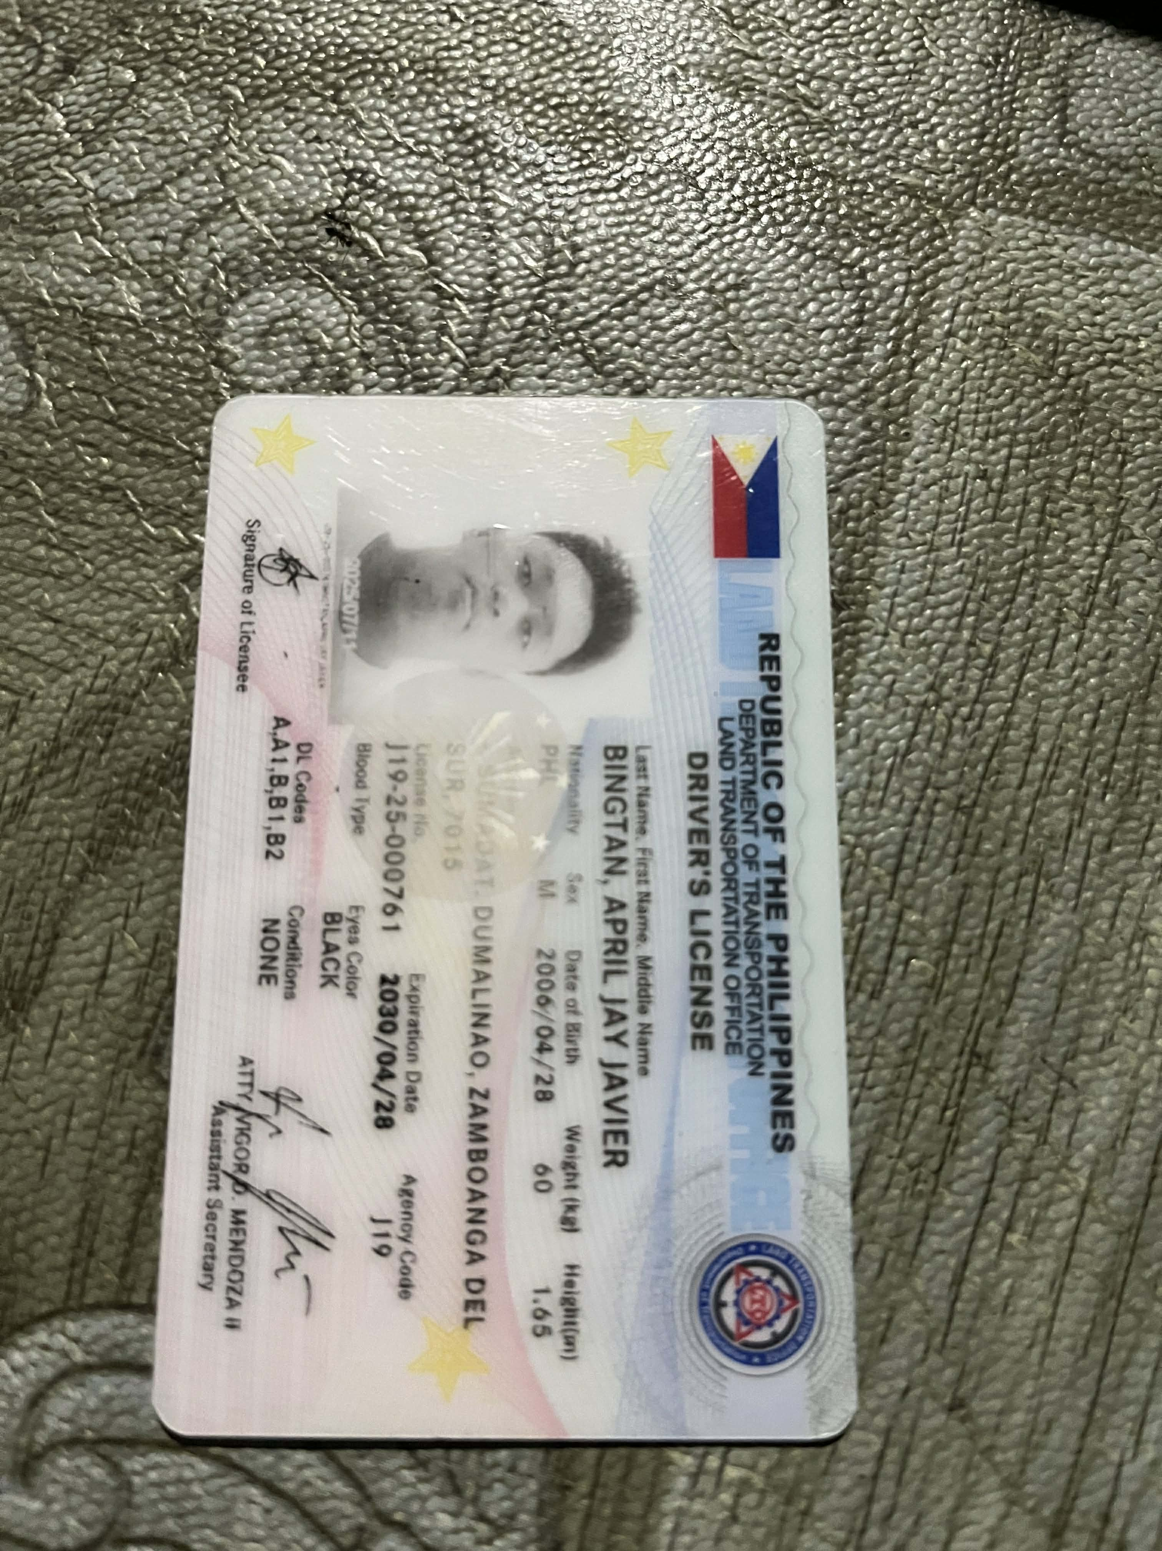
Attach ID Photo Here
